UNITED STATES
SECURITIES AND EXCHANGE COMMISSION
Washington, D.C. 20549
__________________________________
FORM 8-K
__________________________________
CURRENT REPORT
Pursuant to Section 13 or 15(d)
of The Securities Exchange Act of 1934
Date of Report (Date of earliest event reported): May 7, 2026
Opendoor Technologies Inc.
(Exact name of registrant as specified in its charter)
Delaware |  |  | 001-39253 |  |  | 30-1318214
(State or other jurisdiction  of incorporation) |  |  | (Commission  File Number) |  |  | (I.R.S. Employer  Identification No.)
1295 West Washington Street, Suite 115
Tempe, |  |  | AZ |  |  | 85288
(Address of principal executive offices) |  |  |  |  |  | (Zip Code)
(480) 618-6760
(Registrant’s telephone number, including area code)
N/A
(Former name or former address, if changed since last report)
Check the appropriate box below if the Form 8-K filing is intended to simultaneously satisfy the filing obligation of the registrant under any of the following provisions:
☐ |  |  | Written communications pursuant to Rule 425 under the Securities Act (17 CFR 230.425)
☐ |  |  | Soliciting material pursuant to Rule 14a-12 under the Exchange Act (17 CFR 240.14a-12)
☐ |  |  | Pre-commencement communications pursuant to Rule 14d-2(b) under the Exchange Act (17 CFR 240.14d-2(b))
☐ |  |  | Pre-commencement communications pursuant to Rule 13e-4(c) under the Exchange Act (17 CFR 240.13e-4(c))
Securities registered pursuant to Section 12(b) of the Act:
Title of each class |  |  |  |  |  | Trading Symbol(s) |  |  |  |  |  | Name of each exchange  on which registered
Common stock, $0.0001 par value per share |  |  |  |  |  | OPEN |  |  |  |  |  | The Nasdaq Stock Market LLC
Series K Warrants, each whole warrant exercisable to purchase one share of common stock at an exercise price of $9.00 per warrant |  |  |  |  |  | OPENW |  |  |  |  |  | The Nasdaq Stock Market LLC
Series A Warrants, each whole warrant exercisable to purchase one share of common stock at an exercise price of $13.00 per warrant |  |  |  |  |  | OPENL |  |  |  |  |  | The Nasdaq Stock Market LLC
Series Z Warrants, each whole warrant exercisable to purchase one share of common stock at an exercise price of $17.00 per warrant |  |  |  |  |  | OPENZ |  |  |  |  |  | The Nasdaq Stock Market LLC
Indicate by check mark whether the registrant is an emerging growth company as defined in Rule 405 of the Securities Act of 1933 (§230.405 of this chapter) or Rule 12b-2 of the Securities Exchange Act of 1934 (§240.12b-2 of this chapter).
Emerging growth company ☐
If an emerging growth company, indicate by check mark if the registrant has elected not to use the extended transition period for complying with any new or revised financial accounting standards provided pursuant to Section 13(a) of the Exchange Act. o

Item 2.02Results of Operations and Financial Condition
On May 7, 2026, Opendoor Technologies Inc. (the “Company”) issued a press release announcing its financial results for the first quarter ended March 31, 2026. A copy of the press release is furnished as Exhibit 99.1 to this Current Report on Form 8-K.

Item 7.01 Regulation FD Disclosure
On May 7, 2026, the Company posted an earnings supplement (the “Supplement”) and supplemental macroeconomic charts (the “Supplemental Macro Charts”) in the “Investor Relations” portion of its website at investor.opendoor.com. A copy of the Supplement and the Supplemental Macro Charts is attached to this Current Report on Form 8-K as Exhibit 99.2 and 99.3, respectively.
The information contained in Items 2.02 and 7.01 of this Current Report (including Exhibits 99.1, 99.2, and 99.3 attached hereto) shall not be deemed “filed” for purposes of Section 18 of the Securities Exchange Act of 1934, as amended (the “Exchange Act”), or otherwise subject to the liabilities of that section, nor shall it be deemed incorporated by reference in any filing under the Securities Act of 1933, as amended, or the Exchange Act, except as shall be expressly set forth by specific reference in such a filing.

Item 9.01Financial Statements and Exhibits
(d)Exhibits.
Exhibit No. |  |  |  |  |  | Description
99.1 |  |  |  |  |  | Press Release issued by Opendoor Technologies Inc. on May 7, 2026
99.2 |  |  |  |  |  | Financial Supplement issued by Opendoor Technologies Inc. on May 7, 2026
99.3 |  |  |  |  |  | Supplemental Macro Charts issued by Opendoor Technologies Inc. on May 7, 2026
104 |  |  |  |  |  | Cover Page Interactive Data File (Cover page XBRL tags are embedded within the Inline XBRL document)

2

SIGNATURES
Pursuant to the requirements of the Securities Exchange Act of 1934, the registrant has duly caused this report to be signed on its behalf by the undersigned hereunto duly authorized.
 |  |  | Opendoor Technologies Inc.
Date: May 7, 2026 |  |  | By: |  |  | /s/ Christy Schwartz
 |  |  | Name: |  |  | Christy Schwartz
 |  |  | Title: |  |  | Chief Financial Officer

3
Exhibit 99.1
Q1 2026 Open House: October Was Just The Start - Cohort After Cohort Beating On Margin & Resale Velocity While Acquisitions Accelerate
Largest acquisition contract quarter since 2022; resale margin improved every month since September 2025, with March 2026 delivering higher contribution margin than any quarter since 2Q24; aged inventory decreased to 10% from 51% in 3Q25; and both 4Q25 and January 2026 cohorts are the best cash acquisition cohorts in Opendoor history (ex-COVID era)
SAN FRANCISCO, California - May 7, 2026 - Opendoor Technologies Inc. (Nasdaq: OPEN), a leading e-commerce platform for residential real estate transactions, today reported financial results for its first quarter ended March 31, 2026.
“As of April 1st, Opendoor is adjusted EBITDA profitable, on a 12-month go-forward basis. The October cohort was just the start. A full quarter later, we’ve gone from a claim to a track record. Our 4Q25 and January 2026 cash acquisition cohorts have the best combination of margin, margin stability, and resale velocity of any corresponding cohort in company history (excluding the COVID-era cohorts)1. And, each of our October, November, December, and January cohorts are selling faster than any corresponding cohort since COVID. Acquisition contracts are up 2x quarter-over-quarter, back to levels we haven’t seen since 2022. Aged inventory has been cut from half the book to one-tenth while scaling volume. As a result, resale contribution margin is at its highest level in nearly two years,” said Kaz Nejatian, CEO of Opendoor.
“We're seeing a step-function change in cohort margins, margin stability, resale velocity, and inventory health. Across those metrics, performance is among the strongest in our 10+ year operating history.”
“These don't all move in the same direction by accident. This is a structural shift that requires a different model than the legacy framework most people are still using for this company. Better acquisitions, faster turns, stronger margins. The machine is working.”
We are executing against three management objectives critical to reaching profitability. The table below shows our progress against each objective this quarter.
Management Objective |  |  | How You Can Hold Us Accountable |  |  | How We’re Executing
(1) Scale Acquisitions |  |  | - Acquisition contract dashboard on accountable.opendoor.com. |  |  | - Homes purchased increased 45% from the prior quarter.  - 5,000+ acquisition contracts in 1Q 2026; double 4Q 2025 and highest level since 2022.
1 “COVID” refers to the periods March 2020 through March 2023.

(2) Improve Unit Economics and Resale Velocity |  |  | - % of Homes on the market for greater than 120 Days (Reported quarterly).  - Product, feature & partnership launches tracked on accountable.opendoor.com |  |  | - % of homes on the market over 120 Days declined from 33% to 10% quarter-over-quarter, compared to 33% for the overall market.  - Contribution Margin has improved every month since September, with March 2026 delivering higher contribution margin than any quarter since 2Q24.  - October, November, December, and January cohorts are each selling faster than any corresponding cohort since COVID.
(3) Build Operating Leverage (1) |  |  | - Fixed operating expenses hold relatively steady as we rescale volumes (Reported quarterly).  - Trailing 12-month operations expense as a % of trailing 12-month revenue holds relatively steady or decreases over time. (Reported quarterly.) |  |  | - Fixed operating expenses were $33M in 1Q 2026 compared to $35M in 4Q 2026 and $39M in 1Q 2025, down $2M quarter-over-quarter and $6M year-over-year.  - Trailing 12-month operations expense as a % of revenue held steady at 1.3% quarter-over-quarter.
(1) See Segment Information note within our most recent Annual Report on Form 10-K for the year ended December 31, 2025 and our Quarterly Reports on Form 10-Q for the quarters ended March 31, 2026, September 30, 2025, and June 30, 2025.

First Quarter 2026 Key Highlights
 |  |  |  |  |  | Three Months Ended
(In millions, except percentages and non-dollar amounts) |  |  |  |  |  | March 31,  2026 |  |  |  |  |  |  |  |  |  |  |  | March 31,  2025 |  |  |  |  |  | Change
Revenue |  |  |  |  |  | $ | 720 |  |  |  |  |  |  |  |  |  |  | $ | 1,153 |  |  |  |  | $ | (433)
Gross profit |  |  |  |  |  | $ | 72 |  |  |  |  |  |  |  |  |  |  | $ | 99 |  |  |  |  | $ | (27)
Gross Margin |  |  |  |  |  | 10.0 |  | % |  |  |  |  |  |  |  |  |  | 8.6 |  | %
Net loss |  |  |  |  |  | $ | (173) |  |  |  |  |  |  |  |  |  |  | $ | (85) |  |  |  |  | $ | (88)
Homes sold |  |  |  |  |  | 1,921 |  |  |  |  |  |  |  |  |  |  |  | 2,946 |  |  |  |  |  | (1,025)
Homes purchased |  |  |  |  |  | 2,474 |  |  |  |  |  |  |  |  |  |  |  | 3,609 |  |  |  |  |  | (1,135)
Homes in inventory (at period end) |  |  |  |  |  | 3,420 |  |  |  |  |  |  |  |  |  |  |  | 7,080 |  |  |  |  |  | (3,660)
Inventory (at period end) |  |  |  |  |  | $ | 1,139 |  |  |  |  |  |  |  |  |  |  | $ | 2,362 |  |  |  |  | $ | (1,223)
Homes under contract to purchase (at period end) |  |  |  |  |  | 1,939 |  |  |  |  |  |  |  |  |  |  |  | 1,051
Non-GAAP Financial Highlights (1)
Contribution Profit |  |  |  |  |  | $ | 32 |  |  |  |  |  |  |  |  |  |  | $ | 54 |  |  |  |  | $ | (22)
Contribution Margin |  |  |  |  |  | 4.4 |  | % |  |  |  |  |  |  |  |  |  | 4.7 |  | %
Adjusted EBITDA |  |  |  |  |  | $ | (31) |  |  |  |  |  |  |  |  |  |  | $ | (30) |  |  |  |  | $ | (1)
Adjusted EBITDA Margin |  |  |  |  |  | (4.3) |  | % |  |  |  |  |  |  |  |  |  | (2.6) |  | %
Adjusted Net Loss |  |  |  |  |  | $ | (49) |  |  |  |  |  |  |  |  |  |  | $ | (63) |  |  |  |  | $ | 14
(1) See “—Use of Non-GAAP Financial Measures” for further details and a reconciliation of such non-GAAP measures to their nearest comparable GAAP measures.

Financial Outlook
We're focused on making the right long-term decisions to rebuild Opendoor rather than managing to short-term guidance. We're making meaningful progress and remain focused on execution. With that context, we want to provide you with the following guideposts:
•We are driving to Adjusted Net Income positive by the end of 2026, measured on a 12-month go-forward basis.
•Q2 2026 Financial Outlook:
◦Acquisitions: You can track our acquisition contracts on accountable.opendoor.com2.
◦Revenue: We expect revenue growth of approximately 25% quarter-over-quarter.
◦Contribution Margin3: Our Contribution Margin bottomed out in September 2025 and has been improving every month since. We expect Contribution Margin for Q2 2026 to fall in the middle of our 5-7% targeted Contribution Margin range.
2 The estimates and information presented at accountable.opendoor.com rely on assumptions and are subject to limitations; accordingly, no guarantee is made as to their accuracy. Acquisition contract volume represents contracts under which Opendoor has agreed to acquire a property, including through its Cash Plus program, and does not reflect contracts that are subsequently cancelled.
3 Opendoor has not provided a quantitative reconciliation of forecasted Contribution Margin to forecasted GAAP gross margin nor a reconciliation of forecasted Adjusted EBITDA to forecasted GAAP net income (loss) within this press release because the Company is unable, without making unreasonable efforts, to calculate certain reconciling items with confidence. These items include, but are not limited to, inventory valuation adjustment and equity securities fair value adjustment. These items, which could materially affect the computation of forward-looking GAAP gross profit (loss), GAAP gross margin, and net income (loss), are inherently uncertain and depend on various factors, some of which are outside of the Company’s control. For more information regarding the non-GAAP financial measures discussed in this press release, please see “Use of Non-GAAP Financial Measures” following the financial tables below.

.
◦Adjusted EBITDA3: We expect to be Adjusted EBITDA breakeven for Q2 2026, plus or minus a few million. We expect to be Adjusted EBITDA profitable on a 12-month go-forward basis starting in Q2 2026.
You can continue to follow our progress on home acquisition contracts and product and feature launches every single week at accountable.opendoor.com.

Conference Call and Webcast Details
Opendoor will host a webcast to discuss its financial results on May 7, 2026, at 2:00 p.m. Pacific Time. A live webcast of the call can be accessed from Opendoor’s Investor Relations website at https://investor.opendoor.com. An archived version of the webcast will be available from the same website after the call.
About Opendoor
Opendoor’s mission is to tilt the world in favor of homeowners, by making homeownership simpler, faster, and fairer for everyone. Since 2014, the Company has provided people across the U.S. with a simpler, more certain way to sell and buy a home. Opendoor currently operates in markets nationwide. For more information, please visit www.opendoor.com.
Opendoor investors and others should note that we have used, and intend to continue to use, our website (including accountable.opendoor.com and investor.opendoor.com), press releases, Securities and Exchange Commission (“SEC”) filings, blogs, community hub and social media accounts, as well as the X (formerly known as Twitter) accounts of its Chief Executive Officer, @Nejatian, and @Opendoor, as means of disclosing material non-public information and for complying with its disclosure obligations under Regulation FD. Opendoor encourages investors and others to review the information Opendoor makes public in the foregoing locations as such information could be deemed to be material information. Please note that this list may be updated from time to time. Investors should subscribe to these social media accounts and Opendoor’s investor alerts, in addition to following its press releases, SEC filings, public conference calls and webcasts.
Forward Looking Statements
This press release contains certain forward-looking statements within the meaning of Section 27A the Private Securities Litigation Reform Act of 1995, as amended. All statements contained in this press release that do not relate to matters of historical fact should be considered forward-looking, including statements regarding our fiscal 2026 and second quarter of 2026 financial outlook; whether we are able to operate a level consistent with positive adjusted EBITDA going forward; scaling acquisitions, improving unit economics and resale velocity, and building operating leverage; transitioning to direct-to-consumer relationships and expanding our product suite; ongoing performance of our October, November and December 2025 and January 2026 cohorts; our future product offerings, including our ability to leverage AI to drive operational efficiency; the future health and status of our financial condition; and our business strategy and plans, including plans to continue to invest in and enhance our products. These forward-looking statements generally are identified by the words “anticipate”, “believe”, “contemplate”, “continue”, “could”, “estimate”, “expect”, “forecast”, “future”, “guidance”, “intend”, “may”, “might”, “opportunity”, “outlook”, “plan”, “possible”, “potential”, “predict”, “project”, “should”, “strategy”, “strive”, “target”, “vision”, “will”, or “would”, any negative of these words or other similar terms or expressions. The absence of these words does not mean that a statement is not forward-looking. Forward-

looking statements are predictions, projections and other statements about future events that are based on current expectations and assumptions and, as a result, are subject to risks and uncertainties that can cause actual results to differ materially from those in such forward-looking statements. The factors that could cause or contribute to actual future events to differ materially from the forward-looking statements in this press release include but are not limited to: our ability to implement our strategy; the current and future health and stability of the economy, financial conditions and residential housing market, including any extended downturns or slowdowns; changes in general economic and financial conditions (including federal monetary policy, the imposition of tariffs and price or exchange controls, interest rates, inflation, actual or anticipated recession, home price fluctuations, and housing inventory), as well as the probability of such changes occurring, that impact demand for our products and services, lower our profitability or reduce our access to future financings; actual or anticipated fluctuations in our financial condition and results of operations; changes in projected operational and financial results; our real estate assets and increased competition in the U.S. residential real estate industry; our ability to operate and grow our core business products, including the ability to obtain sufficient financing and resell purchased homes; investment of resources to pursue strategies and develop new products and services that may not prove effective or that are not attractive to customers and/or partners or that do not allow us to compete successfully; our ability to acquire and resell homes profitably; our ability to grow market share; our ability to leverage AI to drive operational efficiency; our ability to manage our growth effectively; our ability to expeditiously sell and appropriately price our inventory; our ability to access sources of capital, including debt financing to finance our real estate inventories and other sources of capital to finance operations and growth; our ability to maintain liquidity and to raise the funds necessary for any cash settlement upon conversion of our outstanding convertible notes or upon repurchasing our outstanding convertible notes; any dilutive effect on our common stock upon any settlement of our outstanding convertible notes through the conversion of notes into shares of our common stock; our ability to maintain and enhance our products and brand, and to attract customers; our ability to manage, develop and refine our digital platform, including our automated pricing and valuation technology; our ability to realize expected benefits from our restructuring and cost reduction efforts; our ability to comply with multiple listing service rules and requirements to access and use listing data, and to maintain or establish relationships with listings and data providers; our ability to obtain or maintain licenses and permits to support our current and future business operations; acquisitions, strategic partnerships, joint ventures, capital-raising activities or other corporate transactions or commitments by us or our competitors; actual or anticipated changes in technology, products, markets or services by us or our competitors; our ability to protect our brand and intellectual property; our success in retaining or recruiting, or changes required in, our officers, key employees and/or directors; the impact of the regulatory environment and potential regulatory instability within our industry and complexities with compliance related to such environment; any future impact of pandemics, epidemics, or other public health crises on our ability to operate, demand for our products and services, or general economic conditions; our ability to maintain our listing on the Nasdaq Global Select Market; changes in laws or government regulation affecting our business; the impact of pending or future litigation or regulatory actions; and the volatility in the price of our common stock and warrants. The foregoing list of factors is not exhaustive. You should carefully consider the foregoing factors and the other risks and uncertainties described under the caption “Risk Factors” in our most recent Annual Report on Form 10-K filed with the Securities and Exchange Commission (the “SEC”) on February 19, 2026, as updated by our periodic reports and other filings with the SEC. These filings identify and address other important risks and uncertainties that could cause actual events and results to differ materially from those contained in the forward-looking statements. Forward-looking statements speak only as of the date they are made. Readers are cautioned not to put undue reliance on forward-looking statements, and, except as required by law, we assume no obligation and do not intend to

update or revise these forward-looking statements, whether as a result of new information, future events, or otherwise. We do not give any assurance that we will achieve our expectations.
Contact Information

Investors:
investors@opendoor.com

Media:
Contact Kaz on X @Nejatian

OPENDOOR TECHNOLOGIES INC.
FINANCIAL HIGHLIGHTS AND OPERATING METRICS
(In millions, except percentages, homes sold, number of markets, homes purchased, and homes in inventory)
(Unaudited)

 |  |  |  |  |  | Three Months Ended
(In millions, except percentages and non-dollar amounts) |  |  |  |  |  | March 31,  2026 |  |  |  |  |  | December 31,  2025 |  |  |  |  |  | September 30,  2025 |  |  |  |  |  | June 30,  2025 |  |  |  |  |  | March 31,  2025
Revenue |  |  |  |  |  | $ | 720 |  |  |  |  | $ | 736 |  |  |  |  | $ | 915 |  |  |  |  | $ | 1,567 |  |  |  |  | $ | 1,153
Gross profit |  |  |  |  |  | $ | 72 |  |  |  |  | $ | 57 |  |  |  |  | $ | 66 |  |  |  |  | $ | 128 |  |  |  |  | $ | 99
Gross Margin |  |  |  |  |  | 10.0 |  | % |  |  |  | 7.7 |  | % |  |  |  | 7.2 |  | % |  |  |  | 8.2 |  | % |  |  |  | 8.6 |  | %
Net loss |  |  |  |  |  | $ | (173) |  |  |  |  | $ | (1,096) |  |  |  |  | $ | (90) |  |  |  |  | $ | (29) |  |  |  |  | $ | (85)
Homes sold |  |  |  |  |  | 1,921 |  |  |  |  |  | 1,978 |  |  |  |  |  | 2,568 |  |  |  |  |  | 4,299 |  |  |  |  |  | 2,946
Homes purchased |  |  |  |  |  | 2,474 |  |  |  |  |  | 1,706 |  |  |  |  |  | 1,169 |  |  |  |  |  | 1,757 |  |  |  |  |  | 3,609
Homes in inventory (at period end) |  |  |  |  |  | 3,420 |  |  |  |  |  | 2,867 |  |  |  |  |  | 3,139 |  |  |  |  |  | 4,538 |  |  |  |  |  | 7,080
Inventory (at period end) |  |  |  |  |  | $ | 1,139 |  |  |  |  | $ | 925 |  |  |  |  | $ | 1,053 |  |  |  |  | $ | 1,530 |  |  |  |  | $ | 2,362
Percentage of homes “on the market” for greater than 120 days (at period end) |  |  |  |  |  | 10 |  | % |  |  |  | 33 |  | % |  |  |  | 51 |  | % |  |  |  | 36 |  | % |  |  |  | 27 |  | %
Non-GAAP Financial Highlights (1)
Contribution Profit |  |  |  |  |  | $ | 32 |  |  |  |  | $ | 7 |  |  |  |  | $ | 20 |  |  |  |  | $ | 69 |  |  |  |  | $ | 54
Contribution Margin |  |  |  |  |  | 4.4 |  | % |  |  |  | 1.0 |  | % |  |  |  | 2.2 |  | % |  |  |  | 4.4 |  | % |  |  |  | 4.7 |  | %
Adjusted EBITDA |  |  |  |  |  | $ | (31) |  |  |  |  | $ | (43) |  |  |  |  | $ | (33) |  |  |  |  | $ | 23 |  |  |  |  | $ | (30)
Adjusted EBITDA Margin |  |  |  |  |  | (4.3) |  | % |  |  |  | (5.8) |  | % |  |  |  | (3.6) |  | % |  |  |  | 1.5 |  | % |  |  |  | (2.6) |  | %
Adjusted Net Loss |  |  |  |  |  | $ | (49) |  |  |  |  | $ | (62) |  |  |  |  | $ | (61) |  |  |  |  | $ | (9) |  |  |  |  | $ | (63)
(1) See “—Use of Non-GAAP Financial Measures” for further details and a reconciliation of such non-GAAP measures to their nearest comparable GAAP measures.

OPENDOOR TECHNOLOGIES INC.
CONDENSED CONSOLIDATED STATEMENTS OF OPERATIONS
(In millions, except share amounts which are presented in thousands, and per share amounts)
(Unaudited)

 |  |  | Three Months Ended
 |  |  | March 31, 2026 |  |  |  |  |  | December 31, 2025 |  |  |  |  |  | September 30, 2025 |  |  |  |  |  | June 30, 2025 |  |  |  |  |  | March 31, 2025
REVENUE |  |  | $ | 720 |  |  |  |  | $ | 736 |  |  |  |  | $ | 915 |  |  |  |  | $ | 1,567 |  |  |  |  | $ | 1,153
COST OF REVENUE |  |  | 648 |  |  |  |  |  | 679 |  |  |  |  |  | 849 |  |  |  |  |  | 1,439 |  |  |  |  |  | 1,054
GROSS PROFIT |  |  | 72 |  |  |  |  |  | 57 |  |  |  |  |  | 66 |  |  |  |  |  | 128 |  |  |  |  |  | 99
OPERATING EXPENSES:
Sales, marketing and operations |  |  | 70 |  |  |  |  |  | 60 |  |  |  |  |  | 66 |  |  |  |  |  | 86 |  |  |  |  |  | 98
General and administrative |  |  | 137 |  |  |  |  |  | 129 |  |  |  |  |  | 48 |  |  |  |  |  | 28 |  |  |  |  |  | 33
Technology and development |  |  | 24 |  |  |  |  |  | 18 |  |  |  |  |  | 19 |  |  |  |  |  | 21 |  |  |  |  |  | 21
Restructuring |  |  | — |  |  |  |  |  | — |  |  |  |  |  | 1 |  |  |  |  |  | 6 |  |  |  |  |  | 3
Total operating expenses |  |  | 231 |  |  |  |  |  | 207 |  |  |  |  |  | 134 |  |  |  |  |  | 141 |  |  |  |  |  | 155
LOSS FROM OPERATIONS |  |  | (159) |  |  |  |  |  | (150) |  |  |  |  |  | (68) |  |  |  |  |  | (13) |  |  |  |  |  | (56)
(LOSS) GAIN ON EXTINGUISHMENT OF DEBT |  |  | (1) |  |  |  |  |  | (933) |  |  |  |  |  | (1) |  |  |  |  |  | 10 |  |  |  |  |  | —
INTEREST EXPENSE |  |  | (23) |  |  |  |  |  | (28) |  |  |  |  |  | (34) |  |  |  |  |  | (36) |  |  |  |  |  | (33)
OTHER INCOME – Net |  |  | 10 |  |  |  |  |  | 14 |  |  |  |  |  | 14 |  |  |  |  |  | 10 |  |  |  |  |  | 4
LOSS BEFORE INCOME TAXES |  |  | (173) |  |  |  |  |  | (1,097) |  |  |  |  |  | (89) |  |  |  |  |  | (29) |  |  |  |  |  | (85)
INCOME TAX EXPENSE |  |  | — |  |  |  |  |  | 1 |  |  |  |  |  | (1) |  |  |  |  |  | — |  |  |  |  |  | —
NET LOSS |  |  | $ | (173) |  |  |  |  | $ | (1,096) |  |  |  |  | $ | (90) |  |  |  |  | $ | (29) |  |  |  |  | $ | (85)
Net loss per share attributable to common shareholders:
Basic |  |  | $ | (0.18) |  |  |  |  | $ | (1.26) |  |  |  |  | $ | (0.12) |  |  |  |  | $ | (0.04) |  |  |  |  | $ | (0.12)
Diluted |  |  | $ | (0.18) |  |  |  |  | $ | (1.26) |  |  |  |  | $ | (0.12) |  |  |  |  | $ | (0.04) |  |  |  |  | $ | (0.12)
Weighted-average shares outstanding:
Basic |  |  | 959,332 |  |  |  |  |  | 869,822 |  |  |  |  |  | 741,939 |  |  |  |  |  | 729,484 |  |  |  |  |  | 723,542
Diluted |  |  | 959,332 |  |  |  |  |  | 869,822 |  |  |  |  |  | 741,939 |  |  |  |  |  | 729,484 |  |  |  |  |  | 723,542

OPENDOOR TECHNOLOGIES INC.
CONDENSED CONSOLIDATED BALANCE SHEETS
(In millions, except share data)
(Unaudited)
 |  |  |  |  |  | March 31,  2026 |  |  |  |  |  | December 31,  2025
ASSETS
CURRENT ASSETS:
Cash and cash equivalents |  |  |  |  |  | $ | 999 |  |  |  |  | $ | 962
Restricted cash |  |  |  |  |  | 68 |  |  |  |  |  | 339
Escrow receivable |  |  |  |  |  | 10 |  |  |  |  |  | 4
Real estate inventory, net |  |  |  |  |  | 1,139 |  |  |  |  |  | 925
Other current assets ($1 and $0 carried at fair value) |  |  |  |  |  | 26 |  |  |  |  |  | 69
Total current assets |  |  |  |  |  | 2,242 |  |  |  |  |  | 2,299
PROPERTY AND EQUIPMENT – Net |  |  |  |  |  | 25 |  |  |  |  |  | 27
RIGHT OF USE ASSETS |  |  |  |  |  | 8 |  |  |  |  |  | 8
GOODWILL |  |  |  |  |  | 3 |  |  |  |  |  | 3
OTHER ASSETS |  |  |  |  |  | 71 |  |  |  |  |  | 70
TOTAL ASSETS |  |  |  |  |  | $ | 2,349 |  |  |  |  | $ | 2,407
LIABILITIES AND SHAREHOLDERS’ EQUITY
CURRENT LIABILITIES:
Accounts payable and other accrued liabilities |  |  |  |  |  | $ | 53 |  |  |  |  | $ | 80
Non-recourse asset-backed debt – current portion |  |  |  |  |  | 68 |  |  |  |  |  | 52
Convertible senior notes – current portion |  |  |  |  |  | 193 |  |  |  |  |  | 193
Interest payable |  |  |  |  |  | 2 |  |  |  |  |  | 1
Lease liabilities – current portion |  |  |  |  |  | 1 |  |  |  |  |  | 1
Total current liabilities |  |  |  |  |  | 317 |  |  |  |  |  | 327
NON-RECOURSE ASSET-BACKED DEBT – Net of current portion |  |  |  |  |  | 1,070 |  |  |  |  |  | 1,068
LEASE LIABILITIES – Net of current portion |  |  |  |  |  | 6 |  |  |  |  |  | 6
OTHER LIABILITIES |  |  |  |  |  | 2 |  |  |  |  |  | 1
Total liabilities |  |  |  |  |  | 1,395 |  |  |  |  |  | 1,402
SHAREHOLDERS’ EQUITY:
Common stock, $0.0001 par value; 3,000,000,000 shares authorized; 963,283,777 and 957,245,487 shares issued, respectively; 963,283,777 and 957,245,487 shares outstanding, respectively |  |  |  |  |  | — |  |  |  |  |  | —
Additional paid-in capital |  |  |  |  |  | 6,160 |  |  |  |  |  | 6,038
Accumulated deficit |  |  |  |  |  | (5,206) |  |  |  |  |  | (5,033)
Accumulated other comprehensive loss |  |  |  |  |  | — |  |  |  |  |  | —
Total shareholders’ equity |  |  |  |  |  | 954 |  |  |  |  |  | 1,005
TOTAL LIABILITIES AND SHAREHOLDERS’ EQUITY |  |  |  |  |  | $ | 2,349 |  |  |  |  | $ | 2,407

OPENDOOR TECHNOLOGIES INC.
CONDENSED CONSOLIDATED STATEMENTS OF CASH FLOWS
(In millions)
(Unaudited)
Three Months Ended
March 31,
 |  |  | 2026 |  |  |  |  |  | 2025
CASH FLOWS FROM OPERATING ACTIVITIES:
Net loss |  |  | $ | (173) |  |  |  |  | $ | (85)
Adjustments to reconcile net loss to cash, cash equivalents, and restricted cash used in operating activities:
Depreciation and amortization |  |  | 8 |  |  |  |  |  | 10
Amortization of right of use asset |  |  | — |  |  |  |  |  | 1
Stock-based compensation |  |  | 120 |  |  |  |  |  | 14
Inventory valuation adjustment |  |  | 9 |  |  |  |  |  | 13
Change in fair value of equity securities |  |  | — |  |  |  |  |  | 3
Other |  |  | 3 |  |  |  |  |  | —
Origination of mortgage loans held for sale |  |  | (1) |  |  |  |  |  | —
Loss on extinguishment of debt |  |  | 1 |  |  |  |  |  | —
Changes in operating assets and liabilities:
Escrow receivable |  |  | (6) |  |  |  |  |  | (14)
Real estate inventory |  |  | (221) |  |  |  |  |  | (212)
Other assets |  |  | 42 |  |  |  |  |  | (16)
Accounts payable and other accrued liabilities |  |  | (29) |  |  |  |  |  | 8
Interest payable |  |  | 1 |  |  |  |  |  | —
Lease liabilities |  |  | — |  |  |  |  |  | (1)
Net cash used in operating activities |  |  | (246) |  |  |  |  |  | (279)
CASH FLOWS FROM INVESTING ACTIVITIES:
Purchase of property and equipment |  |  | (4) |  |  |  |  |  | (4)
Proceeds from sales, maturities, redemptions and paydowns of marketable securities |  |  | — |  |  |  |  |  | 6
Net cash (used in) provided by investing activities |  |  | (4) |  |  |  |  |  | 2
CASH FLOWS FROM FINANCING ACTIVITIES:
Proceeds from issuance of common stock for ESPP |  |  | 1 |  |  |  |  |  | 1
Proceeds from non-recourse asset-backed debt |  |  | 68 |  |  |  |  |  | 576
Principal payments on non-recourse asset-backed debt |  |  | (53) |  |  |  |  |  | (362)
Payment of loan origination fees and debt issuance costs |  |  | — |  |  |  |  |  | (8)
Net cash provided by financing activities |  |  | 16 |  |  |  |  |  | 207
NET DECREASE IN CASH, CASH EQUIVALENTS, AND RESTRICTED CASH |  |  | (234) |  |  |  |  |  | (70)
CASH, CASH EQUIVALENTS, AND RESTRICTED CASH – Beginning of period |  |  | 1,301 |  |  |  |  |  | 763
CASH, CASH EQUIVALENTS, AND RESTRICTED CASH – End of period |  |  | $ | 1,067 |  |  |  |  | $ | 693
SUPPLEMENTAL DISCLOSURE OF CASH FLOW INFORMATION – Cash paid during the period for interest |  |  | $ | 20 |  |  |  |  | $ | 31
DISCLOSURES OF NONCASH INVESTING AND FINANCING ACTIVITIES:
Stock-based compensation expense capitalized for internally developed software |  |  | $ | 1 |  |  |  |  | $ | 1
RECONCILIATION TO CONDENSED CONSOLIDATED BALANCE SHEETS:
Cash and cash equivalents |  |  | $ | 999 |  |  |  |  | $ | 559
Restricted cash |  |  | 68 |  |  |  |  |  | 134
Cash, cash equivalents, and restricted cash |  |  | $ | 1,067 |  |  |  |  | $ | 693

Use of Non-GAAP Financial Measures
To provide investors with additional information regarding the Company’s financial results, this press release includes references to certain non-GAAP financial measures that are used by management. The Company believes these non-GAAP financial measures including Adjusted Gross Profit, Contribution Profit, Adjusted Net Loss, Adjusted EBITDA, and any such non-GAAP financial measures expressed as a Margin, are useful to investors as supplemental operational measurements to evaluate the Company’s financial performance.
The non-GAAP financial measures should not be considered in isolation or as a substitute for the Company’s reported GAAP results because they may include or exclude certain items as compared to similar GAAP-based measures, and such measures may not be comparable to similarly-titled measures reported by other companies. Management uses these non-GAAP financial measures for financial and operational decision-making and as a means to evaluate period-to-period comparisons. Management believes that these non-GAAP financial measures provide meaningful supplemental information regarding the Company’s performance by excluding certain items that may not be indicative of the Company’s recurring operating results.
Adjusted Gross Profit and Contribution Profit
To provide investors with additional information regarding our margins and return on inventory acquired, we have included Adjusted Gross Profit and Contribution Profit, which are non-GAAP financial measures. We believe that Adjusted Gross Profit and Contribution Profit are useful financial measures for investors as they are supplemental measures used by management in evaluating unit level economics and our operating performance. Each of these measures is intended to present the economics related to homes sold during a given period. We do so by including revenue generated from homes sold (and adjacent services) in the period and only the expenses that are directly attributable to such home sales, even if such expenses were recognized in prior periods, and excluding expenses related to homes that remain in inventory as of the end of the period. Contribution Profit provides investors a measure to assess Opendoor’s ability to generate returns on homes sold during a reporting period after considering home purchase costs, renovation and repair costs, holding costs and selling costs.
Adjusted Gross Profit and Contribution Profit are supplemental measures of our operating performance and have limitations as analytical tools. For example, these measures include costs that were recorded in prior periods under GAAP and exclude, in connection with homes held in inventory at the end of the period, costs required to be recorded under GAAP in the same period. Accordingly, these measures should not be considered in isolation or as a substitute for analysis of our results as reported under GAAP. We include a reconciliation of these measures to the most directly comparable GAAP financial measure, which is gross profit.
Adjusted Gross Profit / Margin
We calculate Adjusted Gross Profit as gross profit under GAAP adjusted for (1) inventory valuation adjustment in the current period, and (2) inventory valuation adjustment in prior periods. Inventory valuation adjustment in the current period is calculated by adding back the inventory valuation adjustments recorded during the period on homes that remain in inventory at period end. Inventory valuation adjustment in prior periods is calculated by subtracting the inventory valuation adjustments recorded in prior periods on homes sold in the current period. Adjusted Gross Margin is Adjusted Gross Profit as a percentage of revenue.
We view this metric as an important measure of business performance as it captures gross margin performance isolated to homes sold in a given period and provides comparability across reporting periods. Adjusted Gross Profit helps management assess home pricing, service fees and renovation performance for a specific resale cohort.
Contribution Profit / Margin
We calculate Contribution Profit as Adjusted Gross Profit, minus certain costs incurred on homes sold during the current period including: (1) holding costs incurred in the current period, (2) holding costs incurred in prior periods, and (3) direct selling costs. Contribution Margin is Contribution Profit as a percentage of revenue. Contribution Profit per Home Sold is calculated by dividing Contribution Profit by the number of homes sold in the period.
We view these metrics as an important measure of business performance as it captures the unit level performance isolated to homes sold in a given period and provides comparability across reporting periods. Contribution Profit helps management assess the revenues and certain costs directly attributable to a specific resale cohort.

OPENDOOR TECHNOLOGIES INC.
RECONCILIATION OF GAAP TO NON-GAAP MEASURES
(In millions, except percentages, and homes sold)
(Unaudited)

The following table presents a reconciliation of our Adjusted Gross Profit and Contribution Profit to our gross profit, which is the most directly comparable GAAP measure, for the periods indicated:
 |  |  |  |  |  | Three Months Ended
(in millions, except percentages and homes sold, or as noted) |  |  |  |  |  | March 31, 2026 |  |  |  |  |  | December 31, 2025 |  |  |  |  |  | September 30, 2025 |  |  |  |  |  | June 30, 2025 |  |  |  |  |  | March 31, 2025
Revenue (GAAP) |  |  |  |  |  | $ | 720 |  |  |  |  | $ | 736 |  |  |  |  | $ | 915 |  |  |  |  | $ | 1,567 |  |  |  |  | $ | 1,153
Gross profit (GAAP) |  |  |  |  |  | $ | 72 |  |  |  |  | $ | 57 |  |  |  |  | $ | 66 |  |  |  |  | $ | 128 |  |  |  |  | $ | 99
Gross Margin |  |  |  |  |  | 10.0 |  | % |  |  |  | 7.7 |  | % |  |  |  | 7.2 |  | % |  |  |  | 8.2 |  | % |  |  |  | 8.6 |  | %
Adjustments:
Inventory valuation adjustment – Current Period(1)(2) |  |  |  |  |  | 9 |  |  |  |  |  | 9 |  |  |  |  |  | 15 |  |  |  |  |  | 21 |  |  |  |  |  | 13
Inventory valuation adjustment – Prior Periods(1)(3) |  |  |  |  |  | (14) |  |  |  |  |  | (21) |  |  |  |  |  | (17) |  |  |  |  |  | (14) |  |  |  |  |  | (12)
Adjusted Gross Profit |  |  |  |  |  | $ | 67 |  |  |  |  | $ | 45 |  |  |  |  | $ | 64 |  |  |  |  | $ | 135 |  |  |  |  | $ | 100
Adjusted Gross Margin |  |  |  |  |  | 9.3 |  | % |  |  |  | 6.1 |  | % |  |  |  | 7.0 |  | % |  |  |  | 8.6 |  | % |  |  |  | 8.7 |  | %
Adjustments:
Direct selling costs(4) |  |  |  |  |  | (23) |  |  |  |  |  | (23) |  |  |  |  |  | (28) |  |  |  |  |  | (43) |  |  |  |  |  | (29)
Holding costs on sales – Current Period(5)(6) |  |  |  |  |  | (3) |  |  |  |  |  | (4) |  |  |  |  |  | (4) |  |  |  |  |  | (6) |  |  |  |  |  | (5)
Holding costs on sales – Prior Periods(5)(7) |  |  |  |  |  | (9) |  |  |  |  |  | (11) |  |  |  |  |  | (12) |  |  |  |  |  | (17) |  |  |  |  |  | (12)
Contribution Profit |  |  |  |  |  | $ | 32 |  |  |  |  | $ | 7 |  |  |  |  | $ | 20 |  |  |  |  | $ | 69 |  |  |  |  | $ | 54
Homes sold in period |  |  |  |  |  | 1,921 |  |  |  |  |  | 1,978 |  |  |  |  |  | 2,568 |  |  |  |  |  | 4,299 |  |  |  |  |  | 2,946
Contribution Profit per Home Sold (in thousands) |  |  |  |  |  | $ | 17 |  |  |  |  | $ | 4 |  |  |  |  | $ | 8 |  |  |  |  | $ | 16 |  |  |  |  | $ | 18
Contribution Margin |  |  |  |  |  | 4.4 |  | % |  |  |  | 1.0 |  | % |  |  |  | 2.2 |  | % |  |  |  | 4.4 |  | % |  |  |  | 4.7 |  | %
________________
(1)Inventory valuation adjustment includes adjustments to record real estate inventory at the lower of its carrying amount or its net realizable value.
(2)Inventory valuation adjustment — Current Period is the inventory valuation adjustments recorded during the period presented associated with homes that remain in inventory at period end.
(3)Inventory valuation adjustment — Prior Periods is the inventory valuation adjustments recorded in prior periods associated with homes that sold in the period presented.
(4)Represents selling costs incurred related to homes sold in the relevant period. This primarily includes broker commissions, external title and escrow-related fees and transfer taxes. Selling costs are included in Sales, marketing and operations on the condensed consolidated statements of operations.
(5)Holding costs primarily include property taxes, insurance, utilities, homeowners association dues and maintenance costs. Holding costs are included in Sales, marketing, and operations on the condensed consolidated statements of operations.
(6)Represents holding costs incurred in the period presented on homes sold in the period presented.
(7)Represents holding costs incurred in prior periods on homes sold in the period presented.
Adjusted Net Loss and Adjusted EBITDA
We also present Adjusted Net Loss and Adjusted EBITDA, which are non-GAAP financial measures that management uses to assess our underlying financial performance. These measures are also commonly used by investors and analysts to compare the underlying performance of companies in our industry. We believe these measures provide investors with meaningful period over period comparisons of our underlying performance, adjusted for certain charges that are non-cash, not directly related to our revenue-generating operations, not aligned to related revenue, or not reflective of ongoing operating results that vary in frequency and amount.

Adjusted Net Loss and Adjusted EBITDA are supplemental measures of our operating performance and have important limitations. For example, these measures exclude the impact of certain costs required to be recorded under GAAP. These measures also include inventory valuation adjustments that were recorded in prior periods under GAAP and exclude, in connection with homes held in inventory at the end of the period, inventory valuation adjustments required to be recorded under GAAP in the same period. These measures could differ substantially from similarly titled measures presented by other companies in our industry or companies in other industries. Accordingly, these measures should not be considered in isolation or as a substitute for analysis of our results as reported under GAAP. We include a reconciliation of these measures to the most directly comparable GAAP financial measure, which is net loss.
Adjusted Net Loss
We calculate Adjusted Net Loss as GAAP net loss adjusted to exclude non-cash expenses of stock-based compensation, equity securities fair value adjustment and the amortization of stock-based compensation capitalized to internally developed software (“IDSW”). It excludes expenses that are not directly related to our revenue-generating operations such as restructuring and CEO make-whole provision. It also excludes loss (gain) on extinguishment of debt as these expenses or gains were incurred as a result of decisions made by management to terminate or partially extinguish portions of our outstanding credit facilities or convertible senior notes early; these expenses or gains are not reflective of ongoing operating results and vary in frequency and amount. Adjusted Net Loss also aligns the timing of inventory valuation adjustments recorded under GAAP to the period in which the related revenue is recorded in order to improve the comparability of this measure to our non-GAAP financial measures of unit economics, as described above. Our calculation of Adjusted Net Loss does not currently include the tax effects of the non-GAAP adjustments because our taxes and such tax effects have not been material to date.
Adjusted EBITDA / Margin
We calculated Adjusted EBITDA as Adjusted Net Loss adjusted for depreciation and amortization, property financing and other interest expense, interest income, and income tax expense. Adjusted EBITDA is a supplemental performance measure that our management uses to assess our operating performance and the operating leverage in our business. Adjusted EBITDA Margin is Adjusted EBITDA as a percentage of revenue.

The following table presents a reconciliation of our Adjusted Net Loss and Adjusted EBITDA to our net loss, which is the most directly comparable GAAP measure, for the periods indicated:
 |  |  |  |  |  | Three Months Ended
(in millions, except percentages) |  |  |  |  |  | March 31, 2026 |  |  |  |  |  | December 31, 2025 |  |  |  |  |  | September 30, 2025 |  |  |  |  |  | June 30, 2025 |  |  |  |  |  | March 31, 2025
Revenue (GAAP) |  |  |  |  |  | $ | 720 |  |  |  |  | $ | 736 |  |  |  |  | $ | 915 |  |  |  |  | $ | 1,567 |  |  |  |  | $ | 1,153
Net loss (GAAP) |  |  |  |  |  | $ | (173) |  |  |  |  | $ | (1,096) |  |  |  |  | $ | (90) |  |  |  |  | $ | (29) |  |  |  |  | $ | (85)
Adjustments:
Stock-based compensation |  |  |  |  |  | 15 |  |  |  |  |  | 16 |  |  |  |  |  | 13 |  |  |  |  |  | 13 |  |  |  |  |  | 14
Stock-based compensation for market condition RSUs |  |  |  |  |  | 105 |  |  |  |  |  | 89 |  |  |  |  |  | 14 |  |  |  |  |  | — |  |  |  |  |  | —
Equity securities fair value adjustment(1) |  |  |  |  |  | — |  |  |  |  |  | — |  |  |  |  |  | — |  |  |  |  |  | — |  |  |  |  |  | 3
Amortization of stock-based compensation capitalized to IDSW |  |  |  |  |  | 3 |  |  |  |  |  | 3 |  |  |  |  |  | 4 |  |  |  |  |  | 4 |  |  |  |  |  | 3
Inventory valuation adjustment – Current Period(2)(3) |  |  |  |  |  | 9 |  |  |  |  |  | 9 |  |  |  |  |  | 15 |  |  |  |  |  | 21 |  |  |  |  |  | 13
Inventory valuation adjustment — Prior Periods(2)(4) |  |  |  |  |  | (14) |  |  |  |  |  | (21) |  |  |  |  |  | (17) |  |  |  |  |  | (14) |  |  |  |  |  | (12)
Restructuring(5) |  |  |  |  |  | — |  |  |  |  |  | — |  |  |  |  |  | 1 |  |  |  |  |  | 6 |  |  |  |  |  | 3
CEO make-whole provision(6) |  |  |  |  |  | 5 |  |  |  |  |  | 5 |  |  |  |  |  | — |  |  |  |  |  | — |  |  |  |  |  | —
Loss (gain) on extinguishment of debt |  |  |  |  |  | 1 |  |  |  |  |  | 933 |  |  |  |  |  | 1 |  |  |  |  |  | (10) |  |  |  |  |  | —
Other(7) |  |  |  |  |  | — |  |  |  |  |  | — |  |  |  |  |  | (2) |  |  |  |  |  | — |  |  |  |  |  | (2)
Adjusted Net Loss |  |  |  |  |  | $ | (49) |  |  |  |  | $ | (62) |  |  |  |  | $ | (61) |  |  |  |  | $ | (9) |  |  |  |  | $ | (63)
Adjustments:
Depreciation and amortization, excluding amortization of intangibles |  |  |  |  |  | 5 |  |  |  |  |  | 5 |  |  |  |  |  | 5 |  |  |  |  |  | 5 |  |  |  |  |  | 5
Property financing(8) |  |  |  |  |  | 19 |  |  |  |  |  | 21 |  |  |  |  |  | 23 |  |  |  |  |  | 29 |  |  |  |  |  | 29
Other interest expense(9) |  |  |  |  |  | 4 |  |  |  |  |  | 7 |  |  |  |  |  | 11 |  |  |  |  |  | 7 |  |  |  |  |  | 4
Interest income(10) |  |  |  |  |  | (10) |  |  |  |  |  | (13) |  |  |  |  |  | (12) |  |  |  |  |  | (9) |  |  |  |  |  | (5)
Income tax expense |  |  |  |  |  | — |  |  |  |  |  | (1) |  |  |  |  |  | 1 |  |  |  |  |  | — |  |  |  |  |  | —
Adjusted EBITDA |  |  |  |  |  | $ | (31) |  |  |  |  | $ | (43) |  |  |  |  | $ | (33) |  |  |  |  | $ | 23 |  |  |  |  | $ | (30)
Adjusted EBITDA Margin |  |  |  |  |  | (4.3) |  | % |  |  |  | (5.8) |  | % |  |  |  | (3.6) |  | % |  |  |  | 1.5 |  | % |  |  |  | (2.6) |  | %
________________
(1)Represents the gains and losses on certain financial instruments, which are marked to fair value at the end of each period.
(2)Inventory valuation adjustment includes adjustments to record real estate inventory at the lower of its carrying amount or its net realizable value.
(3)Inventory valuation adjustment — Current Period is the inventory valuation adjustments recorded during the period presented associated with homes that remain in inventory at period end.
(4)Inventory valuation adjustment — Prior Periods is the inventory valuation adjustments recorded in prior periods associated with homes that sold in the period presented.
(5)Restructuring costs consist primarily of severance and employee termination benefits and bonuses incurred in connection with the elimination of employees’ roles, consulting fees and expenses related to the termination of certain leases incurred during the restructuring process.
(6)In connection with the appointment of the Company's new Chief Executive Officer in September 2025, the Company granted two make-whole awards related to compensation forfeited from his former employer. The awards consist of (i) a $15 million cash award and (ii) a restricted stock unit award with a grant date value of $15 million. Both awards vest nine months after his start date, contingent upon his continued service as Chief Executive Officer through the vesting date, and are expensed over the requisite service period. The CEO make-whole provision adjustment reflects only the expense associated with the cash make-whole award. The expense associated with the restricted stock unit make-whole award is included in the stock-based compensation line item presented separately in the reconciliation above.
(7)Primarily includes related party services income.
(8)Includes interest expense on our non-recourse asset-backed debt facilities.
(9)Includes (i) amortization of debt issuance costs, loan origination fees, commitment fees, unused fees, and other interest-related costs on our asset-backed debt facilities, and (ii) amortization of debt issuance costs and debt discounts and interest expense related to our convertible senior notes.

(10)Consists mainly of interest earned on cash, cash equivalents and restricted cash.
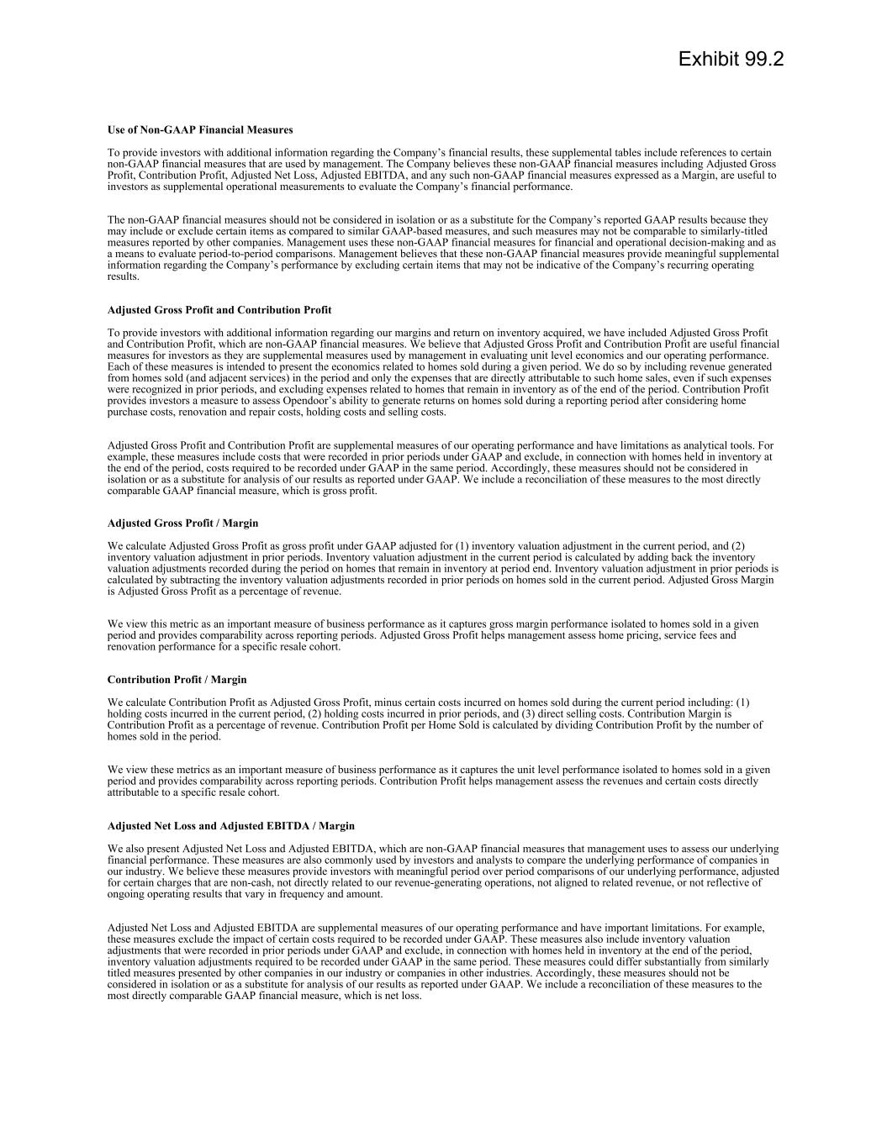

Use of Non-GAAP Financial Measures To provide investors with additional information regarding the Company’s financial results, these supplemental tables include references to certain non-GAAP financial measures that are used by management. The Company believes these non-GAAP financial measures including Adjusted Gross Profit, Contribution Profit, Adjusted Net Loss, Adjusted EBITDA, and any such non-GAAP financial measures expressed as a Margin, are useful to investors as supplemental operational measurements to evaluate the Company’s financial performance. The non-GAAP financial measures should not be considered in isolation or as a substitute for the Company’s reported GAAP results because they may include or exclude certain items as compared to similar GAAP-based measures, and such measures may not be comparable to similarly-titled measures reported by other companies. Management uses these non-GAAP financial measures for financial and operational decision-making and as a means to evaluate period-to-period comparisons. Management believes that these non-GAAP financial measures provide meaningful supplemental information regarding the Company’s performance by excluding certain items that may not be indicative of the Company’s recurring operating results. Adjusted Gross Profit and Contribution Profit To provide investors with additional information regarding our margins and return on inventory acquired, we have included Adjusted Gross Profit and Contribution Profit, which are non-GAAP financial measures. We believe that Adjusted Gross Profit and Contribution Profit are useful financial measures for investors as they are supplemental measures used by management in evaluating unit level economics and our operating performance. Each of these measures is intended to present the economics related to homes sold during a given period. We do so by including revenue generated from homes sold (and adjacent services) in the period and only the expenses that are directly attributable to such home sales, even if such expenses were recognized in prior periods, and excluding expenses related to homes that remain in inventory as of the end of the period. Contribution Profit provides investors a measure to assess Opendoor’s ability to generate returns on homes sold during a reporting period after considering home purchase costs, renovation and repair costs, holding costs and selling costs. Adjusted Gross Profit and Contribution Profit are supplemental measures of our operating performance and have limitations as analytical tools. For example, these measures include costs that were recorded in prior periods under GAAP and exclude, in connection with homes held in inventory at the end of the period, costs required to be recorded under GAAP in the same period. Accordingly, these measures should not be considered in isolation or as a substitute for analysis of our results as reported under GAAP. We include a reconciliation of these measures to the most directly comparable GAAP financial measure, which is gross profit. Adjusted Gross Profit / Margin We calculate Adjusted Gross Profit as gross profit under GAAP adjusted for (1) inventory valuation adjustment in the current period, and (2) inventory valuation adjustment in prior periods. Inventory valuation adjustment in the current period is calculated by adding back the inventory valuation adjustments recorded during the period on homes that remain in inventory at period end. Inventory valuation adjustment in prior periods is calculated by subtracting the inventory valuation adjustments recorded in prior periods on homes sold in the current period. Adjusted Gross Margin is Adjusted Gross Profit as a percentage of revenue. We view this metric as an important measure of business performance as it captures gross margin performance isolated to homes sold in a given period and provides comparability across reporting periods. Adjusted Gross Profit helps management assess home pricing, service fees and renovation performance for a specific resale cohort. Contribution Profit / Margin We calculate Contribution Profit as Adjusted Gross Profit, minus certain costs incurred on homes sold during the current period including: (1) holding costs incurred in the current period, (2) holding costs incurred in prior periods, and (3) direct selling costs. Contribution Margin is Contribution Profit as a percentage of revenue. Contribution Profit per Home Sold is calculated by dividing Contribution Profit by the number of homes sold in the period. We view these metrics as an important measure of business performance as it captures the unit level performance isolated to homes sold in a given period and provides comparability across reporting periods. Contribution Profit helps management assess the revenues and certain costs directly attributable to a specific resale cohort. Adjusted Net Loss and Adjusted EBITDA / Margin We also present Adjusted Net Loss and Adjusted EBITDA, which are non-GAAP financial measures that management uses to assess our underlying financial performance. These measures are also commonly used by investors and analysts to compare the underlying performance of companies in our industry. We believe these measures provide investors with meaningful period over period comparisons of our underlying performance, adjusted for certain charges that are non-cash, not directly related to our revenue-generating operations, not aligned to related revenue, or not reflective of ongoing operating results that vary in frequency and amount. Adjusted Net Loss and Adjusted EBITDA are supplemental measures of our operating performance and have important limitations. For example, these measures exclude the impact of certain costs required to be recorded under GAAP. These measures also include inventory valuation adjustments that were recorded in prior periods under GAAP and exclude, in connection with homes held in inventory at the end of the period, inventory valuation adjustments required to be recorded under GAAP in the same period. These measures could differ substantially from similarly titled measures presented by other companies in our industry or companies in other industries. Accordingly, these measures should not be considered in isolation or as a substitute for analysis of our results as reported under GAAP. We include a reconciliation of these measures to the most directly comparable GAAP financial measure, which is net loss. Exhibit 99.2

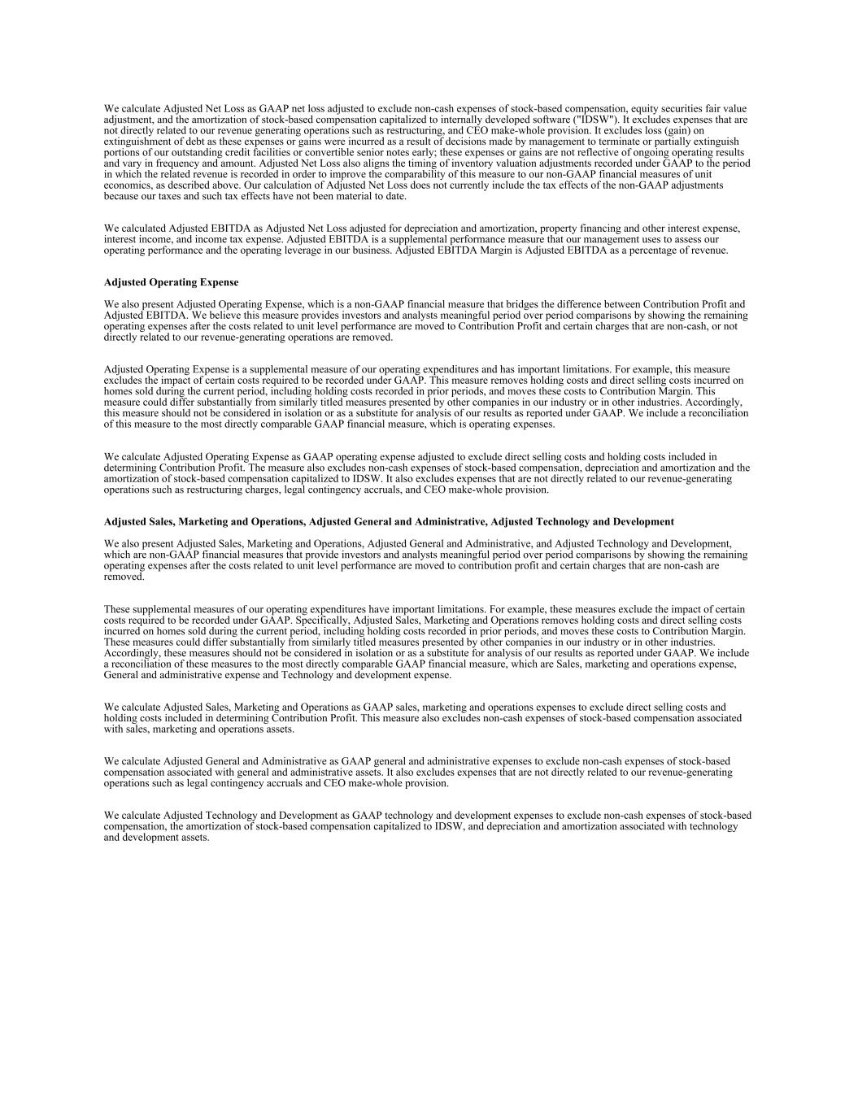
We calculate Adjusted Net Loss as GAAP net loss adjusted to exclude non-cash expenses of stock-based compensation, equity securities fair value adjustment, and the amortization of stock-based compensation capitalized to internally developed software ("IDSW"). It excludes expenses that are not directly related to our revenue generating operations such as restructuring, and CEO make-whole provision. It excludes loss (gain) on extinguishment of debt as these expenses or gains were incurred as a result of decisions made by management to terminate or partially extinguish portions of our outstanding credit facilities or convertible senior notes early; these expenses or gains are not reflective of ongoing operating results and vary in frequency and amount. Adjusted Net Loss also aligns the timing of inventory valuation adjustments recorded under GAAP to the period in which the related revenue is recorded in order to improve the comparability of this measure to our non-GAAP financial measures of unit economics, as described above. Our calculation of Adjusted Net Loss does not currently include the tax effects of the non-GAAP adjustments because our taxes and such tax effects have not been material to date. We calculated Adjusted EBITDA as Adjusted Net Loss adjusted for depreciation and amortization, property financing and other interest expense, interest income, and income tax expense. Adjusted EBITDA is a supplemental performance measure that our management uses to assess our operating performance and the operating leverage in our business. Adjusted EBITDA Margin is Adjusted EBITDA as a percentage of revenue. Adjusted Operating Expense We also present Adjusted Operating Expense, which is a non-GAAP financial measure that bridges the difference between Contribution Profit and Adjusted EBITDA. We believe this measure provides investors and analysts meaningful period over period comparisons by showing the remaining operating expenses after the costs related to unit level performance are moved to Contribution Profit and certain charges that are non-cash, or not directly related to our revenue-generating operations are removed. Adjusted Operating Expense is a supplemental measure of our operating expenditures and has important limitations. For example, this measure excludes the impact of certain costs required to be recorded under GAAP. This measure removes holding costs and direct selling costs incurred on homes sold during the current period, including holding costs recorded in prior periods, and moves these costs to Contribution Margin. This measure could differ substantially from similarly titled measures presented by other companies in our industry or in other industries. Accordingly, this measure should not be considered in isolation or as a substitute for analysis of our results as reported under GAAP. We include a reconciliation of this measure to the most directly comparable GAAP financial measure, which is operating expenses. We calculate Adjusted Operating Expense as GAAP operating expense adjusted to exclude direct selling costs and holding costs included in determining Contribution Profit. The measure also excludes non-cash expenses of stock-based compensation, depreciation and amortization and the amortization of stock-based compensation capitalized to IDSW. It also excludes expenses that are not directly related to our revenue-generating operations such as restructuring charges, legal contingency accruals, and CEO make-whole provision. Adjusted Sales, Marketing and Operations, Adjusted General and Administrative, Adjusted Technology and Development We also present Adjusted Sales, Marketing and Operations, Adjusted General and Administrative, and Adjusted Technology and Development, which are non-GAAP financial measures that provide investors and analysts meaningful period over period comparisons by showing the remaining operating expenses after the costs related to unit level performance are moved to contribution profit and certain charges that are non-cash are removed. These supplemental measures of our operating expenditures have important limitations. For example, these measures exclude the impact of certain costs required to be recorded under GAAP. Specifically, Adjusted Sales, Marketing and Operations removes holding costs and direct selling costs incurred on homes sold during the current period, including holding costs recorded in prior periods, and moves these costs to Contribution Margin. These measures could differ substantially from similarly titled measures presented by other companies in our industry or in other industries. Accordingly, these measures should not be considered in isolation or as a substitute for analysis of our results as reported under GAAP. We include a reconciliation of these measures to the most directly comparable GAAP financial measure, which are Sales, marketing and operations expense, General and administrative expense and Technology and development expense. We calculate Adjusted Sales, Marketing and Operations as GAAP sales, marketing and operations expenses to exclude direct selling costs and holding costs included in determining Contribution Profit. This measure also excludes non-cash expenses of stock-based compensation associated with sales, marketing and operations assets. We calculate Adjusted General and Administrative as GAAP general and administrative expenses to exclude non-cash expenses of stock-based compensation associated with general and administrative assets. It also excludes expenses that are not directly related to our revenue-generating operations such as legal contingency accruals and CEO make-whole provision. We calculate Adjusted Technology and Development as GAAP technology and development expenses to exclude non-cash expenses of stock-based compensation, the amortization of stock-based compensation capitalized to IDSW, and depreciation and amortization associated with technology and development assets.

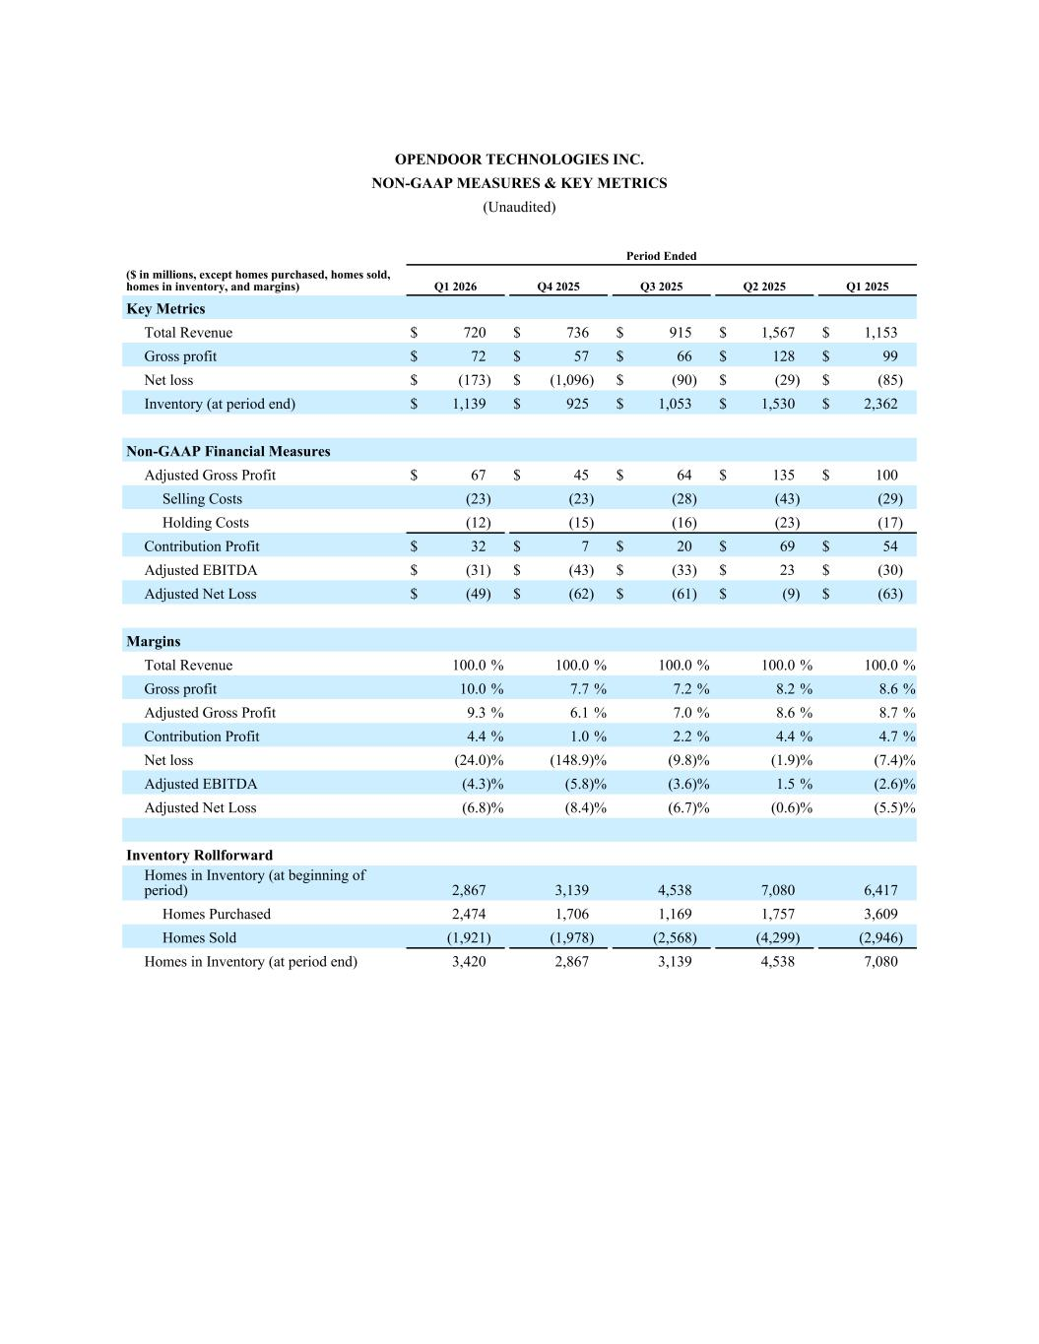
OPENDOOR TECHNOLOGIES INC. NON-GAAP MEASURES & KEY METRICS (Unaudited) Period Ended ($ in millions, except homes purchased, homes sold, homes in inventory, and margins) Q1 2026 Q4 2025 Q3 2025 Q2 2025 Q1 2025 Key Metrics Total Revenue $ 720 $ 736 $ 915 $ 1,567 $ 1,153 Gross profit $ 72 $ 57 $ 66 $ 128 $ 99 Net loss $ (173) $ (1,096) $ (90) $ (29) $ (85) Inventory (at period end) $ 1,139 $ 925 $ 1,053 $ 1,530 $ 2,362 Non-GAAP Financial Measures Adjusted Gross Profit $ 67 $ 45 $ 64 $ 135 $ 100 Selling Costs (23) (23) (28) (43) (29) Holding Costs (12) (15) (16) (23) (17) Contribution Profit $ 32 $ 7 $ 20 $ 69 $ 54 Adjusted EBITDA $ (31) $ (43) $ (33) $ 23 $ (30) Adjusted Net Loss $ (49) $ (62) $ (61) $ (9) $ (63) Margins Total Revenue 100.0 % 100.0 % 100.0 % 100.0 % 100.0 % Gross profit 10.0 % 7.7 % 7.2 % 8.2 % 8.6 % Adjusted Gross Profit 9.3 % 6.1 % 7.0 % 8.6 % 8.7 % Contribution Profit 4.4 % 1.0 % 2.2 % 4.4 % 4.7 % Net loss (24.0) % (148.9) % (9.8) % (1.9) % (7.4) % Adjusted EBITDA (4.3) % (5.8) % (3.6) % 1.5 % (2.6) % Adjusted Net Loss (6.8) % (8.4) % (6.7) % (0.6) % (5.5) % Inventory Rollforward Homes in Inventory (at beginning of period) 2,867 3,139 4,538 7,080 6,417 Homes Purchased 2,474 1,706 1,169 1,757 3,609 Homes Sold (1,921) (1,978) (2,568) (4,299) (2,946) Homes in Inventory (at period end) 3,420 2,867 3,139 4,538 7,080

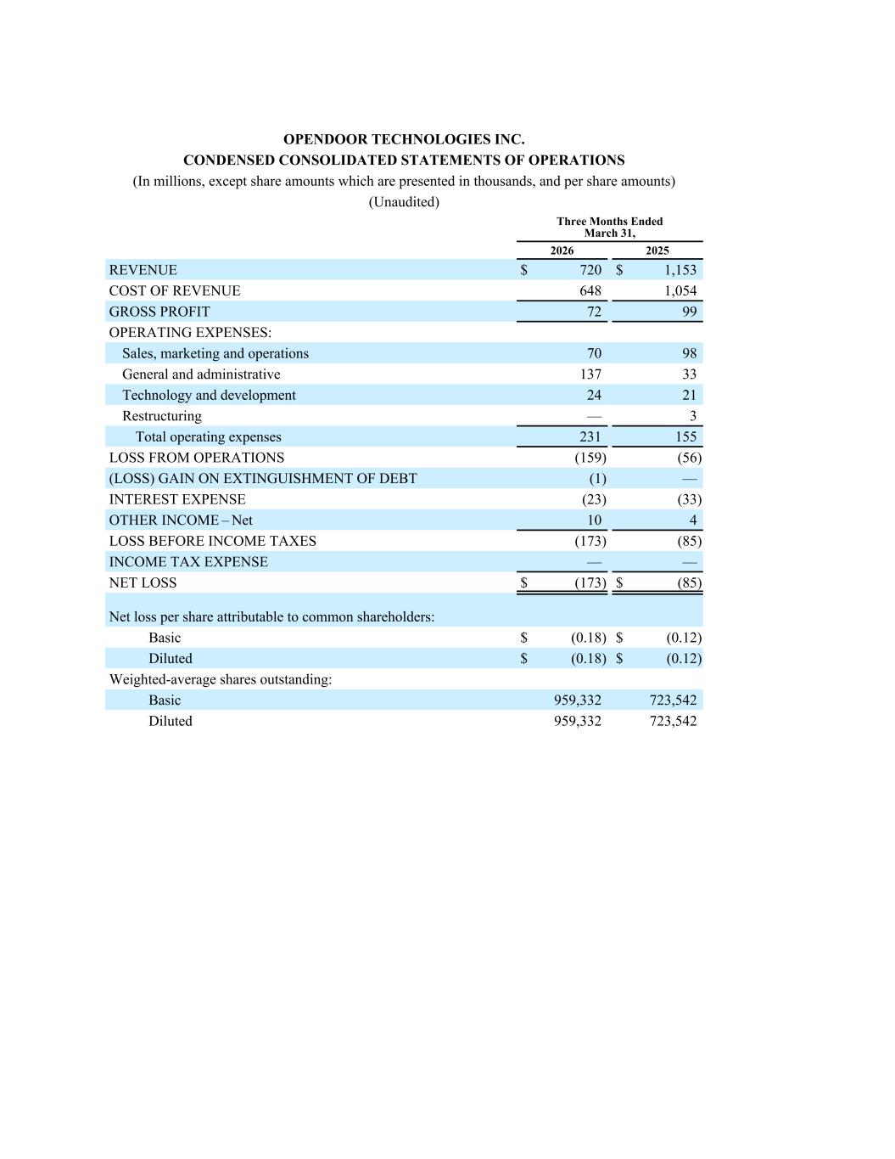
OPENDOOR TECHNOLOGIES INC. CONDENSED CONSOLIDATED STATEMENTS OF OPERATIONS (In millions, except share amounts which are presented in thousands, and per share amounts) (Unaudited) Three Months Ended March 31, 2026 2025 REVENUE $ 720 $ 1,153 COST OF REVENUE 648 1,054 GROSS PROFIT 72 99 OPERATING EXPENSES: Sales, marketing and operations 70 98 General and administrative 137 33 Technology and development 24 21 Restructuring — 3 Total operating expenses 231 155 LOSS FROM OPERATIONS (159) (56) (LOSS) GAIN ON EXTINGUISHMENT OF DEBT (1) — INTEREST EXPENSE (23) (33) OTHER INCOME – Net 10 4 LOSS BEFORE INCOME TAXES (173) (85) INCOME TAX EXPENSE — — NET LOSS $ (173) $ (85) Net loss per share attributable to common shareholders: Basic $ (0.18) $ (0.12) Diluted $ (0.18) $ (0.12) Weighted-average shares outstanding: Basic 959,332 723,542 Diluted 959,332 723,542

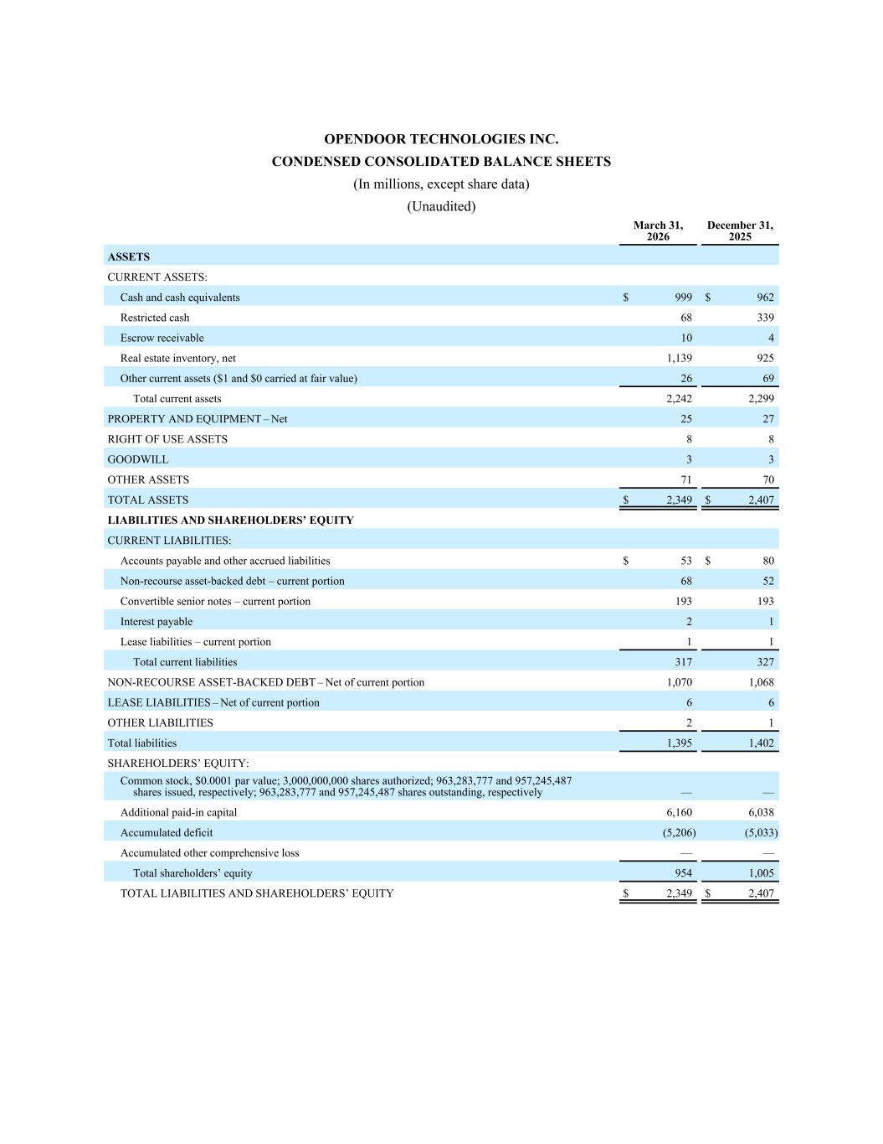
OPENDOOR TECHNOLOGIES INC. CONDENSED CONSOLIDATED BALANCE SHEETS (In millions, except share data) (Unaudited) March 31, 2026 December 31, 2025 ASSETS CURRENT ASSETS: Cash and cash equivalents $ 999 $ 962 Restricted cash 68 339 Escrow receivable 10 4 Real estate inventory, net 1,139 925 Other current assets ($1 and $0 carried at fair value) 26 69 Total current assets 2,242 2,299 PROPERTY AND EQUIPMENT – Net 25 27 RIGHT OF USE ASSETS 8 8 GOODWILL 3 3 OTHER ASSETS 71 70 TOTAL ASSETS $ 2,349 $ 2,407 LIABILITIES AND SHAREHOLDERS’ EQUITY CURRENT LIABILITIES: Accounts payable and other accrued liabilities $ 53 $ 80 Non-recourse asset-backed debt – current portion 68 52 Convertible senior notes – current portion 193 193 Interest payable 2 1 Lease liabilities – current portion 1 1 Total current liabilities 317 327 NON-RECOURSE ASSET-BACKED DEBT – Net of current portion 1,070 1,068 LEASE LIABILITIES – Net of current portion 6 6 OTHER LIABILITIES 2 1 Total liabilities 1,395 1,402 SHAREHOLDERS’ EQUITY: Common stock, $0.0001 par value; 3,000,000,000 shares authorized; 963,283,777 and 957,245,487 shares issued, respectively; 963,283,777 and 957,245,487 shares outstanding, respectively — — Additional paid-in capital 6,160 6,038 Accumulated deficit (5,206) (5,033) Accumulated other comprehensive loss — — Total shareholders’ equity 954 1,005 TOTAL LIABILITIES AND SHAREHOLDERS’ EQUITY $ 2,349 $ 2,407

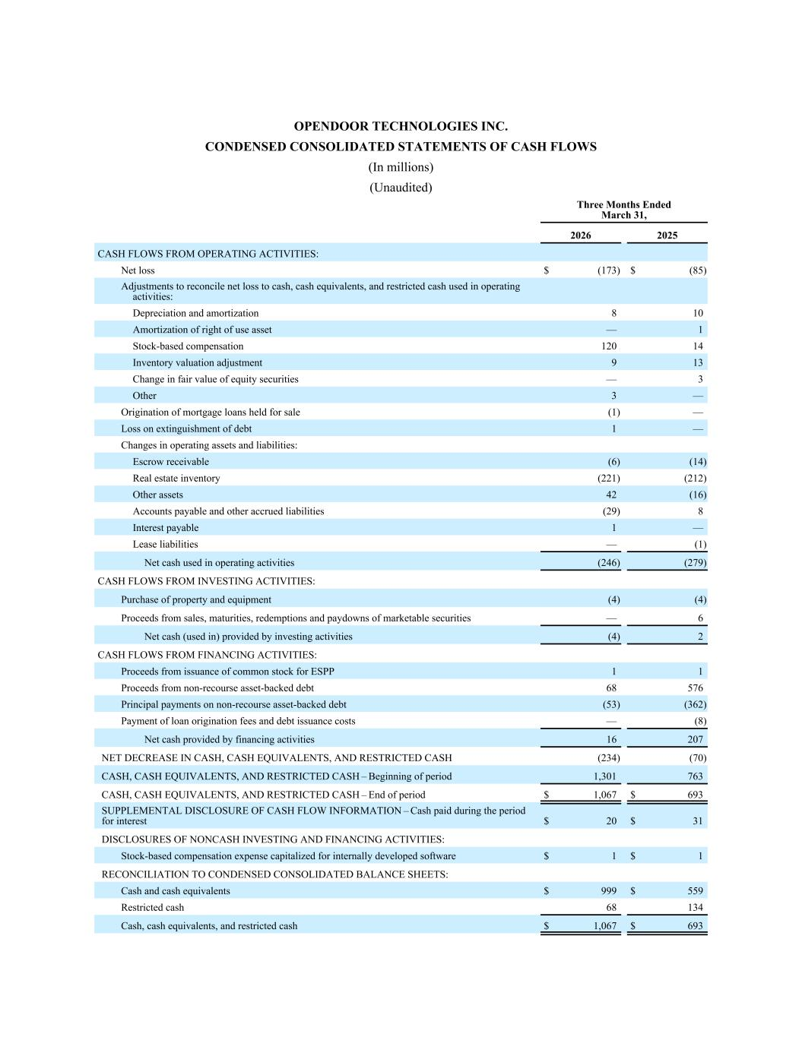
OPENDOOR TECHNOLOGIES INC. CONDENSED CONSOLIDATED STATEMENTS OF CASH FLOWS (In millions) (Unaudited) Three Months Ended March 31, 2026 2025 CASH FLOWS FROM OPERATING ACTIVITIES: Net loss $ (173) $ (85) Adjustments to reconcile net loss to cash, cash equivalents, and restricted cash used in operating activities: Depreciation and amortization 8 10 Amortization of right of use asset — 1 Stock-based compensation 120 14 Inventory valuation adjustment 9 13 Change in fair value of equity securities — 3 Other 3 — Origination of mortgage loans held for sale (1) — Loss on extinguishment of debt 1 — Changes in operating assets and liabilities: Escrow receivable (6) (14) Real estate inventory (221) (212) Other assets 42 (16) Accounts payable and other accrued liabilities (29) 8 Interest payable 1 — Lease liabilities — (1) Net cash used in operating activities (246) (279) CASH FLOWS FROM INVESTING ACTIVITIES: Purchase of property and equipment (4) (4) Proceeds from sales, maturities, redemptions and paydowns of marketable securities — 6 Net cash (used in) provided by investing activities (4) 2 CASH FLOWS FROM FINANCING ACTIVITIES: Proceeds from issuance of common stock for ESPP 1 1 Proceeds from non-recourse asset-backed debt 68 576 Principal payments on non-recourse asset-backed debt (53) (362) Payment of loan origination fees and debt issuance costs — (8) Net cash provided by financing activities 16 207 NET DECREASE IN CASH, CASH EQUIVALENTS, AND RESTRICTED CASH (234) (70) CASH, CASH EQUIVALENTS, AND RESTRICTED CASH – Beginning of period 1,301 763 CASH, CASH EQUIVALENTS, AND RESTRICTED CASH – End of period $ 1,067 $ 693 SUPPLEMENTAL DISCLOSURE OF CASH FLOW INFORMATION – Cash paid during the period for interest $ 20 $ 31 DISCLOSURES OF NONCASH INVESTING AND FINANCING ACTIVITIES: Stock-based compensation expense capitalized for internally developed software $ 1 $ 1 RECONCILIATION TO CONDENSED CONSOLIDATED BALANCE SHEETS: Cash and cash equivalents $ 999 $ 559 Restricted cash 68 134 Cash, cash equivalents, and restricted cash $ 1,067 $ 693

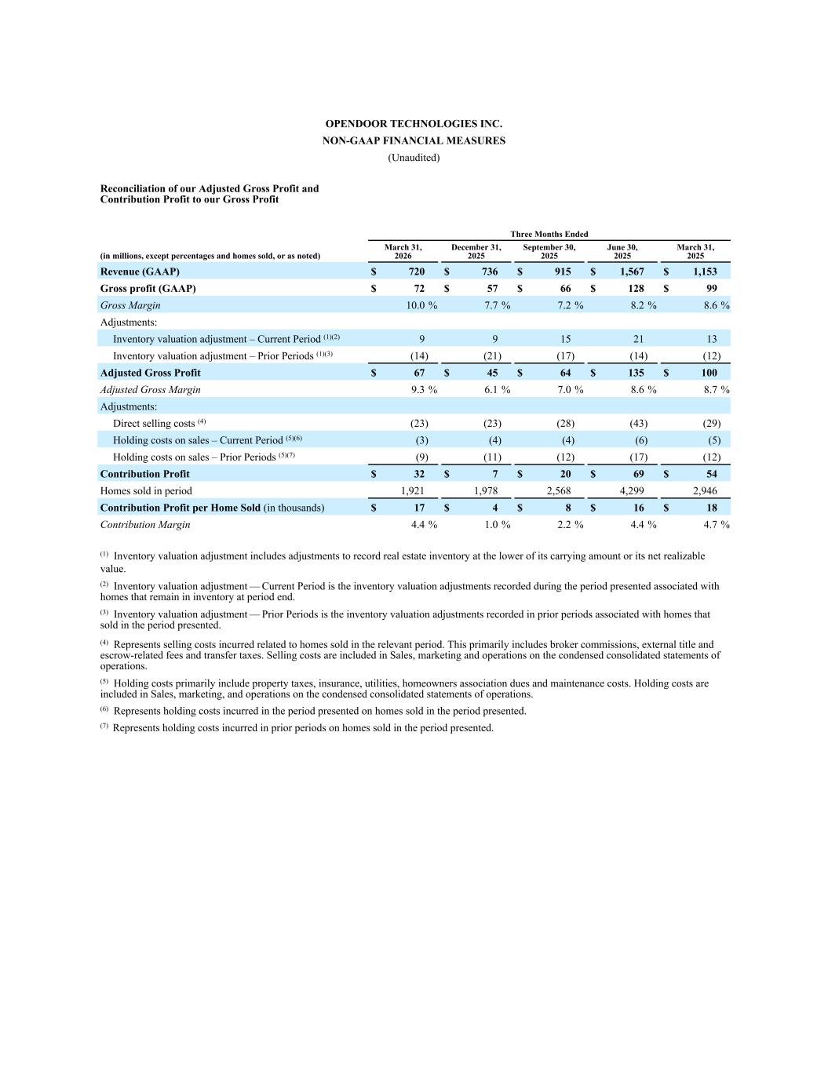
OPENDOOR TECHNOLOGIES INC. NON-GAAP FINANCIAL MEASURES (Unaudited) Reconciliation of our Adjusted Gross Profit and Contribution Profit to our Gross Profit Three Months Ended (in millions, except percentages and homes sold, or as noted) March 31, 2026 December 31, 2025 September 30, 2025 June 30, 2025 March 31, 2025 Revenue (GAAP) $ 720 $ 736 $ 915 $ 1,567 $ 1,153 Gross profit (GAAP) $ 72 $ 57 $ 66 $ 128 $ 99 Gross Margin 10.0 % 7.7 % 7.2 % 8.2 % 8.6 % Adjustments: Inventory valuation adjustment – Current Period (1)(2) 9 9 15 21 13 Inventory valuation adjustment – Prior Periods (1)(3) (14) (21) (17) (14) (12) Adjusted Gross Profit $ 67 $ 45 $ 64 $ 135 $ 100 Adjusted Gross Margin 9.3 % 6.1 % 7.0 % 8.6 % 8.7 % Adjustments: Direct selling costs (4) (23) (23) (28) (43) (29) Holding costs on sales – Current Period (5)(6) (3) (4) (4) (6) (5) Holding costs on sales – Prior Periods (5)(7) (9) (11) (12) (17) (12) Contribution Profit $ 32 $ 7 $ 20 $ 69 $ 54 Homes sold in period 1,921 1,978 2,568 4,299 2,946 Contribution Profit per Home Sold (in thousands) $ 17 $ 4 $ 8 $ 16 $ 18 Contribution Margin 4.4 % 1.0 % 2.2 % 4.4 % 4.7 % (1) Inventory valuation adjustment includes adjustments to record real estate inventory at the lower of its carrying amount or its net realizable value. (2) Inventory valuation adjustment — Current Period is the inventory valuation adjustments recorded during the period presented associated with homes that remain in inventory at period end. (3) Inventory valuation adjustment — Prior Periods is the inventory valuation adjustments recorded in prior periods associated with homes that sold in the period presented. (4) Represents selling costs incurred related to homes sold in the relevant period. This primarily includes broker commissions, external title and escrow-related fees and transfer taxes. Selling costs are included in Sales, marketing and operations on the condensed consolidated statements of operations. (5) Holding costs primarily include property taxes, insurance, utilities, homeowners association dues and maintenance costs. Holding costs are included in Sales, marketing, and operations on the condensed consolidated statements of operations. (6) Represents holding costs incurred in the period presented on homes sold in the period presented. (7) Represents holding costs incurred in prior periods on homes sold in the period presented.

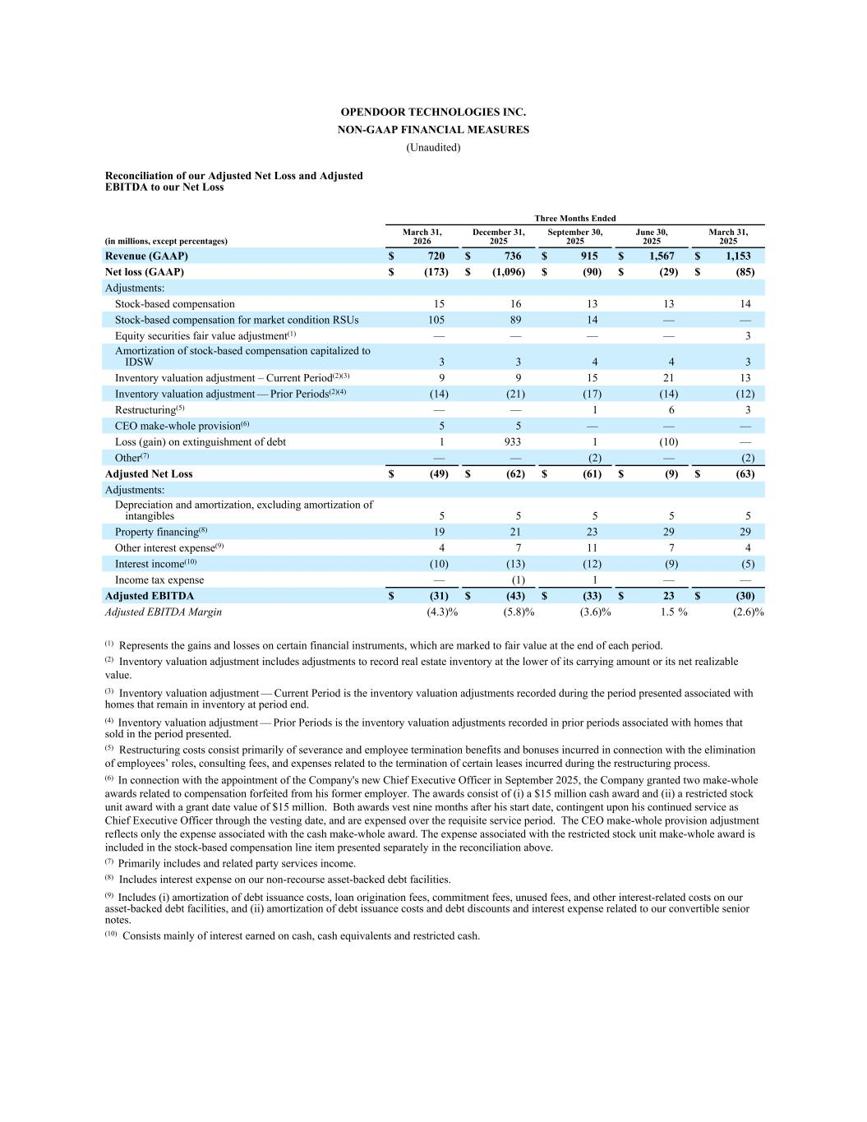
OPENDOOR TECHNOLOGIES INC. NON-GAAP FINANCIAL MEASURES (Unaudited) Reconciliation of our Adjusted Net Loss and Adjusted EBITDA to our Net Loss Three Months Ended (in millions, except percentages) March 31, 2026 December 31, 2025 September 30, 2025 June 30, 2025 March 31, 2025 Revenue (GAAP) $ 720 $ 736 $ 915 $ 1,567 $ 1,153 Net loss (GAAP) $ (173) $ (1,096) $ (90) $ (29) $ (85) Adjustments: Stock-based compensation 15 16 13 13 14 Stock-based compensation for market condition RSUs 105 89 14 — — Equity securities fair value adjustment(1) — — — — 3 Amortization of stock-based compensation capitalized to IDSW 3 3 4 4 3 Inventory valuation adjustment – Current Period(2)(3) 9 9 15 21 13 Inventory valuation adjustment — Prior Periods(2)(4) (14) (21) (17) (14) (12) Restructuring(5) — — 1 6 3 CEO make-whole provision(6) 5 5 — — — Loss (gain) on extinguishment of debt 1 933 1 (10) — Other(7) — — (2) — (2) Adjusted Net Loss $ (49) $ (62) $ (61) $ (9) $ (63) Adjustments: Depreciation and amortization, excluding amortization of intangibles 5 5 5 5 5 Property financing(8) 19 21 23 29 29 Other interest expense(9) 4 7 11 7 4 Interest income(10) (10) (13) (12) (9) (5) Income tax expense — (1) 1 — — Adjusted EBITDA $ (31) $ (43) $ (33) $ 23 $ (30) Adjusted EBITDA Margin (4.3) % (5.8) % (3.6) % 1.5 % (2.6) % (1) Represents the gains and losses on certain financial instruments, which are marked to fair value at the end of each period. (2) Inventory valuation adjustment includes adjustments to record real estate inventory at the lower of its carrying amount or its net realizable value. (3) Inventory valuation adjustment — Current Period is the inventory valuation adjustments recorded during the period presented associated with homes that remain in inventory at period end. (4) Inventory valuation adjustment — Prior Periods is the inventory valuation adjustments recorded in prior periods associated with homes that sold in the period presented. (5) Restructuring costs consist primarily of severance and employee termination benefits and bonuses incurred in connection with the elimination of employees’ roles, consulting fees, and expenses related to the termination of certain leases incurred during the restructuring process. (6) In connection with the appointment of the Company's new Chief Executive Officer in September 2025, the Company granted two make-whole awards related to compensation forfeited from his former employer. The awards consist of (i) a $15 million cash award and (ii) a restricted stock unit award with a grant date value of $15 million. Both awards vest nine months after his start date, contingent upon his continued service as Chief Executive Officer through the vesting date, and are expensed over the requisite service period. The CEO make-whole provision adjustment reflects only the expense associated with the cash make-whole award. The expense associated with the restricted stock unit make-whole award is included in the stock-based compensation line item presented separately in the reconciliation above. (7) Primarily includes and related party services income. (8) Includes interest expense on our non-recourse asset-backed debt facilities. (9) Includes (i) amortization of debt issuance costs, loan origination fees, commitment fees, unused fees, and other interest-related costs on our asset-backed debt facilities, and (ii) amortization of debt issuance costs and debt discounts and interest expense related to our convertible senior notes. (10) Consists mainly of interest earned on cash, cash equivalents and restricted cash.

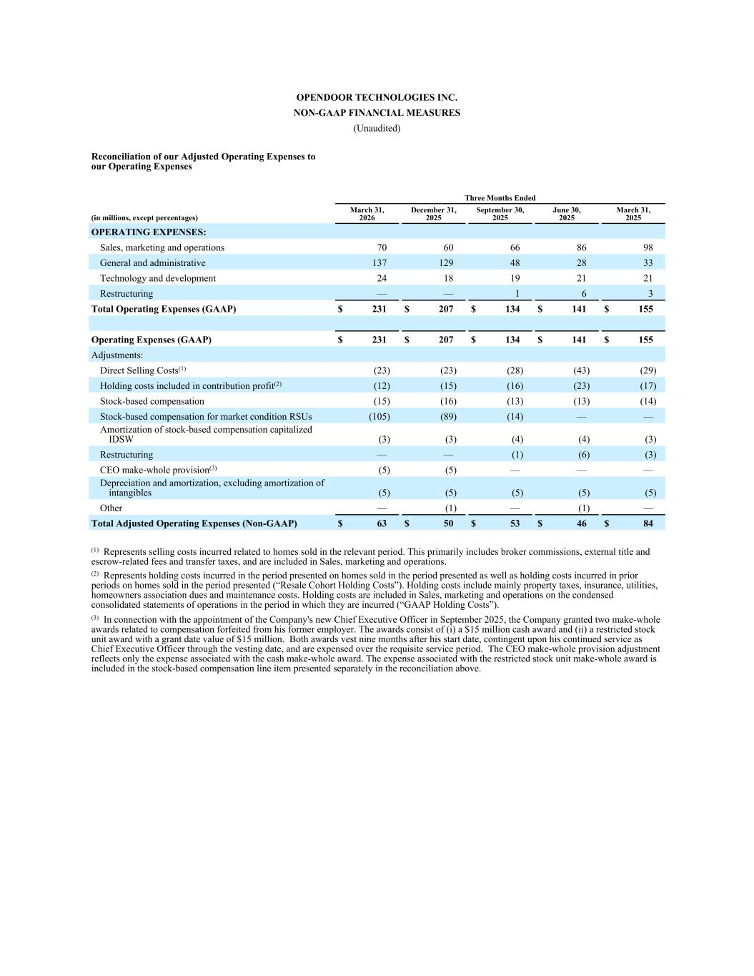
OPENDOOR TECHNOLOGIES INC. NON-GAAP FINANCIAL MEASURES (Unaudited) Reconciliation of our Adjusted Operating Expenses to our Operating Expenses Three Months Ended (in millions, except percentages) March 31, 2026 December 31, 2025 September 30, 2025 June 30, 2025 March 31, 2025 OPERATING EXPENSES: Sales, marketing and operations 70 60 66 86 98 General and administrative 137 129 48 28 33 Technology and development 24 18 19 21 21 Restructuring — — 1 6 3 Total Operating Expenses (GAAP) $ 231 $ 207 $ 134 $ 141 $ 155 Operating Expenses (GAAP) $ 231 $ 207 $ 134 $ 141 $ 155 Adjustments: Direct Selling Costs(1) (23) (23) (28) (43) (29) Holding costs included in contribution profit(2) (12) (15) (16) (23) (17) Stock-based compensation (15) (16) (13) (13) (14) Stock-based compensation for market condition RSUs (105) (89) (14) — — Amortization of stock-based compensation capitalized IDSW (3) (3) (4) (4) (3) Restructuring — — (1) (6) (3) CEO make-whole provision(3) (5) (5) — — — Depreciation and amortization, excluding amortization of intangibles (5) (5) (5) (5) (5) Other — (1) — (1) — Total Adjusted Operating Expenses (Non-GAAP) $ 63 $ 50 $ 53 $ 46 $ 84 (1) Represents selling costs incurred related to homes sold in the relevant period. This primarily includes broker commissions, external title and escrow-related fees and transfer taxes, and are included in Sales, marketing and operations. (2) Represents holding costs incurred in the period presented on homes sold in the period presented as well as holding costs incurred in prior periods on homes sold in the period presented (“Resale Cohort Holding Costs”). Holding costs include mainly property taxes, insurance, utilities, homeowners association dues and maintenance costs. Holding costs are included in Sales, marketing and operations on the condensed consolidated statements of operations in the period in which they are incurred (“GAAP Holding Costs”). (3) In connection with the appointment of the Company's new Chief Executive Officer in September 2025, the Company granted two make-whole awards related to compensation forfeited from his former employer. The awards consist of (i) a $15 million cash award and (ii) a restricted stock unit award with a grant date value of $15 million. Both awards vest nine months after his start date, contingent upon his continued service as Chief Executive Officer through the vesting date, and are expensed over the requisite service period. The CEO make-whole provision adjustment reflects only the expense associated with the cash make-whole award. The expense associated with the restricted stock unit make-whole award is included in the stock-based compensation line item presented separately in the reconciliation above.

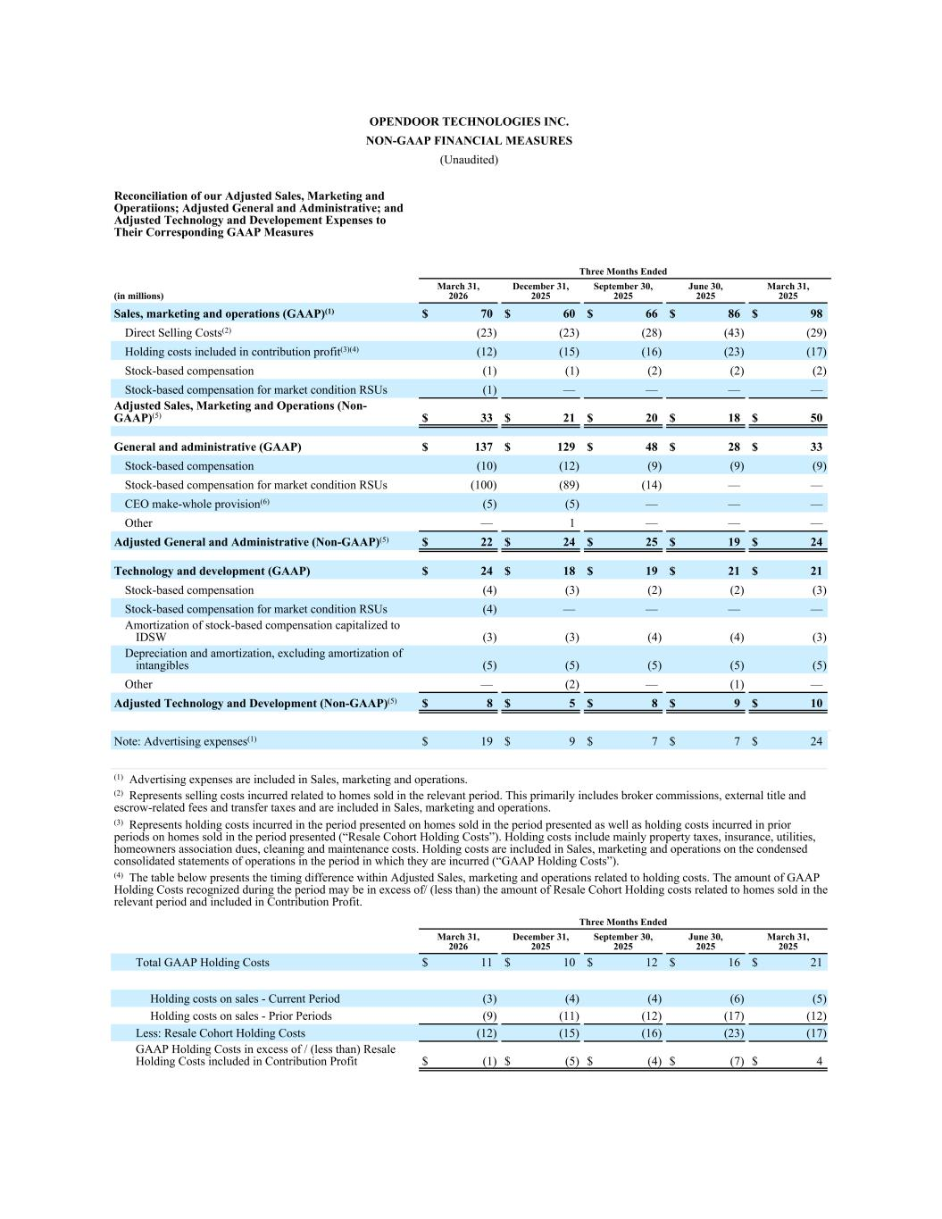
OPENDOOR TECHNOLOGIES INC. NON-GAAP FINANCIAL MEASURES (Unaudited) Reconciliation of our Adjusted Sales, Marketing and Operatiions; Adjusted General and Administrative; and Adjusted Technology and Developement Expenses to Their Corresponding GAAP Measures Three Months Ended (in millions) March 31, 2026 December 31, 2025 September 30, 2025 June 30, 2025 March 31, 2025 Sales, marketing and operations (GAAP)(1) $ 70 $ 60 $ 66 $ 86 $ 98 Direct Selling Costs(2) (23) (23) (28) (43) (29) Holding costs included in contribution profit(3)(4) (12) (15) (16) (23) (17) Stock-based compensation (1) (1) (2) (2) (2) Stock-based compensation for market condition RSUs (1) — — — — Adjusted Sales, Marketing and Operations (Non- GAAP)(5) $ 33 $ 21 $ 20 $ 18 $ 50 General and administrative (GAAP) $ 137 $ 129 $ 48 $ 28 $ 33 Stock-based compensation (10) (12) (9) (9) (9) Stock-based compensation for market condition RSUs (100) (89) (14) — — CEO make-whole provision(6) (5) (5) — — — Other — 1 — — — Adjusted General and Administrative (Non-GAAP)(5) $ 22 $ 24 $ 25 $ 19 $ 24 Technology and development (GAAP) $ 24 $ 18 $ 19 $ 21 $ 21 Stock-based compensation (4) (3) (2) (2) (3) Stock-based compensation for market condition RSUs (4) — — — — Amortization of stock-based compensation capitalized to IDSW (3) (3) (4) (4) (3) Depreciation and amortization, excluding amortization of intangibles (5) (5) (5) (5) (5) Other — (2) — (1) — Adjusted Technology and Development (Non-GAAP)(5) $ 8 $ 5 $ 8 $ 9 $ 10 Note: Advertising expenses(1) $ 19 $ 9 $ 7 $ 7 $ 24 (1) Advertising expenses are included in Sales, marketing and operations. (2) Represents selling costs incurred related to homes sold in the relevant period. This primarily includes broker commissions, external title and escrow-related fees and transfer taxes and are included in Sales, marketing and operations. (3) Represents holding costs incurred in the period presented on homes sold in the period presented as well as holding costs incurred in prior periods on homes sold in the period presented (“Resale Cohort Holding Costs”). Holding costs include mainly property taxes, insurance, utilities, homeowners association dues, cleaning and maintenance costs. Holding costs are included in Sales, marketing and operations on the condensed consolidated statements of operations in the period in which they are incurred (“GAAP Holding Costs”). (4) The table below presents the timing difference within Adjusted Sales, marketing and operations related to holding costs. The amount of GAAP Holding Costs recognized during the period may be in excess of/ (less than) the amount of Resale Cohort Holding costs related to homes sold in the relevant period and included in Contribution Profit. Three Months Ended March 31, 2026 December 31, 2025 September 30, 2025 June 30, 2025 March 31, 2025 Total GAAP Holding Costs $ 11 $ 10 $ 12 $ 16 $ 21 Holding costs on sales - Current Period (3) (4) (4) (6) (5) Holding costs on sales - Prior Periods (9) (11) (12) (17) (12) Less: Resale Cohort Holding Costs (12) (15) (16) (23) (17) GAAP Holding Costs in excess of / (less than) Resale Holding Costs included in Contribution Profit $ (1) $ (5) $ (4) $ (7) $ 4


(5) The sum of Adjusted Sales, Marketing and Operations, Adjusted General and Administrative, and Adjusted Technology and Development expenses is equal to Total Adjusted Operated Expenses (Non-GAAP). Refer to the "Reconciliation of our Adjusted Operating Expenses to our Operating Expenses" table. (6) In connection with the appointment of the Company's new Chief Executive Officer in September 2025, the Company granted two make-whole awards related to compensation forfeited from his former employer. The awards consist of (i) a $15 million cash award and (ii) a restricted stock unit award with a grant date value of $15 million. Both awards vest nine months after his start date, contingent upon his continued service as Chief Executive Officer through the vesting date, and are expensed over the requisite service period. The CEO make-whole provision adjustment reflects only the expense associated with the cash make-whole award. The expense associated with the restricted stock unit make-whole award is included in the stock-based compensation line item presented separately in the reconciliation above.

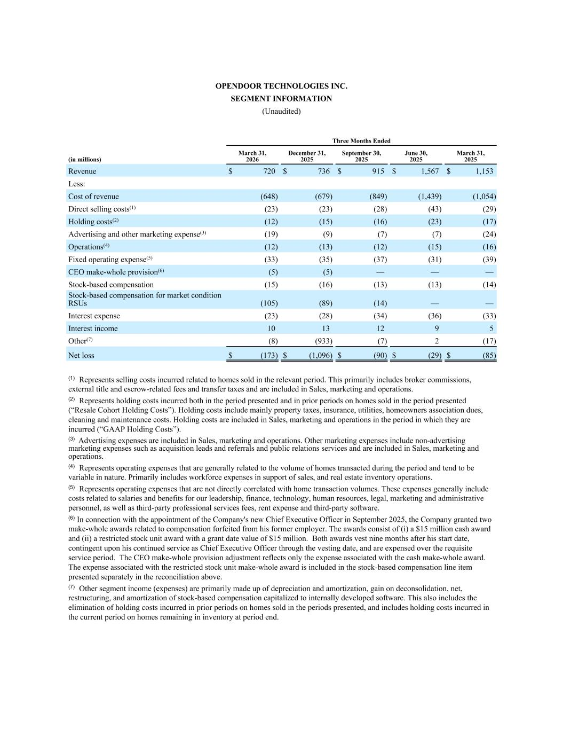
OPENDOOR TECHNOLOGIES INC. SEGMENT INFORMATION (Unaudited) Three Months Ended (in millions) March 31, 2026 December 31, 2025 September 30, 2025 June 30, 2025 March 31, 2025 Revenue $ 720 $ 736 $ 915 $ 1,567 $ 1,153 Less: Cost of revenue (648) (679) (849) (1,439) (1,054) Direct selling costs(1) (23) (23) (28) (43) (29) Holding costs(2) (12) (15) (16) (23) (17) Advertising and other marketing expense(3) (19) (9) (7) (7) (24) Operations(4) (12) (13) (12) (15) (16) Fixed operating expense(5) (33) (35) (37) (31) (39) CEO make-whole provision(6) (5) (5) — — — Stock-based compensation (15) (16) (13) (13) (14) Stock-based compensation for market condition RSUs (105) (89) (14) — — Interest expense (23) (28) (34) (36) (33) Interest income 10 13 12 9 5 Other(7) (8) (933) (7) 2 (17) Net loss $ (173) $ (1,096) $ (90) $ (29) $ (85) (1) Represents selling costs incurred related to homes sold in the relevant period. This primarily includes broker commissions, external title and escrow-related fees and transfer taxes and are included in Sales, marketing and operations. (2) Represents holding costs incurred both in the period presented and in prior periods on homes sold in the period presented (“Resale Cohort Holding Costs”). Holding costs include mainly property taxes, insurance, utilities, homeowners association dues, cleaning and maintenance costs. Holding costs are included in Sales, marketing and operations in the period in which they are incurred (“GAAP Holding Costs”). (3) Advertising expenses are included in Sales, marketing and operations. Other marketing expenses include non-advertising marketing expenses such as acquisition leads and referrals and public relations services and are included in Sales, marketing and operations. (4) Represents operating expenses that are generally related to the volume of homes transacted during the period and tend to be variable in nature. Primarily includes workforce expenses in support of sales, and real estate inventory operations. (5) Represents operating expenses that are not directly correlated with home transaction volumes. These expenses generally include costs related to salaries and benefits for our leadership, finance, technology, human resources, legal, marketing and administrative personnel, as well as third-party professional services fees, rent expense and third-party software. (6) In connection with the appointment of the Company's new Chief Executive Officer in September 2025, the Company granted two make-whole awards related to compensation forfeited from his former employer. The awards consist of (i) a $15 million cash award and (ii) a restricted stock unit award with a grant date value of $15 million. Both awards vest nine months after his start date, contingent upon his continued service as Chief Executive Officer through the vesting date, and are expensed over the requisite service period. The CEO make-whole provision adjustment reflects only the expense associated with the cash make-whole award. The expense associated with the restricted stock unit make-whole award is included in the stock-based compensation line item presented separately in the reconciliation above. (7) Other segment income (expenses) are primarily made up of depreciation and amortization, gain on deconsolidation, net, restructuring, and amortization of stock-based compensation capitalized to internally developed software. This also includes the elimination of holding costs incurred in prior periods on homes sold in the periods presented, and includes holding costs incurred in the current period on homes remaining in inventory at period end.


Supplemental Macro Charts 1Q26 1Q26 Macro Charts Exhibit 99.3

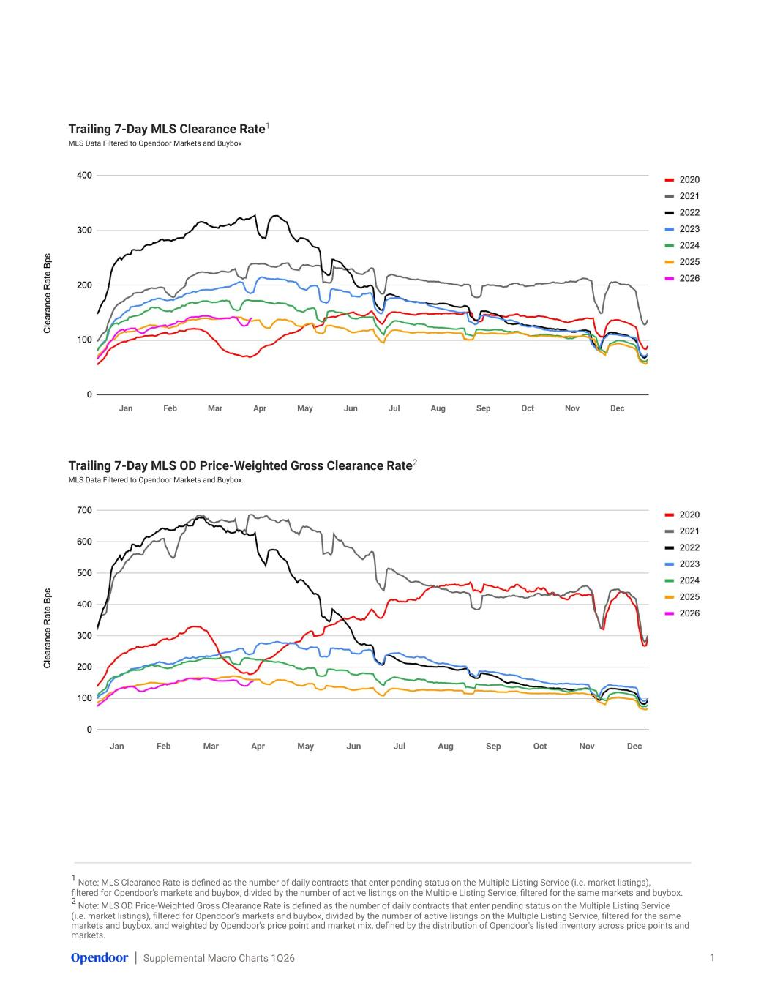
Supplemental Macro Charts 1Q26 1 Note: MLS Clearance Rate is defined as the number of daily contracts that enter pending status on the Multiple Listing Service (i.e. market listings), filtered for Opendoor’s markets and buybox, divided by the number of active listings on the Multiple Listing Service, filtered for the same markets and buybox. 2 Note: MLS OD Price-Weighted Gross Clearance Rate is defined as the number of daily contracts that enter pending status on the Multiple Listing Service (i.e. market listings), filtered for Opendoor’s markets and buybox, divided by the number of active listings on the Multiple Listing Service, filtered for the same markets and buybox, and weighted by Opendoor's price point and market mix, defined by the distribution of Opendoor's listed inventory across price points and markets. Trailing 7-Day MLS Clearance Rate1 MLS Data Filtered to Opendoor Markets and Buybox 1 Jan Feb Mar Apr May Jun Jul Aug Sep Oct Nov Dec Trailing 7-Day MLS OD Price-Weighted Gross Clearance Rate2 MLS Data Filtered to Opendoor Markets and Buybox Jan Feb Mar Apr May Jun Jul Aug Sep Oct Nov Dec

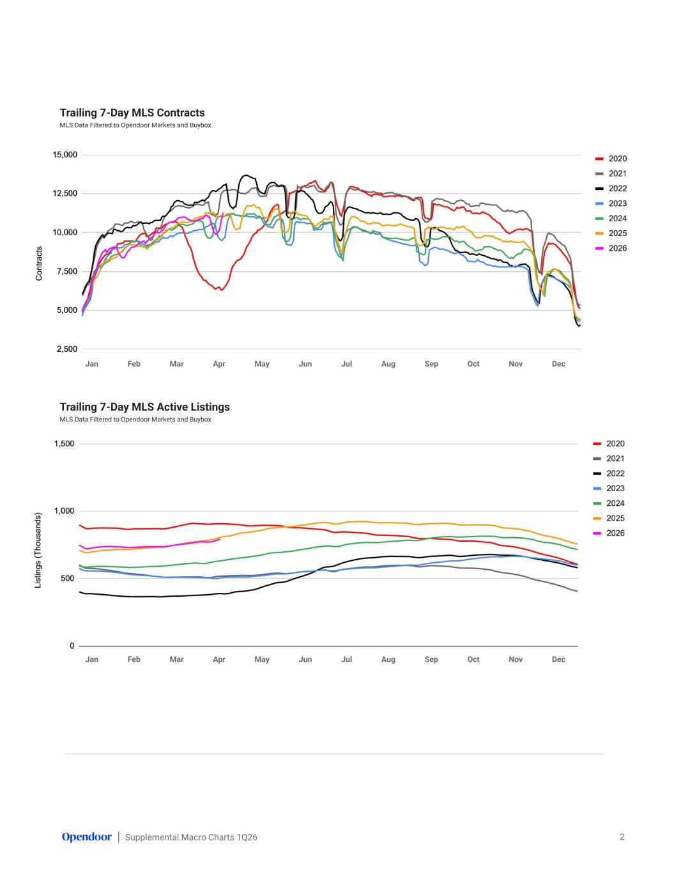
Supplemental Macro Charts 1Q26 Trailing 7-Day MLS Contracts MLS Data Filtered to Opendoor Markets and Buybox 2 Trailing 7-Day MLS Active Listings MLS Data Filtered to Opendoor Markets and Buybox Jan Feb Mar Apr May Jun Jul Aug Sep Oct Nov Dec Jan Feb Mar Apr May Jun Jul Aug Sep Oct Nov Dec

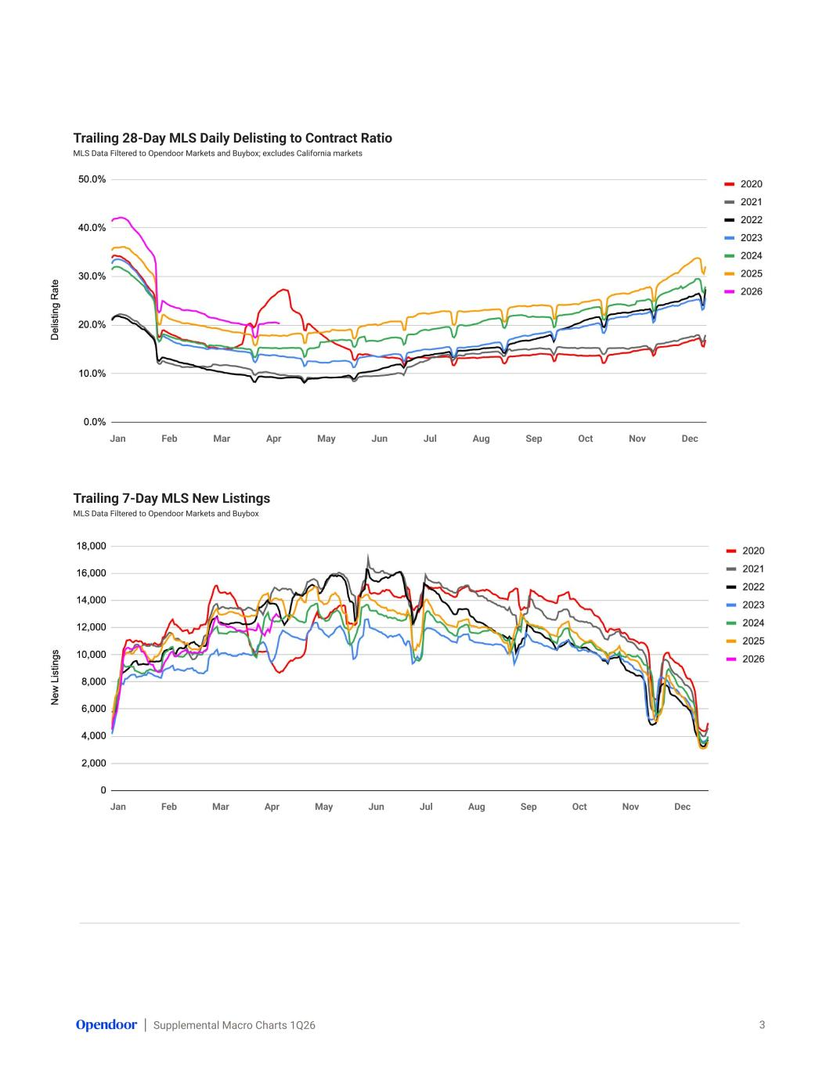
Supplemental Macro Charts 1Q26 Trailing 28-Day MLS Daily Delisting to Contract Ratio MLS Data Filtered to Opendoor Markets and Buybox; excludes California markets 3 Trailing 7-Day MLS New Listings MLS Data Filtered to Opendoor Markets and Buybox Jan Feb Mar Apr May Jun Jul Aug Sep Oct Nov Dec Jan Feb Mar Apr May Jun Jul Aug Sep Oct Nov Dec

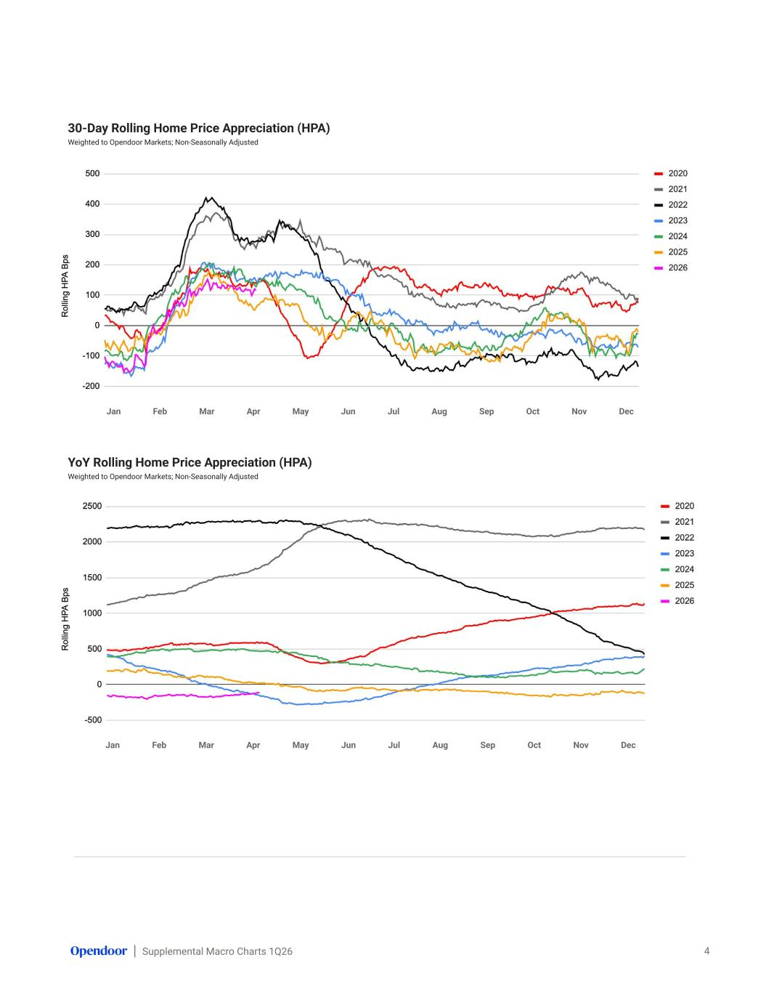
Supplemental Macro Charts 1Q26 30-Day Rolling Home Price Appreciation (HPA) Weighted to Opendoor Markets; Non-Seasonally Adjusted 4 YoY Rolling Home Price Appreciation (HPA) Weighted to Opendoor Markets; Non-Seasonally Adjusted Jan Feb Mar Apr May Jun Jul Aug Sep Oct Nov Dec Jan Feb Mar Apr May Jun Jul Aug Sep Oct Nov Dec

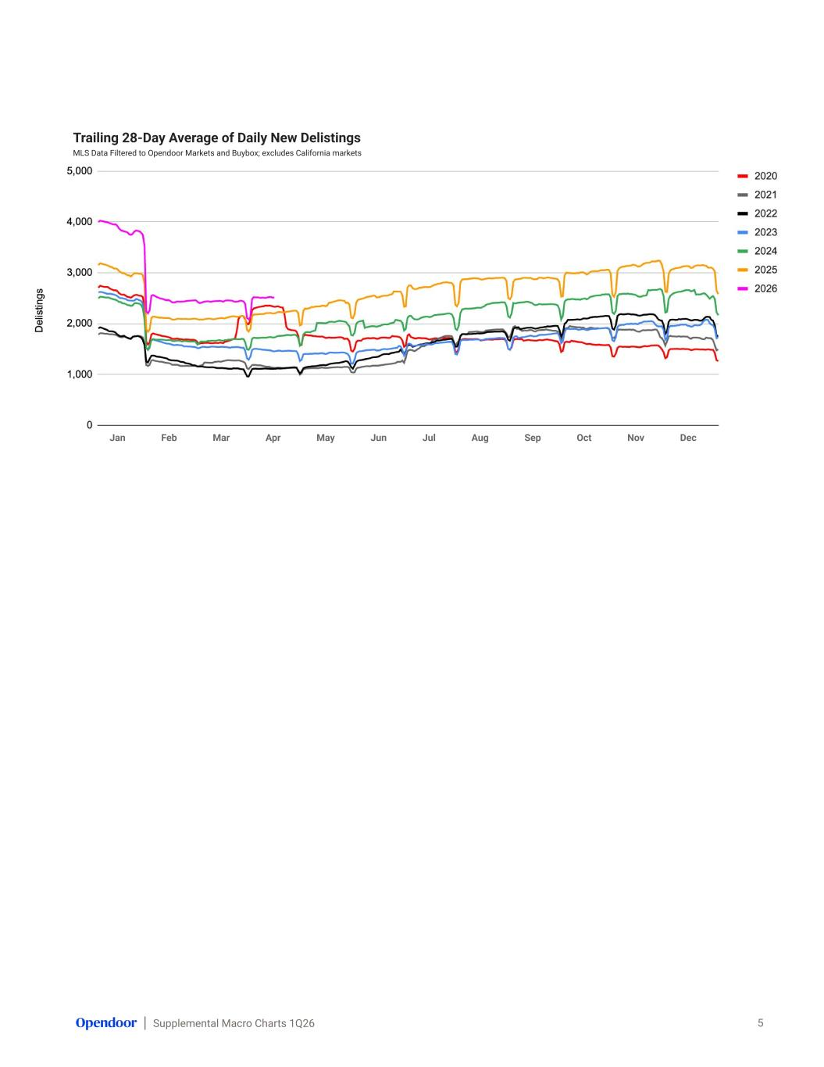
Supplemental Macro Charts 1Q26 Trailing 28-Day Average of Daily New Delistings MLS Data Filtered to Opendoor Markets and Buybox; excludes California markets 5 Jan Feb Mar Apr May Jun Jul Aug Sep Oct Nov Dec

