UNITED STATES

SECURITIES AND EXCHANGE COMMISSION

Washington, D.C. 20549

FORM 8-K

CURRENT REPORT

PURSUANT TO SECTION 13 OR 15(D)

OF THE SECURITIES EXCHANGE ACT OF 1934

Date of Report (Date of earliest event reported): September 15, 2020

Social Capital Hedosophia Holdings Corp. II

(Exact name of registrant as specified in its charter)

Cayman Islands | 001-39253 | 98-1515020
(State or other jurisdiction | (Commission | (I.R.S. Employer
of incorporation) | File Number) | Identification No.)
317 University Ave, Suite 200 |  | 94301
Palo Alto, California |  | 94301
Palo Alto, California |  | (Zip Code)
(Address of principal executive offices) |  | (Zip Code)

(650) 521-9007

(Registrant's telephone number, including area code)

Not Applicable

(Former name or former address, if changed since last report)

Check the appropriate box below if the Form 8-K filing is intended to simultaneously satisfy the filing obligation of the registrant under any of the following provisions:

- Written communications pursuant to Rule 425 under the Securities Act (17 CFR 230.425)

- Soliciting material pursuant to Rule 14a-12 under the Exchange Act (17 CFR 240.14a-12)

- Pre-commencement communications pursuant to Rule 14d-2(b) under the Exchange Act (17 CFR 240.14d-2(b))

- Pre-commencement communications pursuant to Rule 13e-4(c) under the Exchange Act (17 CFR 240.13e-4(c)) Securities registered pursuant to Section 12(b) of the Act:

Title of each class |  | Trading Symbol(s) |  | Name of each exchange on which registered
Units, each consisting of one Class A ordinary share, |  | IPOB.U |  | New York Stock Exchange
$0.0001 par value, and one-third of one Warrant to
purchase one Class A ordinary share
Class A ordinary shares, $0.0001 par value per share |  | IPOB |  | New York Stock Exchange
Warrants to purchase Class A ordinary shares |  | IPOB.WS |  | New York Stock Exchange

Indicate by check mark whether the registrant is an emerging growth company as defined in Rule 405 of the Securities Act of 1933 (§230.405 of this chapter) or Rule 12b-2 of the Securities Exchange Act of 1934 (§240.12b-2 of this chapter).

Emerging growth company ☒

If an emerging growth company, indicate by check mark if the registrant has elected not to use the extended transition period for complying with any new or revised financial accounting standards provided pursuant to Section 13(a) of the Exchange Act. ☐

Item 1.01 Entry into a Material Definitive Agreement.

On September 15, 2020, Social Capital Hedosophia Holdings Corp. II, a Cayman Islands exempted company limited by shares ("SCH"), announced that it entered into an Agreement and Plan of Merger (the "Merger Agreement"), by and among Hestia Merger Sub Inc., a Delaware corporation and a direct wholly owned subsidiary of SCH ("Merger Sub"), and Opendoor Labs Inc., a Delaware corporation ("Opendoor").

Pursuant to the Merger Agreement, and subject to the approval of SCH's shareholders, among other things: (i) prior to the Closing, SCH shall domesticate as a Delaware corporation in accordance with Section 388 of the Delaware General Corporation Law, as amended, and the Cayman Islands Companies Law (2020 Revision) (the "Domestication"), (ii) at the Closing, upon the terms and subject to the conditions of the Merger Agreement, in accordance with the DGCL, Merger Sub will merge with and into Opendoor, the separate corporate existence of Merger Sub will cease and Opendoor will be the surviving corporation and a wholly owned subsidiary of SCH (the "Merger"), (iii) upon consummation of the Merger, all of the equity interests of Opendoor will be converted into the right to receive the number of shares of common stock, par value $0.0001 per share, of SCH (after its Domestication as a corporation incorporated in the State of Delaware) ("SCH Common Stock") equal to the quotient obtained by dividing (x) $5,000,000,000 by (y) $10.00 and

- upon the consummation of the Merger, SCH shall immediately be renamed "Opendoor Technologies Inc." The Closing is subject to the satisfaction or waiver of certain closing conditions contained in the Merger Agreement.

On September 15, 2020, concurrently with the execution of the Merger Agreement, SCH also announced that it entered into subscription agreements (the "Subscription Agreements") with certain investors (collectively, the "PIPE Investors") pursuant to, and on the terms and subject to the conditions of which, the PIPE Investors have collectively subscribed for 60 million shares of SCH Common Stock for an aggregate purchase price equal to $600 million (the "PIPE Investment"), a portion of which is expected to be funded by one or more affiliates of current Opendoor stockholders and of SCH Sponsor II LLC, SCH's sponsor (the "Sponsor"), respectively. The PIPE Investment will be consummated substantially concurrently with the closing of the transactions contemplated by the Merger Agreement, subject to the terms and conditions contemplated by the Subscription Agreements.

On September 15, 2020, SCH also announced entry into a Support Agreement (the "Sponsor Support Agreement"), by and among SCH, the Sponsor and Opendoor, pursuant to which the Sponsor and each director of SCH agreed to, among other things, vote in favor of the Merger Agreement and the transactions contemplated thereby, in each case, subject to the terms and conditions contemplated by the Sponsor Support Agreement. In addition, SCH has entered into a Support Agreement (the "Company Support Agreement") by and among SCH, Opendoor and certain stockholders of Opendoor (the "Key Stockholders"), pursuant to which the Key Stockholders have agreed to, among other things, vote in favor of the Merger Agreement and the transactions contemplated thereby, in each case, subject to the terms and conditions contemplated by the Company Support Agreement.

A copy of the Merger Agreement, the form of the Subscription Agreements, the Sponsor Support Agreement and the Company Support Agreement will be filed by amendment on Form 8-K/A to this Current Report within four business days of the date hereof as Exhibit 2.1, Exhibit 10.1, Exhibit 10.2 and Exhibit 10.3, respectively, and the foregoing description of each of the Merger Agreement, Subscription Agreements, Sponsor Support Agreement and Company Support Agreement is qualified in its entirety by reference thereto.

Item 3.02 Unregistered Sales of Equity Securities

The disclosure set forth above in Item 1.01 of this Current Report on Form 8-K with respect to the PIPE Investment is incorporated by reference in this Item 3.02. The shares of SCH Common Stock to be issued in connection with the PIPE Investment will not be registered under the Securities Act of 1933, as amended (the "Securities Act"), and will be issued in reliance on the exemption from registration requirements thereof provided by Section 4(a)(2) of the Securities Act.

Item 7.01 Regulation FD Disclosure.

On September 15, 2020, SCH and Opendoor issued a joint press release (the "Press Release") announcing the execution of the Merger Agreement.

The Press Release is attached hereto as Exhibit 99.1 and incorporated by reference herein.

Attached as Exhibit 99.2 and Exhibit 99.3 and incorporated herein by reference are the investor presentations dated September 15, 2020, for use by SCH in meetings with certain of its shareholders as well as other persons with respect to SCH's proposed transaction with Opendoor, as described in this Current Report on Form 8-K.

The information in this Item 7.01, including Exhibit 99.1, Exhibit 99.2 and Exhibit 99.3 and is furnished and shall not be deemed "filed" for purposes of Section 18 of the Securities Exchange Act of 1934, as amended (the "Exchange Act"), or otherwise subject to liabilities under that section, and shall not be deemed to be incorporated by reference into the filings of SCH under the Securities Act or the Exchange Act, regardless of any general incorporation language in such filings. This Current Report on Form 8-K will not be deemed an admission as to the materiality of any information of the information contained in this Item 7.01, including Exhibit 99.1, Exhibit 99.2 and Exhibit 99.3.

Additional Information and Where to Find It

This Current Report on Form 8-K relates to a proposed transaction between Opendoor and SCH. This Current Report on Form 8-K does not constitute an offer to sell or exchange, or the solicitation of an offer to buy or exchange, any securities, nor shall there be any sale of securities in any jurisdiction in which such offer, sale or exchange would be unlawful prior to registration or qualification under the securities laws of any such jurisdiction. SCH intends to file a registration statement on Form S-4 with the U.S. Securities and Exchange Commission (the "SEC"), which will include a document that serves as a prospectus and proxy statement of SCH, referred to as a proxy statement/prospectus. A proxy statement/prospectus will be sent to all SCH shareholders. SCH also will file other documents regarding the proposed transaction with the SEC. Before making any voting decision, investors and security holders of SCH are urged to read the registration statement, the proxy statement/prospectus and all other relevant documents filed or that will be filed with the SEC in connection with the proposed transaction as they become available because they will contain important information about the proposed transaction.

Investors and security holders will be able to obtain free copies of the registration statement, the proxy statement/prospectus and all other relevant documents filed or that will be filed with the SEC by SCH through the website maintained by the SEC at www.sec.gov.

The documents filed by SCH with the SEC also may be obtained free of charge at SCH's website at http://www.socialcapitalhedosophiaholdings.com/docsb.html or upon written request to 317 University Ave, Suite 200, Palo Alto, California 94301.

Participants in Solicitation

SCH and its directors and executive officers may be deemed to be participants in the solicitation of proxies from SCH's shareholders in connection with the proposed transaction. A list of the names of such directors and executive officers and information regarding their interests in the business combination will be contained in the proxy statement/prospectus when available. You may obtain free copies of these documents as described in the preceding paragraph.

Forward-Looking Statements Legend

This Current Report on Form 8-K contains certain forward-looking statements within the meaning of the federal securities laws with respect to the proposed transaction between Opendoor and SCH. These forward-looking statements generally are identified by the words "believe," "project," "expect," "anticipate," "estimate," "intend," "strategy," "future," "opportunity," "plan," "may," "should," "will," "would," "will be," "will continue," "will likely result," and similar expressions. Forward-looking statements are predictions, projections and other statements about future events that are based on current expectations and assumptions and, as a result, are subject to risks and uncertainties. Many factors could cause actual future events to differ materially from the forward-looking statements in this document, including but not limited to: (i) the risk that the transaction may not be completed in a timely manner or at all, which may adversely affect the price of SCH's securities, (ii) the risk that the transaction may not be completed by SCH's business combination deadline and the potential failure to obtain an extension of the business combination deadline if sought by SCH, (iii) the failure to satisfy the conditions to the consummation of the transaction, including the adoption of the Merger Agreement by the shareholders of SCH, the satisfaction of the minimum trust account amount following redemptions by SCH's public shareholders and the receipt of certain governmental and regulatory approvals, (iv) the lack of a third party valuation in determining whether or not to pursue the proposed transaction, (v) the inability to complete the PIPE Investment, (vi) the occurrence of any event, change or other circumstance that could give rise to the termination of the Merger Agreement, (vii) the effect of the announcement or pendency of the transaction on Opendoor's business relationships, operating results, and business generally, (viii) risks that the proposed transaction disrupts current plans and operations of Opendoor, (ix) the outcome of any legal proceedings that may be instituted against Opendoor or against SCH related to the Merger Agreement or the proposed transaction, (x) the ability to maintain the listing of SCH's securities on a national securities exchange, (xi) changes in the competitive and regulated industries in which Opendoor operates, variations in operating performance across competitors, changes in laws and regulations affecting Opendoor's business and changes in the combined capital structure, (xii) the ability to implement business plans, forecasts, and other expectations after the completion of the proposed transaction, and identify and realize additional opportunities, and (xiii) the risk of downturns and a changing regulatory landscape in the highly competitive residential real estate industry. The foregoing list of factors is not exhaustive. You should carefully consider the foregoing factors and the other risks and uncertainties described in the "Risk Factors" section of SCH's registration on Form S-1 (File No. 333-237864), the registration statement on Form S-4 discussed above and other documents filed by SCH from time to time with the SEC. These filings identify and address other important risks and uncertainties that could cause actual events and results to differ materially from those contained in the forward-looking statements. Forward-looking statements speak only as of the date they are made. Readers are cautioned not to put undue reliance on forward-looking statements, and Opendoor and SCH assume no obligation and do not intend to update or revise these forward-looking statements, whether as a result of new information, future events, or otherwise. Neither Opendoor nor SCH gives any assurance that either Opendoor or SCH, or the combined company, will achieve its expectations.

Item 9.01. Financial Statements and Exhibits.

(d) Exhibits.

Exhibit No. |  |  | Description
99.1 |  |  | Joint Press Release, dated as of September 15, 2020.
99.2 |  |  | Investor Presentation, dated as of September 15, 2020.
99.3 |  |  | Introductory Presentation, dated as of September 15, 2020.

SIGNATURE

Pursuant to the requirements of the Securities Exchange Act of 1934, the registrant has duly caused this report to be signed on its behalf by the undersigned hereunto duly authorized.

Social Capital Hedosophia Holdings Corp. II

Date: September 15, 2020

By: | /s/ Chamath Palihapitiya
Name: | Chamath Palihapitiya
Title: | Chief Executive Officer

Exhibit 99.1

Opendoor, a Leading Digital Platform for Residential Real Estate, Announces Plans to Become Publicly-traded via Merger with Social Capital Hedosophia

- Opendoor has reinvented how people buy and sell a home with its simple, digital and on-demand experience

- The transaction will enable Opendoor to continue to invest in growth, market expansion and new products that will accelerate Opendoor’s plan to become a digital one-stop shop for homeowners
- The transaction values Opendoor at an enterprise value of $4.8 billion, and is expected to provide up to $1.0 billion in cash proceeds, including a fully committed PIPE of $600 million and up to $414 million of cash held in the trust account of Social Capital Hedosophia Holdings Corp. II (“SCH”)

- Insiders are making a significant commitment of $200 million of the $600 million PIPE. This $200 million commitment includes $100 million from Chamath Palihapitiya, Founder and CEO of SCH, $58 million from Hedosophia, with the remainder invested by existing Opendoor shareholders, Access Industries and Lennar, along with Opendoor management

- Top-tier institutional investors anchoring the remaining $400 million of PIPE investments include funds and accounts managed by BlackRock and Healthcare of Ontario Pension Plan (HOOPP)
- 100 percent of cash proceeds will be retained by Opendoor, with existing shareholders of Opendoor rolling 100 percent of their equity into the combined company

SAN FRANCISCO and PALO ALTO, CA – September 15, 2020 – Opendoor Labs Inc. (“Opendoor” or the “Company”), the pioneer and market leader in iBuying, has entered into a definitive business combination agreement with Social Capital Hedosophia Holdings Corp. II (NYSE: IPOB) ("SCH"), a publicly traded special purpose acquisition company, to bring public a leading digital platform for residential real estate.

Company Overview

Founded in 2014, Opendoor has reinvented the real estate transaction, offering an on-demand, digital experience to buy and sell a home. Opendoor enables homeowners to sell and buy online in a few taps of a button, providing greater simplicity, certainty and convenience than ever before. Since its founding, the Company has served over 80,000 customers and sold over $10 billion of homes. In 2019, the company sold more than 18,000 homes, generating $4.7 billion in revenue.

Residential real estate remains the largest, undisrupted market in the U.S. with $1.6 trillion in annual home sales and less than one percent online penetration. For consumers, the current process of buying or selling a home is complex, uncertain, time consuming and offline. Opendoor, as the innovator and market leader in iBuying, streamlines the transaction and brings the end-to-end experience online. Homeowners can go online to request and accept an offer, select their preferred closing date, sign and close. This collapses the entire house selling process into a few simple steps and removes up to 100 days of hassle and uncertainty. Home buyers can download the Opendoor app, tour and visit homes instantly with self-tours, get financing at competitive rates, and make an offer, all with just a mobile device. Collectively, Opendoor has built a simple, elegant, on-demand buying and selling experience.

The shift from offline to online consumption continues to accelerate, driving increased customer awareness, adoption and growth. Consumers are prioritizing safety, demanding digital experiences, moving out of dense areas and searching for more space to work from home. These trends create significant tailwinds for Opendoor, whose mission is to empower people with the freedom to move.

Opendoor currently operates in 21 markets across the U.S., including cities such as Phoenix, Dallas-Fort Worth, Raleigh-Durham, Atlanta and Orlando. Given the demand for a digital way to buy and sell a home and the much needed digitization of services around the home, Opendoor plans to grow market share in existing markets, expand to new markets and launch new products that make real estate transactions even more seamless.

1

The Company’s management team, led by Founder and CEO Eric Wu, will continue to lead Opendoor. SCH’s Director, Adam Bain (former Chief Operating Officer of Twitter), will join the merged company’s Board of Directors upon completion of the transaction.

Management Comments

Eric Wu, Founder and CEO of Opendoor, said:

“We founded Opendoor to make it simple and instant to buy and sell a home, to delight customers and make their lives less stressful, and to build an iconic, once in a generation company. This is one of many milestones towards our mission and will help us accelerate the path towards building the digital one-stop-shop to move. I am grateful for the continued support from my teammates and shareholders and most thankful for the tens of thousands – and I hope soon to be hundreds of thousands – of families, couples and individuals that trust Opendoor with the largest financial decision of their life. We are energized by the opportunity to make our online, streamlined experience available to millions of homeowners every day.”

Chamath Palihapitiya, Founder and CEO of Social Capital Hedosophia II, said:

“We created the IPO 2.0 platform to identify and partner with iconic technology companies with proven management teams and assist in their transition to the public markets. Opendoor perfectly embodies this vision. The Company is transforming the $1.6 trillion residential real estate market by combining a superior user experience, streamlined operations and machine learning to create a seamless digital experience. We are excited to work with Eric and the supremely talented Opendoor team to unlock home ownership for millions of Americans.”

Transaction Overview

On September 15, 2020, SCH (NYSE: IPOB.U) entered into a definitive agreement to combine with Opendoor through a combination of stock and cash financing. The business combination values Opendoor at an enterprise value of $4.8 billion, representing 1.0x 2019 revenue.

The transaction is expected to deliver up to $1.0 billion of gross proceeds, including the contribution of up to $414 million of cash held in SCH’s trust account from its initial public offering in April 2020. The transaction is further supported by a $600 million PIPE at $10.00 per share, with $200 million from entities affiliated with SCH, including $100 million from Chamath Palihapitiya, Founder and CEO of SCH, $58 million from Hedosophia, and the remainder from existing Opendoor shareholders, Access Industries and Lennar, along with Opendoor management. New investors to Opendoor via additional PIPE contributions include funds and accounts managed by BlackRock and Healthcare of Ontario Pension Plan (HOOPP). Existing Opendoor shareholders have agreed to roll 100 percent of their equity into the new company. Upon completion of the transaction, Opendoor expects to have up to $1.5 billion in cash on its balance sheet to fund operations and support new and existing growth initiatives. All references to cash on the balance sheet, available cash from the trust account and retained transaction proceeds are subject to any redemptions by the public shareholders of SCH and payment of transaction expenses.

The transaction, which has been unanimously approved by the Boards of Directors of Opendoor and SCH, is subject to approval by SCH's shareholders and other customary closing conditions.

Additional information about the proposed transaction, including a copy of the merger agreement and investor presentation, will be provided in a Current Report on Form 8-K to be filed by SCH today with the Securities and Exchange Commission (“SEC”) and available at www.sec.gov.

2

Conference Call Information

Opendoor and SCH will host a joint investor conference call to discuss the proposed transaction and review an investor presentation today, Tuesday, September 15, 2020 at 4:00 p.m. ET.

To listen to the prepared remarks via audio webcast, go to Opendoor’s investor website, at https://opendoor.com/w/investors.

Investor Presentation

A link to the Company's investor presentation can be found on Opendoor’s investor website, at https://opendoor.com/w/investors.

Advisors

Connaught acted as financial advisor, Credit Suisse acted as capital markets advisor and placement agent and Skadden, Arps, Slate, Meagher & Flom LLP acted as legal advisor to SCH. Citi acted as financial advisor and Latham & Watkins LLP acted as legal advisor to Opendoor.

About Social Capital Hedosophia II

Social Capital Hedosophia II is a partnership between the investment firms of Social Capital and Hedosophia. Social Capital Hedosophia II unites technologists, entrepreneurs and technology-oriented investors around a shared vision of identifying and investing in innovative and agile technology companies. To learn more about Social Capital Hedosophia, visit www.socialcapitalhedosophiaholdings.com.

About Opendoor

Opendoor’s mission is to empower everyone with the freedom to move. Since 2014, Opendoor has provided people across the U.S. with a radically simple way to buy, sell or trade-in a home. Opendoor currently operates in 21 markets in the U.S. and is headquartered in San Francisco. For more information, please visit www.opendoor.com.

Additional Information and Where to Find It

This press release relates to a proposed transaction between Opendoor and SCH. This press release does not constitute an offer to sell or exchange, or the solicitation of an offer to buy or exchange, any securities, nor shall there be any sale of securities in any jurisdiction in which such offer, sale or exchange would be unlawful prior to registration or qualification under the securities laws of any such jurisdiction. SCH intends to file a registration statement on Form S-4 with the SEC, which will include a document that serves as a prospectus and proxy statement of SCH, referred to as a proxy statement/prospectus. A proxy statement/prospectus will be sent to all SCH shareholders. SCH also will file other documents regarding the proposed transaction with the SEC. Before making any voting decision, investors and security holders of SCH are urged to read the registration statement, the proxy statement/prospectus and all other relevant documents filed or that will be filed with the SEC in connection with the proposed transaction as they become available because they will contain important information about the proposed transaction.

Investors and security holders will be able to obtain free copies of the registration statement, the proxy statement/prospectus and all other relevant documents filed or that will be filed with the SEC by SCH through the website maintained by the SEC at www.sec.gov.

3

The documents filed by SCH with the SEC also may be obtained free of charge at SCH's website at http://www.socialcapitalhedosophiaholdings.com/docsb.html or upon written request to 317 University Ave, Suite 200, Palo Alto, California 94301.

Participants in Solicitation

SCH and its directors and executive officers may be deemed to be participants in the solicitation of proxies from SCH's shareholders in connection with the proposed transaction. A list of the names of such directors and executive officers and information regarding their interests in the business combination will be contained in the proxy statement/prospectus when available. You may obtain free copies of these documents as described in the preceding paragraph.

Forward-Looking Statements

This press release contains certain forward-looking statements within the meaning of the federal securities laws with respect to the proposed transaction between Opendoor and SCH, including statements regarding the anticipated benefits of the transaction, the anticipated timing of the transaction, future financial condition and performance of Opendoor and expected financial impacts of the transaction (including future revenue, pro forma enterprise value and cash balance), the satisfaction of closing conditions to the transaction, the PIPE transaction, the level of redemptions of SCH’s public shareholders and the products and markets and expected future performance and market opportunities of Opendoor. These forward-looking statements generally are identified by the words "believe," "project," "expect," "anticipate," "estimate," "intend," "strategy," "future," "opportunity," "plan," "may," "should," "will," "would," "will be," "will continue," "will likely result," and similar expressions. Forward-looking statements are predictions, projections and other statements about future events that are based on current expectations and assumptions and, as a result, are subject to risks and uncertainties. Many factors could cause actual future events to differ materially from the forward-looking statements in this press release, including but not limited to: (i) the risk that the transaction may not be completed in a timely manner or at all, which may adversely affect the price of SCH's securities, (ii) the risk that the transaction may not be completed by SCH's business combination deadline and the potential failure to obtain an extension of the business combination deadline if sought by SCH, (iii) the failure to satisfy the conditions to the consummation of the transaction, including the approval of the merger agreement by the shareholders of SCH, the satisfaction of the minimum trust account amount following any redemptions by SCH's public shareholders and the receipt of certain governmental and regulatory approvals, (iv) the lack of a third party valuation in determining whether or not to pursue the proposed transaction, (v) the inability to complete the PIPE transaction, (vi) the occurrence of any event, change or other circumstance that could give rise to the termination of the merger agreement, (vii) the effect of the announcement or pendency of the transaction on Opendoor's business relationships, operating results, and business generally, (viii) risks that the proposed transaction disrupts current plans and operations of Opendoor, (ix) the outcome of any legal proceedings that may be instituted against Opendoor or against SCH related to the merger agreement or the proposed transaction, (x) the ability to maintain the listing of SCH's securities on a national securities exchange,

- changes in the competitive and regulated industries in which Opendoor operates, variations in operating performance across competitors, changes in laws and regulations affecting Opendoor's business and changes in the combined capital structure, (xii) the ability to implement business plans, forecasts, and other expectations after the completion of the proposed transaction, and identify and realize additional opportunities, (xiii) the risk of downturns and a changing regulatory landscape in the highly competitive residential real estate industry, and (ix) costs related to the transaction and the failure to realize anticipated benefits of the transaction or to realize estimated pro forma results and underlying assumptions, including with respect to estimated shareholder redemptions. The foregoing list of factors is not exhaustive. You should carefully consider the foregoing factors and the other risks and uncertainties described in the "Risk Factors" section of the registration statement on Form S-4 discussed above and other documents filed by SCH from time to time with the SEC. These filings identify and address other important risks and uncertainties that could cause actual events and results to differ materially from those contained in the forward-looking statements. Forward-looking statements speak only as of the date they are made. Readers are cautioned not to put undue reliance on forward-looking statements, and Opendoor and SCH assume no obligation and do not intend to update or revise these forward-looking statements, whether as a result of new information, future events, or otherwise. Neither Opendoor nor SCH gives any assurance that either Opendoor or SCH, or the combined company, will achieve its expectations.

4

Contacts

Opendoor

Investors:

Whitney Kukulka

The Blueshirt Group

investors@opendoor.com

Media:

Sheila Tran / Charles Stewart

Opendoor

press@opendoor.com

Social Capital Hedosophia II

Media:

Sara Evans / Kerry Golds

Finsbury

sara.evans@finsbury.com / kerry.golds@finsbury.com

+1.917.344.9279 / +1.646.957.2279

Jonathan Gasthalter / Carissa Felger

Gasthalter & Co.

SCH@gasthalter.com

5

Exhibit 99.2


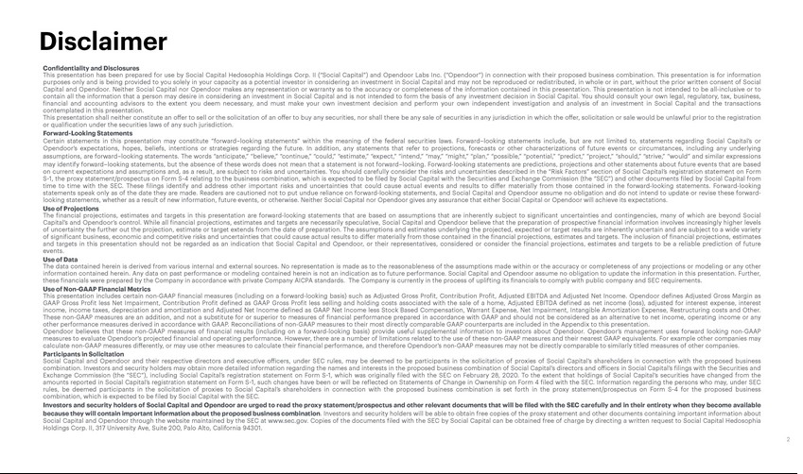

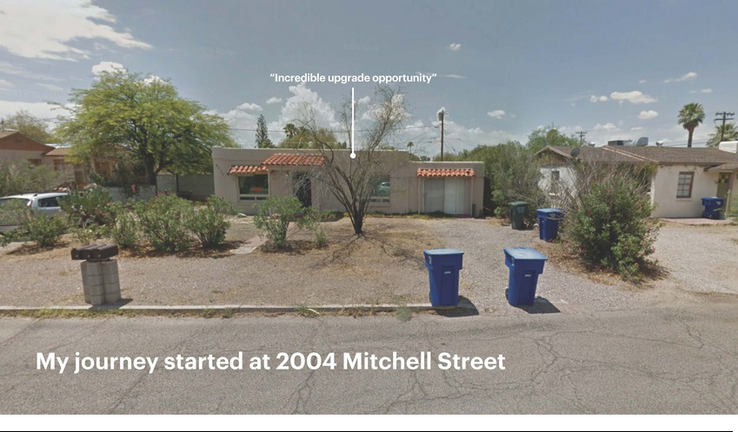







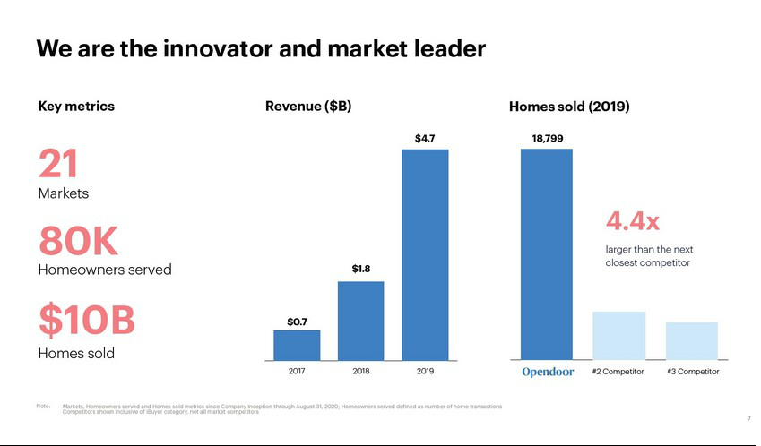

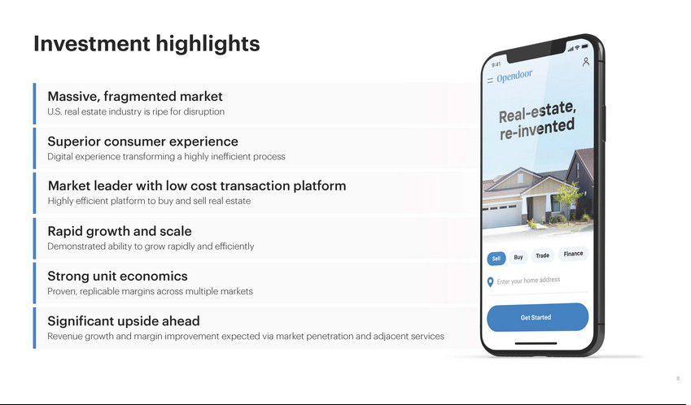

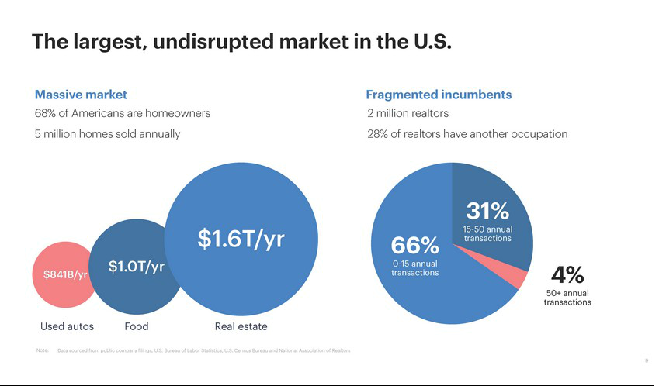

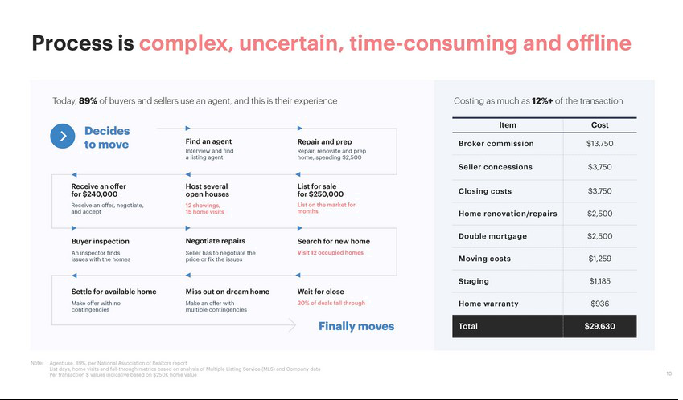





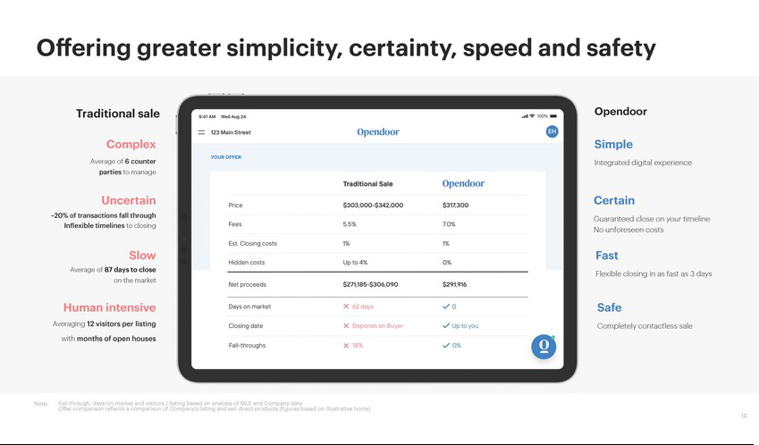

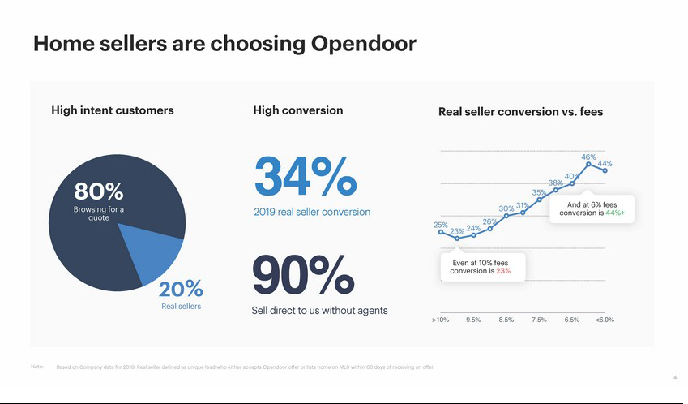

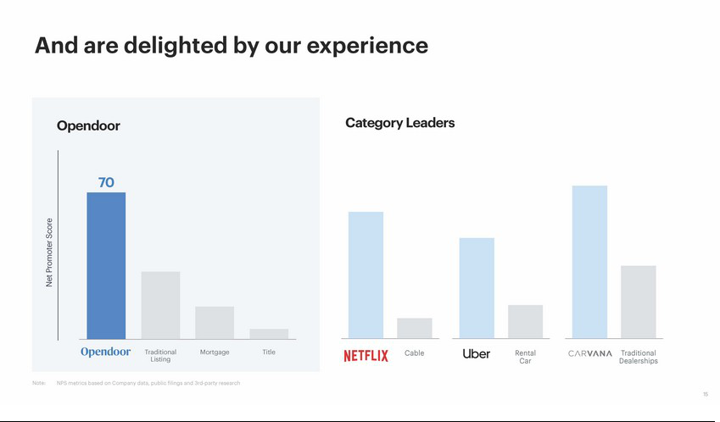

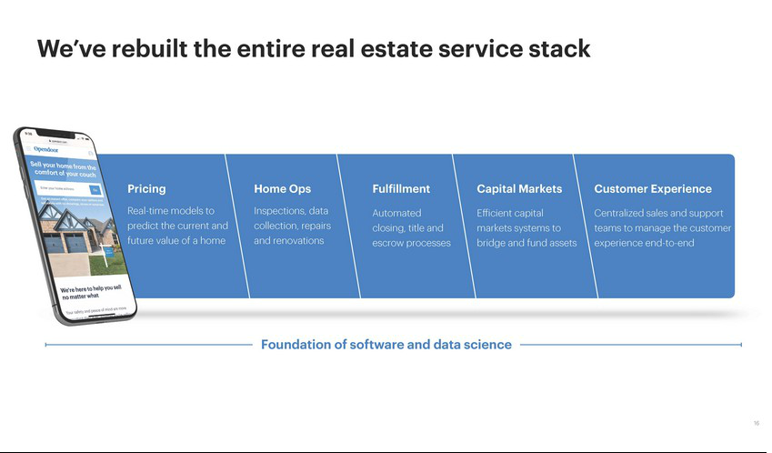

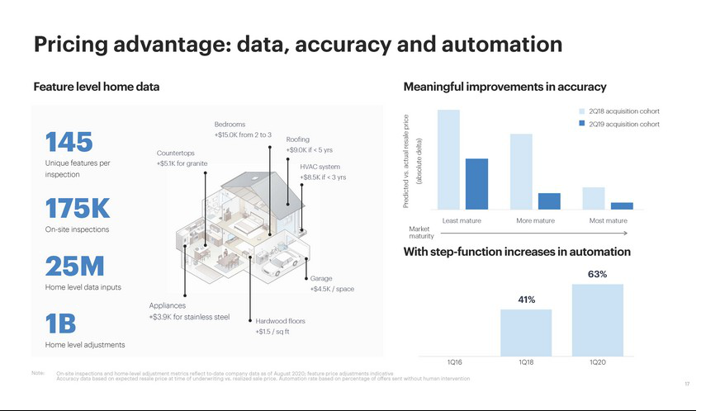

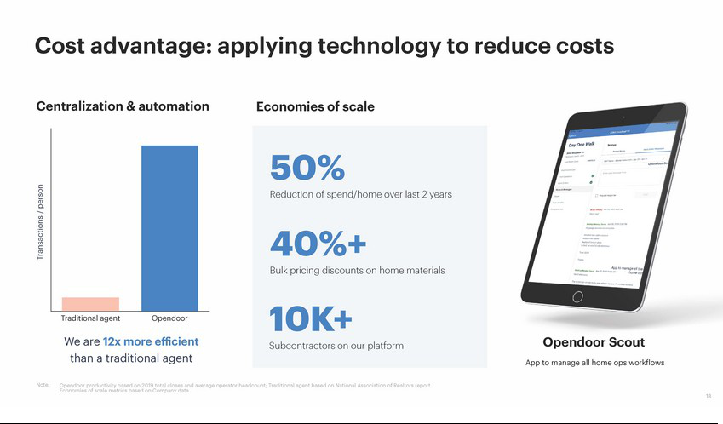



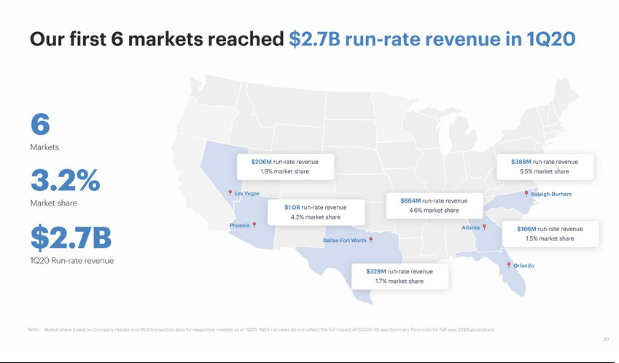

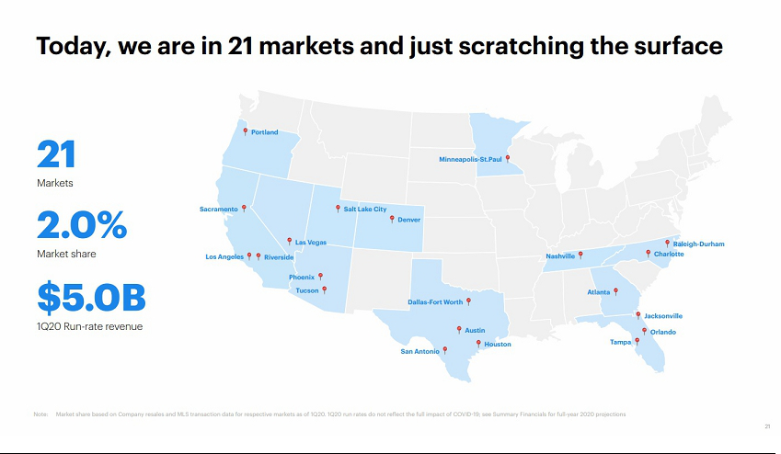

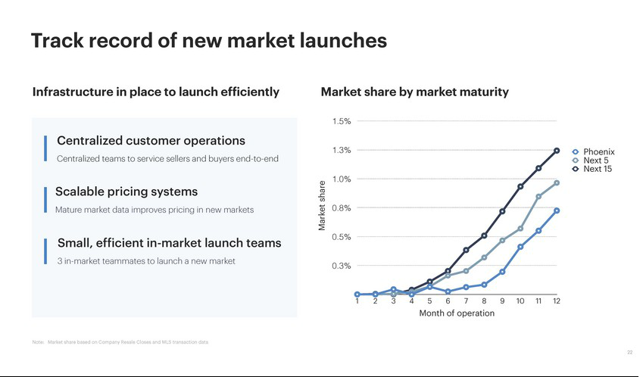

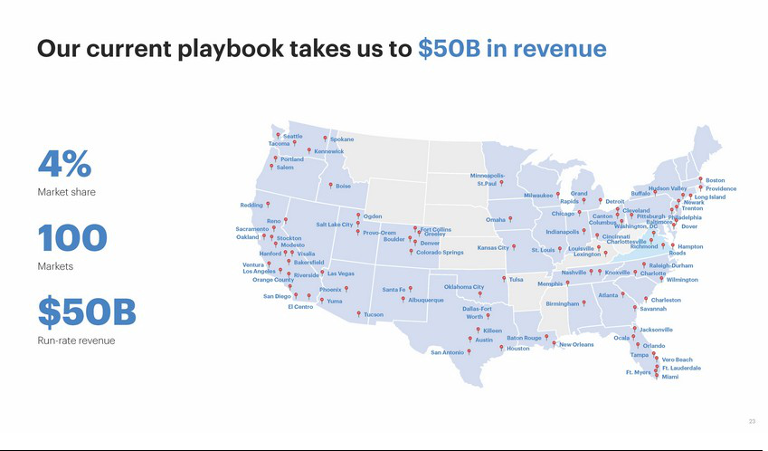

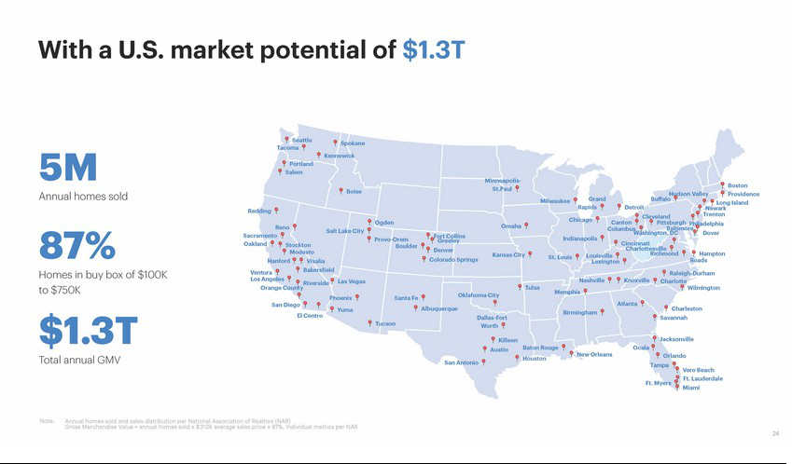



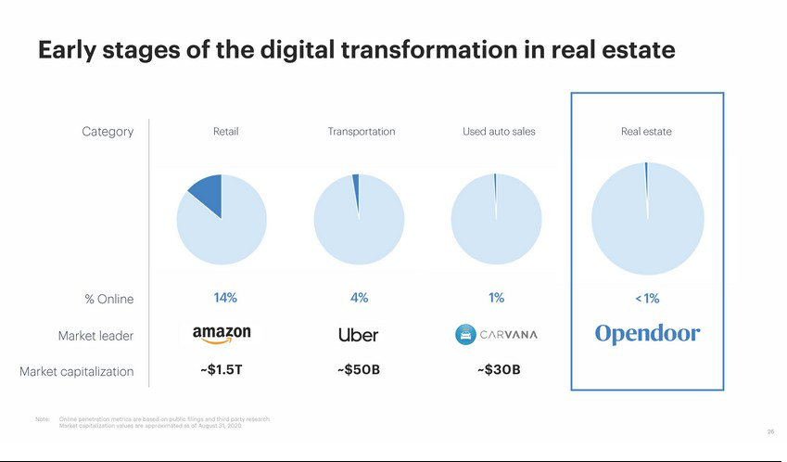

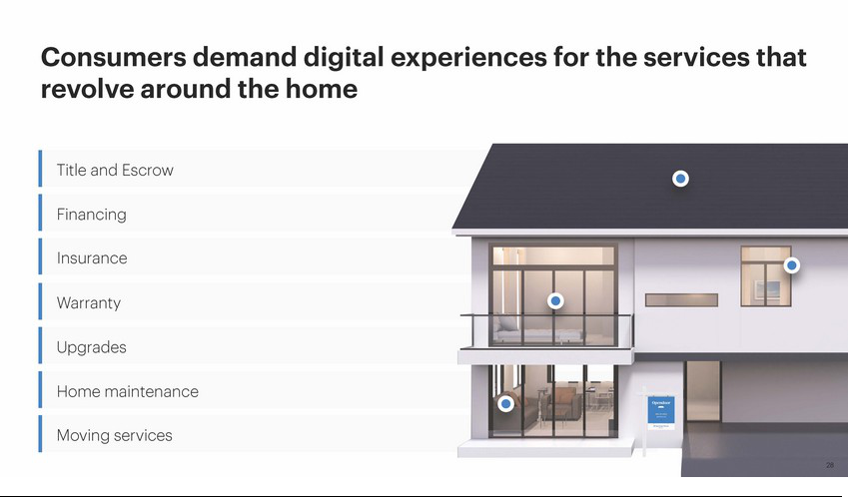





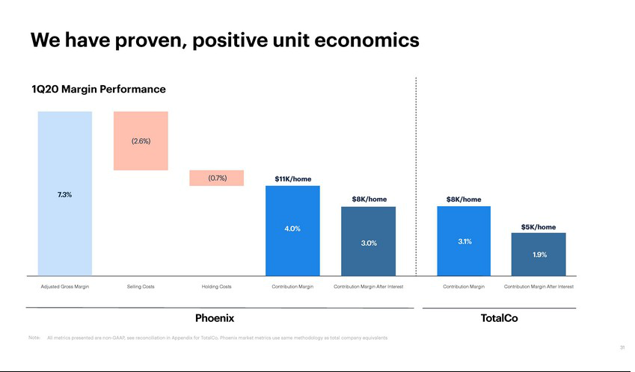

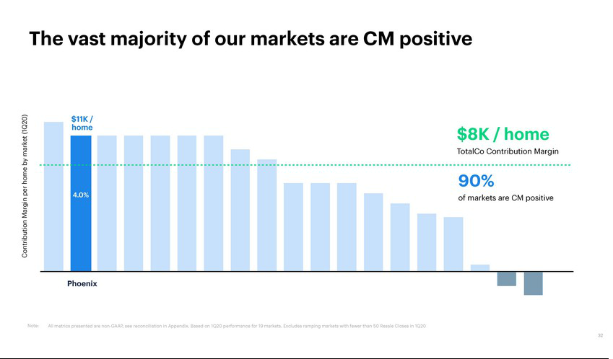

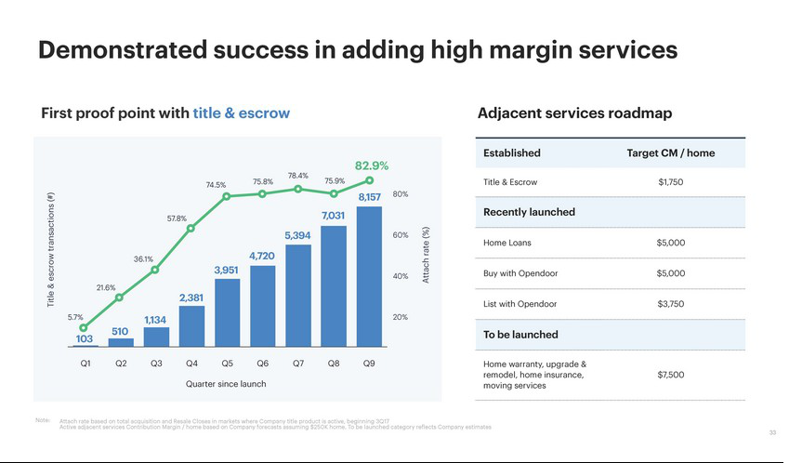

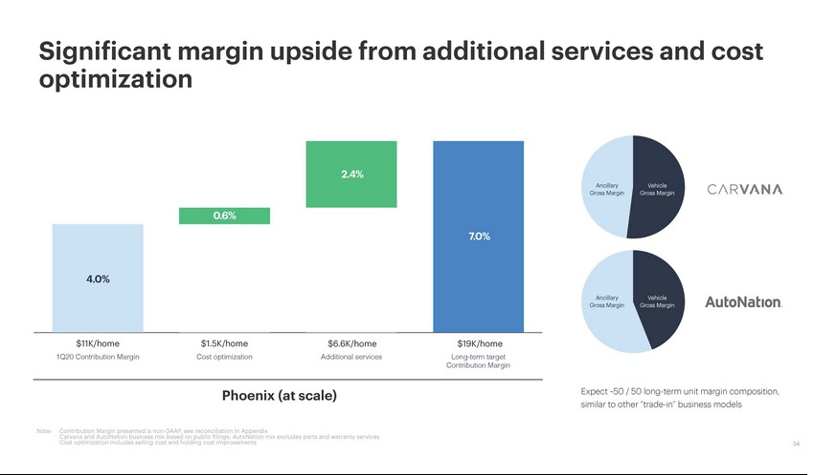

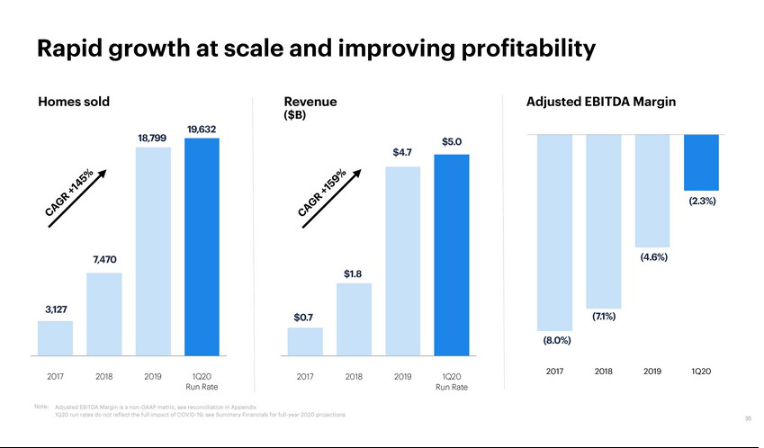

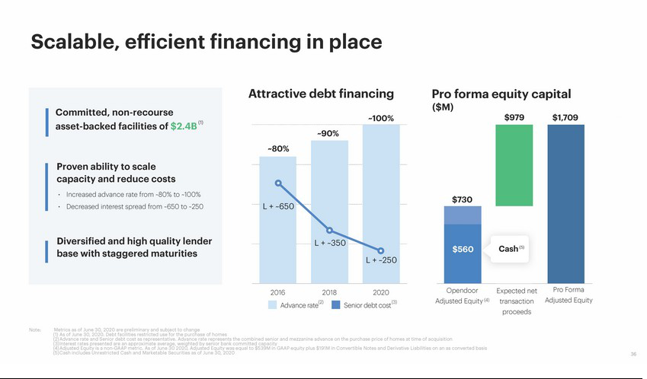

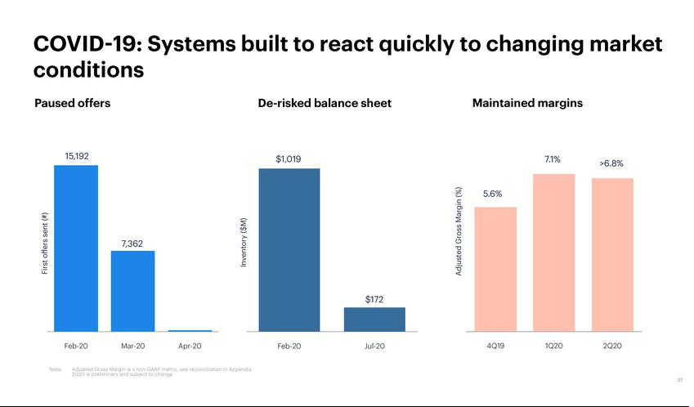

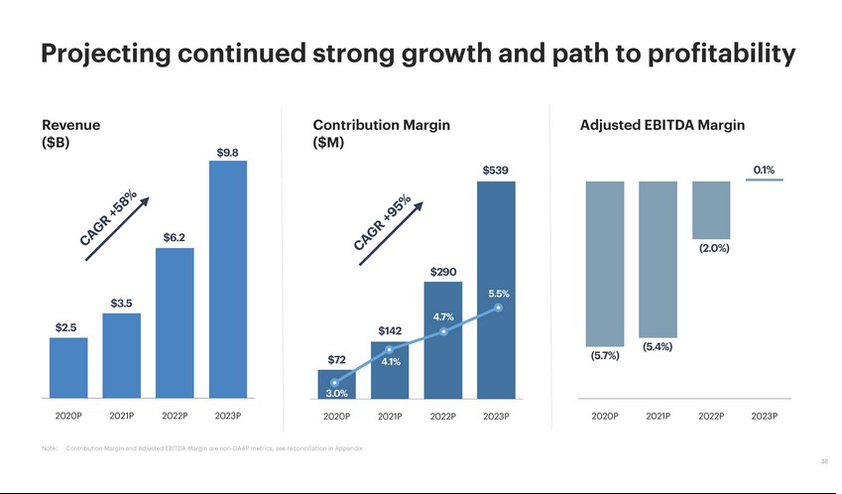

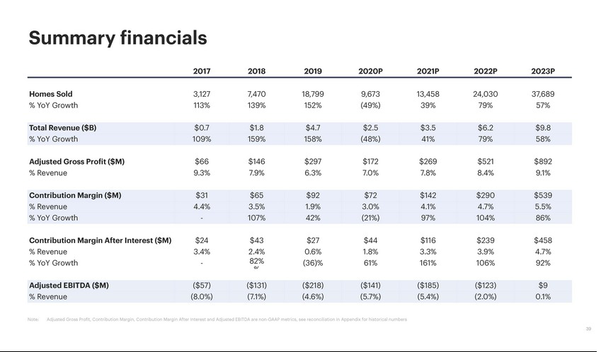

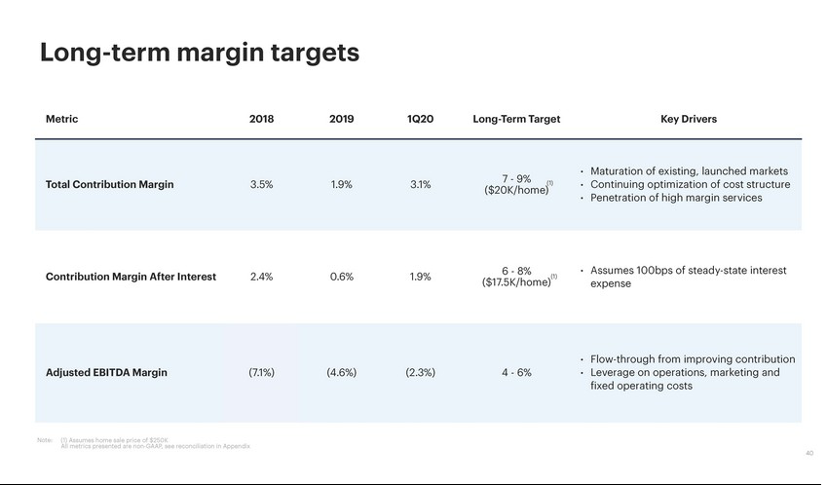

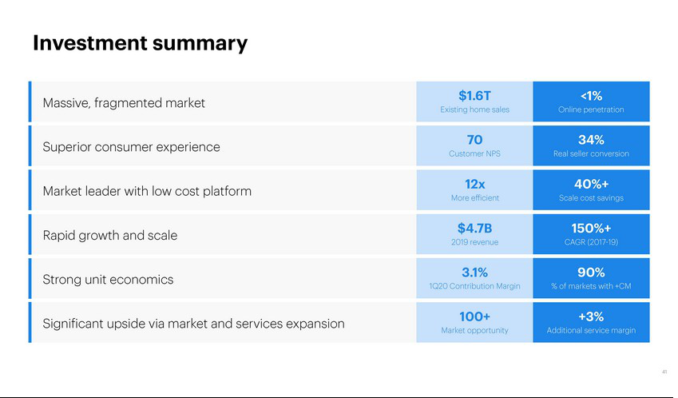





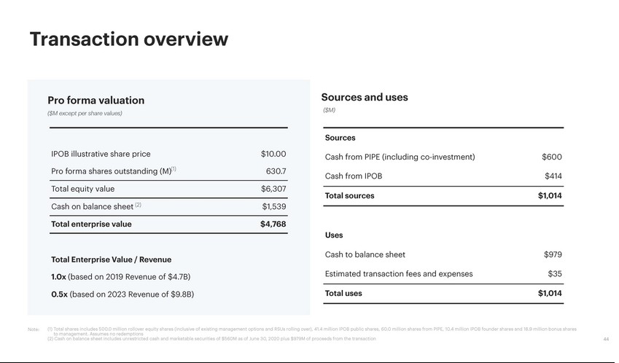

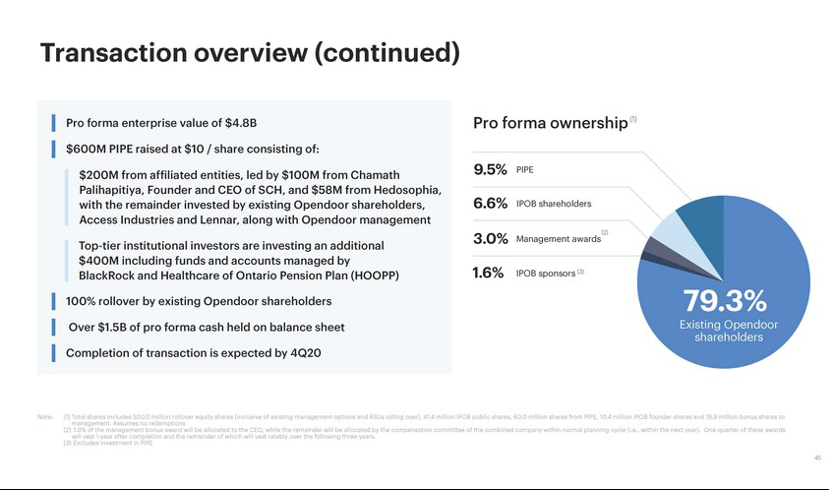



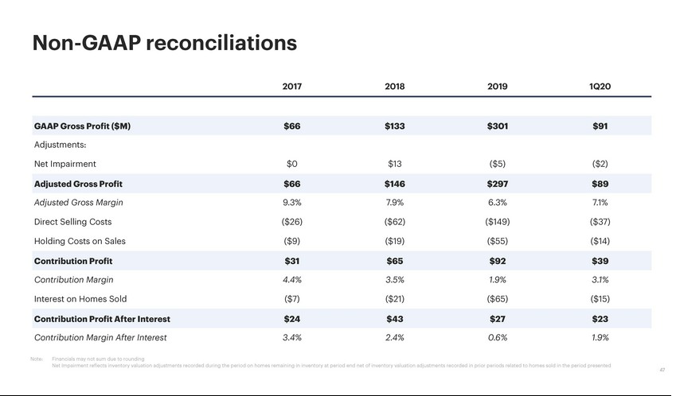

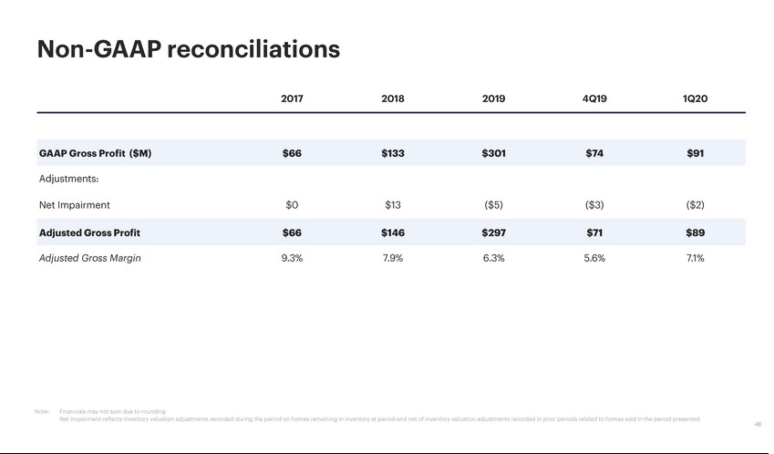

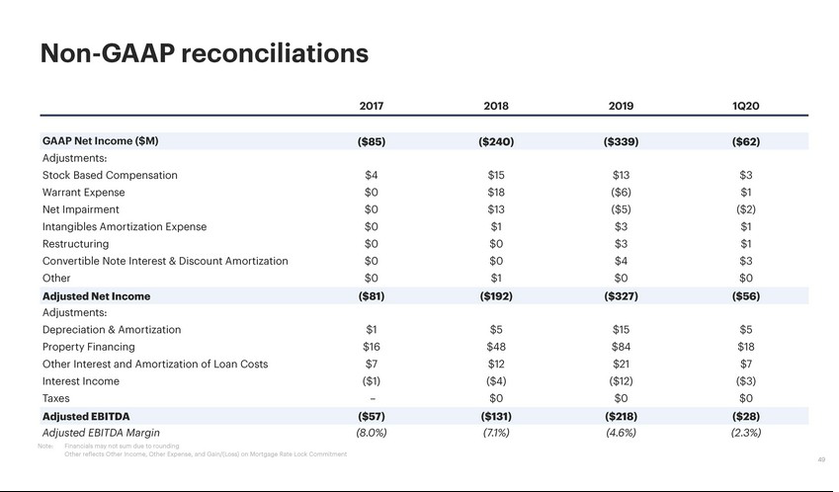

Exhibit 99.3










