UNITED STATES
SECURITIES AND EXCHANGE COMMISSION
Washington, D.C. 20549
__________________________________
FORM 8-K
__________________________________
CURRENT REPORT
Pursuant to Section 13 or 15(d)
of The Securities Exchange Act of 1934
Date of Report (Date of earliest event reported): October 1, 2025
Opendoor Technologies Inc.
(Exact name of registrant as specified in its charter)
Delaware |  |  | 001-39253 |  |  | 30-1318214
(State or other jurisdiction  of incorporation) |  |  | (Commission  File Number) |  |  | (I.R.S. Employer  Identification No.)
410 N. Scottsdale Road, Suite 1000
Tempe, |  |  | AZ |  |  | 85288
(Address of principal executive offices) |  |  |  |  |  | (Zip Code)
(480) 618-6760
(Registrant’s telephone number, including area code)
N/A
(Former name or former address, if changed since last report)
Check the appropriate box below if the Form 8-K filing is intended to simultaneously satisfy the filing obligation of the registrant under any of the following provisions:
☐ |  |  | Written communications pursuant to Rule 425 under the Securities Act (17 CFR 230.425)
☐ |  |  | Soliciting material pursuant to Rule 14a-12 under the Exchange Act (17 CFR 240.14a-12)
☐ |  |  | Pre-commencement communications pursuant to Rule 14d-2(b) under the Exchange Act (17 CFR 240.14d-2(b))
☐ |  |  | Pre-commencement communications pursuant to Rule 13e-4(c) under the Exchange Act (17 CFR 240.13e-4(c))
Securities registered pursuant to Section 12(b) of the Act:
Title of each class |  |  |  |  |  | Trading Symbol(s) |  |  |  |  |  | Name of each exchange  on which registered
Common stock, $0.0001 par value per share |  |  |  |  |  | OPEN |  |  |  |  |  | The Nasdaq Stock Market LLC
Indicate by check mark whether the registrant is an emerging growth company as defined in Rule 405 of the Securities Act of 1933 (§230.405 of this chapter) or Rule 12b-2 of the Securities Exchange Act of 1934 (§240.12b-2 of this chapter).
Emerging growth company ☐
If an emerging growth company, indicate by check mark if the registrant has elected not to use the extended transition period for complying with any new or revised financial accounting standards provided pursuant to Section 13(a) of the Exchange Act. o

Item 8.01Other Events.
On September 11, 2025, the U.S. District Court for the District of Arizona (the “District Court”) issued an order granting preliminary approval (the “Preliminary Approval”) of the proposed settlement of the derivative action captioned Gera v. Palihapitiya, et al. (Case No. 2:23-cv-02164-SMB) (the “Gera Action”), which settlement includes the settlement of other related litigation pending in the U.S. District Court for the District of Delaware and the Delaware Court of Chancery (collectively, the “Settled Matters”). As previously disclosed, the parties to the Settled Matters participated in a global mediation on February 7, 2025 and agreed to a settlement in principle that Opendoor Technologies Inc. (the “Company”) would adopt certain corporate governance reforms as part of a potential global resolution of the Settled Matters and in exchange for a full release of claims. As previously disclosed, on June 27, 2025, (i) the Company executed a Stipulation of Settlement memorializing the terms and conditions of the settlement and (ii) plaintiff in the Gera Action filed a motion for preliminary approval of the proposed settlement.
Pursuant to the District Court’s order granting preliminary approval of the settlement, copies of (i) the Stipulation of Settlement (and exhibits thereto) and (ii) the Notice to Current Opendoor Stockholders of Proposed Settlement and Dismissal with Prejudice of Derivative Actions are attached hereto as Exhibits 99.1 and 99.2, respectively.

Item 9.01Financial Statements and Exhibits
(d)Exhibits.
Exhibit No. |  |  |  |  |  | Description
99.1 |  |  |  |  |  | Stipulation of Settlement
99.2 |  |  |  |  |  | Notice to Current Opendoor Stockholders of Proposed Settlement and Dismissal
104 |  |  |  |  |  | Cover Page Interactive Data File (Cover page XBRL tags are embedded within the Inline XBRL document)

2

SIGNATURES
Pursuant to the requirements of the Securities Exchange Act of 1934, the registrant has duly caused this report to be signed on its behalf by the undersigned hereunto duly authorized.
 |  |  | Opendoor Technologies Inc.
Date: October 1, 2025 |  |  | By: |  |  | /s/ Kaz Nejatian
 |  |  | Name: |  |  | Kaz Nejatian
 |  |  | Title: |  |  | Chief Executive Officer
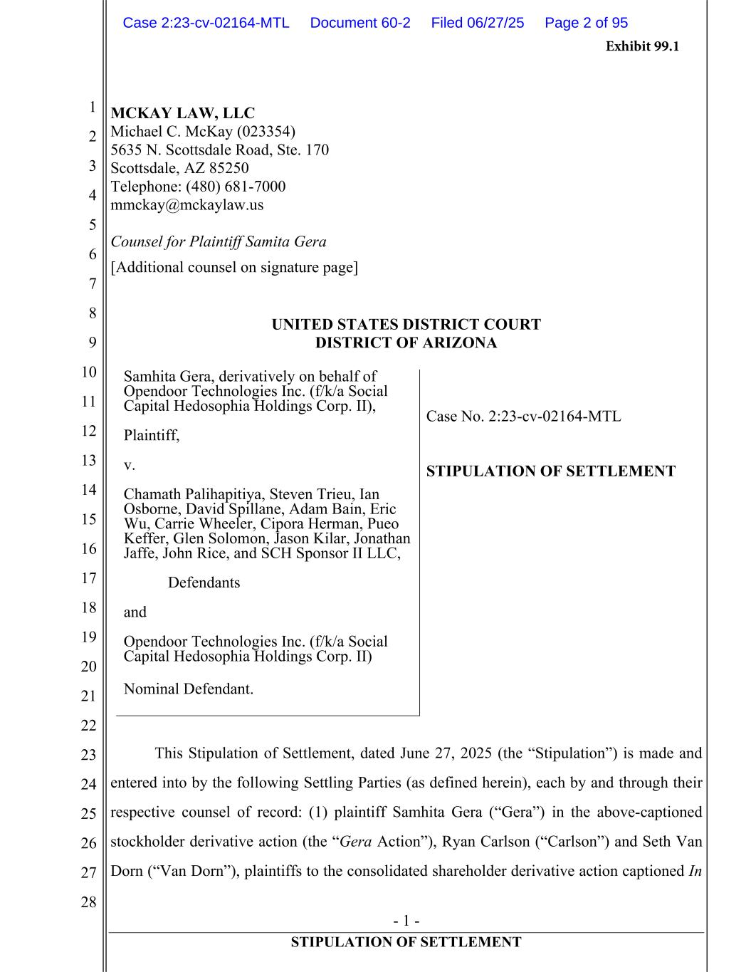
3
- 1 - STIPULATION OF SETTLEMENT 1 2 3 4 5 6 7 8 9 10 11 12 13 14 15 16 17 18 19 20 21 22 23 24 25 26 27 28 MCKAY LAW, LLC Michael C. McKay (023354) 5635 N. Scottsdale Road, Ste. 170 Scottsdale, AZ 85250 Telephone: (480) 681-7000 mmckay@mckaylaw.us Counsel for Plaintiff Samita Gera [Additional counsel on signature page] UNITED STATES DISTRICT COURT DISTRICT OF ARIZONA Samhita Gera, derivatively on behalf of Opendoor Technologies Inc. (f/k/a Social Capital Hedosophia Holdings Corp. II), Plaintiff, v. Chamath Palihapitiya, Steven Trieu, Ian Osborne, David Spillane, Adam Bain, Eric Wu, Carrie Wheeler, Cipora Herman, Pueo Keffer, Glen Solomon, Jason Kilar, Jonathan Jaffe, John Rice, and SCH Sponsor II LLC, Defendants and Opendoor Technologies Inc. (f/k/a Social Capital Hedosophia Holdings Corp. II) Nominal Defendant. Case No. 2:23-cv-02164-MTL STIPULATION OF SETTLEMENT This Stipulation of Settlement, dated June 27, 2025 (the “Stipulation”) is made and entered into by the following Settling Parties (as defined herein), each by and through their respective counsel of record: (1) plaintiff Samhita Gera (“Gera”) in the above-captioned stockholder derivative action (the “Gera Action”), Ryan Carlson (“Carlson”) and Seth Van Dorn (“Van Dorn”), plaintiffs to the consolidated shareholder derivative action captioned In Case 2:23-cv-02164-MTL Document 60-2 Filed 06/27/25 Page 2 of 95 Exhibit 99.1

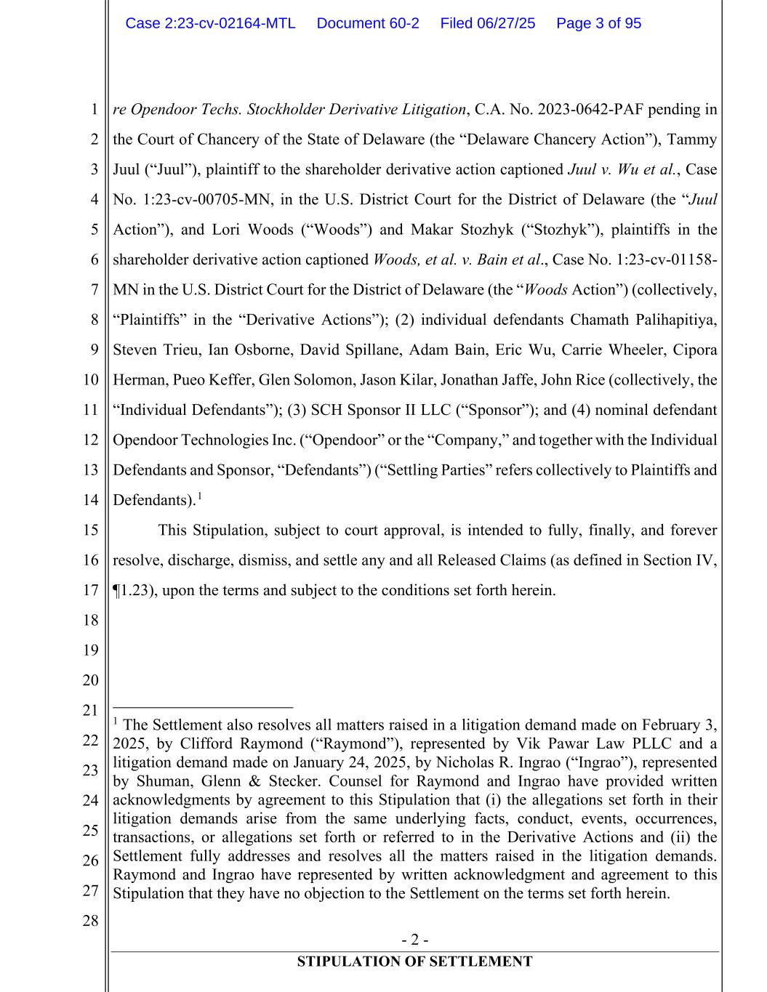
- 2 - STIPULATION OF SETTLEMENT 1 2 3 4 5 6 7 8 9 10 11 12 13 14 15 16 17 18 19 20 21 22 23 24 25 26 27 28 re Opendoor Techs. Stockholder Derivative Litigation, C.A. No. 2023-0642-PAF pending in the Court of Chancery of the State of Delaware (the “Delaware Chancery Action”), Tammy Juul (“Juul”), plaintiff to the shareholder derivative action captioned Juul v. Wu et al., Case No. 1:23-cv-00705-MN, in the U.S. District Court for the District of Delaware (the “Juul Action”), and Lori Woods (“Woods”) and Makar Stozhyk (“Stozhyk”), plaintiffs in the shareholder derivative action captioned Woods, et al. v. Bain et al., Case No. 1:23-cv-01158- MN in the U.S. District Court for the District of Delaware (the “Woods Action”) (collectively, “Plaintiffs” in the “Derivative Actions”); (2) individual defendants Chamath Palihapitiya, Steven Trieu, Ian Osborne, David Spillane, Adam Bain, Eric Wu, Carrie Wheeler, Cipora Herman, Pueo Keffer, Glen Solomon, Jason Kilar, Jonathan Jaffe, John Rice (collectively, the “Individual Defendants”); (3) SCH Sponsor II LLC (“Sponsor”); and (4) nominal defendant Opendoor Technologies Inc. (“Opendoor” or the “Company,” and together with the Individual Defendants and Sponsor, “Defendants”) (“Settling Parties” refers collectively to Plaintiffs and Defendants).1 This Stipulation, subject to court approval, is intended to fully, finally, and forever resolve, discharge, dismiss, and settle any and all Released Claims (as defined in Section IV, ¶1.23), upon the terms and subject to the conditions set forth herein. 1 The Settlement also resolves all matters raised in a litigation demand made on February 3, 2025, by Clifford Raymond (“Raymond”), represented by Vik Pawar Law PLLC and a litigation demand made on January 24, 2025, by Nicholas R. Ingrao (“Ingrao”), represented by Shuman, Glenn & Stecker. Counsel for Raymond and Ingrao have provided written acknowledgments by agreement to this Stipulation that (i) the allegations set forth in their litigation demands arise from the same underlying facts, conduct, events, occurrences, transactions, or allegations set forth or referred to in the Derivative Actions and (ii) the Settlement fully addresses and resolves all the matters raised in the litigation demands. Raymond and Ingrao have represented by written acknowledgment and agreement to this Stipulation that they have no objection to the Settlement on the terms set forth herein. Case 2:23-cv-02164-MTL Document 60-2 Filed 06/27/25 Page 3 of 95

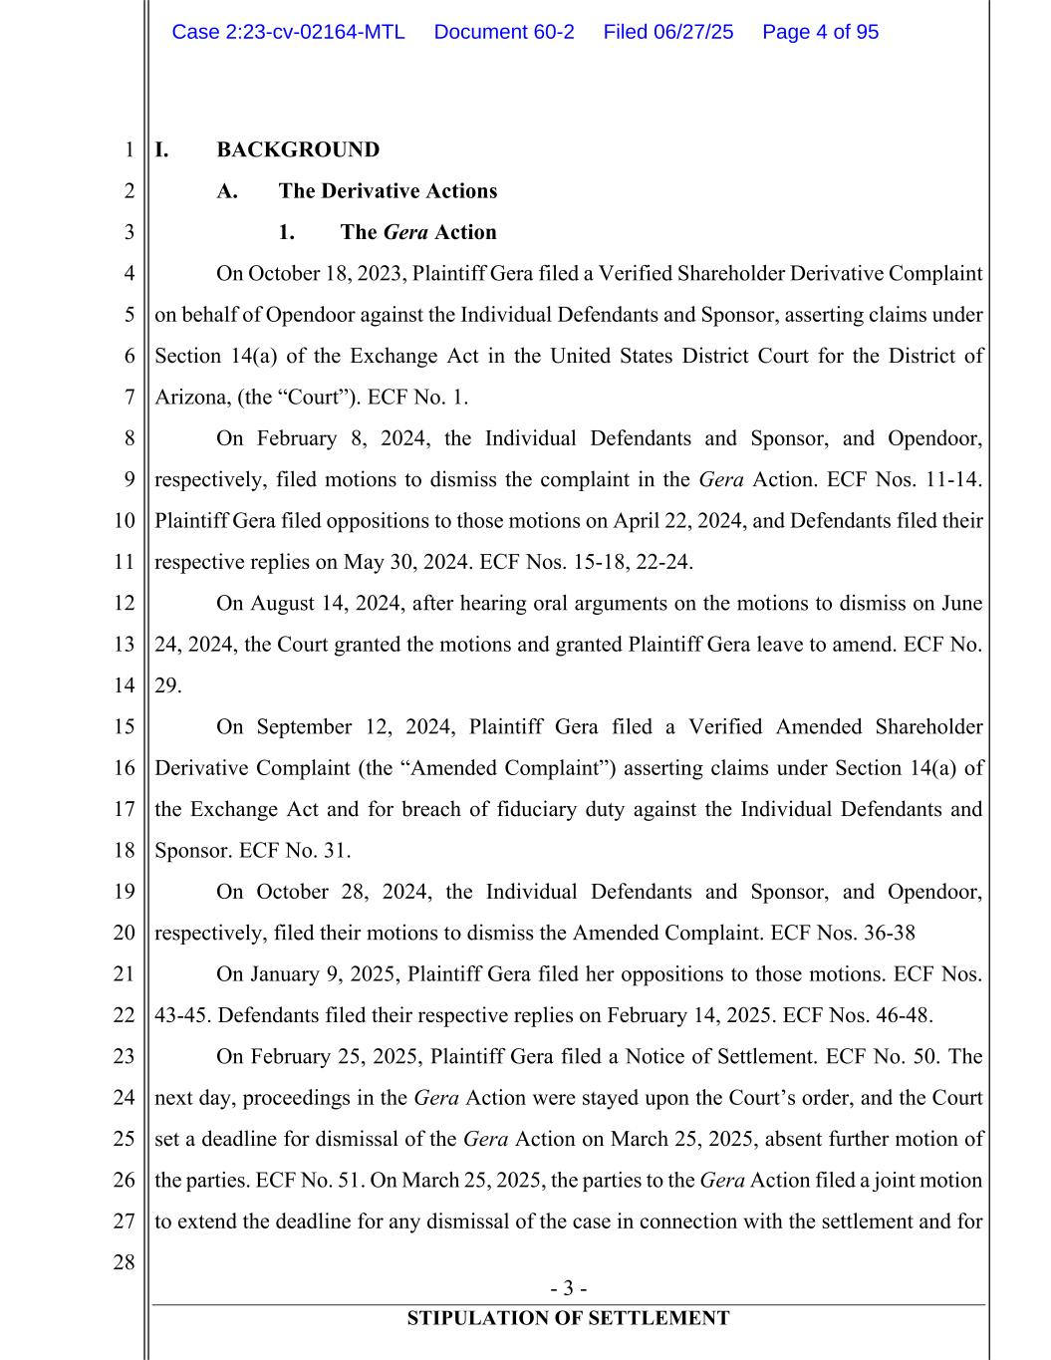
- 3 - STIPULATION OF SETTLEMENT 1 2 3 4 5 6 7 8 9 10 11 12 13 14 15 16 17 18 19 20 21 22 23 24 25 26 27 28 I. BACKGROUND A. The Derivative Actions 1. The Gera Action On October 18, 2023, Plaintiff Gera filed a Verified Shareholder Derivative Complaint on behalf of Opendoor against the Individual Defendants and Sponsor, asserting claims under Section 14(a) of the Exchange Act in the United States District Court for the District of Arizona, (the “Court”). ECF No. 1. On February 8, 2024, the Individual Defendants and Sponsor, and Opendoor, respectively, filed motions to dismiss the complaint in the Gera Action. ECF Nos. 11-14. Plaintiff Gera filed oppositions to those motions on April 22, 2024, and Defendants filed their respective replies on May 30, 2024. ECF Nos. 15-18, 22-24. On August 14, 2024, after hearing oral arguments on the motions to dismiss on June 24, 2024, the Court granted the motions and granted Plaintiff Gera leave to amend. ECF No. 29. On September 12, 2024, Plaintiff Gera filed a Verified Amended Shareholder Derivative Complaint (the “Amended Complaint”) asserting claims under Section 14(a) of the Exchange Act and for breach of fiduciary duty against the Individual Defendants and Sponsor. ECF No. 31. On October 28, 2024, the Individual Defendants and Sponsor, and Opendoor, respectively, filed their motions to dismiss the Amended Complaint. ECF Nos. 36-38 On January 9, 2025, Plaintiff Gera filed her oppositions to those motions. ECF Nos. 43-45. Defendants filed their respective replies on February 14, 2025. ECF Nos. 46-48. On February 25, 2025, Plaintiff Gera filed a Notice of Settlement. ECF No. 50. The next day, proceedings in the Gera Action were stayed upon the Court’s order, and the Court set a deadline for dismissal of the Gera Action on March 25, 2025, absent further motion of the parties. ECF No. 51. On March 25, 2025, the parties to the Gera Action filed a joint motion to extend the deadline for any dismissal of the case in connection with the settlement and for Case 2:23-cv-02164-MTL Document 60-2 Filed 06/27/25 Page 4 of 95

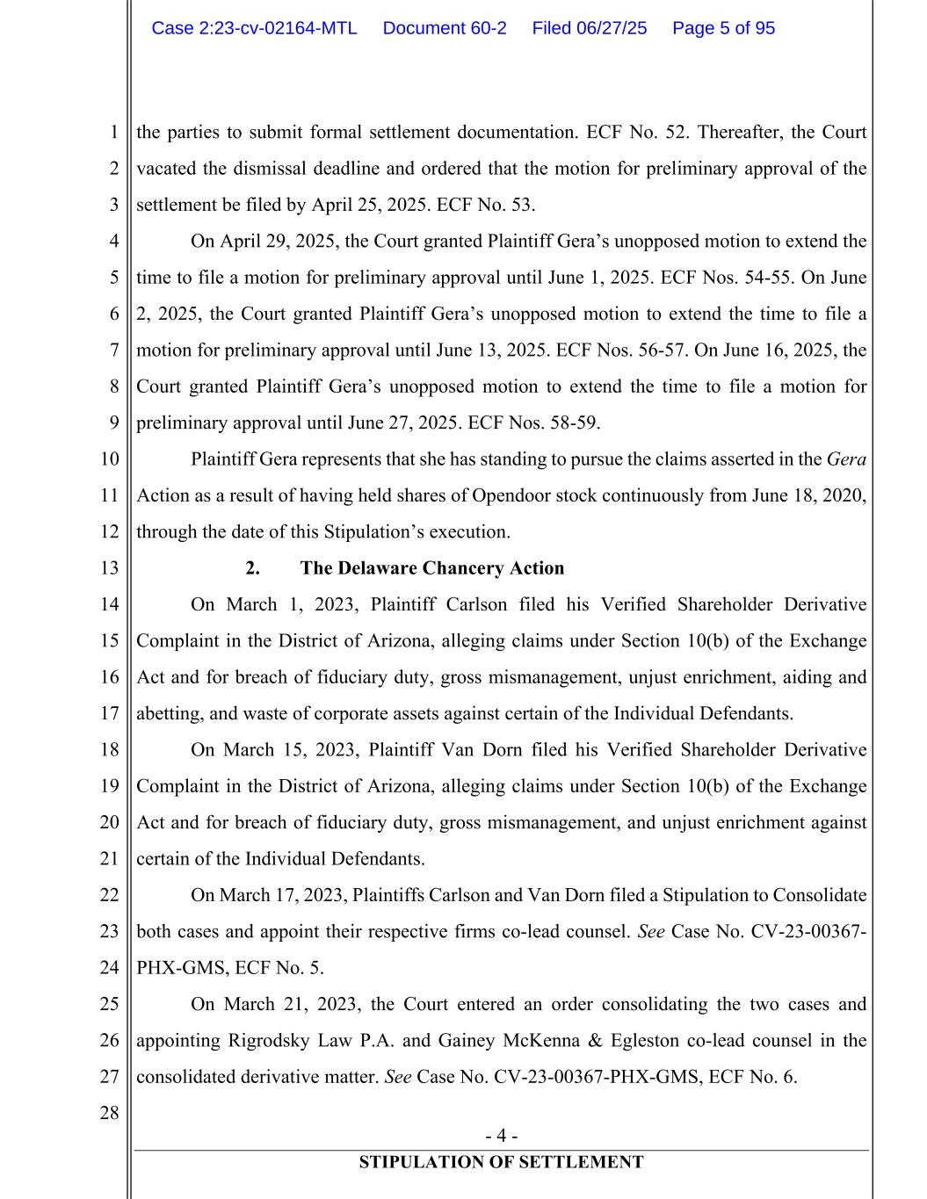
- 4 - STIPULATION OF SETTLEMENT 1 2 3 4 5 6 7 8 9 10 11 12 13 14 15 16 17 18 19 20 21 22 23 24 25 26 27 28 the parties to submit formal settlement documentation. ECF No. 52. Thereafter, the Court vacated the dismissal deadline and ordered that the motion for preliminary approval of the settlement be filed by April 25, 2025. ECF No. 53. On April 29, 2025, the Court granted Plaintiff Gera’s unopposed motion to extend the time to file a motion for preliminary approval until June 1, 2025. ECF Nos. 54-55. On June 2, 2025, the Court granted Plaintiff Gera’s unopposed motion to extend the time to file a motion for preliminary approval until June 13, 2025. ECF Nos. 56-57. On June 16, 2025, the Court granted Plaintiff Gera’s unopposed motion to extend the time to file a motion for preliminary approval until June 27, 2025. ECF Nos. 58-59. Plaintiff Gera represents that she has standing to pursue the claims asserted in the Gera Action as a result of having held shares of Opendoor stock continuously from June 18, 2020, through the date of this Stipulation’s execution. 2. The Delaware Chancery Action On March 1, 2023, Plaintiff Carlson filed his Verified Shareholder Derivative Complaint in the District of Arizona, alleging claims under Section 10(b) of the Exchange Act and for breach of fiduciary duty, gross mismanagement, unjust enrichment, aiding and abetting, and waste of corporate assets against certain of the Individual Defendants. On March 15, 2023, Plaintiff Van Dorn filed his Verified Shareholder Derivative Complaint in the District of Arizona, alleging claims under Section 10(b) of the Exchange Act and for breach of fiduciary duty, gross mismanagement, and unjust enrichment against certain of the Individual Defendants. On March 17, 2023, Plaintiffs Carlson and Van Dorn filed a Stipulation to Consolidate both cases and appoint their respective firms co-lead counsel. See Case No. CV-23-00367- PHX-GMS, ECF No. 5. On March 21, 2023, the Court entered an order consolidating the two cases and appointing Rigrodsky Law P.A. and Gainey McKenna & Egleston co-lead counsel in the consolidated derivative matter. See Case No. CV-23-00367-PHX-GMS, ECF No. 6. Case 2:23-cv-02164-MTL Document 60-2 Filed 06/27/25 Page 5 of 95

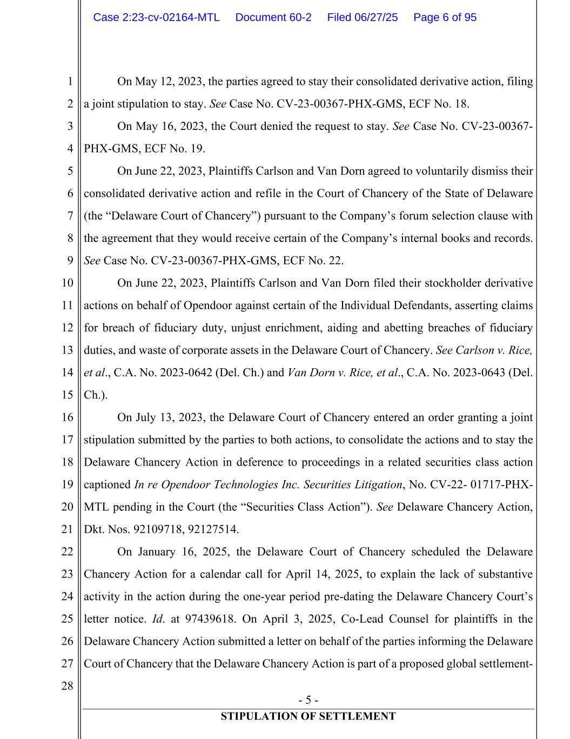
- 5 - STIPULATION OF SETTLEMENT 1 2 3 4 5 6 7 8 9 10 11 12 13 14 15 16 17 18 19 20 21 22 23 24 25 26 27 28 On May 12, 2023, the parties agreed to stay their consolidated derivative action, filing a joint stipulation to stay. See Case No. CV-23-00367-PHX-GMS, ECF No. 18. On May 16, 2023, the Court denied the request to stay. See Case No. CV-23-00367- PHX-GMS, ECF No. 19. On June 22, 2023, Plaintiffs Carlson and Van Dorn agreed to voluntarily dismiss their consolidated derivative action and refile in the Court of Chancery of the State of Delaware (the “Delaware Court of Chancery”) pursuant to the Company’s forum selection clause with the agreement that they would receive certain of the Company’s internal books and records. See Case No. CV-23-00367-PHX-GMS, ECF No. 22. On June 22, 2023, Plaintiffs Carlson and Van Dorn filed their stockholder derivative actions on behalf of Opendoor against certain of the Individual Defendants, asserting claims for breach of fiduciary duty, unjust enrichment, aiding and abetting breaches of fiduciary duties, and waste of corporate assets in the Delaware Court of Chancery. See Carlson v. Rice, et al., C.A. No. 2023-0642 (Del. Ch.) and Van Dorn v. Rice, et al., C.A. No. 2023-0643 (Del. Ch.). On July 13, 2023, the Delaware Court of Chancery entered an order granting a joint stipulation submitted by the parties to both actions, to consolidate the actions and to stay the Delaware Chancery Action in deference to proceedings in a related securities class action captioned In re Opendoor Technologies Inc. Securities Litigation, No. CV-22- 01717-PHX- MTL pending in the Court (the “Securities Class Action”). See Delaware Chancery Action, Dkt. Nos. 92109718, 92127514. On January 16, 2025, the Delaware Court of Chancery scheduled the Delaware Chancery Action for a calendar call for April 14, 2025, to explain the lack of substantive activity in the action during the one-year period pre-dating the Delaware Chancery Court’s letter notice. Id. at 97439618. On April 3, 2025, Co-Lead Counsel for plaintiffs in the Delaware Chancery Action submitted a letter on behalf of the parties informing the Delaware Court of Chancery that the Delaware Chancery Action is part of a proposed global settlement- Case 2:23-cv-02164-MTL Document 60-2 Filed 06/27/25 Page 6 of 95

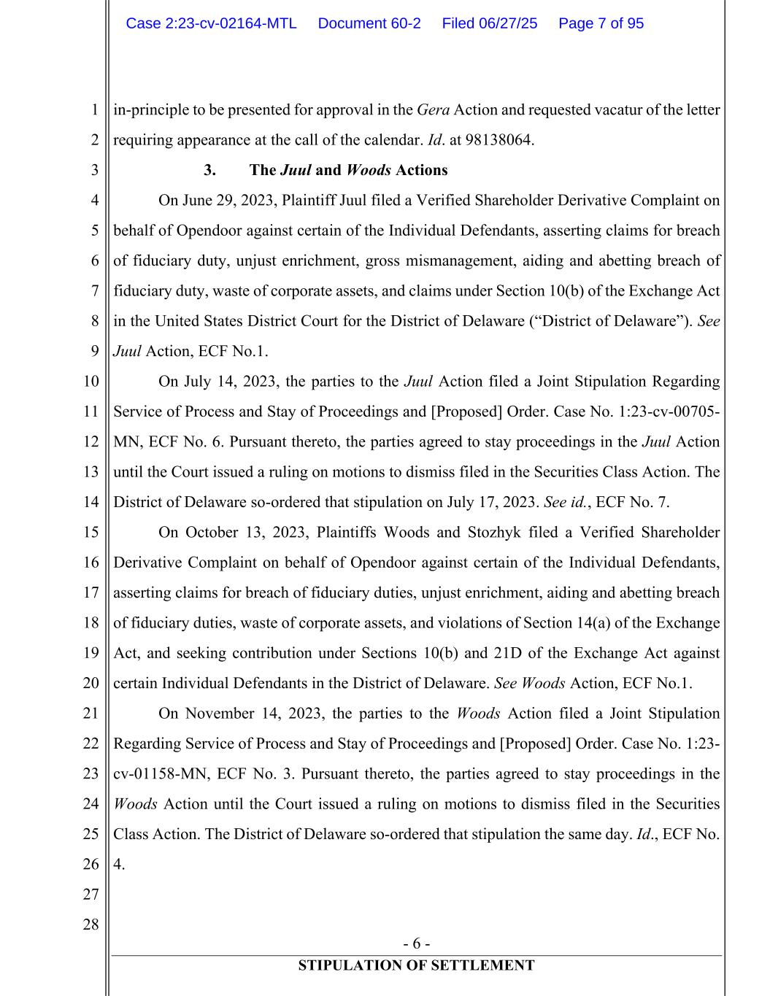
- 6 - STIPULATION OF SETTLEMENT 1 2 3 4 5 6 7 8 9 10 11 12 13 14 15 16 17 18 19 20 21 22 23 24 25 26 27 28 in-principle to be presented for approval in the Gera Action and requested vacatur of the letter requiring appearance at the call of the calendar. Id. at 98138064. 3. The Juul and Woods Actions On June 29, 2023, Plaintiff Juul filed a Verified Shareholder Derivative Complaint on behalf of Opendoor against certain of the Individual Defendants, asserting claims for breach of fiduciary duty, unjust enrichment, gross mismanagement, aiding and abetting breach of fiduciary duty, waste of corporate assets, and claims under Section 10(b) of the Exchange Act in the United States District Court for the District of Delaware (“District of Delaware”). See Juul Action, ECF No.1. On July 14, 2023, the parties to the Juul Action filed a Joint Stipulation Regarding Service of Process and Stay of Proceedings and [Proposed] Order. Case No. 1:23-cv-00705- MN, ECF No. 6. Pursuant thereto, the parties agreed to stay proceedings in the Juul Action until the Court issued a ruling on motions to dismiss filed in the Securities Class Action. The District of Delaware so-ordered that stipulation on July 17, 2023. See id., ECF No. 7. On October 13, 2023, Plaintiffs Woods and Stozhyk filed a Verified Shareholder Derivative Complaint on behalf of Opendoor against certain of the Individual Defendants, asserting claims for breach of fiduciary duties, unjust enrichment, aiding and abetting breach of fiduciary duties, waste of corporate assets, and violations of Section 14(a) of the Exchange Act, and seeking contribution under Sections 10(b) and 21D of the Exchange Act against certain Individual Defendants in the District of Delaware. See Woods Action, ECF No.1. On November 14, 2023, the parties to the Woods Action filed a Joint Stipulation Regarding Service of Process and Stay of Proceedings and [Proposed] Order. Case No. 1:23- cv-01158-MN, ECF No. 3. Pursuant thereto, the parties agreed to stay proceedings in the Woods Action until the Court issued a ruling on motions to dismiss filed in the Securities Class Action. The District of Delaware so-ordered that stipulation the same day. Id., ECF No. 4. Case 2:23-cv-02164-MTL Document 60-2 Filed 06/27/25 Page 7 of 95

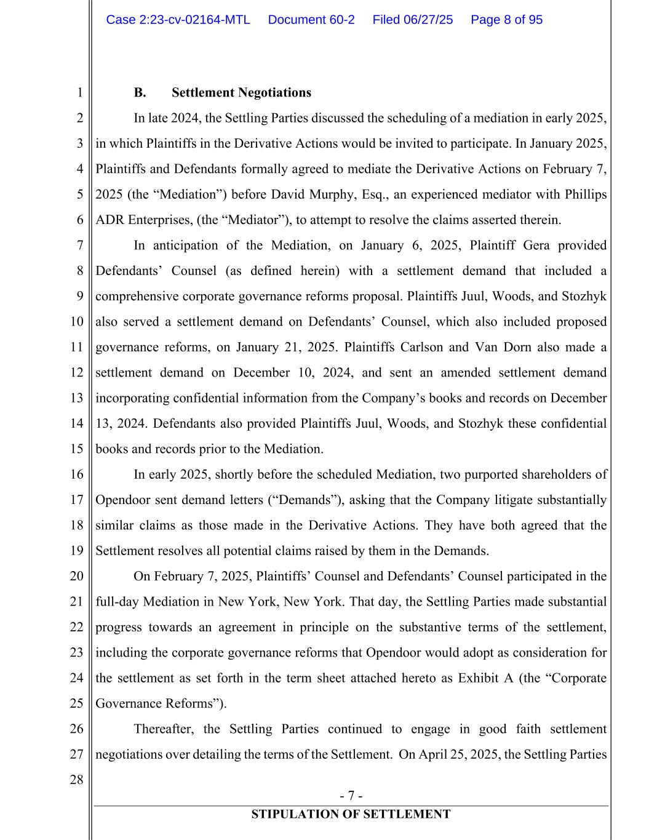
- 7 - STIPULATION OF SETTLEMENT 1 2 3 4 5 6 7 8 9 10 11 12 13 14 15 16 17 18 19 20 21 22 23 24 25 26 27 28 B. Settlement Negotiations In late 2024, the Settling Parties discussed the scheduling of a mediation in early 2025, in which Plaintiffs in the Derivative Actions would be invited to participate. In January 2025, Plaintiffs and Defendants formally agreed to mediate the Derivative Actions on February 7, 2025 (the “Mediation”) before David Murphy, Esq., an experienced mediator with Phillips ADR Enterprises, (the “Mediator”), to attempt to resolve the claims asserted therein. In anticipation of the Mediation, on January 6, 2025, Plaintiff Gera provided Defendants’ Counsel (as defined herein) with a settlement demand that included a comprehensive corporate governance reforms proposal. Plaintiffs Juul, Woods, and Stozhyk also served a settlement demand on Defendants’ Counsel, which also included proposed governance reforms, on January 21, 2025. Plaintiffs Carlson and Van Dorn also made a settlement demand on December 10, 2024, and sent an amended settlement demand incorporating confidential information from the Company’s books and records on December 13, 2024. Defendants also provided Plaintiffs Juul, Woods, and Stozhyk these confidential books and records prior to the Mediation. In early 2025, shortly before the scheduled Mediation, two purported shareholders of Opendoor sent demand letters (“Demands”), asking that the Company litigate substantially similar claims as those made in the Derivative Actions. They have both agreed that the Settlement resolves all potential claims raised by them in the Demands. On February 7, 2025, Plaintiffs’ Counsel and Defendants’ Counsel participated in the full-day Mediation in New York, New York. That day, the Settling Parties made substantial progress towards an agreement in principle on the substantive terms of the settlement, including the corporate governance reforms that Opendoor would adopt as consideration for the settlement as set forth in the term sheet attached hereto as Exhibit A (the “Corporate Governance Reforms”). Thereafter, the Settling Parties continued to engage in good faith settlement negotiations over detailing the terms of the Settlement. On April 25, 2025, the Settling Parties Case 2:23-cv-02164-MTL Document 60-2 Filed 06/27/25 Page 8 of 95

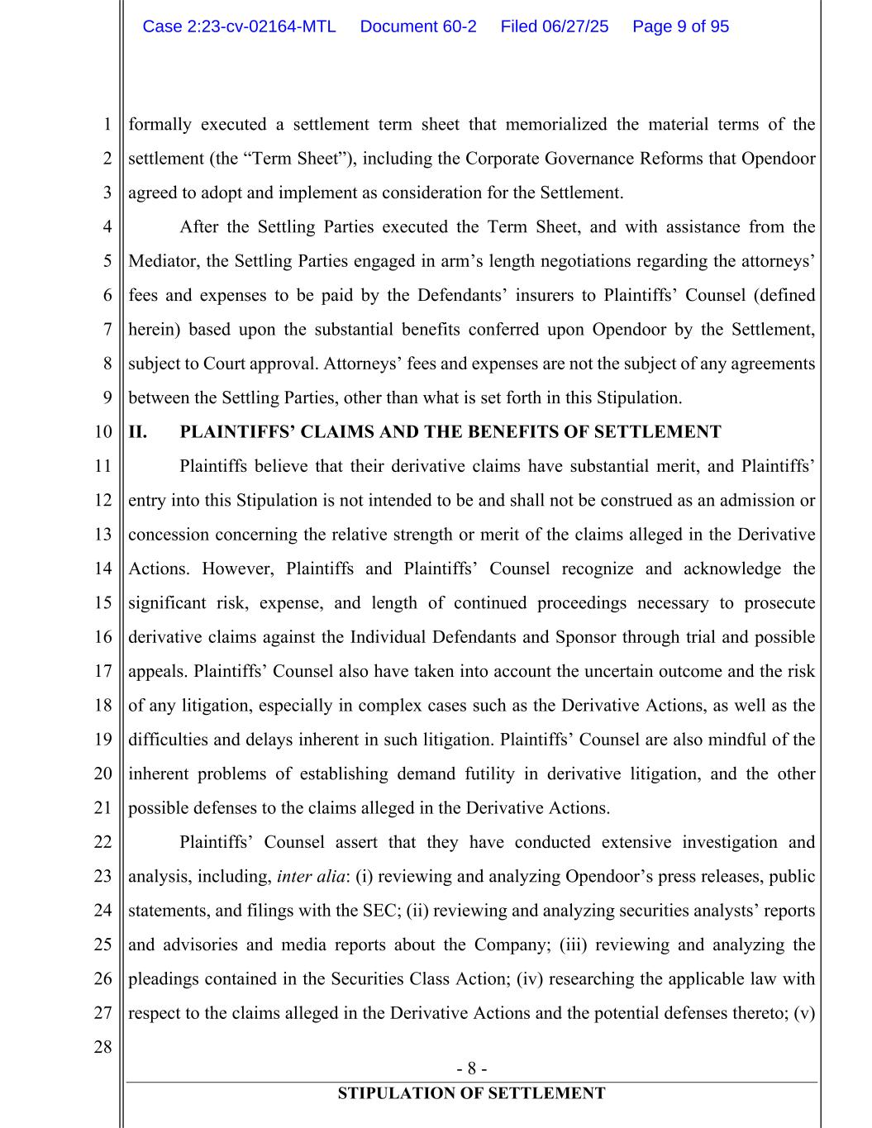
- 8 - STIPULATION OF SETTLEMENT 1 2 3 4 5 6 7 8 9 10 11 12 13 14 15 16 17 18 19 20 21 22 23 24 25 26 27 28 formally executed a settlement term sheet that memorialized the material terms of the settlement (the “Term Sheet”), including the Corporate Governance Reforms that Opendoor agreed to adopt and implement as consideration for the Settlement. After the Settling Parties executed the Term Sheet, and with assistance from the Mediator, the Settling Parties engaged in arm’s length negotiations regarding the attorneys’ fees and expenses to be paid by the Defendants’ insurers to Plaintiffs’ Counsel (defined herein) based upon the substantial benefits conferred upon Opendoor by the Settlement, subject to Court approval. Attorneys’ fees and expenses are not the subject of any agreements between the Settling Parties, other than what is set forth in this Stipulation. II. PLAINTIFFS’ CLAIMS AND THE BENEFITS OF SETTLEMENT Plaintiffs believe that their derivative claims have substantial merit, and Plaintiffs’ entry into this Stipulation is not intended to be and shall not be construed as an admission or concession concerning the relative strength or merit of the claims alleged in the Derivative Actions. However, Plaintiffs and Plaintiffs’ Counsel recognize and acknowledge the significant risk, expense, and length of continued proceedings necessary to prosecute derivative claims against the Individual Defendants and Sponsor through trial and possible appeals. Plaintiffs’ Counsel also have taken into account the uncertain outcome and the risk of any litigation, especially in complex cases such as the Derivative Actions, as well as the difficulties and delays inherent in such litigation. Plaintiffs’ Counsel are also mindful of the inherent problems of establishing demand futility in derivative litigation, and the other possible defenses to the claims alleged in the Derivative Actions. Plaintiffs’ Counsel assert that they have conducted extensive investigation and analysis, including, inter alia: (i) reviewing and analyzing Opendoor’s press releases, public statements, and filings with the SEC; (ii) reviewing and analyzing securities analysts’ reports and advisories and media reports about the Company; (iii) reviewing and analyzing the pleadings contained in the Securities Class Action; (iv) researching the applicable law with respect to the claims alleged in the Derivative Actions and the potential defenses thereto; (v) Case 2:23-cv-02164-MTL Document 60-2 Filed 06/27/25 Page 9 of 95

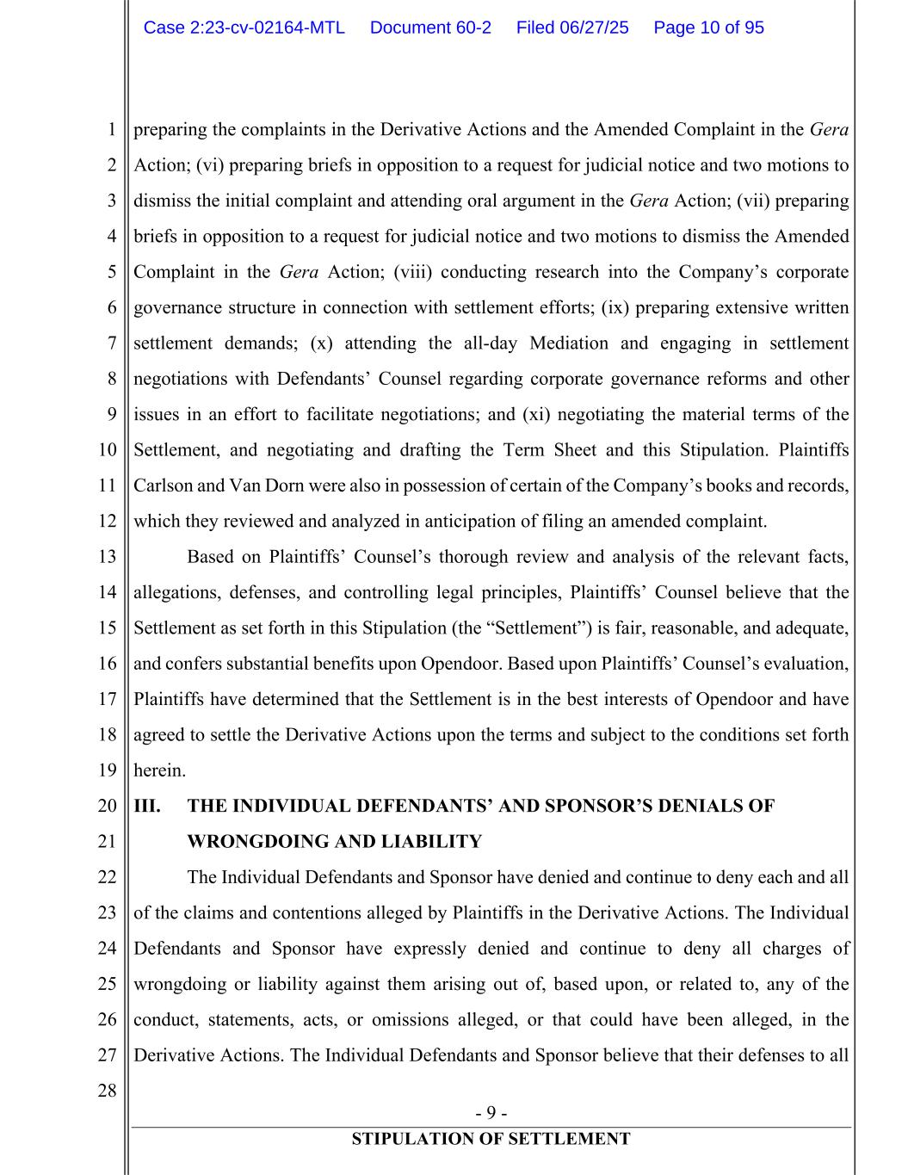
- 9 - STIPULATION OF SETTLEMENT 1 2 3 4 5 6 7 8 9 10 11 12 13 14 15 16 17 18 19 20 21 22 23 24 25 26 27 28 preparing the complaints in the Derivative Actions and the Amended Complaint in the Gera Action; (vi) preparing briefs in opposition to a request for judicial notice and two motions to dismiss the initial complaint and attending oral argument in the Gera Action; (vii) preparing briefs in opposition to a request for judicial notice and two motions to dismiss the Amended Complaint in the Gera Action; (viii) conducting research into the Company’s corporate governance structure in connection with settlement efforts; (ix) preparing extensive written settlement demands; (x) attending the all-day Mediation and engaging in settlement negotiations with Defendants’ Counsel regarding corporate governance reforms and other issues in an effort to facilitate negotiations; and (xi) negotiating the material terms of the Settlement, and negotiating and drafting the Term Sheet and this Stipulation. Plaintiffs Carlson and Van Dorn were also in possession of certain of the Company’s books and records, which they reviewed and analyzed in anticipation of filing an amended complaint. Based on Plaintiffs’ Counsel’s thorough review and analysis of the relevant facts, allegations, defenses, and controlling legal principles, Plaintiffs’ Counsel believe that the Settlement as set forth in this Stipulation (the “Settlement”) is fair, reasonable, and adequate, and confers substantial benefits upon Opendoor. Based upon Plaintiffs’ Counsel’s evaluation, Plaintiffs have determined that the Settlement is in the best interests of Opendoor and have agreed to settle the Derivative Actions upon the terms and subject to the conditions set forth herein. III. THE INDIVIDUAL DEFENDANTS’ AND SPONSOR’S DENIALS OF WRONGDOING AND LIABILITY The Individual Defendants and Sponsor have denied and continue to deny each and all of the claims and contentions alleged by Plaintiffs in the Derivative Actions. The Individual Defendants and Sponsor have expressly denied and continue to deny all charges of wrongdoing or liability against them arising out of, based upon, or related to, any of the conduct, statements, acts, or omissions alleged, or that could have been alleged, in the Derivative Actions. The Individual Defendants and Sponsor believe that their defenses to all Case 2:23-cv-02164-MTL Document 60-2 Filed 06/27/25 Page 10 of 95

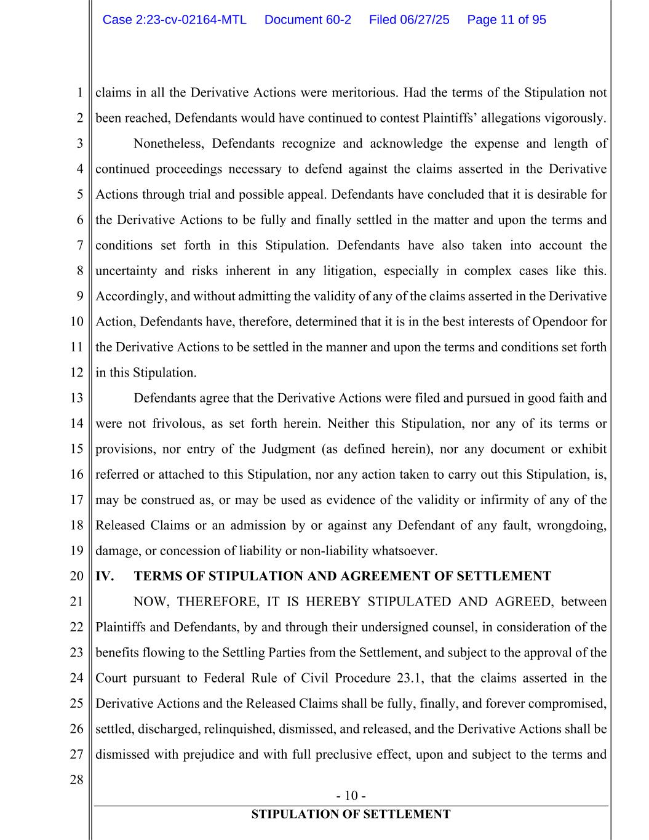
- 10 - STIPULATION OF SETTLEMENT 1 2 3 4 5 6 7 8 9 10 11 12 13 14 15 16 17 18 19 20 21 22 23 24 25 26 27 28 claims in all the Derivative Actions were meritorious. Had the terms of the Stipulation not been reached, Defendants would have continued to contest Plaintiffs’ allegations vigorously. Nonetheless, Defendants recognize and acknowledge the expense and length of continued proceedings necessary to defend against the claims asserted in the Derivative Actions through trial and possible appeal. Defendants have concluded that it is desirable for the Derivative Actions to be fully and finally settled in the matter and upon the terms and conditions set forth in this Stipulation. Defendants have also taken into account the uncertainty and risks inherent in any litigation, especially in complex cases like this. Accordingly, and without admitting the validity of any of the claims asserted in the Derivative Action, Defendants have, therefore, determined that it is in the best interests of Opendoor for the Derivative Actions to be settled in the manner and upon the terms and conditions set forth in this Stipulation. Defendants agree that the Derivative Actions were filed and pursued in good faith and were not frivolous, as set forth herein. Neither this Stipulation, nor any of its terms or provisions, nor entry of the Judgment (as defined herein), nor any document or exhibit referred or attached to this Stipulation, nor any action taken to carry out this Stipulation, is, may be construed as, or may be used as evidence of the validity or infirmity of any of the Released Claims or an admission by or against any Defendant of any fault, wrongdoing, damage, or concession of liability or non-liability whatsoever. IV. TERMS OF STIPULATION AND AGREEMENT OF SETTLEMENT NOW, THEREFORE, IT IS HEREBY STIPULATED AND AGREED, between Plaintiffs and Defendants, by and through their undersigned counsel, in consideration of the benefits flowing to the Settling Parties from the Settlement, and subject to the approval of the Court pursuant to Federal Rule of Civil Procedure 23.1, that the claims asserted in the Derivative Actions and the Released Claims shall be fully, finally, and forever compromised, settled, discharged, relinquished, dismissed, and released, and the Derivative Actions shall be dismissed with prejudice and with full preclusive effect, upon and subject to the terms and Case 2:23-cv-02164-MTL Document 60-2 Filed 06/27/25 Page 11 of 95

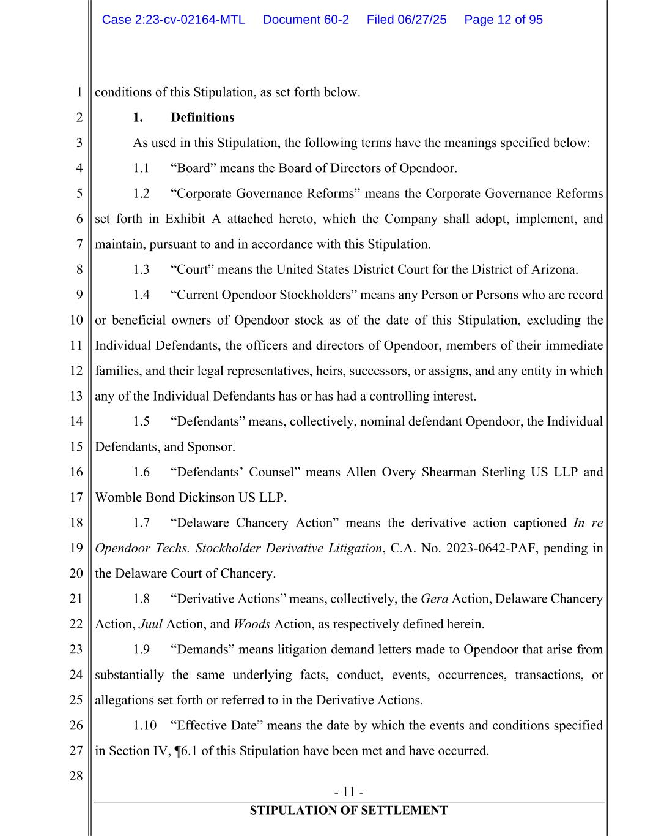
- 11 - STIPULATION OF SETTLEMENT 1 2 3 4 5 6 7 8 9 10 11 12 13 14 15 16 17 18 19 20 21 22 23 24 25 26 27 28 conditions of this Stipulation, as set forth below. 1. Definitions As used in this Stipulation, the following terms have the meanings specified below: 1.1 “Board” means the Board of Directors of Opendoor. 1.2 “Corporate Governance Reforms” means the Corporate Governance Reforms set forth in Exhibit A attached hereto, which the Company shall adopt, implement, and maintain, pursuant to and in accordance with this Stipulation. 1.3 “Court” means the United States District Court for the District of Arizona. 1.4 “Current Opendoor Stockholders” means any Person or Persons who are record or beneficial owners of Opendoor stock as of the date of this Stipulation, excluding the Individual Defendants, the officers and directors of Opendoor, members of their immediate families, and their legal representatives, heirs, successors, or assigns, and any entity in which any of the Individual Defendants has or has had a controlling interest. 1.5 “Defendants” means, collectively, nominal defendant Opendoor, the Individual Defendants, and Sponsor. 1.6 “Defendants’ Counsel” means Allen Overy Shearman Sterling US LLP and Womble Bond Dickinson US LLP. 1.7 “Delaware Chancery Action” means the derivative action captioned In re Opendoor Techs. Stockholder Derivative Litigation, C.A. No. 2023-0642-PAF, pending in the Delaware Court of Chancery. 1.8 “Derivative Actions” means, collectively, the Gera Action, Delaware Chancery Action, Juul Action, and Woods Action, as respectively defined herein. 1.9 “Demands” means litigation demand letters made to Opendoor that arise from substantially the same underlying facts, conduct, events, occurrences, transactions, or allegations set forth or referred to in the Derivative Actions. 1.10 “Effective Date” means the date by which the events and conditions specified in Section IV, ¶6.1 of this Stipulation have been met and have occurred. Case 2:23-cv-02164-MTL Document 60-2 Filed 06/27/25 Page 12 of 95

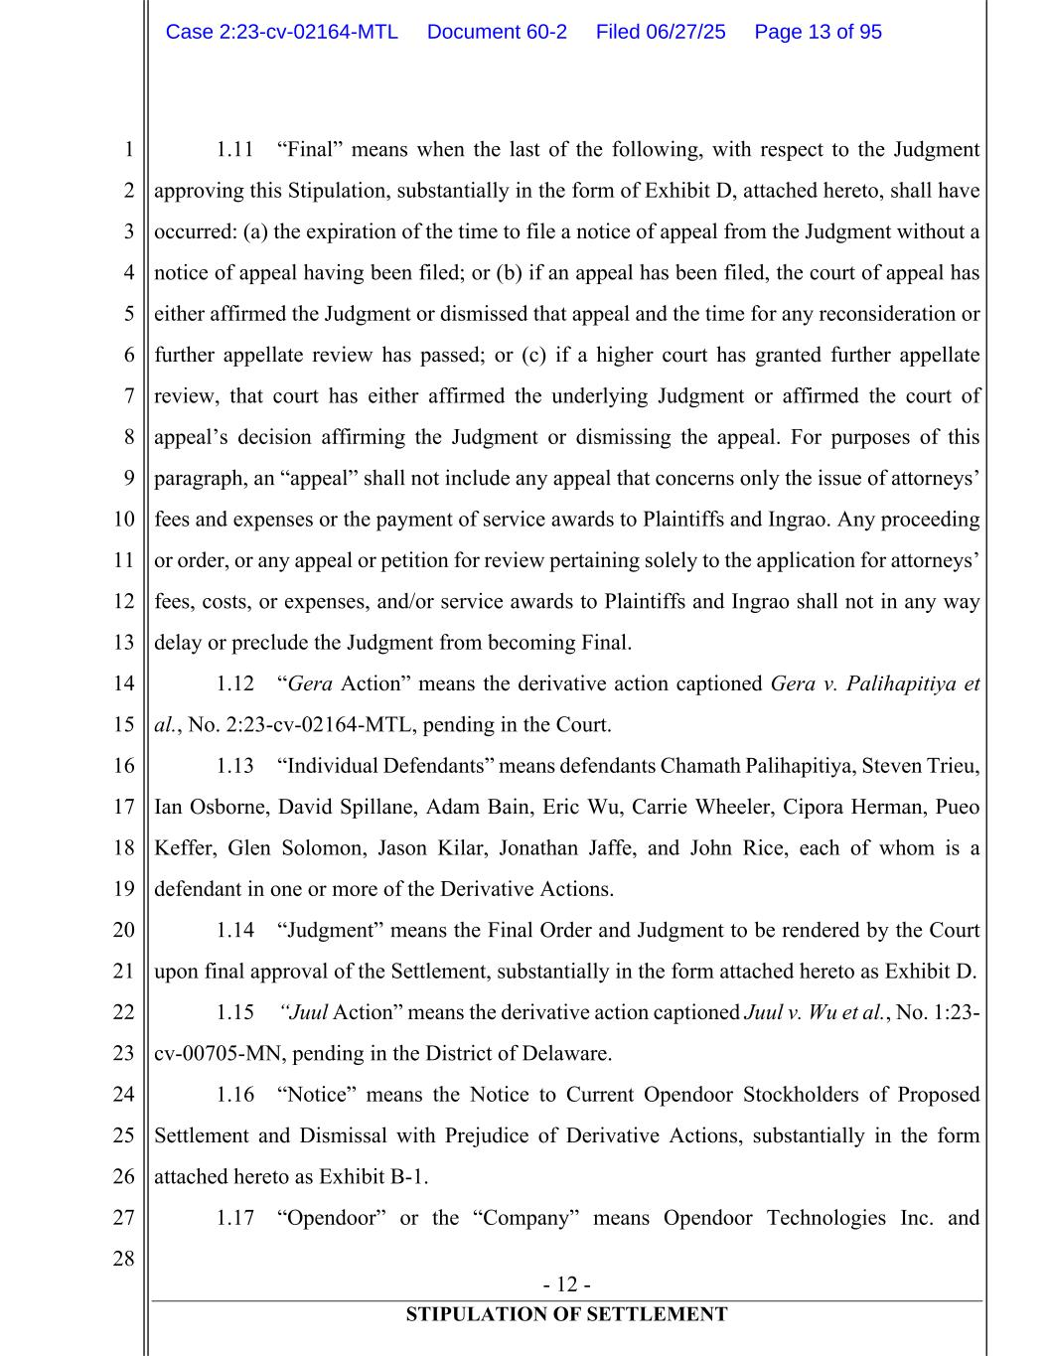
- 12 - STIPULATION OF SETTLEMENT 1 2 3 4 5 6 7 8 9 10 11 12 13 14 15 16 17 18 19 20 21 22 23 24 25 26 27 28 1.11 “Final” means when the last of the following, with respect to the Judgment approving this Stipulation, substantially in the form of Exhibit D, attached hereto, shall have occurred: (a) the expiration of the time to file a notice of appeal from the Judgment without a notice of appeal having been filed; or (b) if an appeal has been filed, the court of appeal has either affirmed the Judgment or dismissed that appeal and the time for any reconsideration or further appellate review has passed; or (c) if a higher court has granted further appellate review, that court has either affirmed the underlying Judgment or affirmed the court of appeal’s decision affirming the Judgment or dismissing the appeal. For purposes of this paragraph, an “appeal” shall not include any appeal that concerns only the issue of attorneys’ fees and expenses or the payment of service awards to Plaintiffs and Ingrao. Any proceeding or order, or any appeal or petition for review pertaining solely to the application for attorneys’ fees, costs, or expenses, and/or service awards to Plaintiffs and Ingrao shall not in any way delay or preclude the Judgment from becoming Final. 1.12 “Gera Action” means the derivative action captioned Gera v. Palihapitiya et al., No. 2:23-cv-02164-MTL, pending in the Court. 1.13 “Individual Defendants” means defendants Chamath Palihapitiya, Steven Trieu, Ian Osborne, David Spillane, Adam Bain, Eric Wu, Carrie Wheeler, Cipora Herman, Pueo Keffer, Glen Solomon, Jason Kilar, Jonathan Jaffe, and John Rice, each of whom is a defendant in one or more of the Derivative Actions. 1.14 “Judgment” means the Final Order and Judgment to be rendered by the Court upon final approval of the Settlement, substantially in the form attached hereto as Exhibit D. 1.15 “Juul Action” means the derivative action captioned Juul v. Wu et al., No. 1:23- cv-00705-MN, pending in the District of Delaware. 1.16 “Notice” means the Notice to Current Opendoor Stockholders of Proposed Settlement and Dismissal with Prejudice of Derivative Actions, substantially in the form attached hereto as Exhibit B-1. 1.17 “Opendoor” or the “Company” means Opendoor Technologies Inc. and Case 2:23-cv-02164-MTL Document 60-2 Filed 06/27/25 Page 13 of 95

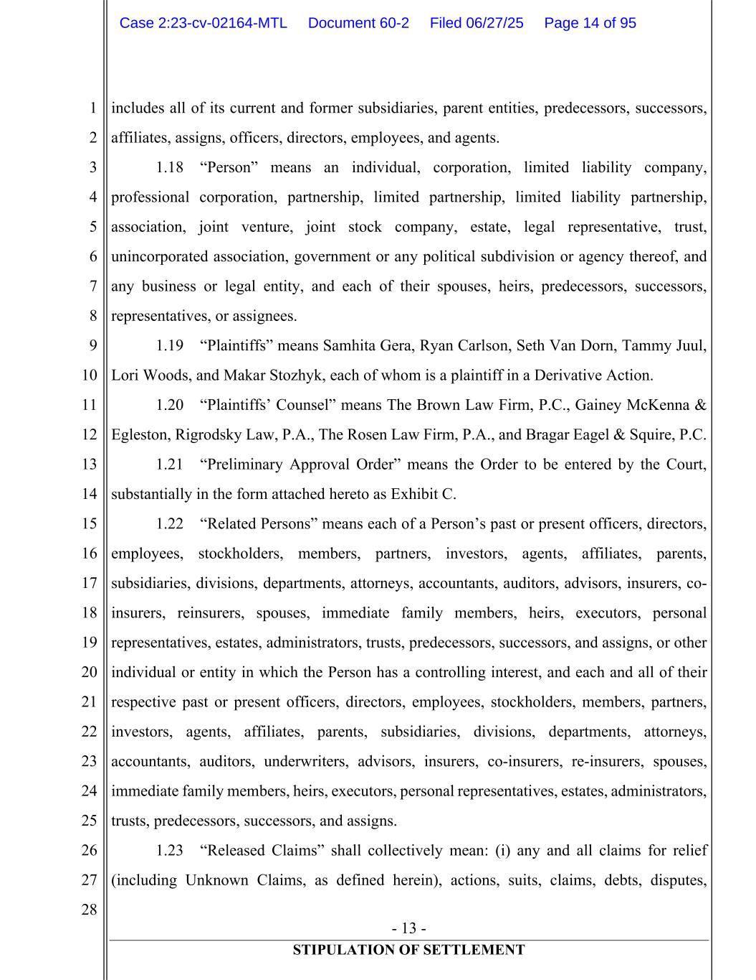
- 13 - STIPULATION OF SETTLEMENT 1 2 3 4 5 6 7 8 9 10 11 12 13 14 15 16 17 18 19 20 21 22 23 24 25 26 27 28 includes all of its current and former subsidiaries, parent entities, predecessors, successors, affiliates, assigns, officers, directors, employees, and agents. 1.18 “Person” means an individual, corporation, limited liability company, professional corporation, partnership, limited partnership, limited liability partnership, association, joint venture, joint stock company, estate, legal representative, trust, unincorporated association, government or any political subdivision or agency thereof, and any business or legal entity, and each of their spouses, heirs, predecessors, successors, representatives, or assignees. 1.19 “Plaintiffs” means Samhita Gera, Ryan Carlson, Seth Van Dorn, Tammy Juul, Lori Woods, and Makar Stozhyk, each of whom is a plaintiff in a Derivative Action. 1.20 “Plaintiffs’ Counsel” means The Brown Law Firm, P.C., Gainey McKenna & Egleston, Rigrodsky Law, P.A., The Rosen Law Firm, P.A., and Bragar Eagel & Squire, P.C. 1.21 “Preliminary Approval Order” means the Order to be entered by the Court, substantially in the form attached hereto as Exhibit C. 1.22 “Related Persons” means each of a Person’s past or present officers, directors, employees, stockholders, members, partners, investors, agents, affiliates, parents, subsidiaries, divisions, departments, attorneys, accountants, auditors, advisors, insurers, co- insurers, reinsurers, spouses, immediate family members, heirs, executors, personal representatives, estates, administrators, trusts, predecessors, successors, and assigns, or other individual or entity in which the Person has a controlling interest, and each and all of their respective past or present officers, directors, employees, stockholders, members, partners, investors, agents, affiliates, parents, subsidiaries, divisions, departments, attorneys, accountants, auditors, underwriters, advisors, insurers, co-insurers, re-insurers, spouses, immediate family members, heirs, executors, personal representatives, estates, administrators, trusts, predecessors, successors, and assigns. 1.23 “Released Claims” shall collectively mean: (i) any and all claims for relief (including Unknown Claims, as defined herein), actions, suits, claims, debts, disputes, Case 2:23-cv-02164-MTL Document 60-2 Filed 06/27/25 Page 14 of 95

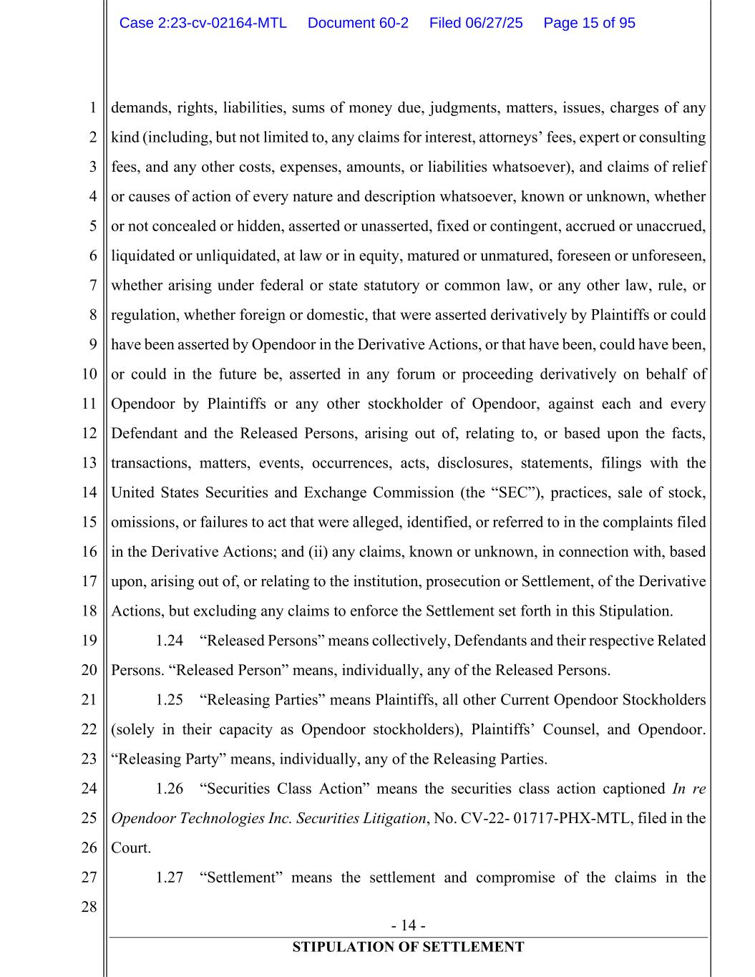
- 14 - STIPULATION OF SETTLEMENT 1 2 3 4 5 6 7 8 9 10 11 12 13 14 15 16 17 18 19 20 21 22 23 24 25 26 27 28 demands, rights, liabilities, sums of money due, judgments, matters, issues, charges of any kind (including, but not limited to, any claims for interest, attorneys’ fees, expert or consulting fees, and any other costs, expenses, amounts, or liabilities whatsoever), and claims of relief or causes of action of every nature and description whatsoever, known or unknown, whether or not concealed or hidden, asserted or unasserted, fixed or contingent, accrued or unaccrued, liquidated or unliquidated, at law or in equity, matured or unmatured, foreseen or unforeseen, whether arising under federal or state statutory or common law, or any other law, rule, or regulation, whether foreign or domestic, that were asserted derivatively by Plaintiffs or could have been asserted by Opendoor in the Derivative Actions, or that have been, could have been, or could in the future be, asserted in any forum or proceeding derivatively on behalf of Opendoor by Plaintiffs or any other stockholder of Opendoor, against each and every Defendant and the Released Persons, arising out of, relating to, or based upon the facts, transactions, matters, events, occurrences, acts, disclosures, statements, filings with the United States Securities and Exchange Commission (the “SEC”), practices, sale of stock, omissions, or failures to act that were alleged, identified, or referred to in the complaints filed in the Derivative Actions; and (ii) any claims, known or unknown, in connection with, based upon, arising out of, or relating to the institution, prosecution or Settlement, of the Derivative Actions, but excluding any claims to enforce the Settlement set forth in this Stipulation. 1.24 “Released Persons” means collectively, Defendants and their respective Related Persons. “Released Person” means, individually, any of the Released Persons. 1.25 “Releasing Parties” means Plaintiffs, all other Current Opendoor Stockholders (solely in their capacity as Opendoor stockholders), Plaintiffs’ Counsel, and Opendoor. “Releasing Party” means, individually, any of the Releasing Parties. 1.26 “Securities Class Action” means the securities class action captioned In re Opendoor Technologies Inc. Securities Litigation, No. CV-22- 01717-PHX-MTL, filed in the Court. 1.27 “Settlement” means the settlement and compromise of the claims in the Case 2:23-cv-02164-MTL Document 60-2 Filed 06/27/25 Page 15 of 95

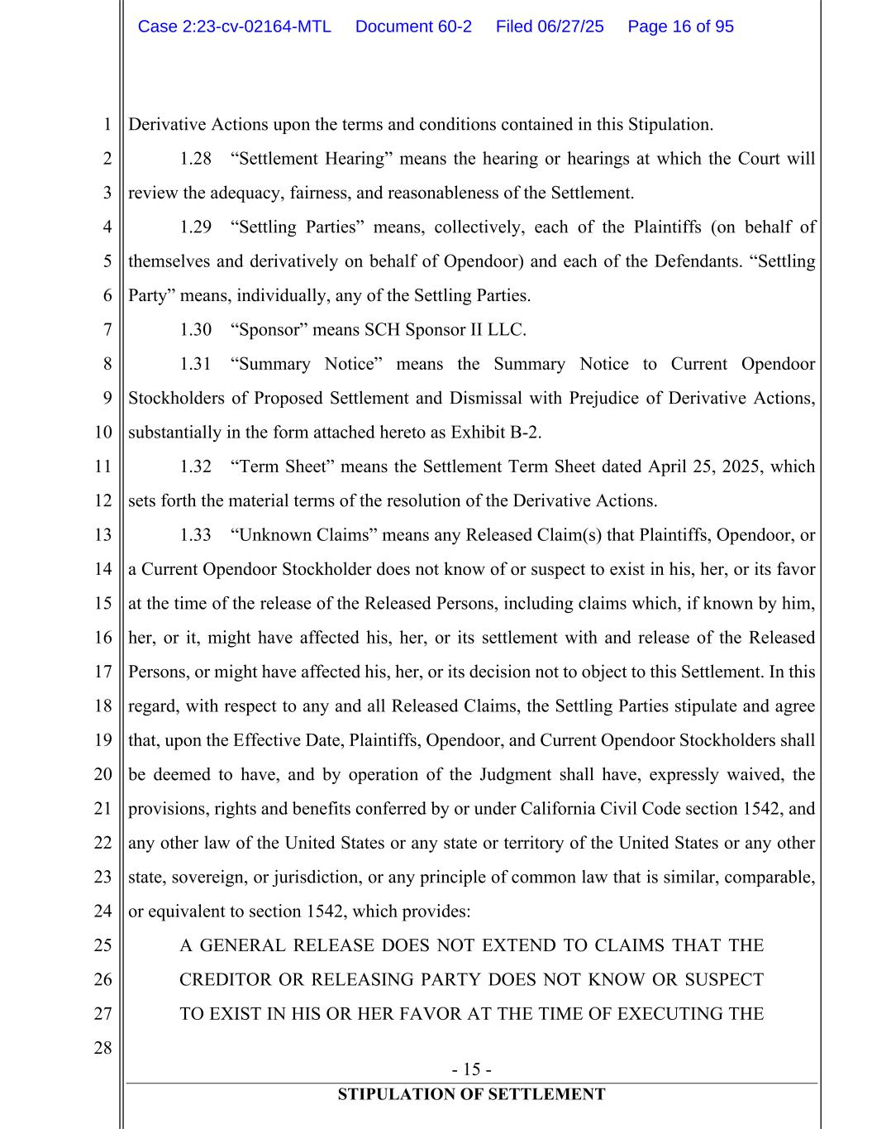
- 15 - STIPULATION OF SETTLEMENT 1 2 3 4 5 6 7 8 9 10 11 12 13 14 15 16 17 18 19 20 21 22 23 24 25 26 27 28 Derivative Actions upon the terms and conditions contained in this Stipulation. 1.28 “Settlement Hearing” means the hearing or hearings at which the Court will review the adequacy, fairness, and reasonableness of the Settlement. 1.29 “Settling Parties” means, collectively, each of the Plaintiffs (on behalf of themselves and derivatively on behalf of Opendoor) and each of the Defendants. “Settling Party” means, individually, any of the Settling Parties. 1.30 “Sponsor” means SCH Sponsor II LLC. 1.31 “Summary Notice” means the Summary Notice to Current Opendoor Stockholders of Proposed Settlement and Dismissal with Prejudice of Derivative Actions, substantially in the form attached hereto as Exhibit B-2. 1.32 “Term Sheet” means the Settlement Term Sheet dated April 25, 2025, which sets forth the material terms of the resolution of the Derivative Actions. 1.33 “Unknown Claims” means any Released Claim(s) that Plaintiffs, Opendoor, or a Current Opendoor Stockholder does not know of or suspect to exist in his, her, or its favor at the time of the release of the Released Persons, including claims which, if known by him, her, or it, might have affected his, her, or its settlement with and release of the Released Persons, or might have affected his, her, or its decision not to object to this Settlement. In this regard, with respect to any and all Released Claims, the Settling Parties stipulate and agree that, upon the Effective Date, Plaintiffs, Opendoor, and Current Opendoor Stockholders shall be deemed to have, and by operation of the Judgment shall have, expressly waived, the provisions, rights and benefits conferred by or under California Civil Code section 1542, and any other law of the United States or any state or territory of the United States or any other state, sovereign, or jurisdiction, or any principle of common law that is similar, comparable, or equivalent to section 1542, which provides: A GENERAL RELEASE DOES NOT EXTEND TO CLAIMS THAT THE CREDITOR OR RELEASING PARTY DOES NOT KNOW OR SUSPECT TO EXIST IN HIS OR HER FAVOR AT THE TIME OF EXECUTING THE Case 2:23-cv-02164-MTL Document 60-2 Filed 06/27/25 Page 16 of 95

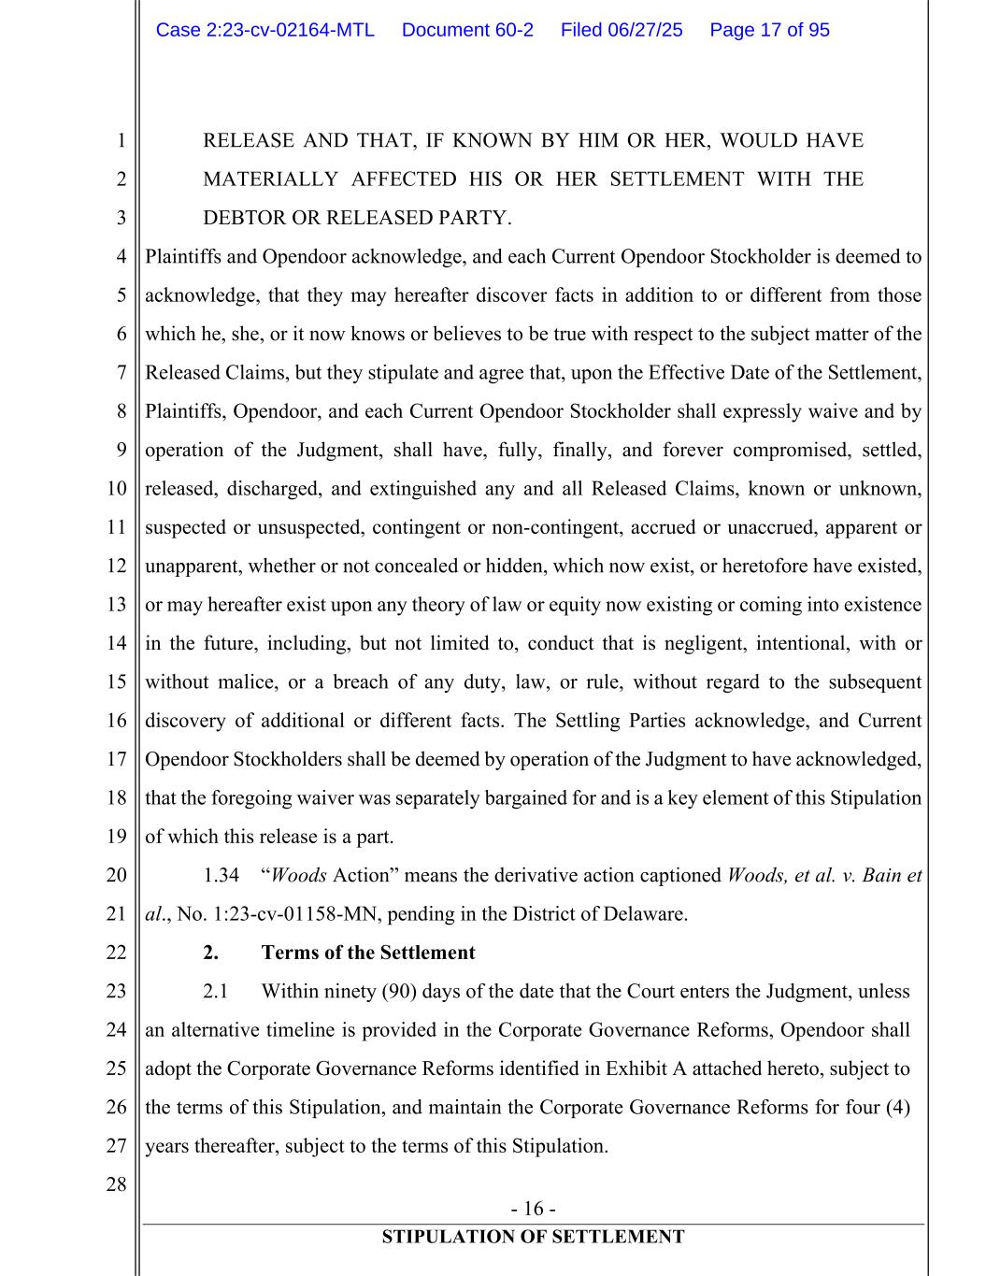
- 16 - STIPULATION OF SETTLEMENT 1 2 3 4 5 6 7 8 9 10 11 12 13 14 15 16 17 18 19 20 21 22 23 24 25 26 27 28 RELEASE AND THAT, IF KNOWN BY HIM OR HER, WOULD HAVE MATERIALLY AFFECTED HIS OR HER SETTLEMENT WITH THE DEBTOR OR RELEASED PARTY. Plaintiffs and Opendoor acknowledge, and each Current Opendoor Stockholder is deemed to acknowledge, that they may hereafter discover facts in addition to or different from those which he, she, or it now knows or believes to be true with respect to the subject matter of the Released Claims, but they stipulate and agree that, upon the Effective Date of the Settlement, Plaintiffs, Opendoor, and each Current Opendoor Stockholder shall expressly waive and by operation of the Judgment, shall have, fully, finally, and forever compromised, settled, released, discharged, and extinguished any and all Released Claims, known or unknown, suspected or unsuspected, contingent or non-contingent, accrued or unaccrued, apparent or unapparent, whether or not concealed or hidden, which now exist, or heretofore have existed, or may hereafter exist upon any theory of law or equity now existing or coming into existence in the future, including, but not limited to, conduct that is negligent, intentional, with or without malice, or a breach of any duty, law, or rule, without regard to the subsequent discovery of additional or different facts. The Settling Parties acknowledge, and Current Opendoor Stockholders shall be deemed by operation of the Judgment to have acknowledged, that the foregoing waiver was separately bargained for and is a key element of this Stipulation of which this release is a part. 1.34 “Woods Action” means the derivative action captioned Woods, et al. v. Bain et al., No. 1:23-cv-01158-MN, pending in the District of Delaware. 2. Terms of the Settlement 2.1 Within ninety (90) days of the date that the Court enters the Judgment, unless an alternative timeline is provided in the Corporate Governance Reforms, Opendoor shall adopt the Corporate Governance Reforms identified in Exhibit A attached hereto, subject to the terms of this Stipulation, and maintain the Corporate Governance Reforms for four (4) years thereafter, subject to the terms of this Stipulation. Case 2:23-cv-02164-MTL Document 60-2 Filed 06/27/25 Page 17 of 95

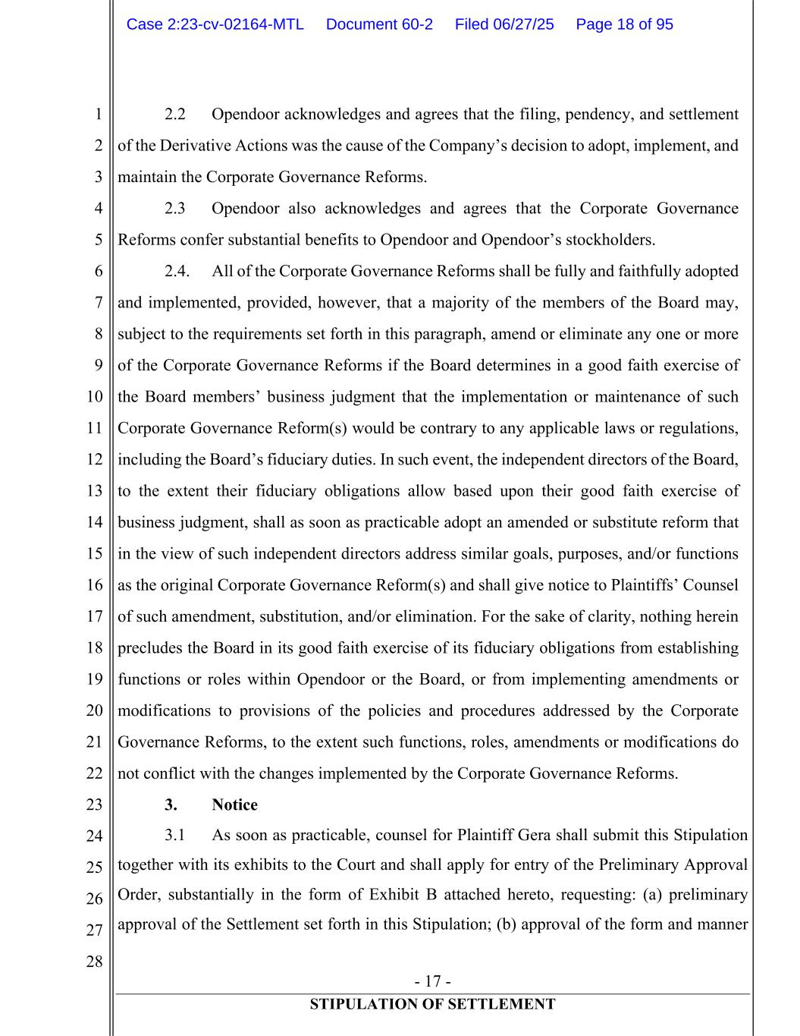
- 17 - STIPULATION OF SETTLEMENT 1 2 3 4 5 6 7 8 9 10 11 12 13 14 15 16 17 18 19 20 21 22 23 24 25 26 27 28 2.2 Opendoor acknowledges and agrees that the filing, pendency, and settlement of the Derivative Actions was the cause of the Company’s decision to adopt, implement, and maintain the Corporate Governance Reforms. 2.3 Opendoor also acknowledges and agrees that the Corporate Governance Reforms confer substantial benefits to Opendoor and Opendoor’s stockholders. 2.4. All of the Corporate Governance Reforms shall be fully and faithfully adopted and implemented, provided, however, that a majority of the members of the Board may, subject to the requirements set forth in this paragraph, amend or eliminate any one or more of the Corporate Governance Reforms if the Board determines in a good faith exercise of the Board members’ business judgment that the implementation or maintenance of such Corporate Governance Reform(s) would be contrary to any applicable laws or regulations, including the Board’s fiduciary duties. In such event, the independent directors of the Board, to the extent their fiduciary obligations allow based upon their good faith exercise of business judgment, shall as soon as practicable adopt an amended or substitute reform that in the view of such independent directors address similar goals, purposes, and/or functions as the original Corporate Governance Reform(s) and shall give notice to Plaintiffs’ Counsel of such amendment, substitution, and/or elimination. For the sake of clarity, nothing herein precludes the Board in its good faith exercise of its fiduciary obligations from establishing functions or roles within Opendoor or the Board, or from implementing amendments or modifications to provisions of the policies and procedures addressed by the Corporate Governance Reforms, to the extent such functions, roles, amendments or modifications do not conflict with the changes implemented by the Corporate Governance Reforms. 3. Notice 3.1 As soon as practicable, counsel for Plaintiff Gera shall submit this Stipulation together with its exhibits to the Court and shall apply for entry of the Preliminary Approval Order, substantially in the form of Exhibit B attached hereto, requesting: (a) preliminary approval of the Settlement set forth in this Stipulation; (b) approval of the form and manner Case 2:23-cv-02164-MTL Document 60-2 Filed 06/27/25 Page 18 of 95

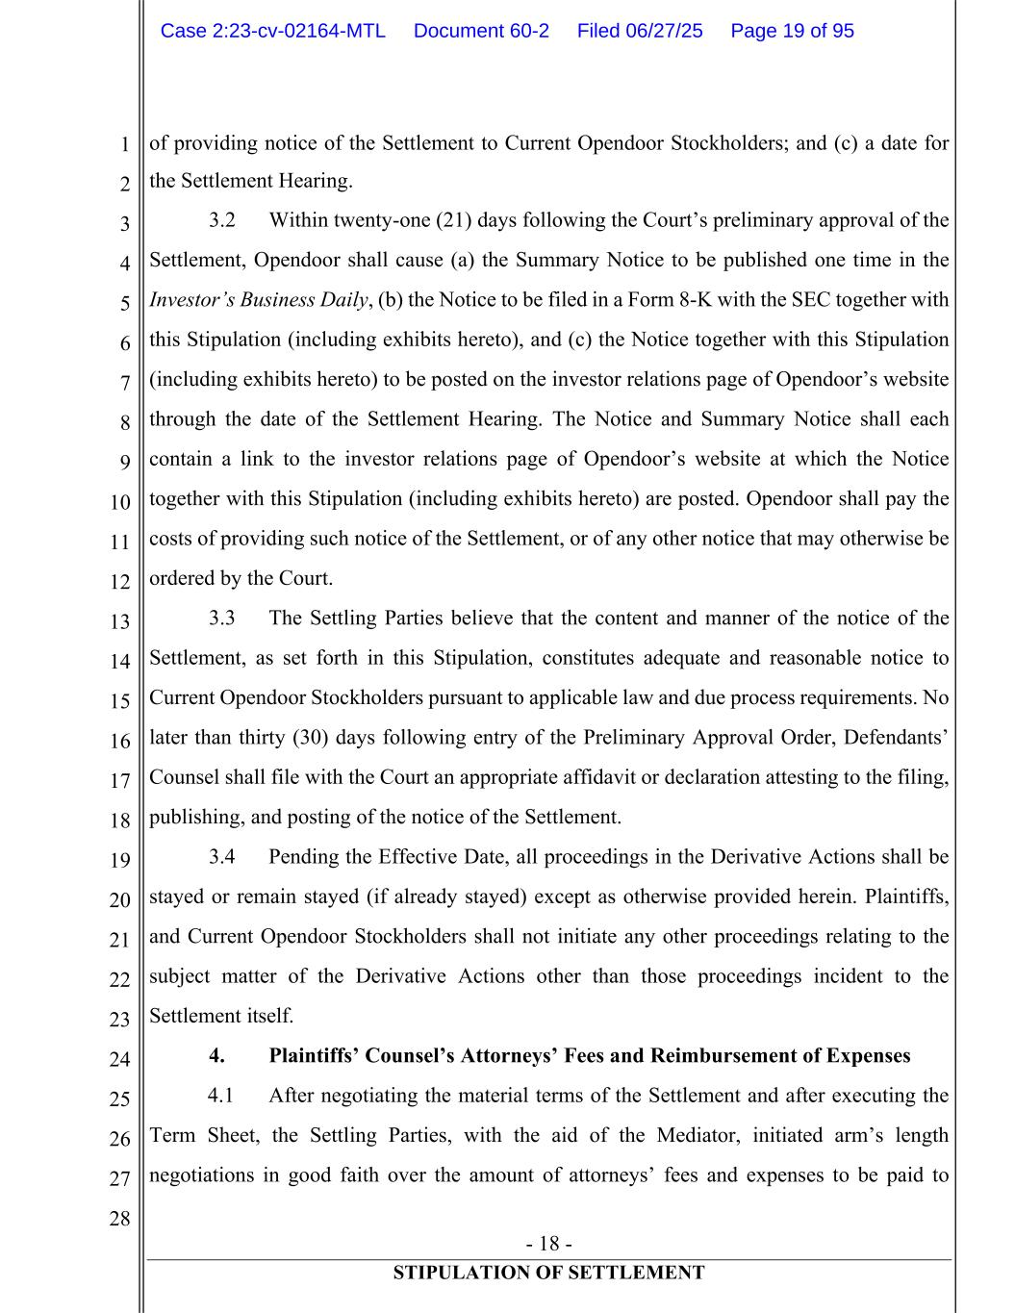
- 18 - STIPULATION OF SETTLEMENT 1 2 3 4 5 6 7 8 9 10 11 12 13 14 15 16 17 18 19 20 21 22 23 24 25 26 27 28 of providing notice of the Settlement to Current Opendoor Stockholders; and (c) a date for the Settlement Hearing. 3.2 Within twenty-one (21) days following the Court’s preliminary approval of the Settlement, Opendoor shall cause (a) the Summary Notice to be published one time in the Investor’s Business Daily, (b) the Notice to be filed in a Form 8-K with the SEC together with this Stipulation (including exhibits hereto), and (c) the Notice together with this Stipulation (including exhibits hereto) to be posted on the investor relations page of Opendoor’s website through the date of the Settlement Hearing. The Notice and Summary Notice shall each contain a link to the investor relations page of Opendoor’s website at which the Notice together with this Stipulation (including exhibits hereto) are posted. Opendoor shall pay the costs of providing such notice of the Settlement, or of any other notice that may otherwise be ordered by the Court. 3.3 The Settling Parties believe that the content and manner of the notice of the Settlement, as set forth in this Stipulation, constitutes adequate and reasonable notice to Current Opendoor Stockholders pursuant to applicable law and due process requirements. No later than thirty (30) days following entry of the Preliminary Approval Order, Defendants’ Counsel shall file with the Court an appropriate affidavit or declaration attesting to the filing, publishing, and posting of the notice of the Settlement. 3.4 Pending the Effective Date, all proceedings in the Derivative Actions shall be stayed or remain stayed (if already stayed) except as otherwise provided herein. Plaintiffs, and Current Opendoor Stockholders shall not initiate any other proceedings relating to the subject matter of the Derivative Actions other than those proceedings incident to the Settlement itself. 4. Plaintiffs’ Counsel’s Attorneys’ Fees and Reimbursement of Expenses 4.1 After negotiating the material terms of the Settlement and after executing the Term Sheet, the Settling Parties, with the aid of the Mediator, initiated arm’s length negotiations in good faith over the amount of attorneys’ fees and expenses to be paid to Case 2:23-cv-02164-MTL Document 60-2 Filed 06/27/25 Page 19 of 95

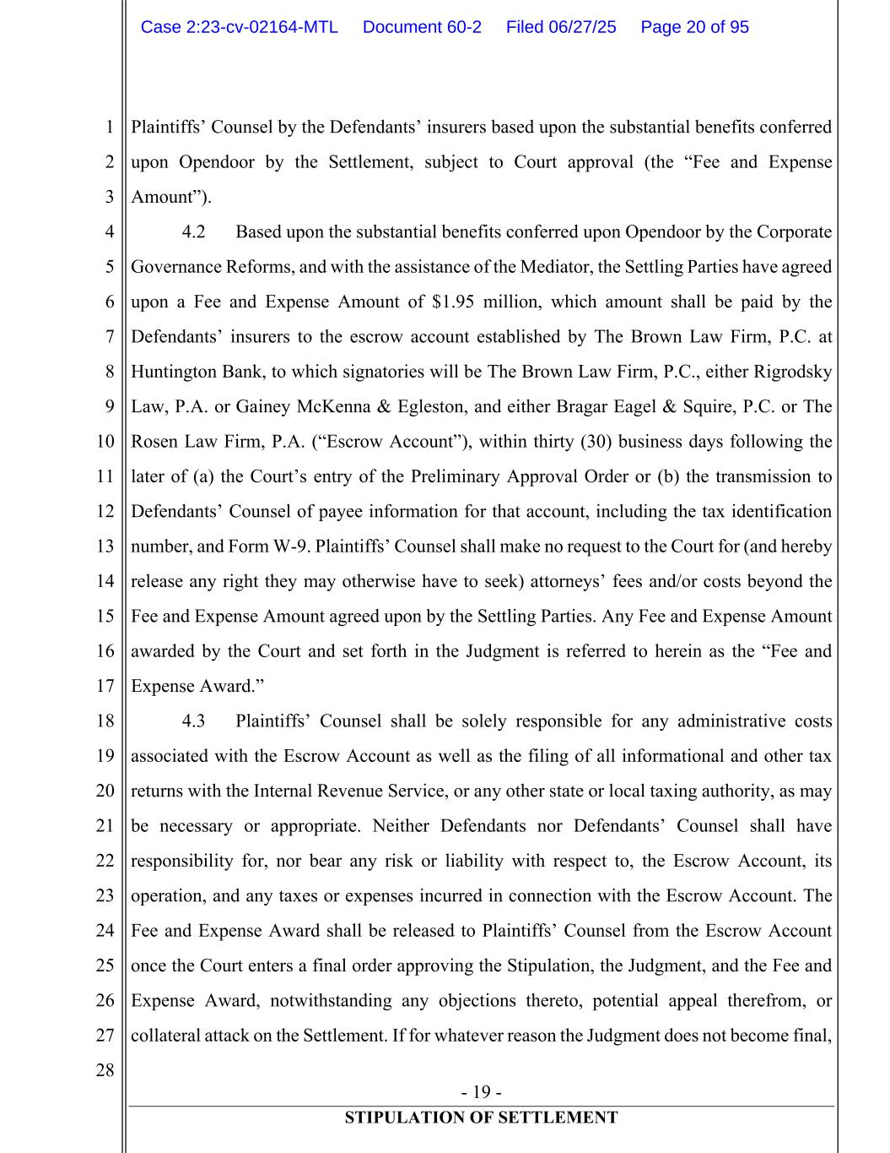
- 19 - STIPULATION OF SETTLEMENT 1 2 3 4 5 6 7 8 9 10 11 12 13 14 15 16 17 18 19 20 21 22 23 24 25 26 27 28 Plaintiffs’ Counsel by the Defendants’ insurers based upon the substantial benefits conferred upon Opendoor by the Settlement, subject to Court approval (the “Fee and Expense Amount”). 4.2 Based upon the substantial benefits conferred upon Opendoor by the Corporate Governance Reforms, and with the assistance of the Mediator, the Settling Parties have agreed upon a Fee and Expense Amount of $1.95 million, which amount shall be paid by the Defendants’ insurers to the escrow account established by The Brown Law Firm, P.C. at Huntington Bank, to which signatories will be The Brown Law Firm, P.C., either Rigrodsky Law, P.A. or Gainey McKenna & Egleston, and either Bragar Eagel & Squire, P.C. or The Rosen Law Firm, P.A. (“Escrow Account”), within thirty (30) business days following the later of (a) the Court’s entry of the Preliminary Approval Order or (b) the transmission to Defendants’ Counsel of payee information for that account, including the tax identification number, and Form W-9. Plaintiffs’ Counsel shall make no request to the Court for (and hereby release any right they may otherwise have to seek) attorneys’ fees and/or costs beyond the Fee and Expense Amount agreed upon by the Settling Parties. Any Fee and Expense Amount awarded by the Court and set forth in the Judgment is referred to herein as the “Fee and Expense Award.” 4.3 Plaintiffs’ Counsel shall be solely responsible for any administrative costs associated with the Escrow Account as well as the filing of all informational and other tax returns with the Internal Revenue Service, or any other state or local taxing authority, as may be necessary or appropriate. Neither Defendants nor Defendants’ Counsel shall have responsibility for, nor bear any risk or liability with respect to, the Escrow Account, its operation, and any taxes or expenses incurred in connection with the Escrow Account. The Fee and Expense Award shall be released to Plaintiffs’ Counsel from the Escrow Account once the Court enters a final order approving the Stipulation, the Judgment, and the Fee and Expense Award, notwithstanding any objections thereto, potential appeal therefrom, or collateral attack on the Settlement. If for whatever reason the Judgment does not become final, Case 2:23-cv-02164-MTL Document 60-2 Filed 06/27/25 Page 20 of 95

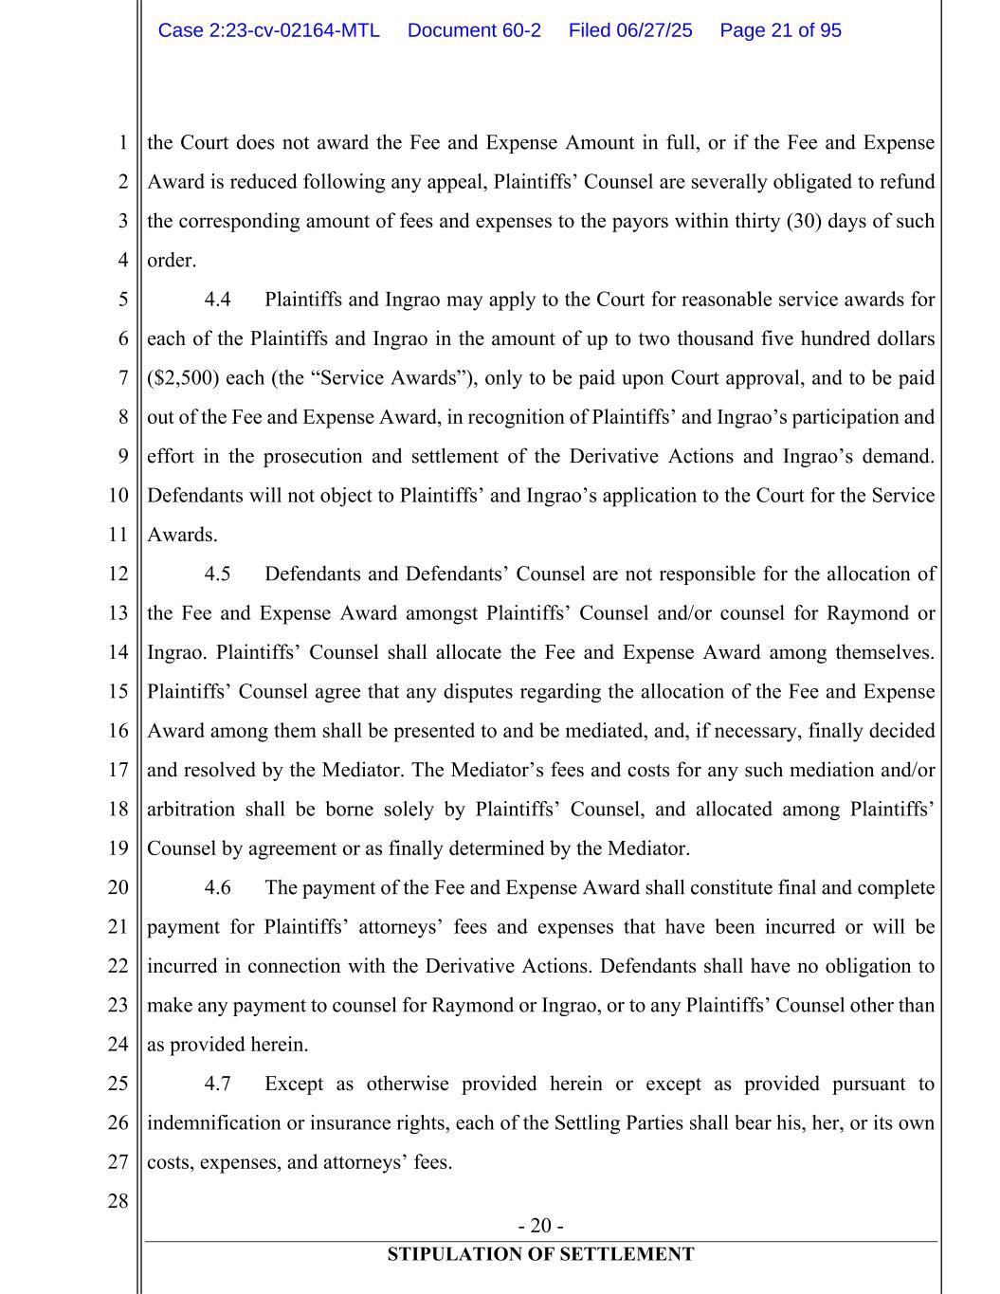
- 20 - STIPULATION OF SETTLEMENT 1 2 3 4 5 6 7 8 9 10 11 12 13 14 15 16 17 18 19 20 21 22 23 24 25 26 27 28 the Court does not award the Fee and Expense Amount in full, or if the Fee and Expense Award is reduced following any appeal, Plaintiffs’ Counsel are severally obligated to refund the corresponding amount of fees and expenses to the payors within thirty (30) days of such order. 4.4 Plaintiffs and Ingrao may apply to the Court for reasonable service awards for each of the Plaintiffs and Ingrao in the amount of up to two thousand five hundred dollars ($2,500) each (the “Service Awards”), only to be paid upon Court approval, and to be paid out of the Fee and Expense Award, in recognition of Plaintiffs’ and Ingrao’s participation and effort in the prosecution and settlement of the Derivative Actions and Ingrao’s demand. Defendants will not object to Plaintiffs’ and Ingrao’s application to the Court for the Service Awards. 4.5 Defendants and Defendants’ Counsel are not responsible for the allocation of the Fee and Expense Award amongst Plaintiffs’ Counsel and/or counsel for Raymond or Ingrao. Plaintiffs’ Counsel shall allocate the Fee and Expense Award among themselves. Plaintiffs’ Counsel agree that any disputes regarding the allocation of the Fee and Expense Award among them shall be presented to and be mediated, and, if necessary, finally decided and resolved by the Mediator. The Mediator’s fees and costs for any such mediation and/or arbitration shall be borne solely by Plaintiffs’ Counsel, and allocated among Plaintiffs’ Counsel by agreement or as finally determined by the Mediator. 4.6 The payment of the Fee and Expense Award shall constitute final and complete payment for Plaintiffs’ attorneys’ fees and expenses that have been incurred or will be incurred in connection with the Derivative Actions. Defendants shall have no obligation to make any payment to counsel for Raymond or Ingrao, or to any Plaintiffs’ Counsel other than as provided herein. 4.7 Except as otherwise provided herein or except as provided pursuant to indemnification or insurance rights, each of the Settling Parties shall bear his, her, or its own costs, expenses, and attorneys’ fees. Case 2:23-cv-02164-MTL Document 60-2 Filed 06/27/25 Page 21 of 95

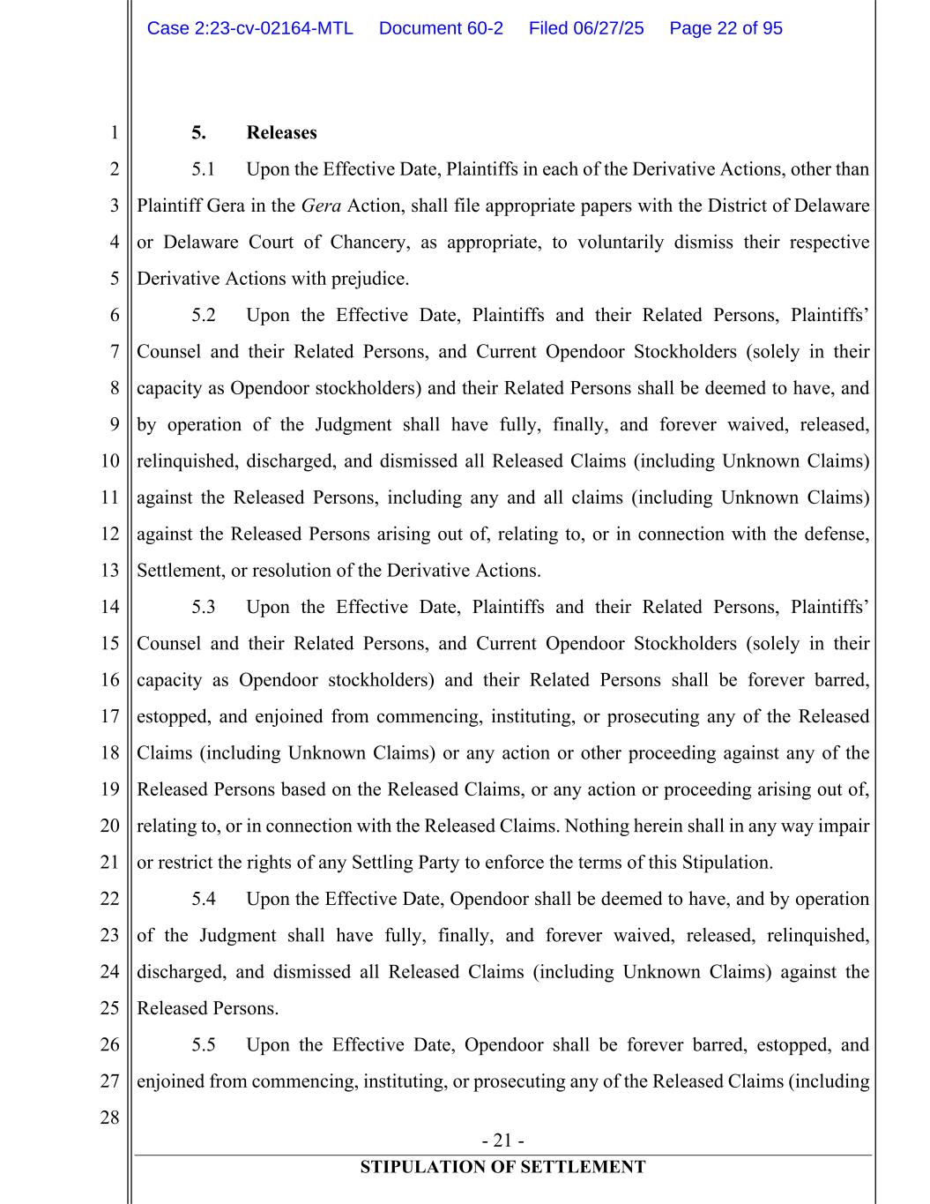
- 21 - STIPULATION OF SETTLEMENT 1 2 3 4 5 6 7 8 9 10 11 12 13 14 15 16 17 18 19 20 21 22 23 24 25 26 27 28 5. Releases 5.1 Upon the Effective Date, Plaintiffs in each of the Derivative Actions, other than Plaintiff Gera in the Gera Action, shall file appropriate papers with the District of Delaware or Delaware Court of Chancery, as appropriate, to voluntarily dismiss their respective Derivative Actions with prejudice. 5.2 Upon the Effective Date, Plaintiffs and their Related Persons, Plaintiffs’ Counsel and their Related Persons, and Current Opendoor Stockholders (solely in their capacity as Opendoor stockholders) and their Related Persons shall be deemed to have, and by operation of the Judgment shall have fully, finally, and forever waived, released, relinquished, discharged, and dismissed all Released Claims (including Unknown Claims) against the Released Persons, including any and all claims (including Unknown Claims) against the Released Persons arising out of, relating to, or in connection with the defense, Settlement, or resolution of the Derivative Actions. 5.3 Upon the Effective Date, Plaintiffs and their Related Persons, Plaintiffs’ Counsel and their Related Persons, and Current Opendoor Stockholders (solely in their capacity as Opendoor stockholders) and their Related Persons shall be forever barred, estopped, and enjoined from commencing, instituting, or prosecuting any of the Released Claims (including Unknown Claims) or any action or other proceeding against any of the Released Persons based on the Released Claims, or any action or proceeding arising out of, relating to, or in connection with the Released Claims. Nothing herein shall in any way impair or restrict the rights of any Settling Party to enforce the terms of this Stipulation. 5.4 Upon the Effective Date, Opendoor shall be deemed to have, and by operation of the Judgment shall have fully, finally, and forever waived, released, relinquished, discharged, and dismissed all Released Claims (including Unknown Claims) against the Released Persons. 5.5 Upon the Effective Date, Opendoor shall be forever barred, estopped, and enjoined from commencing, instituting, or prosecuting any of the Released Claims (including Case 2:23-cv-02164-MTL Document 60-2 Filed 06/27/25 Page 22 of 95

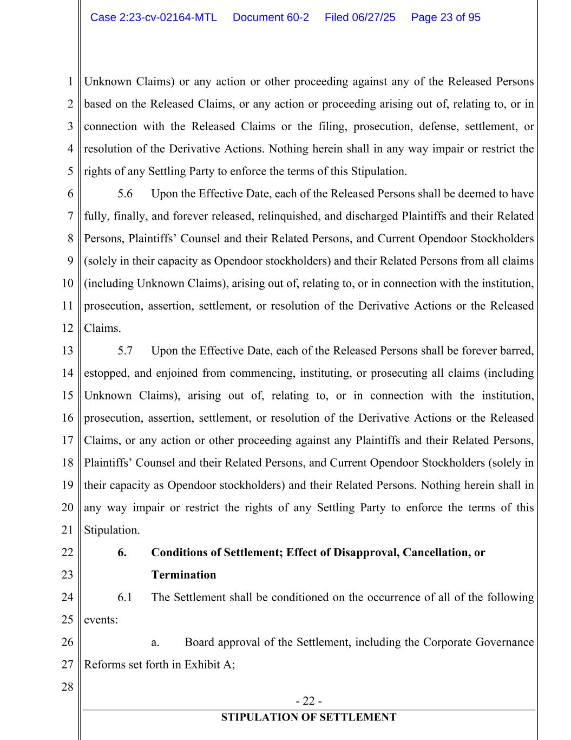
- 22 - STIPULATION OF SETTLEMENT 1 2 3 4 5 6 7 8 9 10 11 12 13 14 15 16 17 18 19 20 21 22 23 24 25 26 27 28 Unknown Claims) or any action or other proceeding against any of the Released Persons based on the Released Claims, or any action or proceeding arising out of, relating to, or in connection with the Released Claims or the filing, prosecution, defense, settlement, or resolution of the Derivative Actions. Nothing herein shall in any way impair or restrict the rights of any Settling Party to enforce the terms of this Stipulation. 5.6 Upon the Effective Date, each of the Released Persons shall be deemed to have fully, finally, and forever released, relinquished, and discharged Plaintiffs and their Related Persons, Plaintiffs’ Counsel and their Related Persons, and Current Opendoor Stockholders (solely in their capacity as Opendoor stockholders) and their Related Persons from all claims (including Unknown Claims), arising out of, relating to, or in connection with the institution, prosecution, assertion, settlement, or resolution of the Derivative Actions or the Released Claims. 5.7 Upon the Effective Date, each of the Released Persons shall be forever barred, estopped, and enjoined from commencing, instituting, or prosecuting all claims (including Unknown Claims), arising out of, relating to, or in connection with the institution, prosecution, assertion, settlement, or resolution of the Derivative Actions or the Released Claims, or any action or other proceeding against any Plaintiffs and their Related Persons, Plaintiffs’ Counsel and their Related Persons, and Current Opendoor Stockholders (solely in their capacity as Opendoor stockholders) and their Related Persons. Nothing herein shall in any way impair or restrict the rights of any Settling Party to enforce the terms of this Stipulation. 6. Conditions of Settlement; Effect of Disapproval, Cancellation, or Termination 6.1 The Settlement shall be conditioned on the occurrence of all of the following events: a. Board approval of the Settlement, including the Corporate Governance Reforms set forth in Exhibit A; Case 2:23-cv-02164-MTL Document 60-2 Filed 06/27/25 Page 23 of 95

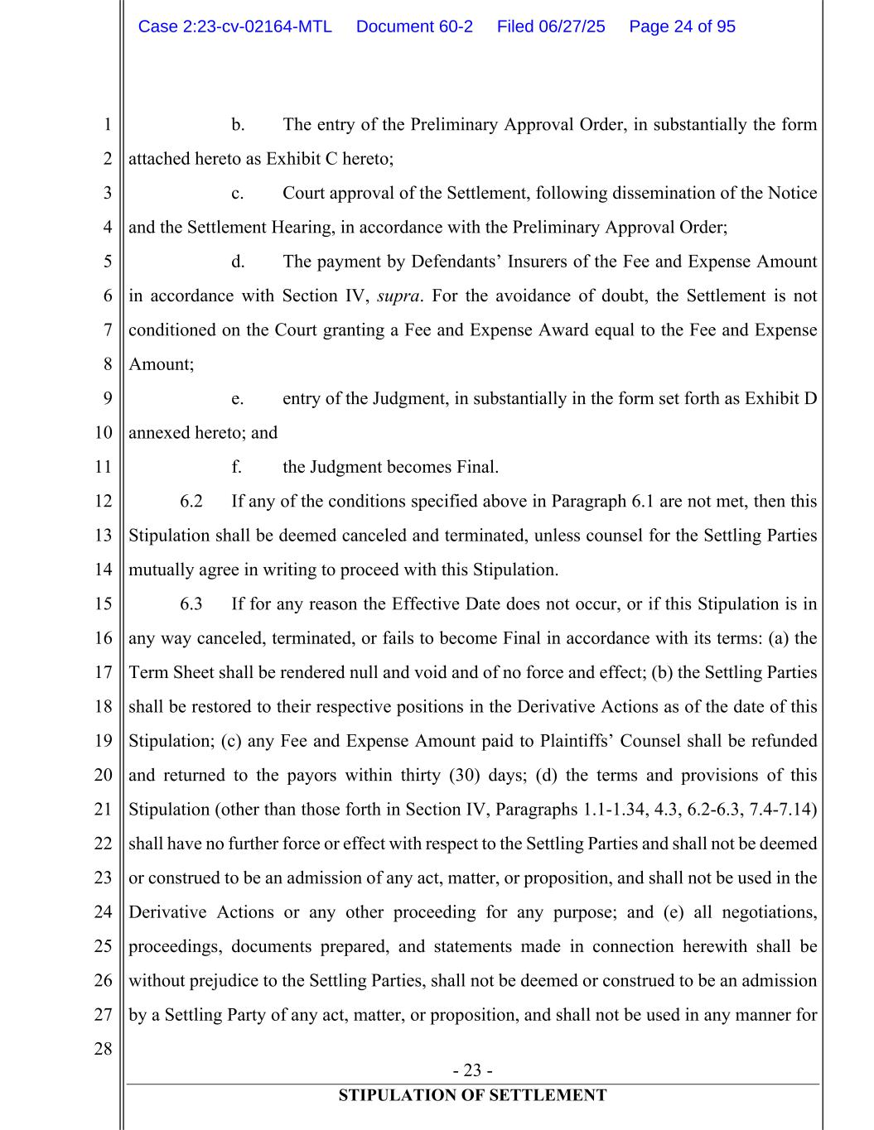
- 23 - STIPULATION OF SETTLEMENT 1 2 3 4 5 6 7 8 9 10 11 12 13 14 15 16 17 18 19 20 21 22 23 24 25 26 27 28 b. The entry of the Preliminary Approval Order, in substantially the form attached hereto as Exhibit C hereto; c. Court approval of the Settlement, following dissemination of the Notice and the Settlement Hearing, in accordance with the Preliminary Approval Order; d. The payment by Defendants’ Insurers of the Fee and Expense Amount in accordance with Section IV, supra. For the avoidance of doubt, the Settlement is not conditioned on the Court granting a Fee and Expense Award equal to the Fee and Expense Amount; e. entry of the Judgment, in substantially in the form set forth as Exhibit D annexed hereto; and f. the Judgment becomes Final. 6.2 If any of the conditions specified above in Paragraph 6.1 are not met, then this Stipulation shall be deemed canceled and terminated, unless counsel for the Settling Parties mutually agree in writing to proceed with this Stipulation. 6.3 If for any reason the Effective Date does not occur, or if this Stipulation is in any way canceled, terminated, or fails to become Final in accordance with its terms: (a) the Term Sheet shall be rendered null and void and of no force and effect; (b) the Settling Parties shall be restored to their respective positions in the Derivative Actions as of the date of this Stipulation; (c) any Fee and Expense Amount paid to Plaintiffs’ Counsel shall be refunded and returned to the payors within thirty (30) days; (d) the terms and provisions of this Stipulation (other than those forth in Section IV, Paragraphs 1.1-1.34, 4.3, 6.2-6.3, 7.4-7.14) shall have no further force or effect with respect to the Settling Parties and shall not be deemed or construed to be an admission of any act, matter, or proposition, and shall not be used in the Derivative Actions or any other proceeding for any purpose; and (e) all negotiations, proceedings, documents prepared, and statements made in connection herewith shall be without prejudice to the Settling Parties, shall not be deemed or construed to be an admission by a Settling Party of any act, matter, or proposition, and shall not be used in any manner for Case 2:23-cv-02164-MTL Document 60-2 Filed 06/27/25 Page 24 of 95

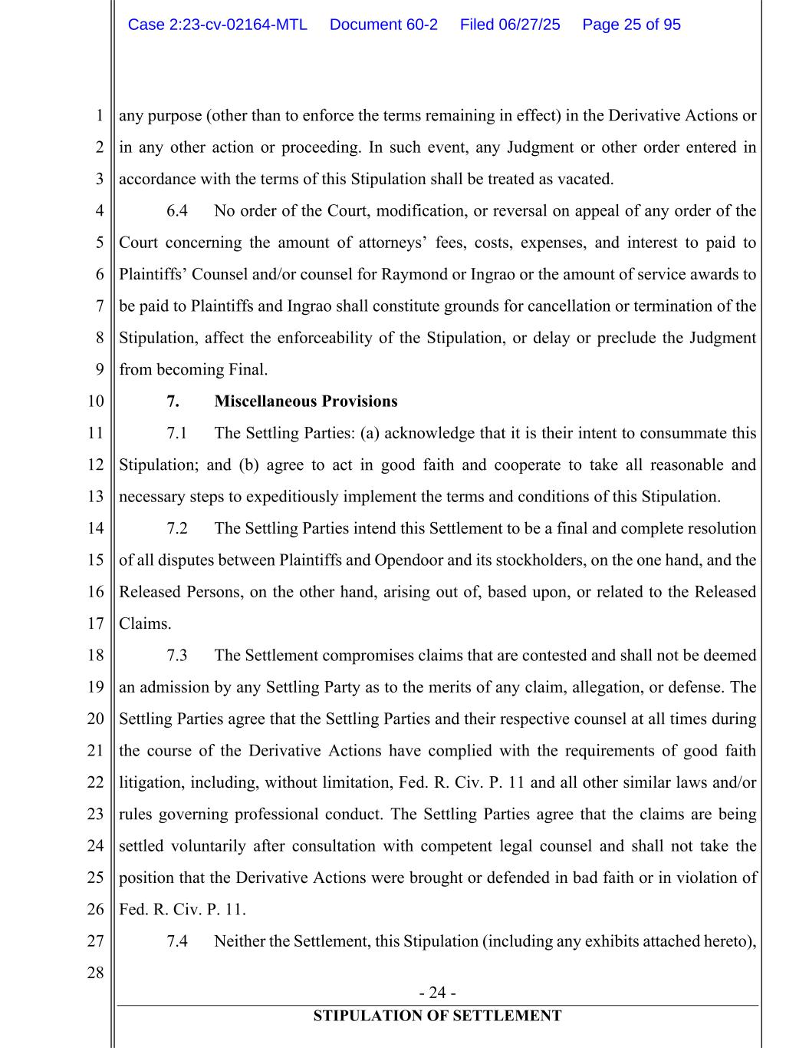
- 24 - STIPULATION OF SETTLEMENT 1 2 3 4 5 6 7 8 9 10 11 12 13 14 15 16 17 18 19 20 21 22 23 24 25 26 27 28 any purpose (other than to enforce the terms remaining in effect) in the Derivative Actions or in any other action or proceeding. In such event, any Judgment or other order entered in accordance with the terms of this Stipulation shall be treated as vacated. 6.4 No order of the Court, modification, or reversal on appeal of any order of the Court concerning the amount of attorneys’ fees, costs, expenses, and interest to paid to Plaintiffs’ Counsel and/or counsel for Raymond or Ingrao or the amount of service awards to be paid to Plaintiffs and Ingrao shall constitute grounds for cancellation or termination of the Stipulation, affect the enforceability of the Stipulation, or delay or preclude the Judgment from becoming Final. 7. Miscellaneous Provisions 7.1 The Settling Parties: (a) acknowledge that it is their intent to consummate this Stipulation; and (b) agree to act in good faith and cooperate to take all reasonable and necessary steps to expeditiously implement the terms and conditions of this Stipulation. 7.2 The Settling Parties intend this Settlement to be a final and complete resolution of all disputes between Plaintiffs and Opendoor and its stockholders, on the one hand, and the Released Persons, on the other hand, arising out of, based upon, or related to the Released Claims. 7.3 The Settlement compromises claims that are contested and shall not be deemed an admission by any Settling Party as to the merits of any claim, allegation, or defense. The Settling Parties agree that the Settling Parties and their respective counsel at all times during the course of the Derivative Actions have complied with the requirements of good faith litigation, including, without limitation, Fed. R. Civ. P. 11 and all other similar laws and/or rules governing professional conduct. The Settling Parties agree that the claims are being settled voluntarily after consultation with competent legal counsel and shall not take the position that the Derivative Actions were brought or defended in bad faith or in violation of Fed. R. Civ. P. 11. 7.4 Neither the Settlement, this Stipulation (including any exhibits attached hereto), Case 2:23-cv-02164-MTL Document 60-2 Filed 06/27/25 Page 25 of 95

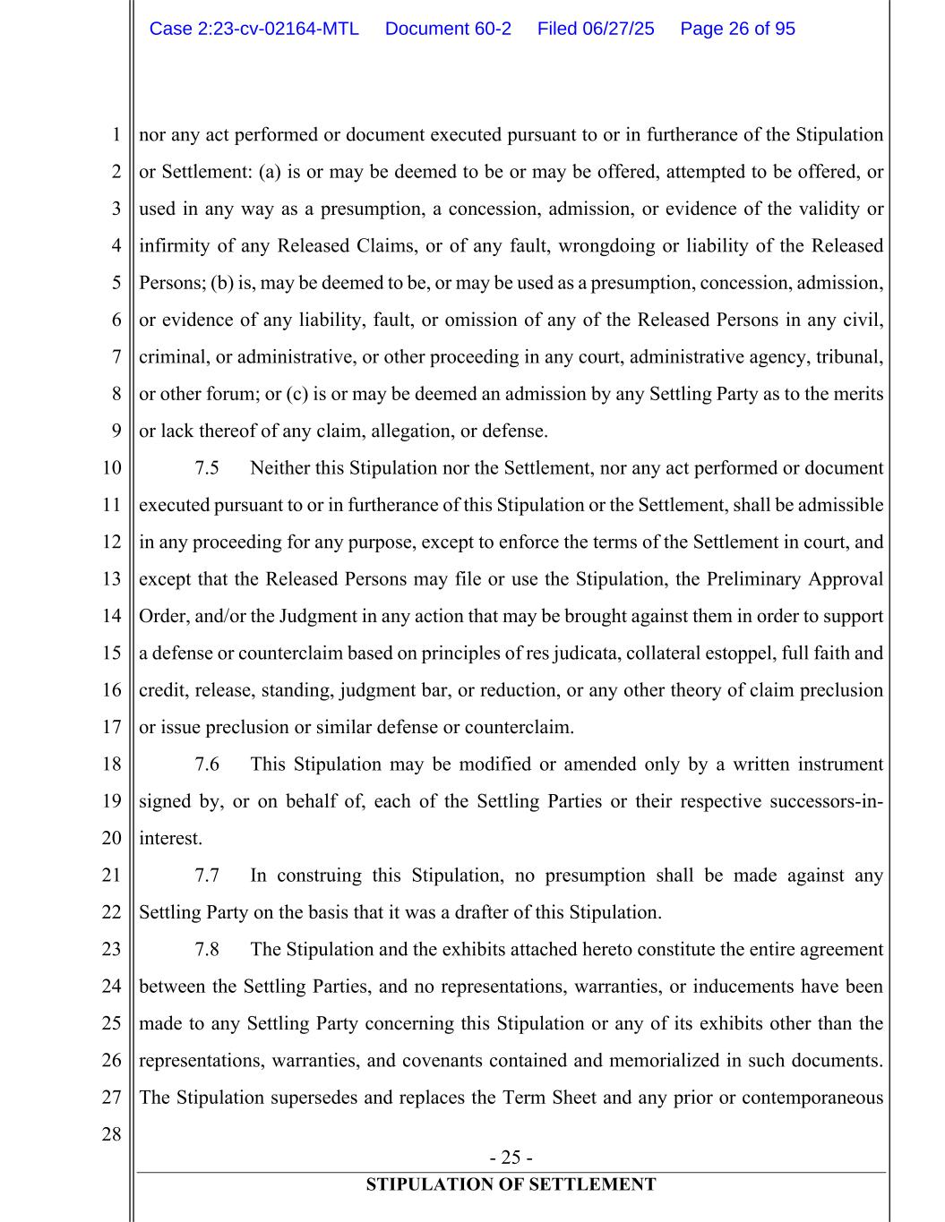
- 25 - STIPULATION OF SETTLEMENT 1 2 3 4 5 6 7 8 9 10 11 12 13 14 15 16 17 18 19 20 21 22 23 24 25 26 27 28 nor any act performed or document executed pursuant to or in furtherance of the Stipulation or Settlement: (a) is or may be deemed to be or may be offered, attempted to be offered, or used in any way as a presumption, a concession, admission, or evidence of the validity or infirmity of any Released Claims, or of any fault, wrongdoing or liability of the Released Persons; (b) is, may be deemed to be, or may be used as a presumption, concession, admission, or evidence of any liability, fault, or omission of any of the Released Persons in any civil, criminal, or administrative, or other proceeding in any court, administrative agency, tribunal, or other forum; or (c) is or may be deemed an admission by any Settling Party as to the merits or lack thereof of any claim, allegation, or defense. 7.5 Neither this Stipulation nor the Settlement, nor any act performed or document executed pursuant to or in furtherance of this Stipulation or the Settlement, shall be admissible in any proceeding for any purpose, except to enforce the terms of the Settlement in court, and except that the Released Persons may file or use the Stipulation, the Preliminary Approval Order, and/or the Judgment in any action that may be brought against them in order to support a defense or counterclaim based on principles of res judicata, collateral estoppel, full faith and credit, release, standing, judgment bar, or reduction, or any other theory of claim preclusion or issue preclusion or similar defense or counterclaim. 7.6 This Stipulation may be modified or amended only by a written instrument signed by, or on behalf of, each of the Settling Parties or their respective successors-in- interest. 7.7 In construing this Stipulation, no presumption shall be made against any Settling Party on the basis that it was a drafter of this Stipulation. 7.8 The Stipulation and the exhibits attached hereto constitute the entire agreement between the Settling Parties, and no representations, warranties, or inducements have been made to any Settling Party concerning this Stipulation or any of its exhibits other than the representations, warranties, and covenants contained and memorialized in such documents. The Stipulation supersedes and replaces the Term Sheet and any prior or contemporaneous Case 2:23-cv-02164-MTL Document 60-2 Filed 06/27/25 Page 26 of 95

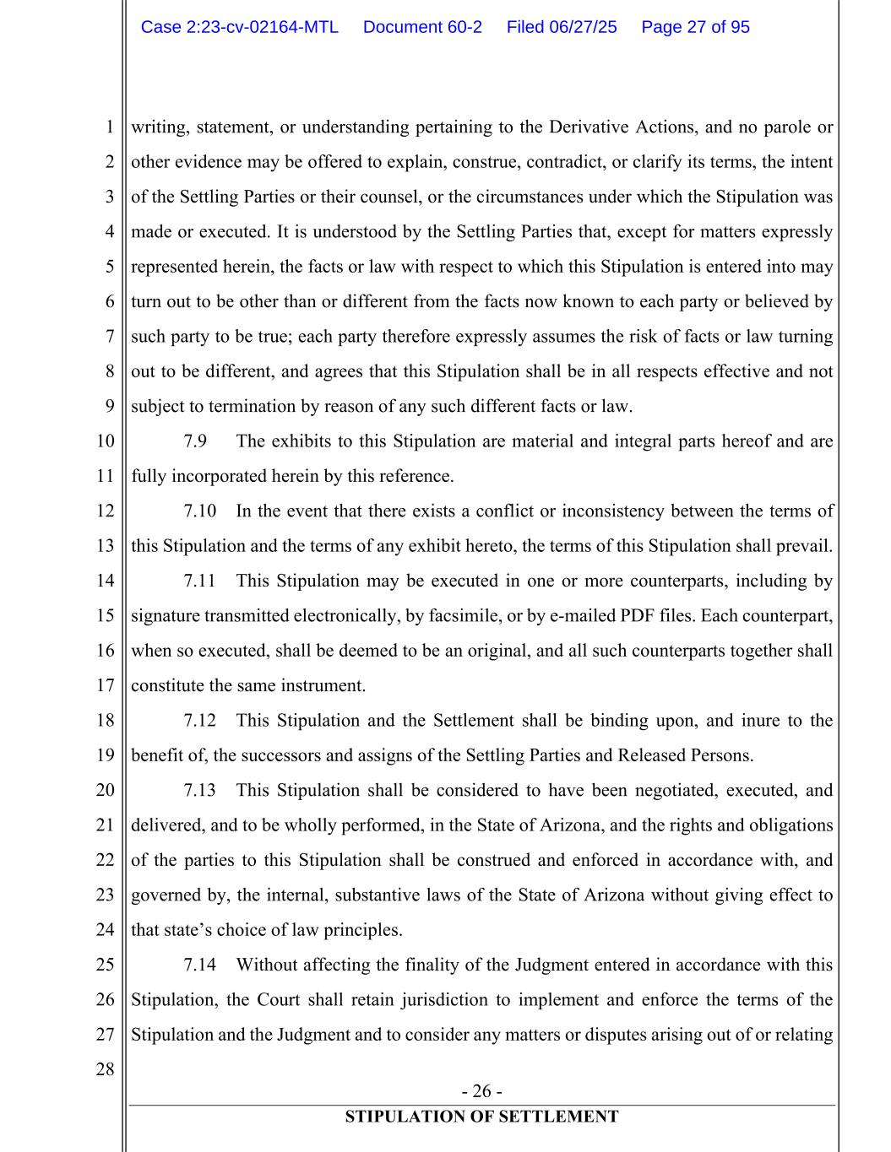
- 26 - STIPULATION OF SETTLEMENT 1 2 3 4 5 6 7 8 9 10 11 12 13 14 15 16 17 18 19 20 21 22 23 24 25 26 27 28 writing, statement, or understanding pertaining to the Derivative Actions, and no parole or other evidence may be offered to explain, construe, contradict, or clarify its terms, the intent of the Settling Parties or their counsel, or the circumstances under which the Stipulation was made or executed. It is understood by the Settling Parties that, except for matters expressly represented herein, the facts or law with respect to which this Stipulation is entered into may turn out to be other than or different from the facts now known to each party or believed by such party to be true; each party therefore expressly assumes the risk of facts or law turning out to be different, and agrees that this Stipulation shall be in all respects effective and not subject to termination by reason of any such different facts or law. 7.9 The exhibits to this Stipulation are material and integral parts hereof and are fully incorporated herein by this reference. 7.10 In the event that there exists a conflict or inconsistency between the terms of this Stipulation and the terms of any exhibit hereto, the terms of this Stipulation shall prevail. 7.11 This Stipulation may be executed in one or more counterparts, including by signature transmitted electronically, by facsimile, or by e-mailed PDF files. Each counterpart, when so executed, shall be deemed to be an original, and all such counterparts together shall constitute the same instrument. 7.12 This Stipulation and the Settlement shall be binding upon, and inure to the benefit of, the successors and assigns of the Settling Parties and Released Persons. 7.13 This Stipulation shall be considered to have been negotiated, executed, and delivered, and to be wholly performed, in the State of Arizona, and the rights and obligations of the parties to this Stipulation shall be construed and enforced in accordance with, and governed by, the internal, substantive laws of the State of Arizona without giving effect to that state’s choice of law principles. 7.14 Without affecting the finality of the Judgment entered in accordance with this Stipulation, the Court shall retain jurisdiction to implement and enforce the terms of the Stipulation and the Judgment and to consider any matters or disputes arising out of or relating Case 2:23-cv-02164-MTL Document 60-2 Filed 06/27/25 Page 27 of 95

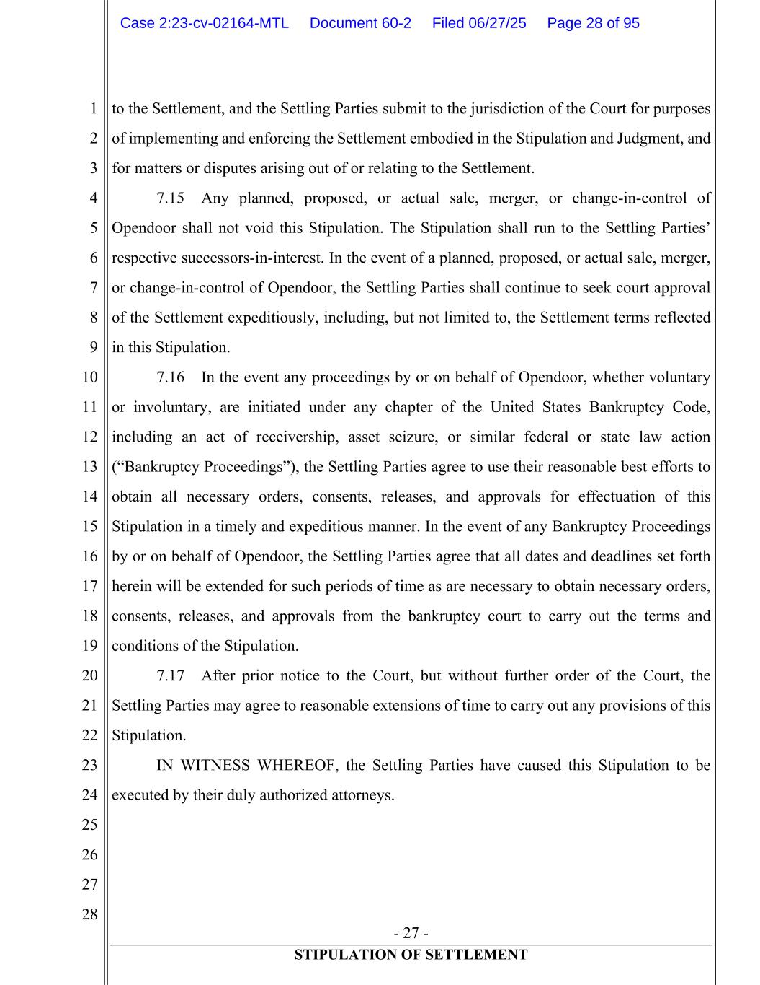
- 27 - STIPULATION OF SETTLEMENT 1 2 3 4 5 6 7 8 9 10 11 12 13 14 15 16 17 18 19 20 21 22 23 24 25 26 27 28 to the Settlement, and the Settling Parties submit to the jurisdiction of the Court for purposes of implementing and enforcing the Settlement embodied in the Stipulation and Judgment, and for matters or disputes arising out of or relating to the Settlement. 7.15 Any planned, proposed, or actual sale, merger, or change-in-control of Opendoor shall not void this Stipulation. The Stipulation shall run to the Settling Parties’ respective successors-in-interest. In the event of a planned, proposed, or actual sale, merger, or change-in-control of Opendoor, the Settling Parties shall continue to seek court approval of the Settlement expeditiously, including, but not limited to, the Settlement terms reflected in this Stipulation. 7.16 In the event any proceedings by or on behalf of Opendoor, whether voluntary or involuntary, are initiated under any chapter of the United States Bankruptcy Code, including an act of receivership, asset seizure, or similar federal or state law action (“Bankruptcy Proceedings”), the Settling Parties agree to use their reasonable best efforts to obtain all necessary orders, consents, releases, and approvals for effectuation of this Stipulation in a timely and expeditious manner. In the event of any Bankruptcy Proceedings by or on behalf of Opendoor, the Settling Parties agree that all dates and deadlines set forth herein will be extended for such periods of time as are necessary to obtain necessary orders, consents, releases, and approvals from the bankruptcy court to carry out the terms and conditions of the Stipulation. 7.17 After prior notice to the Court, but without further order of the Court, the Settling Parties may agree to reasonable extensions of time to carry out any provisions of this Stipulation. IN WITNESS WHEREOF, the Settling Parties have caused this Stipulation to be executed by their duly authorized attorneys. Case 2:23-cv-02164-MTL Document 60-2 Filed 06/27/25 Page 28 of 95

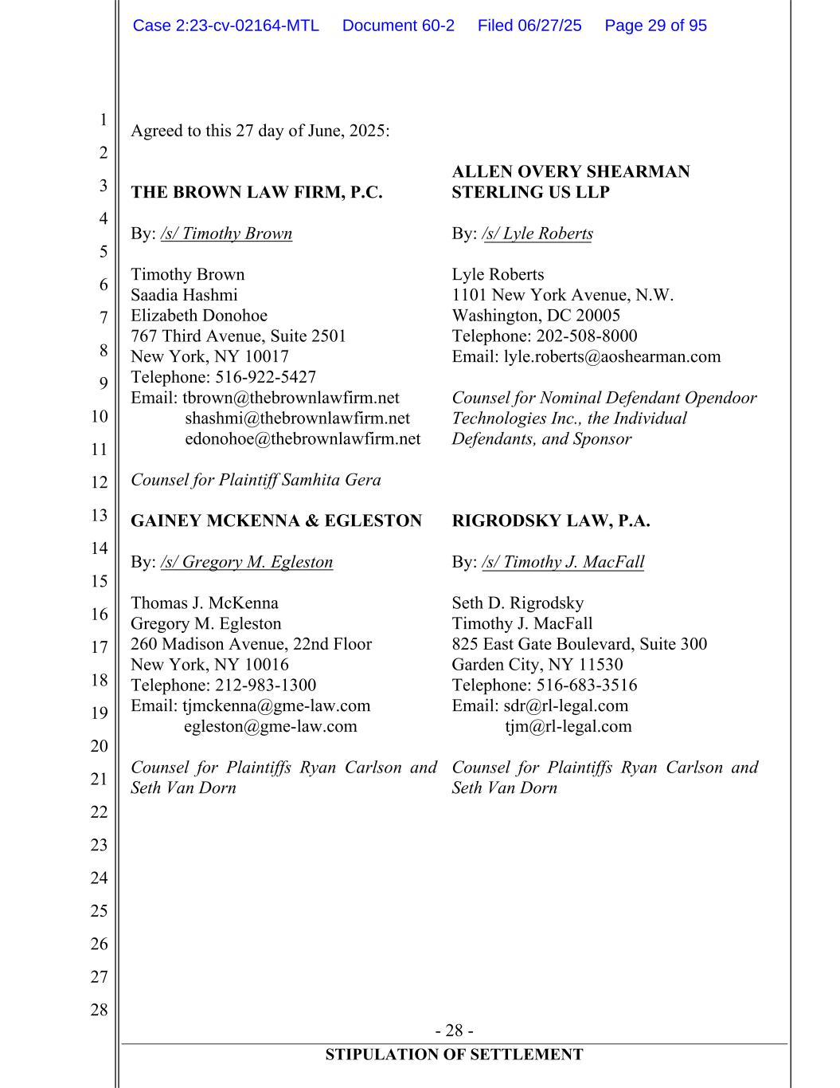
- 28 - STIPULATION OF SETTLEMENT 1 2 3 4 5 6 7 8 9 10 11 12 13 14 15 16 17 18 19 20 21 22 23 24 25 26 27 28 Agreed to this 27 day of June, 2025: THE BROWN LAW FIRM, P.C. By: /s/ Timothy Brown Timothy Brown Saadia Hashmi Elizabeth Donohoe 767 Third Avenue, Suite 2501 New York, NY 10017 Telephone: 516-922-5427 Email: tbrown@thebrownlawfirm.net shashmi@thebrownlawfirm.net edonohoe@thebrownlawfirm.net Counsel for Plaintiff Samhita Gera GAINEY MCKENNA & EGLESTON By: /s/ Gregory M. Egleston Thomas J. McKenna Gregory M. Egleston 260 Madison Avenue, 22nd Floor New York, NY 10016 Telephone: 212-983-1300 Email: tjmckenna@gme-law.com egleston@gme-law.com Counsel for Plaintiffs Ryan Carlson and Seth Van Dorn ALLEN OVERY SHEARMAN STERLING US LLP By: /s/ Lyle Roberts Lyle Roberts 1101 New York Avenue, N.W. Washington, DC 20005 Telephone: 202-508-8000 Email: lyle.roberts@aoshearman.com Counsel for Nominal Defendant Opendoor Technologies Inc., the Individual Defendants, and Sponsor RIGRODSKY LAW, P.A. By: /s/ Timothy J. MacFall Seth D. Rigrodsky Timothy J. MacFall 825 East Gate Boulevard, Suite 300 Garden City, NY 11530 Telephone: 516-683-3516 Email: sdr@rl-legal.com tjm@rl-legal.com Counsel for Plaintiffs Ryan Carlson and Seth Van Dorn Case 2:23-cv-02164-MTL Document 60-2 Filed 06/27/25 Page 29 of 95

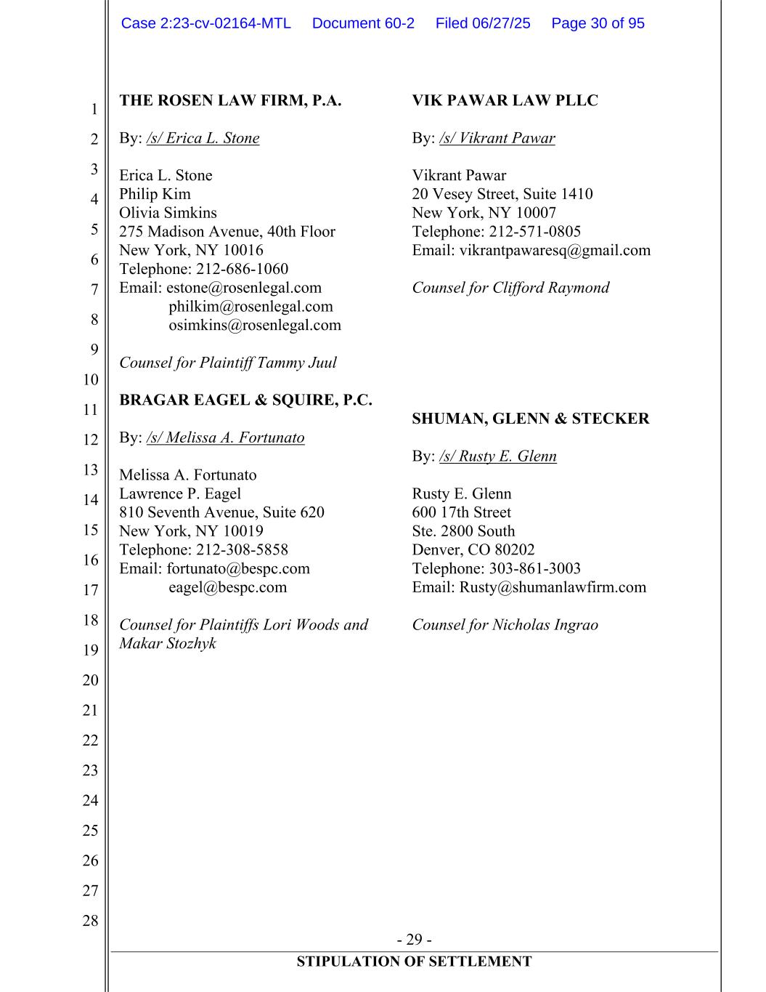
- 29 - STIPULATION OF SETTLEMENT 1 2 3 4 5 6 7 8 9 10 11 12 13 14 15 16 17 18 19 20 21 22 23 24 25 26 27 28 THE ROSEN LAW FIRM, P.A. By: /s/ Erica L. Stone Erica L. Stone Philip Kim Olivia Simkins 275 Madison Avenue, 40th Floor New York, NY 10016 Telephone: 212-686-1060 Email: estone@rosenlegal.com philkim@rosenlegal.com osimkins@rosenlegal.com Counsel for Plaintiff Tammy Juul BRAGAR EAGEL & SQUIRE, P.C. By: /s/ Melissa A. Fortunato Melissa A. Fortunato Lawrence P. Eagel 810 Seventh Avenue, Suite 620 New York, NY 10019 Telephone: 212-308-5858 Email: fortunato@bespc.com eagel@bespc.com Counsel for Plaintiffs Lori Woods and Makar Stozhyk VIK PAWAR LAW PLLC By: /s/ Vikrant Pawar Vikrant Pawar 20 Vesey Street, Suite 1410 New York, NY 10007 Telephone: 212-571-0805 Email: vikrantpawaresq@gmail.com Counsel for Clifford Raymond SHUMAN, GLENN & STECKER By: /s/ Rusty E. Glenn Rusty E. Glenn 600 17th Street Ste. 2800 South Denver, CO 80202 Telephone: 303-861-3003 Email: Rusty@shumanlawfirm.com Counsel for Nicholas Ingrao Case 2:23-cv-02164-MTL Document 60-2 Filed 06/27/25 Page 30 of 95

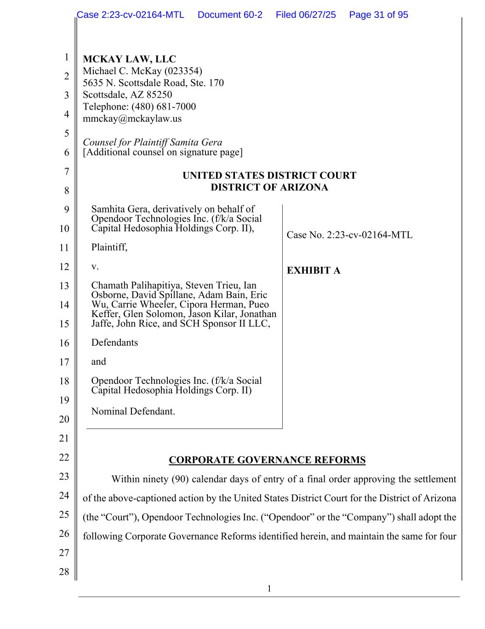
1 1 2 3 4 5 6 7 8 9 10 11 12 13 14 15 16 17 18 19 20 21 22 23 24 25 26 27 28 MCKAY LAW, LLC Michael C. McKay (023354) 5635 N. Scottsdale Road, Ste. 170 Scottsdale, AZ 85250 Telephone: (480) 681-7000 mmckay@mckaylaw.us Counsel for Plaintiff Samita Gera [Additional counsel on signature page] UNITED STATES DISTRICT COURT DISTRICT OF ARIZONA Samhita Gera, derivatively on behalf of Opendoor Technologies Inc. (f/k/a Social Capital Hedosophia Holdings Corp. II), Plaintiff, v. Chamath Palihapitiya, Steven Trieu, Ian Osborne, David Spillane, Adam Bain, Eric Wu, Carrie Wheeler, Cipora Herman, Pueo Keffer, Glen Solomon, Jason Kilar, Jonathan Jaffe, John Rice, and SCH Sponsor II LLC, Defendants and Opendoor Technologies Inc. (f/k/a Social Capital Hedosophia Holdings Corp. II) Nominal Defendant. Case No. 2:23-cv-02164-MTL EXHIBIT A CORPORATE GOVERNANCE REFORMS Within ninety (90) calendar days of entry of a final order approving the settlement of the above-captioned action by the United States District Court for the District of Arizona (the “Court”), Opendoor Technologies Inc. (“Opendoor” or the “Company”) shall adopt the following Corporate Governance Reforms identified herein, and maintain the same for four Case 2:23-cv-02164-MTL Document 60-2 Filed 06/27/25 Page 31 of 95

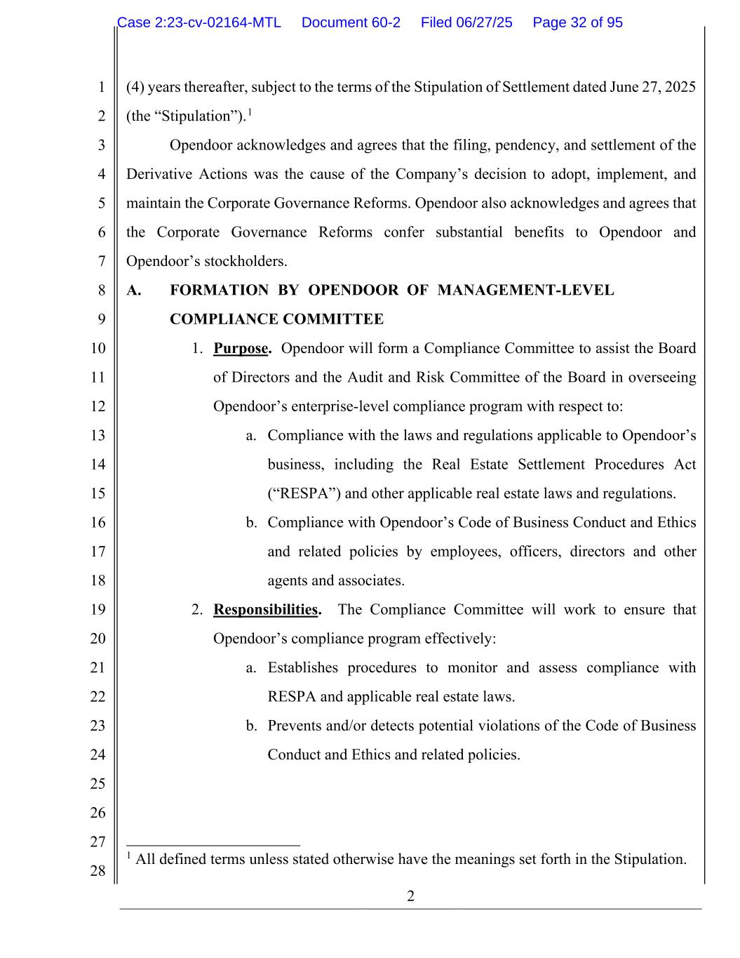
2 1 2 3 4 5 6 7 8 9 10 11 12 13 14 15 16 17 18 19 20 21 22 23 24 25 26 27 28 (4) years thereafter, subject to the terms of the Stipulation of Settlement dated June 27, 2025 (the “Stipulation”).1 Opendoor acknowledges and agrees that the filing, pendency, and settlement of the Derivative Actions was the cause of the Company’s decision to adopt, implement, and maintain the Corporate Governance Reforms. Opendoor also acknowledges and agrees that the Corporate Governance Reforms confer substantial benefits to Opendoor and Opendoor’s stockholders. A. FORMATION BY OPENDOOR OF MANAGEMENT-LEVEL COMPLIANCE COMMITTEE 1. Purpose. Opendoor will form a Compliance Committee to assist the Board of Directors and the Audit and Risk Committee of the Board in overseeing Opendoor’s enterprise-level compliance program with respect to: a. Compliance with the laws and regulations applicable to Opendoor’s business, including the Real Estate Settlement Procedures Act (“RESPA”) and other applicable real estate laws and regulations. b. Compliance with Opendoor’s Code of Business Conduct and Ethics and related policies by employees, officers, directors and other agents and associates. 2. Responsibilities. The Compliance Committee will work to ensure that Opendoor’s compliance program effectively: a. Establishes procedures to monitor and assess compliance with RESPA and applicable real estate laws. b. Prevents and/or detects potential violations of the Code of Business Conduct and Ethics and related policies. 1 All defined terms unless stated otherwise have the meanings set forth in the Stipulation. Case 2:23-cv-02164-MTL Document 60-2 Filed 06/27/25 Page 32 of 95

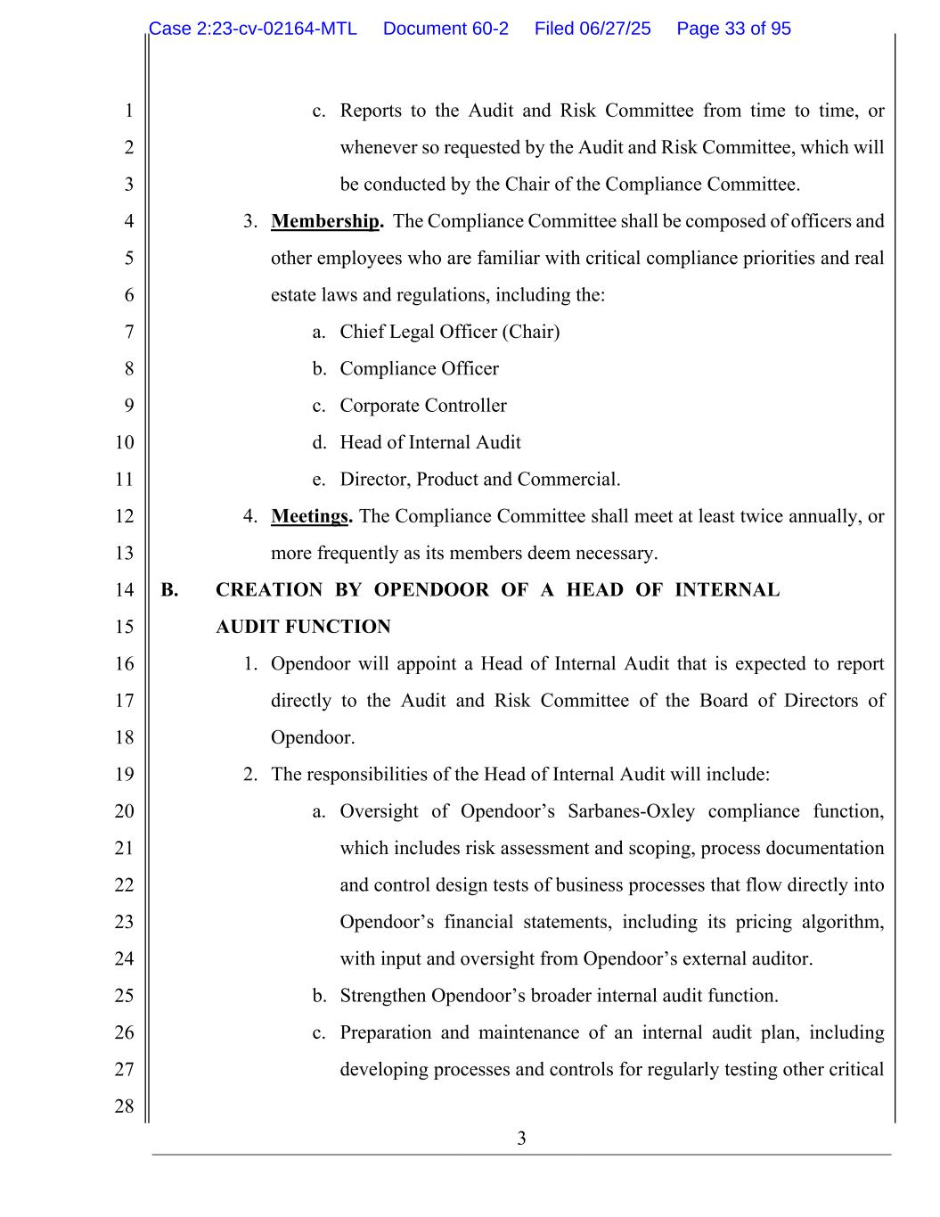
3 1 2 3 4 5 6 7 8 9 10 11 12 13 14 15 16 17 18 19 20 21 22 23 24 25 26 27 28 c. Reports to the Audit and Risk Committee from time to time, or whenever so requested by the Audit and Risk Committee, which will be conducted by the Chair of the Compliance Committee. 3. Membership. The Compliance Committee shall be composed of officers and other employees who are familiar with critical compliance priorities and real estate laws and regulations, including the: a. Chief Legal Officer (Chair) b. Compliance Officer c. Corporate Controller d. Head of Internal Audit e. Director, Product and Commercial. 4. Meetings. The Compliance Committee shall meet at least twice annually, or more frequently as its members deem necessary. B. CREATION BY OPENDOOR OF A HEAD OF INTERNAL AUDIT FUNCTION 1. Opendoor will appoint a Head of Internal Audit that is expected to report directly to the Audit and Risk Committee of the Board of Directors of Opendoor. 2. The responsibilities of the Head of Internal Audit will include: a. Oversight of Opendoor’s Sarbanes-Oxley compliance function, which includes risk assessment and scoping, process documentation and control design tests of business processes that flow directly into Opendoor’s financial statements, including its pricing algorithm, with input and oversight from Opendoor’s external auditor. b. Strengthen Opendoor’s broader internal audit function. c. Preparation and maintenance of an internal audit plan, including developing processes and controls for regularly testing other critical Case 2:23-cv-02164-MTL Document 60-2 Filed 06/27/25 Page 33 of 95

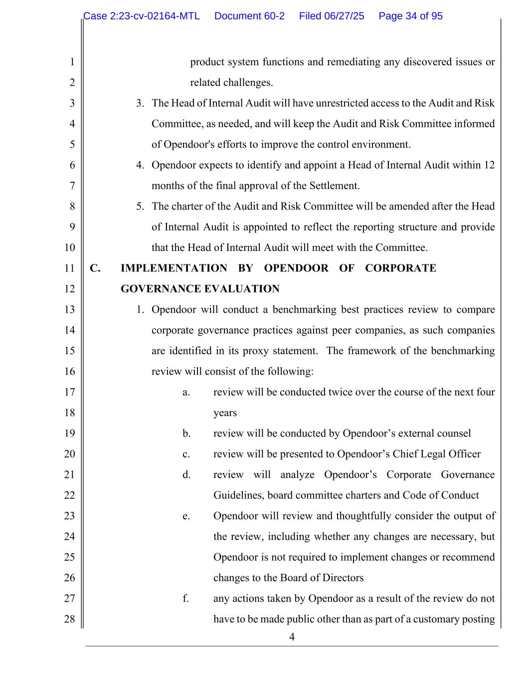
4 1 2 3 4 5 6 7 8 9 10 11 12 13 14 15 16 17 18 19 20 21 22 23 24 25 26 27 28 product system functions and remediating any discovered issues or related challenges. 3. The Head of Internal Audit will have unrestricted access to the Audit and Risk Committee, as needed, and will keep the Audit and Risk Committee informed of Opendoor's efforts to improve the control environment. 4. Opendoor expects to identify and appoint a Head of Internal Audit within 12 months of the final approval of the Settlement. 5. The charter of the Audit and Risk Committee will be amended after the Head of Internal Audit is appointed to reflect the reporting structure and provide that the Head of Internal Audit will meet with the Committee. C. IMPLEMENTATION BY OPENDOOR OF CORPORATE GOVERNANCE EVALUATION 1. Opendoor will conduct a benchmarking best practices review to compare corporate governance practices against peer companies, as such companies are identified in its proxy statement. The framework of the benchmarking review will consist of the following: a. review will be conducted twice over the course of the next four years b. review will be conducted by Opendoor’s external counsel c. review will be presented to Opendoor’s Chief Legal Officer d. review will analyze Opendoor’s Corporate Governance Guidelines, board committee charters and Code of Conduct e. Opendoor will review and thoughtfully consider the output of the review, including whether any changes are necessary, but Opendoor is not required to implement changes or recommend changes to the Board of Directors f. any actions taken by Opendoor as a result of the review do not have to be made public other than as part of a customary posting Case 2:23-cv-02164-MTL Document 60-2 Filed 06/27/25 Page 34 of 95

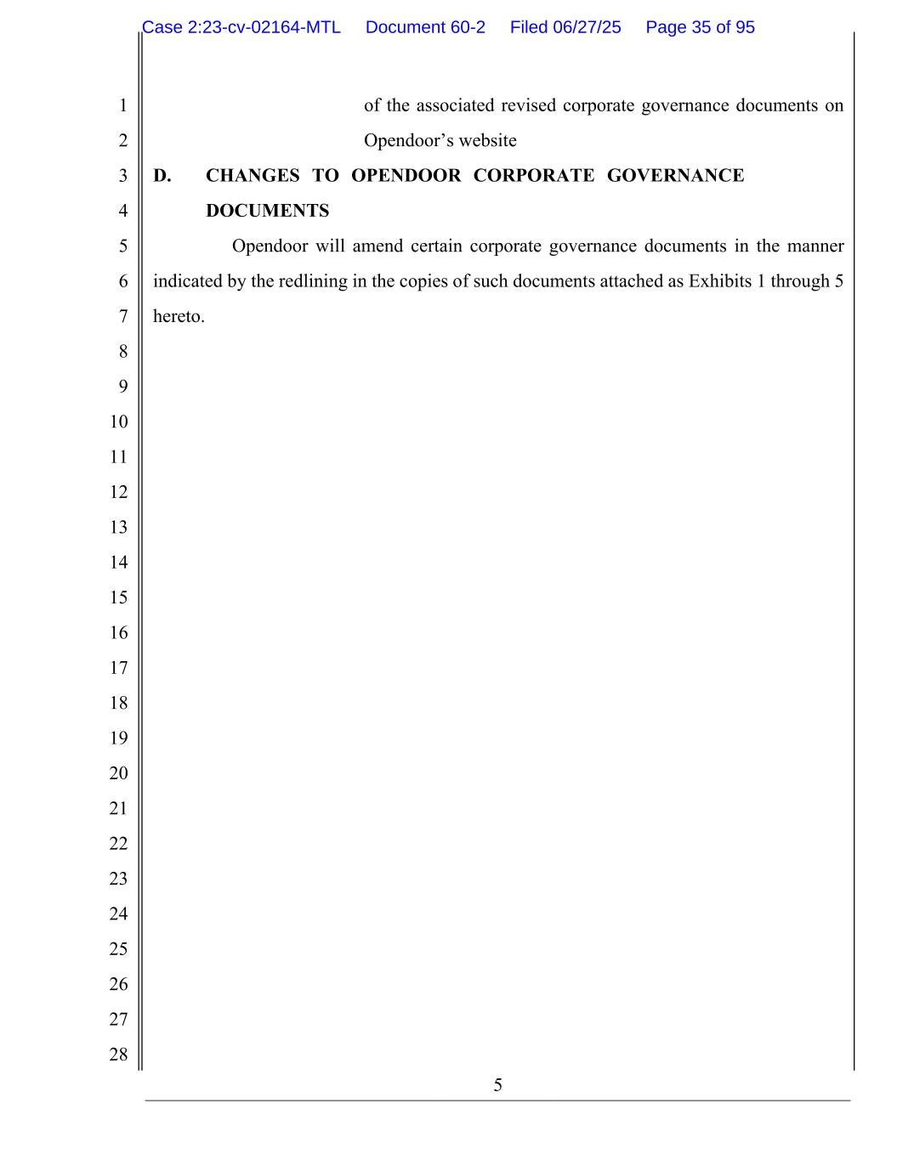
5 1 2 3 4 5 6 7 8 9 10 11 12 13 14 15 16 17 18 19 20 21 22 23 24 25 26 27 28 of the associated revised corporate governance documents on Opendoor’s website D. CHANGES TO OPENDOOR CORPORATE GOVERNANCE DOCUMENTS Opendoor will amend certain corporate governance documents in the manner indicated by the redlining in the copies of such documents attached as Exhibits 1 through 5 hereto. Case 2:23-cv-02164-MTL Document 60-2 Filed 06/27/25 Page 35 of 95


Exhibit 1 Case 2:23-cv-02164-MTL Document 60-2 Filed 06/27/25 Page 36 of 95

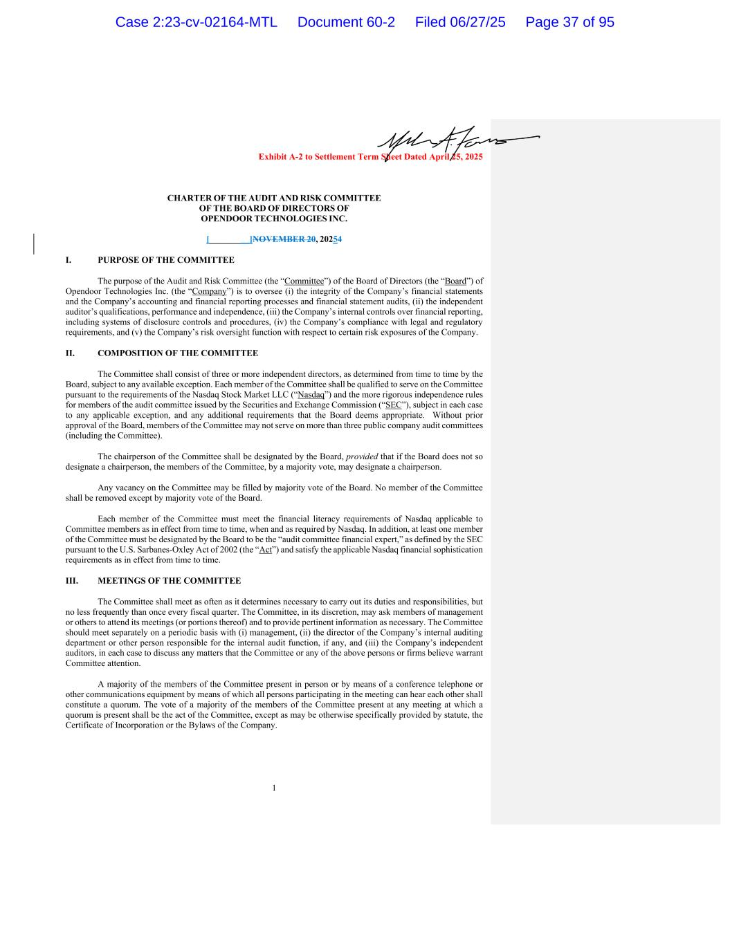
Exhibit A-2 to Settlement Term Sheet Dated April 25, 2025 1 CHARTER OF THE AUDIT AND RISK COMMITTEE OF THE BOARD OF DIRECTORS OF OPENDOOR TECHNOLOGIES INC. [_________]NOVEMBER 20, 20254 I. PURPOSE OF THE COMMITTEE The purpose of the Audit and Risk Committee (the “Committee”) of the Board of Directors (the “Board”) of Opendoor Technologies Inc. (the “Company”) is to oversee (i) the integrity of the Company’s financial statements and the Company’s accounting and financial reporting processes and financial statement audits, (ii) the independent auditor’s qualifications, performance and independence, (iii) the Company’s internal controls over financial reporting, including systems of disclosure controls and procedures, (iv) the Company’s compliance with legal and regulatory requirements, and (v) the Company’s risk oversight function with respect to certain risk exposures of the Company. II. COMPOSITION OF THE COMMITTEE The Committee shall consist of three or more independent directors, as determined from time to time by the Board, subject to any available exception. Each member of the Committee shall be qualified to serve on the Committee pursuant to the requirements of the Nasdaq Stock Market LLC (“Nasdaq”) and the more rigorous independence rules for members of the audit committee issued by the Securities and Exchange Commission (“SEC”), subject in each case to any applicable exception, and any additional requirements that the Board deems appropriate. Without prior approval of the Board, members of the Committee may not serve on more than three public company audit committees (including the Committee). The chairperson of the Committee shall be designated by the Board, provided that if the Board does not so designate a chairperson, the members of the Committee, by a majority vote, may designate a chairperson. Any vacancy on the Committee may be filled by majority vote of the Board. No member of the Committee shall be removed except by majority vote of the Board. Each member of the Committee must meet the financial literacy requirements of Nasdaq applicable to Committee members as in effect from time to time, when and as required by Nasdaq. In addition, at least one member of the Committee must be designated by the Board to be the “audit committee financial expert,” as defined by the SEC pursuant to the U.S. Sarbanes-Oxley Act of 2002 (the “Act”) and satisfy the applicable Nasdaq financial sophistication requirements as in effect from time to time. III. MEETINGS OF THE COMMITTEE The Committee shall meet as often as it determines necessary to carry out its duties and responsibilities, but no less frequently than once every fiscal quarter. The Committee, in its discretion, may ask members of management or others to attend its meetings (or portions thereof) and to provide pertinent information as necessary. The Committee should meet separately on a periodic basis with (i) management, (ii) the director of the Company’s internal auditing department or other person responsible for the internal audit function, if any, and (iii) the Company’s independent auditors, in each case to discuss any matters that the Committee or any of the above persons or firms believe warrant Committee attention. A majority of the members of the Committee present in person or by means of a conference telephone or other communications equipment by means of which all persons participating in the meeting can hear each other shall constitute a quorum. The vote of a majority of the members of the Committee present at any meeting at which a quorum is present shall be the act of the Committee, except as may be otherwise specifically provided by statute, the Certificate of Incorporation or the Bylaws of the Company. Case 2:23-cv-02164-MTL Document 60-2 Filed 06/27/25 Page 37 of 95

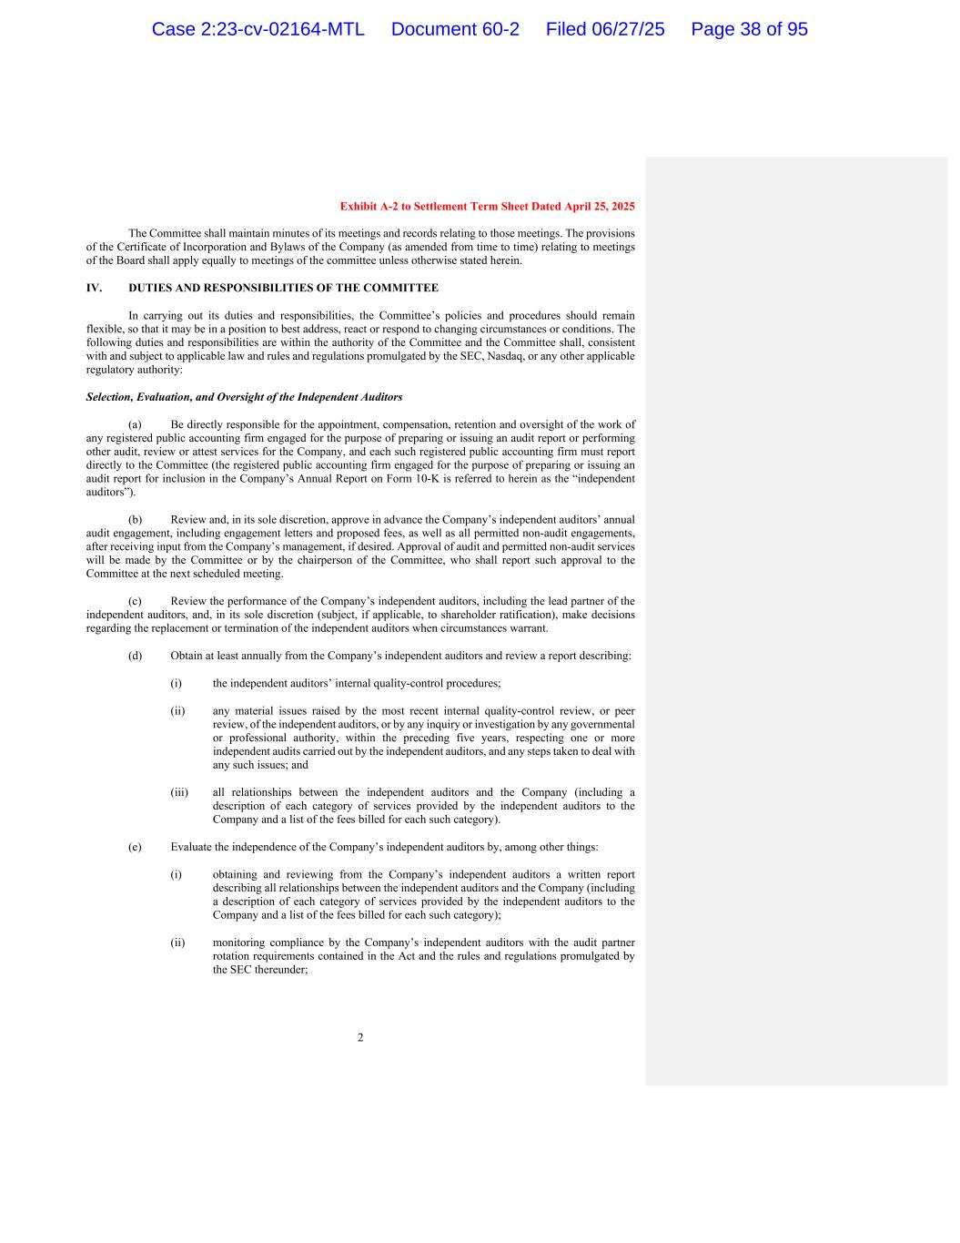
Exhibit A-2 to Settlement Term Sheet Dated April 25, 2025 2 The Committee shall maintain minutes of its meetings and records relating to those meetings. The provisions of the Certificate of Incorporation and Bylaws of the Company (as amended from time to time) relating to meetings of the Board shall apply equally to meetings of the committee unless otherwise stated herein. IV. DUTIES AND RESPONSIBILITIES OF THE COMMITTEE In carrying out its duties and responsibilities, the Committee’s policies and procedures should remain flexible, so that it may be in a position to best address, react or respond to changing circumstances or conditions. The following duties and responsibilities are within the authority of the Committee and the Committee shall, consistent with and subject to applicable law and rules and regulations promulgated by the SEC, Nasdaq, or any other applicable regulatory authority: Selection, Evaluation, and Oversight of the Independent Auditors (a) Be directly responsible for the appointment, compensation, retention and oversight of the work of any registered public accounting firm engaged for the purpose of preparing or issuing an audit report or performing other audit, review or attest services for the Company, and each such registered public accounting firm must report directly to the Committee (the registered public accounting firm engaged for the purpose of preparing or issuing an audit report for inclusion in the Company’s Annual Report on Form 10-K is referred to herein as the “independent auditors”). (b) Review and, in its sole discretion, approve in advance the Company’s independent auditors’ annual audit engagement, including engagement letters and proposed fees, as well as all permitted non-audit engagements, after receiving input from the Company’s management, if desired. Approval of audit and permitted non-audit services will be made by the Committee or by the chairperson of the Committee, who shall report such approval to the Committee at the next scheduled meeting. (c) Review the performance of the Company’s independent auditors, including the lead partner of the independent auditors, and, in its sole discretion (subject, if applicable, to shareholder ratification), make decisions regarding the replacement or termination of the independent auditors when circumstances warrant. (d) Obtain at least annually from the Company’s independent auditors and review a report describing: (i) the independent auditors’ internal quality-control procedures; (ii) any material issues raised by the most recent internal quality-control review, or peer review, of the independent auditors, or by any inquiry or investigation by any governmental or professional authority, within the preceding five years, respecting one or more independent audits carried out by the independent auditors, and any steps taken to deal with any such issues; and (iii) all relationships between the independent auditors and the Company (including a description of each category of services provided by the independent auditors to the Company and a list of the fees billed for each such category). (e) Evaluate the independence of the Company’s independent auditors by, among other things: (i) obtaining and reviewing from the Company’s independent auditors a written report describing all relationships between the independent auditors and the Company (including a description of each category of services provided by the independent auditors to the Company and a list of the fees billed for each such category); (ii) monitoring compliance by the Company’s independent auditors with the audit partner rotation requirements contained in the Act and the rules and regulations promulgated by the SEC thereunder; Case 2:23-cv-02164-MTL Document 60-2 Filed 06/27/25 Page 38 of 95

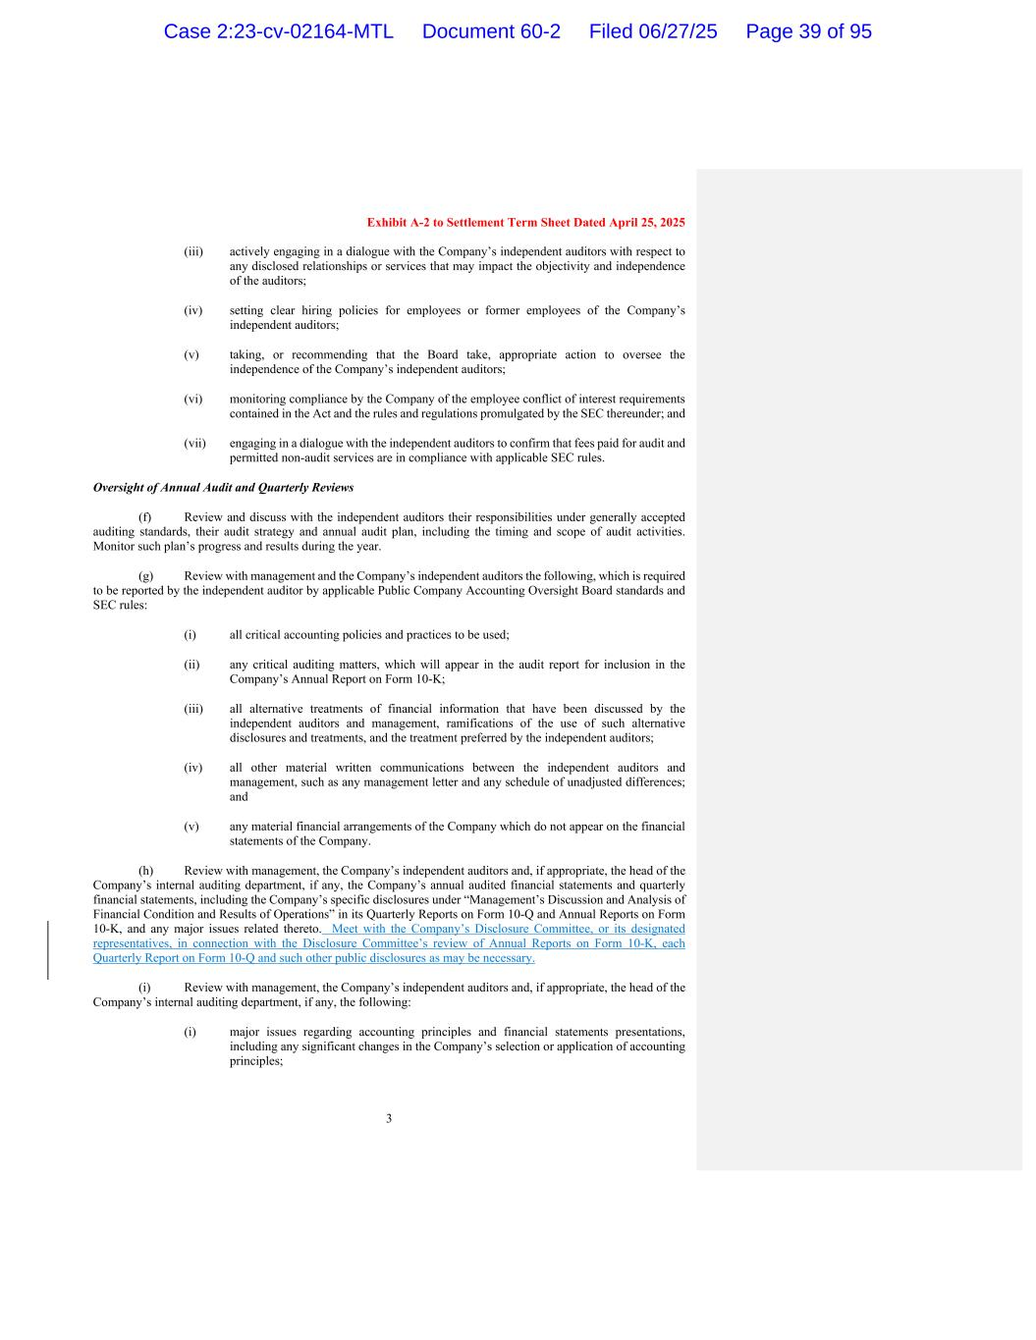
Exhibit A-2 to Settlement Term Sheet Dated April 25, 2025 3 (iii) actively engaging in a dialogue with the Company’s independent auditors with respect to any disclosed relationships or services that may impact the objectivity and independence of the auditors; (iv) setting clear hiring policies for employees or former employees of the Company’s independent auditors; (v) taking, or recommending that the Board take, appropriate action to oversee the independence of the Company’s independent auditors; (vi) monitoring compliance by the Company of the employee conflict of interest requirements contained in the Act and the rules and regulations promulgated by the SEC thereunder; and (vii) engaging in a dialogue with the independent auditors to confirm that fees paid for audit and permitted non-audit services are in compliance with applicable SEC rules. Oversight of Annual Audit and Quarterly Reviews (f) Review and discuss with the independent auditors their responsibilities under generally accepted auditing standards, their audit strategy and annual audit plan, including the timing and scope of audit activities. Monitor such plan’s progress and results during the year. (g) Review with management and the Company’s independent auditors the following, which is required to be reported by the independent auditor by applicable Public Company Accounting Oversight Board standards and SEC rules: (i) all critical accounting policies and practices to be used; (ii) any critical auditing matters, which will appear in the audit report for inclusion in the Company’s Annual Report on Form 10-K; (iii) all alternative treatments of financial information that have been discussed by the independent auditors and management, ramifications of the use of such alternative disclosures and treatments, and the treatment preferred by the independent auditors; (iv) all other material written communications between the independent auditors and management, such as any management letter and any schedule of unadjusted differences; and (v) any material financial arrangements of the Company which do not appear on the financial statements of the Company. (h) Review with management, the Company’s independent auditors and, if appropriate, the head of the Company’s internal auditing department, if any, the Company’s annual audited financial statements and quarterly financial statements, including the Company’s specific disclosures under “Management’s Discussion and Analysis of Financial Condition and Results of Operations” in its Quarterly Reports on Form 10-Q and Annual Reports on Form 10-K, and any major issues related thereto. Meet with the Company’s Disclosure Committee, or its designated representatives, in connection with the Disclosure Committee’s review of Annual Reports on Form 10-K, each Quarterly Report on Form 10-Q and such other public disclosures as may be necessary. (i) Review with management, the Company’s independent auditors and, if appropriate, the head of the Company’s internal auditing department, if any, the following: (i) major issues regarding accounting principles and financial statements presentations, including any significant changes in the Company’s selection or application of accounting principles; Case 2:23-cv-02164-MTL Document 60-2 Filed 06/27/25 Page 39 of 95

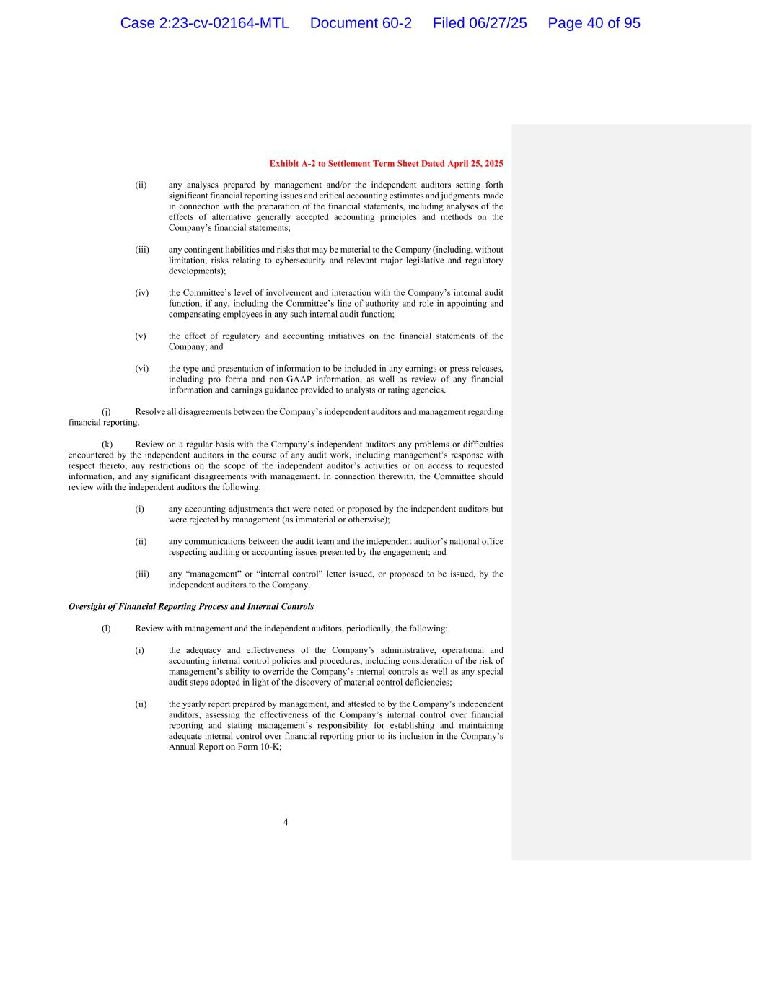
Exhibit A-2 to Settlement Term Sheet Dated April 25, 2025 4 (ii) any analyses prepared by management and/or the independent auditors setting forth significant financial reporting issues and critical accounting estimates and judgments made in connection with the preparation of the financial statements, including analyses of the effects of alternative generally accepted accounting principles and methods on the Company’s financial statements; (iii) any contingent liabilities and risks that may be material to the Company (including, without limitation, risks relating to cybersecurity and relevant major legislative and regulatory developments); (iv) the Committee’s level of involvement and interaction with the Company’s internal audit function, if any, including the Committee’s line of authority and role in appointing and compensating employees in any such internal audit function; (v) the effect of regulatory and accounting initiatives on the financial statements of the Company; and (vi) the type and presentation of information to be included in any earnings or press releases, including pro forma and non-GAAP information, as well as review of any financial information and earnings guidance provided to analysts or rating agencies. (j) Resolve all disagreements between the Company’s independent auditors and management regarding financial reporting. (k) Review on a regular basis with the Company’s independent auditors any problems or difficulties encountered by the independent auditors in the course of any audit work, including management’s response with respect thereto, any restrictions on the scope of the independent auditor’s activities or on access to requested information, and any significant disagreements with management. In connection therewith, the Committee should review with the independent auditors the following: (i) any accounting adjustments that were noted or proposed by the independent auditors but were rejected by management (as immaterial or otherwise); (ii) any communications between the audit team and the independent auditor’s national office respecting auditing or accounting issues presented by the engagement; and (iii) any “management” or “internal control” letter issued, or proposed to be issued, by the independent auditors to the Company. Oversight of Financial Reporting Process and Internal Controls (l) Review with management and the independent auditors, periodically, the following: (i) the adequacy and effectiveness of the Company’s administrative, operational and accounting internal control policies and procedures, including consideration of the risk of management’s ability to override the Company’s internal controls as well as any special audit steps adopted in light of the discovery of material control deficiencies; (ii) the yearly report prepared by management, and attested to by the Company’s independent auditors, assessing the effectiveness of the Company’s internal control over financial reporting and stating management’s responsibility for establishing and maintaining adequate internal control over financial reporting prior to its inclusion in the Company’s Annual Report on Form 10-K; Case 2:23-cv-02164-MTL Document 60-2 Filed 06/27/25 Page 40 of 95

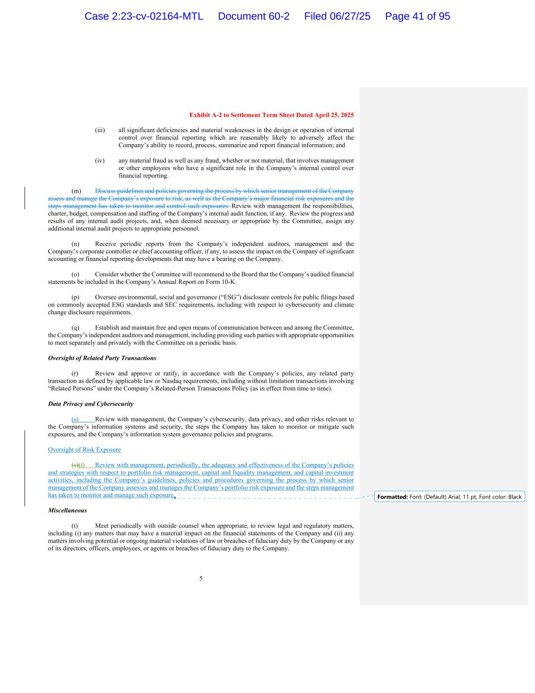
Exhibit A-2 to Settlement Term Sheet Dated April 25, 2025 5 (iii) all significant deficiencies and material weaknesses in the design or operation of internal control over financial reporting which are reasonably likely to adversely affect the Company’s ability to record, process, summarize and report financial information; and (iv) any material fraud as well as any fraud, whether or not material, that involves management or other employees who have a significant role in the Company’s internal control over financial reporting. (m) Discuss guidelines and policies governing the process by which senior management of the Company assess and manage the Company’s exposure to risk, as well as the Company’s major financial risk exposures and the steps management has taken to monitor and control such exposures. Review with management the responsibilities, charter, budget, compensation and staffing of the Company’s internal audit function, if any. Review the progress and results of any internal audit projects, and, when deemed necessary or appropriate by the Committee, assign any additional internal audit projects to appropriate personnel. (n) Receive periodic reports from the Company’s independent auditors, management and the Company’s corporate controller or chief accounting officer, if any, to assess the impact on the Company of significant accounting or financial reporting developments that may have a bearing on the Company. (o) Consider whether the Committee will recommend to the Board that the Company’s audited financial statements be included in the Company’s Annual Report on Form 10-K. (p) Oversee environmental, social and governance (“ESG”) disclosure controls for public filings based on commonly accepted ESG standards and SEC requirements, including with respect to cybersecurity and climate change disclosure requirements. (q) Establish and maintain free and open means of communication between and among the Committee, the Company’s independent auditors and management, including providing such parties with appropriate opportunities to meet separately and privately with the Committee on a periodic basis. Oversight of Related Party Transactions (r) Review and approve or ratify, in accordance with the Company’s policies, any related party transaction as defined by applicable law or Nasdaq requirements, including without limitation transactions involving “Related Persons” under the Company’s Related-Person Transactions Policy (as in effect from time to time). Data Privacy and Cybersecurity (s) Review with management, the Company’s cybersecurity, data privacy, and other risks relevant to the Company’s information systems and security, the steps the Company has taken to monitor or mitigate such exposures, and the Company’s information system governance policies and programs. Oversight of Risk Exposure (s)(t) Review with management, periodically, the adequacy and effectiveness of the Company’s policies and strategies with respect to portfolio risk management, capital and liquidity management, and capital investment activities, including the Company’s guidelines, policies and procedures governing the process by which senior management of the Company assesses and manages the Company’s portfolio risk exposure and the steps management has taken to monitor and manage such exposure. Miscellaneous (t) Meet periodically with outside counsel when appropriate, to review legal and regulatory matters, including (i) any matters that may have a material impact on the financial statements of the Company and (ii) any matters involving potential or ongoing material violations of law or breaches of fiduciary duty by the Company or any of its directors, officers, employees, or agents or breaches of fiduciary duty to the Company. Formatted: Font: (Default) Arial, 11 pt, Font color: Black Case 2:23-cv-02164-MTL Document 60-2 Filed 06/27/25 Page 41 of 95

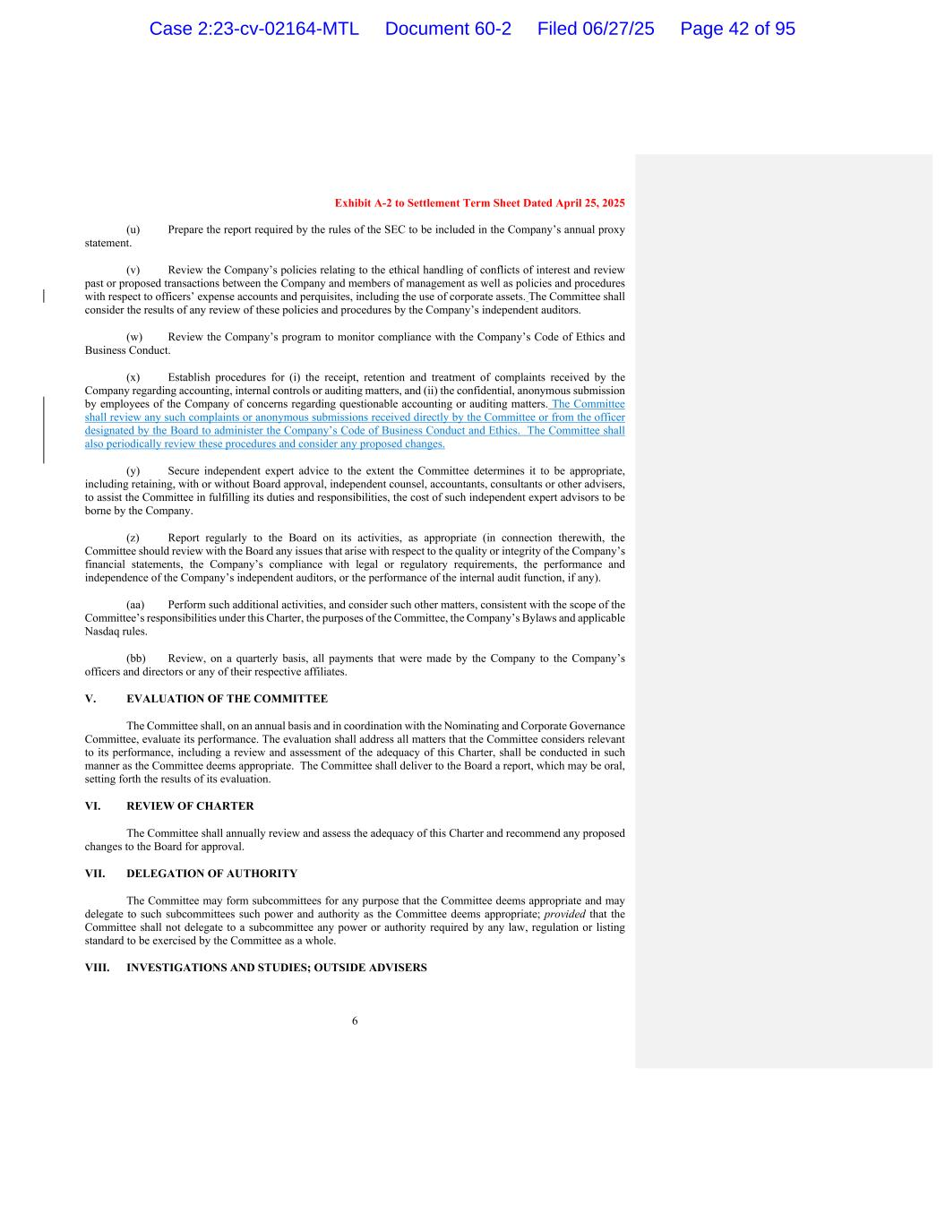
Exhibit A-2 to Settlement Term Sheet Dated April 25, 2025 6 (u) Prepare the report required by the rules of the SEC to be included in the Company’s annual proxy statement. (v) Review the Company’s policies relating to the ethical handling of conflicts of interest and review past or proposed transactions between the Company and members of management as well as policies and procedures with respect to officers’ expense accounts and perquisites, including the use of corporate assets. The Committee shall consider the results of any review of these policies and procedures by the Company’s independent auditors. (w) Review the Company’s program to monitor compliance with the Company’s Code of Ethics and Business Conduct. (x) Establish procedures for (i) the receipt, retention and treatment of complaints received by the Company regarding accounting, internal controls or auditing matters, and (ii) the confidential, anonymous submission by employees of the Company of concerns regarding questionable accounting or auditing matters. The Committee shall review any such complaints or anonymous submissions received directly by the Committee or from the officer designated by the Board to administer the Company’s Code of Business Conduct and Ethics. The Committee shall also periodically review these procedures and consider any proposed changes. (y) Secure independent expert advice to the extent the Committee determines it to be appropriate, including retaining, with or without Board approval, independent counsel, accountants, consultants or other advisers, to assist the Committee in fulfilling its duties and responsibilities, the cost of such independent expert advisors to be borne by the Company. (z) Report regularly to the Board on its activities, as appropriate (in connection therewith, the Committee should review with the Board any issues that arise with respect to the quality or integrity of the Company’s financial statements, the Company’s compliance with legal or regulatory requirements, the performance and independence of the Company’s independent auditors, or the performance of the internal audit function, if any). (aa) Perform such additional activities, and consider such other matters, consistent with the scope of the Committee’s responsibilities under this Charter, the purposes of the Committee, the Company’s Bylaws and applicable Nasdaq rules. (bb) Review, on a quarterly basis, all payments that were made by the Company to the Company’s officers and directors or any of their respective affiliates. V. EVALUATION OF THE COMMITTEE The Committee shall, on an annual basis and in coordination with the Nominating and Corporate Governance Committee, evaluate its performance. The evaluation shall address all matters that the Committee considers relevant to its performance, including a review and assessment of the adequacy of this Charter, shall be conducted in such manner as the Committee deems appropriate. The Committee shall deliver to the Board a report, which may be oral, setting forth the results of its evaluation. VI. REVIEW OF CHARTER The Committee shall annually review and assess the adequacy of this Charter and recommend any proposed changes to the Board for approval. VII. DELEGATION OF AUTHORITY The Committee may form subcommittees for any purpose that the Committee deems appropriate and may delegate to such subcommittees such power and authority as the Committee deems appropriate; provided that the Committee shall not delegate to a subcommittee any power or authority required by any law, regulation or listing standard to be exercised by the Committee as a whole. VIII. INVESTIGATIONS AND STUDIES; OUTSIDE ADVISERS Case 2:23-cv-02164-MTL Document 60-2 Filed 06/27/25 Page 42 of 95

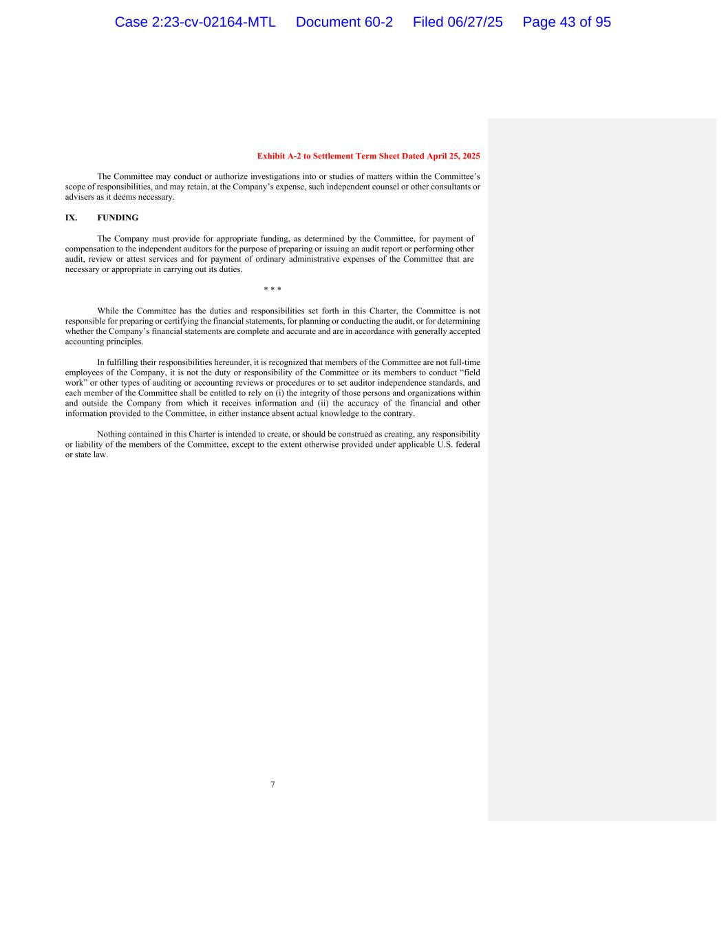
Exhibit A-2 to Settlement Term Sheet Dated April 25, 2025 7 The Committee may conduct or authorize investigations into or studies of matters within the Committee’s scope of responsibilities, and may retain, at the Company’s expense, such independent counsel or other consultants or advisers as it deems necessary. IX. FUNDING The Company must provide for appropriate funding, as determined by the Committee, for payment of compensation to the independent auditors for the purpose of preparing or issuing an audit report or performing other audit, review or attest services and for payment of ordinary administrative expenses of the Committee that are necessary or appropriate in carrying out its duties. * * * While the Committee has the duties and responsibilities set forth in this Charter, the Committee is not responsible for preparing or certifying the financial statements, for planning or conducting the audit, or for determining whether the Company’s financial statements are complete and accurate and are in accordance with generally accepted accounting principles. In fulfilling their responsibilities hereunder, it is recognized that members of the Committee are not full-time employees of the Company, it is not the duty or responsibility of the Committee or its members to conduct “field work” or other types of auditing or accounting reviews or procedures or to set auditor independence standards, and each member of the Committee shall be entitled to rely on (i) the integrity of those persons and organizations within and outside the Company from which it receives information and (ii) the accuracy of the financial and other information provided to the Committee, in either instance absent actual knowledge to the contrary. Nothing contained in this Charter is intended to create, or should be construed as creating, any responsibility or liability of the members of the Committee, except to the extent otherwise provided under applicable U.S. federal or state law. Case 2:23-cv-02164-MTL Document 60-2 Filed 06/27/25 Page 43 of 95


Exhibit A-2 to Settlement Term Sheet Dated April 25, 2025 8 (As adopted by the Board of Directors on September 30, 2021, re-approved by the Board of Directors on December 8, 2022, and amended by the Board of Directors on December 21, 2023, and November 20, 2024 and [ ]) Case 2:23-cv-02164-MTL Document 60-2 Filed 06/27/25 Page 44 of 95


Exhibit 2 Case 2:23-cv-02164-MTL Document 60-2 Filed 06/27/25 Page 45 of 95

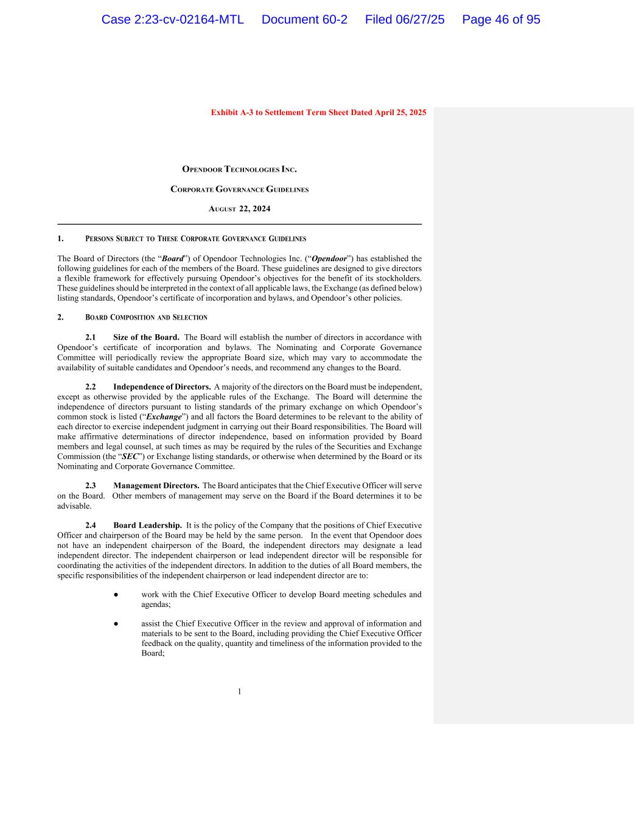
1 Exhibit A-3 to Settlement Term Sheet Dated April 25, 2025 OPENDOOR TECHNOLOGIES INC. CORPORATE GOVERNANCE GUIDELINES AUGUST 22, 2024 1. PERSONS SUBJECT TO THESE CORPORATE GOVERNANCE GUIDELINES The Board of Directors (the “Board”) of Opendoor Technologies Inc. (“Opendoor”) has established the following guidelines for each of the members of the Board. These guidelines are designed to give directors a flexible framework for effectively pursuing Opendoor’s objectives for the benefit of its stockholders. These guidelines should be interpreted in the context of all applicable laws, the Exchange (as defined below) listing standards, Opendoor’s certificate of incorporation and bylaws, and Opendoor’s other policies. 2. BOARD COMPOSITION AND SELECTION 2.1 Size of the Board. The Board will establish the number of directors in accordance with Opendoor’s certificate of incorporation and bylaws. The Nominating and Corporate Governance Committee will periodically review the appropriate Board size, which may vary to accommodate the availability of suitable candidates and Opendoor’s needs, and recommend any changes to the Board. 2.2 Independence of Directors. A majority of the directors on the Board must be independent, except as otherwise provided by the applicable rules of the Exchange. The Board will determine the independence of directors pursuant to listing standards of the primary exchange on which Opendoor’s common stock is listed (“Exchange”) and all factors the Board determines to be relevant to the ability of each director to exercise independent judgment in carrying out their Board responsibilities. The Board will make affirmative determinations of director independence, based on information provided by Board members and legal counsel, at such times as may be required by the rules of the Securities and Exchange Commission (the “SEC”) or Exchange listing standards, or otherwise when determined by the Board or its Nominating and Corporate Governance Committee. 2.3 Management Directors. The Board anticipates that the Chief Executive Officer will serve on the Board. Other members of management may serve on the Board if the Board determines it to be advisable. 2.4 Board Leadership. It is the policy of the Company that the positions of Chief Executive Officer and chairperson of the Board may be held by the same person. In the event that Opendoor does not have an independent chairperson of the Board, the independent directors may designate a lead independent director. The independent chairperson or lead independent director will be responsible for coordinating the activities of the independent directors. In addition to the duties of all Board members, the specific responsibilities of the independent chairperson or lead independent director are to: ● work with the Chief Executive Officer to develop Board meeting schedules and agendas; ● assist the Chief Executive Officer in the review and approval of information and materials to be sent to the Board, including providing the Chief Executive Officer feedback on the quality, quantity and timeliness of the information provided to the Board; Case 2:23-cv-02164-MTL Document 60-2 Filed 06/27/25 Page 46 of 95

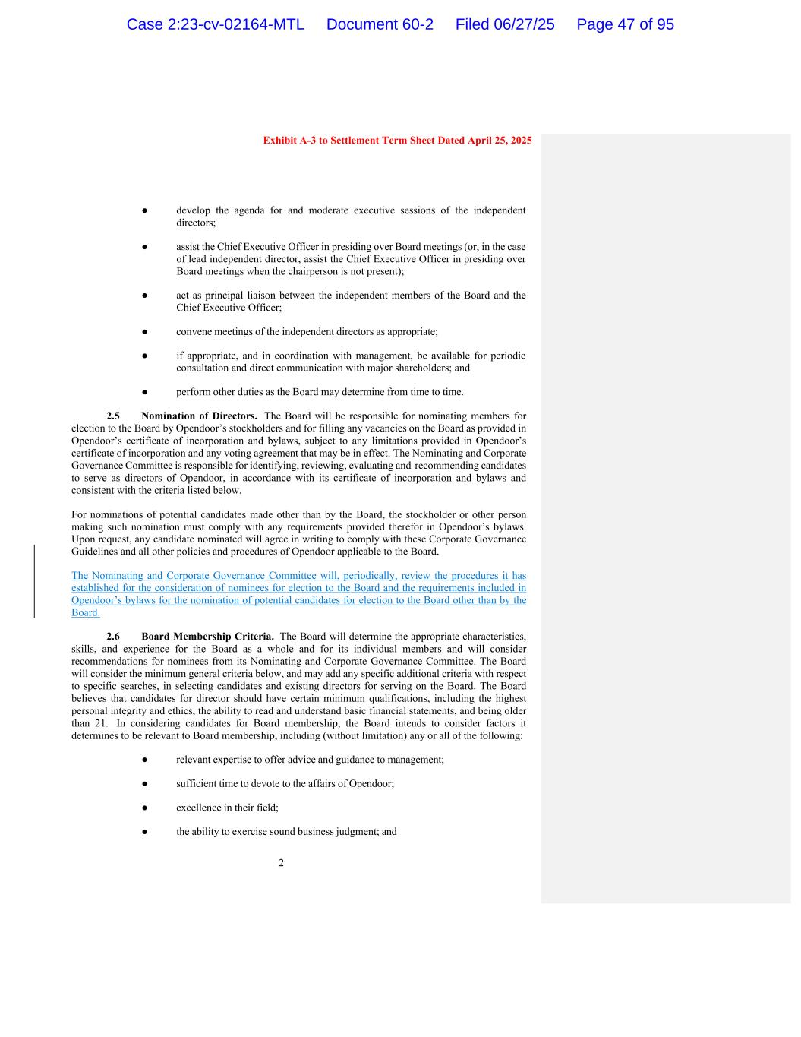
2 Exhibit A-3 to Settlement Term Sheet Dated April 25, 2025 ● develop the agenda for and moderate executive sessions of the independent directors; ● assist the Chief Executive Officer in presiding over Board meetings (or, in the case of lead independent director, assist the Chief Executive Officer in presiding over Board meetings when the chairperson is not present); ● act as principal liaison between the independent members of the Board and the Chief Executive Officer; ● convene meetings of the independent directors as appropriate; ● if appropriate, and in coordination with management, be available for periodic consultation and direct communication with major shareholders; and ● perform other duties as the Board may determine from time to time. 2.5 Nomination of Directors. The Board will be responsible for nominating members for election to the Board by Opendoor’s stockholders and for filling any vacancies on the Board as provided in Opendoor’s certificate of incorporation and bylaws, subject to any limitations provided in Opendoor’s certificate of incorporation and any voting agreement that may be in effect. The Nominating and Corporate Governance Committee is responsible for identifying, reviewing, evaluating and recommending candidates to serve as directors of Opendoor, in accordance with its certificate of incorporation and bylaws and consistent with the criteria listed below. For nominations of potential candidates made other than by the Board, the stockholder or other person making such nomination must comply with any requirements provided therefor in Opendoor’s bylaws. Upon request, any candidate nominated will agree in writing to comply with these Corporate Governance Guidelines and all other policies and procedures of Opendoor applicable to the Board. The Nominating and Corporate Governance Committee will, periodically, review the procedures it has established for the consideration of nominees for election to the Board and the requirements included in Opendoor’s bylaws for the nomination of potential candidates for election to the Board other than by the Board. 2.6 Board Membership Criteria. The Board will determine the appropriate characteristics, skills, and experience for the Board as a whole and for its individual members and will consider recommendations for nominees from its Nominating and Corporate Governance Committee. The Board will consider the minimum general criteria below, and may add any specific additional criteria with respect to specific searches, in selecting candidates and existing directors for serving on the Board. The Board believes that candidates for director should have certain minimum qualifications, including the highest personal integrity and ethics, the ability to read and understand basic financial statements, and being older than 21. In considering candidates for Board membership, the Board intends to consider factors it determines to be relevant to Board membership, including (without limitation) any or all of the following: ● relevant expertise to offer advice and guidance to management; ● sufficient time to devote to the affairs of Opendoor; ● excellence in their field; ● the ability to exercise sound business judgment; and Case 2:23-cv-02164-MTL Document 60-2 Filed 06/27/25 Page 47 of 95

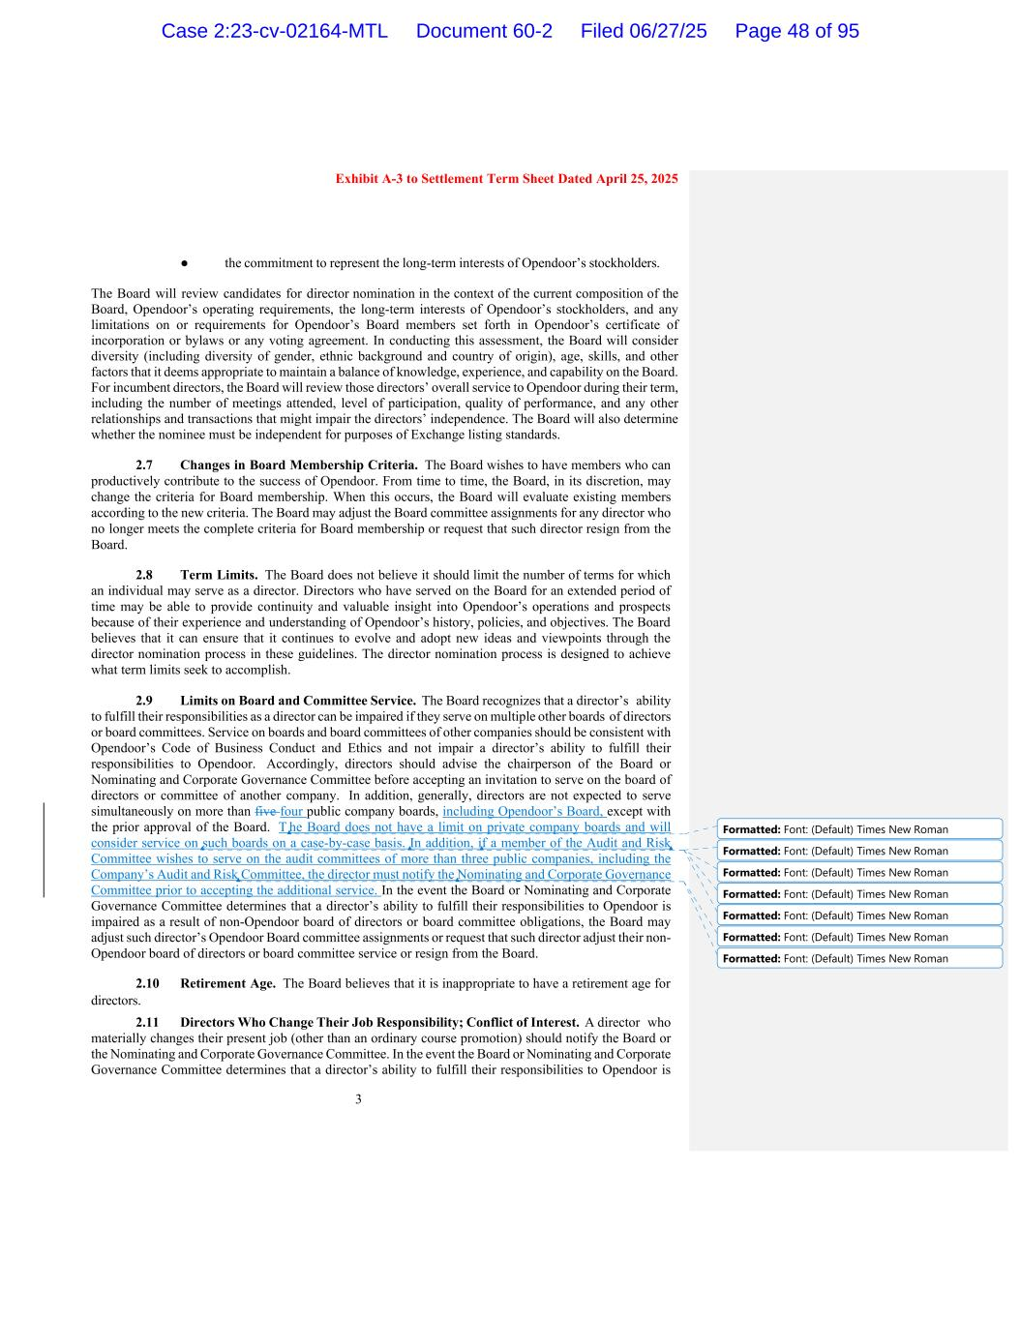
3 Exhibit A-3 to Settlement Term Sheet Dated April 25, 2025 ● the commitment to represent the long-term interests of Opendoor’s stockholders. The Board will review candidates for director nomination in the context of the current composition of the Board, Opendoor’s operating requirements, the long-term interests of Opendoor’s stockholders, and any limitations on or requirements for Opendoor’s Board members set forth in Opendoor’s certificate of incorporation or bylaws or any voting agreement. In conducting this assessment, the Board will consider diversity (including diversity of gender, ethnic background and country of origin), age, skills, and other factors that it deems appropriate to maintain a balance of knowledge, experience, and capability on the Board. For incumbent directors, the Board will review those directors’ overall service to Opendoor during their term, including the number of meetings attended, level of participation, quality of performance, and any other relationships and transactions that might impair the directors’ independence. The Board will also determine whether the nominee must be independent for purposes of Exchange listing standards. 2.7 Changes in Board Membership Criteria. The Board wishes to have members who can productively contribute to the success of Opendoor. From time to time, the Board, in its discretion, may change the criteria for Board membership. When this occurs, the Board will evaluate existing members according to the new criteria. The Board may adjust the Board committee assignments for any director who no longer meets the complete criteria for Board membership or request that such director resign from the Board. 2.8 Term Limits. The Board does not believe it should limit the number of terms for which an individual may serve as a director. Directors who have served on the Board for an extended period of time may be able to provide continuity and valuable insight into Opendoor’s operations and prospects because of their experience and understanding of Opendoor’s history, policies, and objectives. The Board believes that it can ensure that it continues to evolve and adopt new ideas and viewpoints through the director nomination process in these guidelines. The director nomination process is designed to achieve what term limits seek to accomplish. 2.9 Limits on Board and Committee Service. The Board recognizes that a director’s ability to fulfill their responsibilities as a director can be impaired if they serve on multiple other boards of directors or board committees. Service on boards and board committees of other companies should be consistent with Opendoor’s Code of Business Conduct and Ethics and not impair a director’s ability to fulfill their responsibilities to Opendoor. Accordingly, directors should advise the chairperson of the Board or Nominating and Corporate Governance Committee before accepting an invitation to serve on the board of directors or committee of another company. In addition, generally, directors are not expected to serve simultaneously on more than five four public company boards, including Opendoor’s Board, except with the prior approval of the Board. T he Board does not have a limit on private company boards and will consider service on such boards on a case-by-case basis. In addition, if a member of the Audit and Risk Committee wishes to serve on the audit committees of more than three public companies, including the Company’s Audit and Risk Committee, the director must notify the Nominating and Corporate Governance Committee prior to accepting the additional service. In the event the Board or Nominating and Corporate Governance Committee determines that a director’s ability to fulfill their responsibilities to Opendoor is impaired as a result of non-Opendoor board of directors or board committee obligations, the Board may adjust such director’s Opendoor Board committee assignments or request that such director adjust their non- Opendoor board of directors or board committee service or resign from the Board. 2.10 Retirement Age. The Board believes that it is inappropriate to have a retirement age for directors. 2.11 Directors Who Change Their Job Responsibility; Conflict of Interest. A director who materially changes their present job (other than an ordinary course promotion) should notify the Board or the Nominating and Corporate Governance Committee. In the event the Board or Nominating and Corporate Governance Committee determines that a director’s ability to fulfill their responsibilities to Opendoor is Formatted: Font: (Default) Times New Roman Formatted: Font: (Default) Times New Roman Formatted: Font: (Default) Times New Roman Formatted: Font: (Default) Times New Roman Formatted: Font: (Default) Times New Roman Formatted: Font: (Default) Times New Roman Formatted: Font: (Default) Times New Roman Case 2:23-cv-02164-MTL Document 60-2 Filed 06/27/25 Page 48 of 95

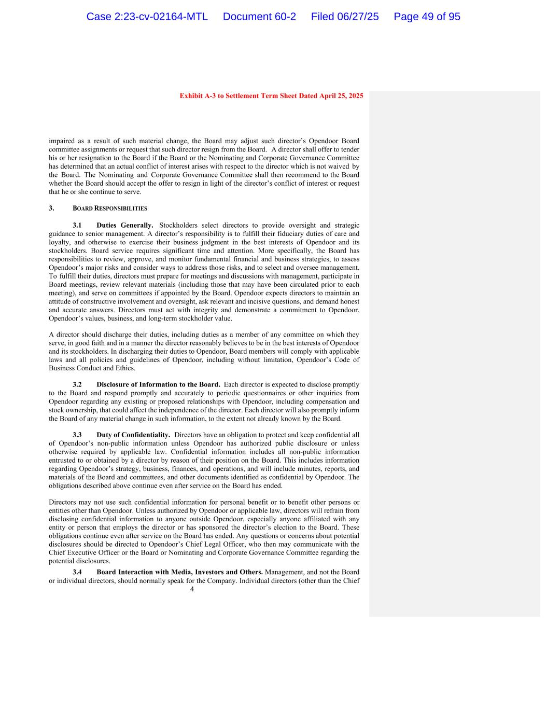
4 Exhibit A-3 to Settlement Term Sheet Dated April 25, 2025 impaired as a result of such material change, the Board may adjust such director’s Opendoor Board committee assignments or request that such director resign from the Board. A director shall offer to tender his or her resignation to the Board if the Board or the Nominating and Corporate Governance Committee has determined that an actual conflict of interest arises with respect to the director which is not waived by the Board. The Nominating and Corporate Governance Committee shall then recommend to the Board whether the Board should accept the offer to resign in light of the director’s conflict of interest or request that he or she continue to serve. 3. BOARD RESPONSIBILITIES 3.1 Duties Generally. Stockholders select directors to provide oversight and strategic guidance to senior management. A director’s responsibility is to fulfill their fiduciary duties of care and loyalty, and otherwise to exercise their business judgment in the best interests of Opendoor and its stockholders. Board service requires significant time and attention. More specifically, the Board has responsibilities to review, approve, and monitor fundamental financial and business strategies, to assess Opendoor’s major risks and consider ways to address those risks, and to select and oversee management. To fulfill their duties, directors must prepare for meetings and discussions with management, participate in Board meetings, review relevant materials (including those that may have been circulated prior to each meeting), and serve on committees if appointed by the Board. Opendoor expects directors to maintain an attitude of constructive involvement and oversight, ask relevant and incisive questions, and demand honest and accurate answers. Directors must act with integrity and demonstrate a commitment to Opendoor, Opendoor’s values, business, and long-term stockholder value. A director should discharge their duties, including duties as a member of any committee on which they serve, in good faith and in a manner the director reasonably believes to be in the best interests of Opendoor and its stockholders. In discharging their duties to Opendoor, Board members will comply with applicable laws and all policies and guidelines of Opendoor, including without limitation, Opendoor’s Code of Business Conduct and Ethics. 3.2 Disclosure of Information to the Board. Each director is expected to disclose promptly to the Board and respond promptly and accurately to periodic questionnaires or other inquiries from Opendoor regarding any existing or proposed relationships with Opendoor, including compensation and stock ownership, that could affect the independence of the director. Each director will also promptly inform the Board of any material change in such information, to the extent not already known by the Board. 3.3 Duty of Confidentiality. Directors have an obligation to protect and keep confidential all of Opendoor’s non-public information unless Opendoor has authorized public disclosure or unless otherwise required by applicable law. Confidential information includes all non-public information entrusted to or obtained by a director by reason of their position on the Board. This includes information regarding Opendoor’s strategy, business, finances, and operations, and will include minutes, reports, and materials of the Board and committees, and other documents identified as confidential by Opendoor. The obligations described above continue even after service on the Board has ended. Directors may not use such confidential information for personal benefit or to benefit other persons or entities other than Opendoor. Unless authorized by Opendoor or applicable law, directors will refrain from disclosing confidential information to anyone outside Opendoor, especially anyone affiliated with any entity or person that employs the director or has sponsored the director’s election to the Board. These obligations continue even after service on the Board has ended. Any questions or concerns about potential disclosures should be directed to Opendoor’s Chief Legal Officer, who then may communicate with the Chief Executive Officer or the Board or Nominating and Corporate Governance Committee regarding the potential disclosures. 3.4 Board Interaction with Media, Investors and Others. Management, and not the Board or individual directors, should normally speak for the Company. Individual directors (other than the Chief Case 2:23-cv-02164-MTL Document 60-2 Filed 06/27/25 Page 49 of 95

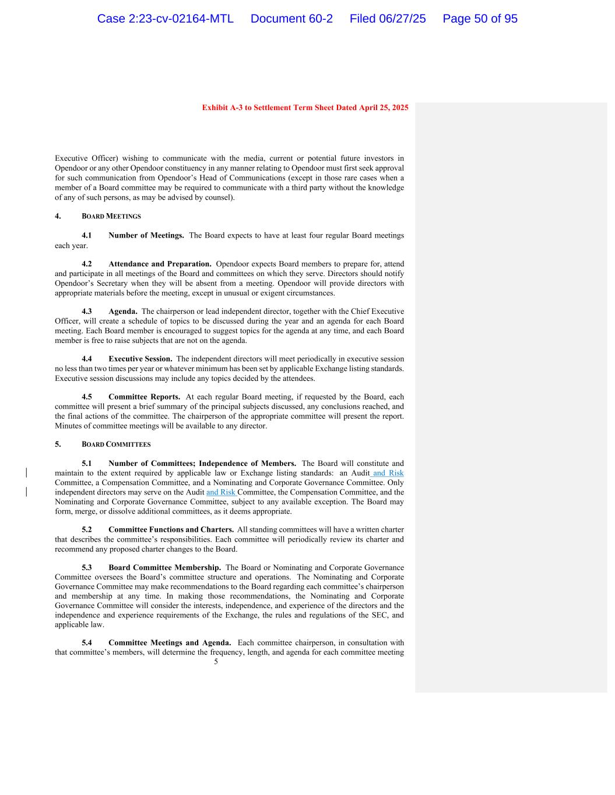
5 Exhibit A-3 to Settlement Term Sheet Dated April 25, 2025 Executive Officer) wishing to communicate with the media, current or potential future investors in Opendoor or any other Opendoor constituency in any manner relating to Opendoor must first seek approval for such communication from Opendoor’s Head of Communications (except in those rare cases when a member of a Board committee may be required to communicate with a third party without the knowledge of any of such persons, as may be advised by counsel). 4. BOARD MEETINGS 4.1 Number of Meetings. The Board expects to have at least four regular Board meetings each year. 4.2 Attendance and Preparation. Opendoor expects Board members to prepare for, attend and participate in all meetings of the Board and committees on which they serve. Directors should notify Opendoor’s Secretary when they will be absent from a meeting. Opendoor will provide directors with appropriate materials before the meeting, except in unusual or exigent circumstances. 4.3 Agenda. The chairperson or lead independent director, together with the Chief Executive Officer, will create a schedule of topics to be discussed during the year and an agenda for each Board meeting. Each Board member is encouraged to suggest topics for the agenda at any time, and each Board member is free to raise subjects that are not on the agenda. 4.4 Executive Session. The independent directors will meet periodically in executive session no less than two times per year or whatever minimum has been set by applicable Exchange listing standards. Executive session discussions may include any topics decided by the attendees. 4.5 Committee Reports. At each regular Board meeting, if requested by the Board, each committee will present a brief summary of the principal subjects discussed, any conclusions reached, and the final actions of the committee. The chairperson of the appropriate committee will present the report. Minutes of committee meetings will be available to any director. 5. BOARD COMMITTEES 5.1 Number of Committees; Independence of Members. The Board will constitute and maintain to the extent required by applicable law or Exchange listing standards: an Audit and Risk Committee, a Compensation Committee, and a Nominating and Corporate Governance Committee. Only independent directors may serve on the Audit and Risk Committee, the Compensation Committee, and the Nominating and Corporate Governance Committee, subject to any available exception. The Board may form, merge, or dissolve additional committees, as it deems appropriate. 5.2 Committee Functions and Charters. All standing committees will have a written charter that describes the committee’s responsibilities. Each committee will periodically review its charter and recommend any proposed charter changes to the Board. 5.3 Board Committee Membership. The Board or Nominating and Corporate Governance Committee oversees the Board’s committee structure and operations. The Nominating and Corporate Governance Committee may make recommendations to the Board regarding each committee’s chairperson and membership at any time. In making those recommendations, the Nominating and Corporate Governance Committee will consider the interests, independence, and experience of the directors and the independence and experience requirements of the Exchange, the rules and regulations of the SEC, and applicable law. 5.4 Committee Meetings and Agenda. Each committee chairperson, in consultation with that committee’s members, will determine the frequency, length, and agenda for each committee meeting Case 2:23-cv-02164-MTL Document 60-2 Filed 06/27/25 Page 50 of 95

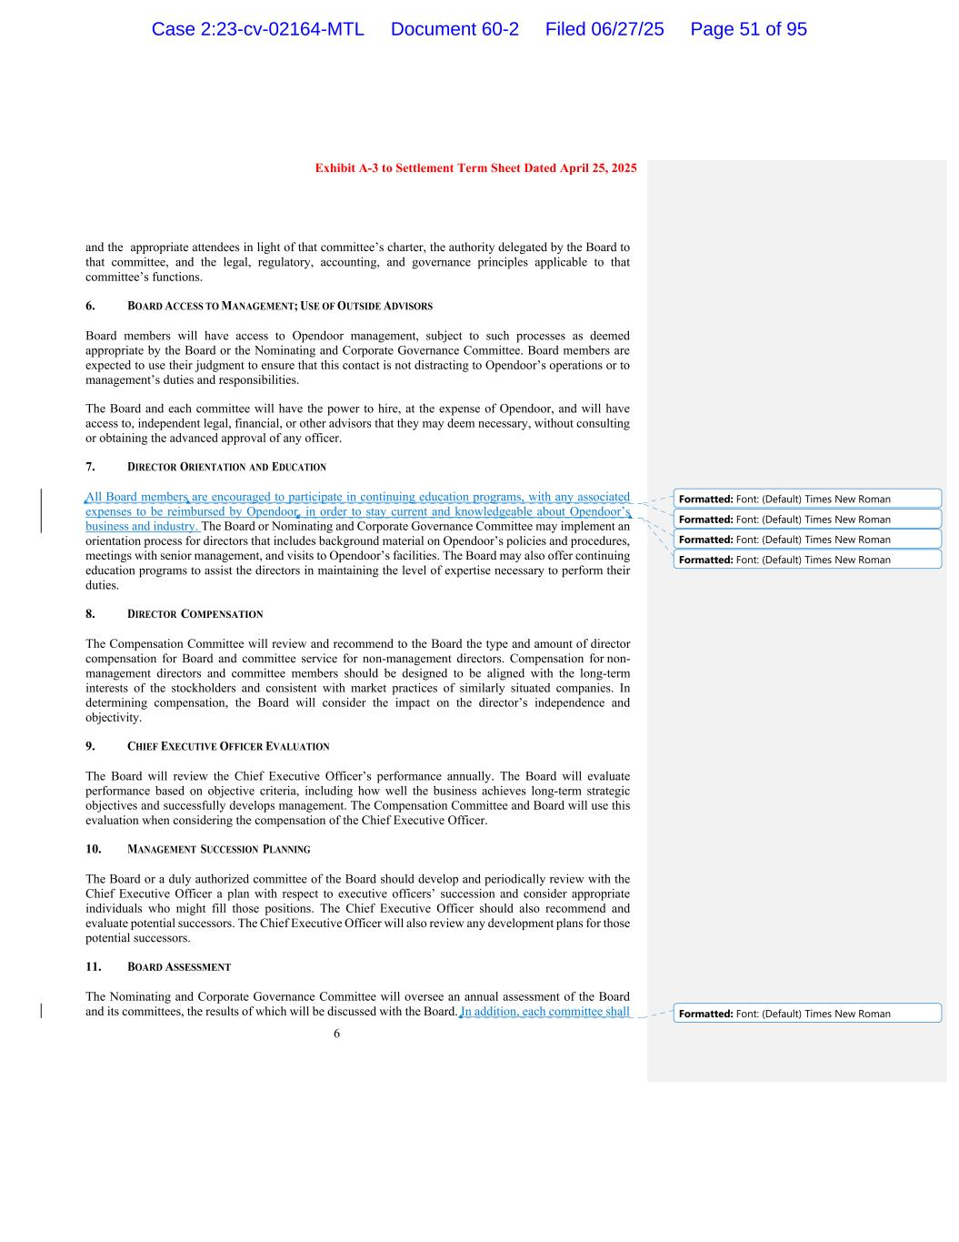
6 Exhibit A-3 to Settlement Term Sheet Dated April 25, 2025 and the appropriate attendees in light of that committee’s charter, the authority delegated by the Board to that committee, and the legal, regulatory, accounting, and governance principles applicable to that committee’s functions. 6. BOARD ACCESS TO MANAGEMENT; USE OF OUTSIDE ADVISORS Board members will have access to Opendoor management, subject to such processes as deemed appropriate by the Board or the Nominating and Corporate Governance Committee. Board members are expected to use their judgment to ensure that this contact is not distracting to Opendoor’s operations or to management’s duties and responsibilities. The Board and each committee will have the power to hire, at the expense of Opendoor, and will have access to, independent legal, financial, or other advisors that they may deem necessary, without consulting or obtaining the advanced approval of any officer. 7. DIRECTOR ORIENTATION AND EDUCATION All Board members are encouraged to participate in continuing education programs, with any associated expenses to be reimbursed by Opendoor, in order to stay current and knowledgeable about Opendoor’s business and industry. The Board or Nominating and Corporate Governance Committee may implement an orientation process for directors that includes background material on Opendoor’s policies and procedures, meetings with senior management, and visits to Opendoor’s facilities. The Board may also offer continuing education programs to assist the directors in maintaining the level of expertise necessary to perform their duties. 8. DIRECTOR COMPENSATION The Compensation Committee will review and recommend to the Board the type and amount of director compensation for Board and committee service for non-management directors. Compensation for non- management directors and committee members should be designed to be aligned with the long-term interests of the stockholders and consistent with market practices of similarly situated companies. In determining compensation, the Board will consider the impact on the director’s independence and objectivity. 9. CHIEF EXECUTIVE OFFICER EVALUATION The Board will review the Chief Executive Officer’s performance annually. The Board will evaluate performance based on objective criteria, including how well the business achieves long-term strategic objectives and successfully develops management. The Compensation Committee and Board will use this evaluation when considering the compensation of the Chief Executive Officer. 10. MANAGEMENT SUCCESSION PLANNING The Board or a duly authorized committee of the Board should develop and periodically review with the Chief Executive Officer a plan with respect to executive officers’ succession and consider appropriate individuals who might fill those positions. The Chief Executive Officer should also recommend and evaluate potential successors. The Chief Executive Officer will also review any development plans for those potential successors. 11. BOARD ASSESSMENT The Nominating and Corporate Governance Committee will oversee an annual assessment of the Board and its committees, the results of which will be discussed with the Board. In addition, each committee shall Formatted: Font: (Default) Times New Roman Formatted: Font: (Default) Times New Roman Formatted: Font: (Default) Times New Roman Formatted: Font: (Default) Times New Roman Formatted: Font: (Default) Times New Roman Case 2:23-cv-02164-MTL Document 60-2 Filed 06/27/25 Page 51 of 95

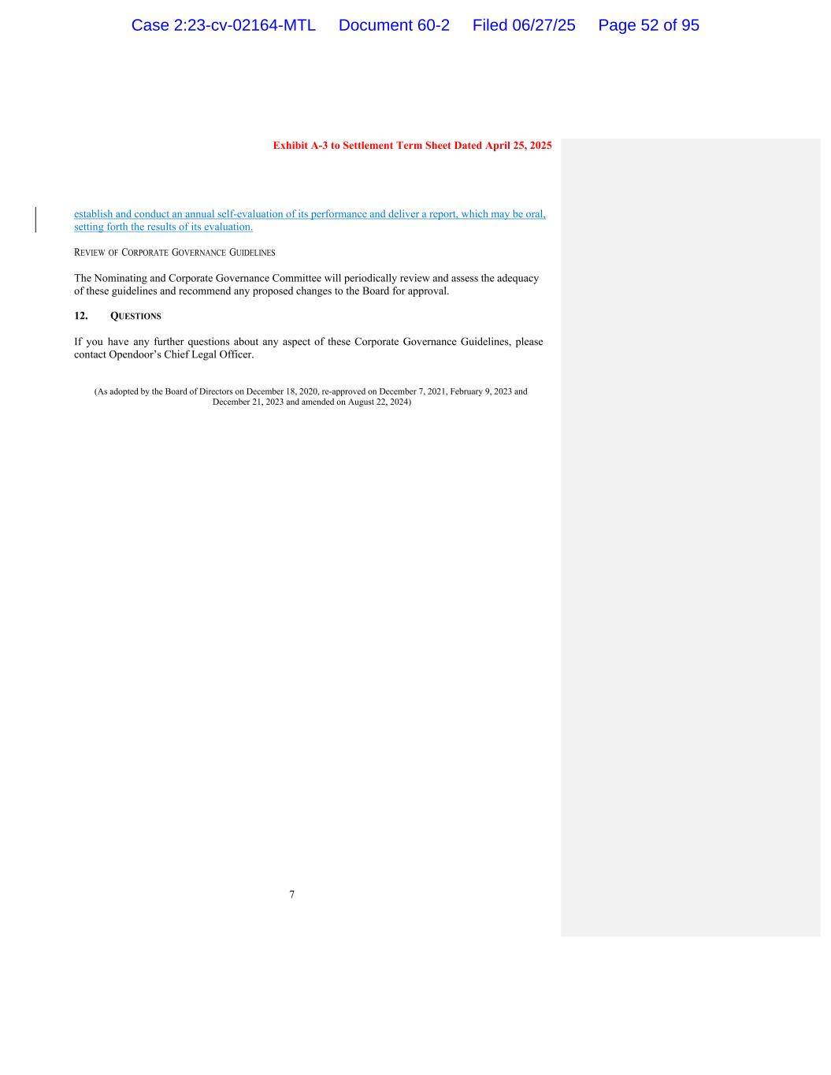
7 Exhibit A-3 to Settlement Term Sheet Dated April 25, 2025 establish and conduct an annual self-evaluation of its performance and deliver a report, which may be oral, setting forth the results of its evaluation. REVIEW OF CORPORATE GOVERNANCE GUIDELINES The Nominating and Corporate Governance Committee will periodically review and assess the adequacy of these guidelines and recommend any proposed changes to the Board for approval. 12. QUESTIONS If you have any further questions about any aspect of these Corporate Governance Guidelines, please contact Opendoor’s Chief Legal Officer. (As adopted by the Board of Directors on December 18, 2020, re-approved on December 7, 2021, February 9, 2023 and December 21, 2023 and amended on August 22, 2024) Case 2:23-cv-02164-MTL Document 60-2 Filed 06/27/25 Page 52 of 95


Exhibit 3 Case 2:23-cv-02164-MTL Document 60-2 Filed 06/27/25 Page 53 of 95

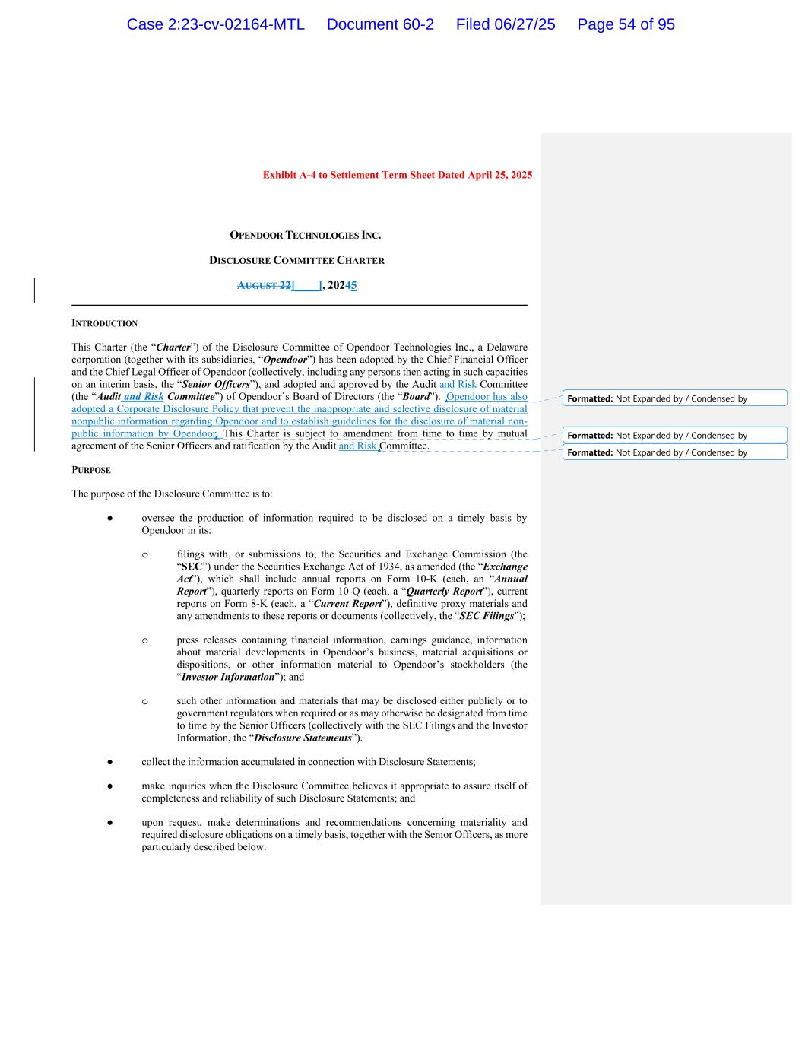
Exhibit A-4 to Settlement Term Sheet Dated April 25, 2025 OPENDOOR TECHNOLOGIES INC. DISCLOSURE COMMITTEE CHARTER AUGUST 22[____], 20245 INTRODUCTION This Charter (the “Charter”) of the Disclosure Committee of Opendoor Technologies Inc., a Delaware corporation (together with its subsidiaries, “Opendoor”) has been adopted by the Chief Financial Officer and the Chief Legal Officer of Opendoor (collectively, including any persons then acting in such capacities on an interim basis, the “Senior Officers”), and adopted and approved by the Audit and Risk Committee (the “Audit and Risk Committee”) of Opendoor’s Board of Directors (the “Board”). Opendoor has also adopted a Corporate Disclosure Policy that prevent the inappropriate and selective disclosure of material nonpublic information regarding Opendoor and to establish guidelines for the disclosure of material non- public information by Opendoor. This Charter is subject to amendment from time to time by mutual agreement of the Senior Officers and ratification by the Audit and Risk Committee. PURPOSE The purpose of the Disclosure Committee is to: ● oversee the production of information required to be disclosed on a timely basis by Opendoor in its: o filings with, or submissions to, the Securities and Exchange Commission (the “SEC”) under the Securities Exchange Act of 1934, as amended (the “Exchange Act”), which shall include annual reports on Form 10-K (each, an “Annual Report”), quarterly reports on Form 10-Q (each, a “Quarterly Report”), current reports on Form 8-K (each, a “Current Report”), definitive proxy materials and any amendments to these reports or documents (collectively, the “SEC Filings”); o press releases containing financial information, earnings guidance, information about material developments in Opendoor’s business, material acquisitions or dispositions, or other information material to Opendoor’s stockholders (the “Investor Information”); and o such other information and materials that may be disclosed either publicly or to government regulators when required or as may otherwise be designated from time to time by the Senior Officers (collectively with the SEC Filings and the Investor Information, the “Disclosure Statements”). ● collect the information accumulated in connection with Disclosure Statements; ● make inquiries when the Disclosure Committee believes it appropriate to assure itself of completeness and reliability of such Disclosure Statements; and ● upon request, make determinations and recommendations concerning materiality and required disclosure obligations on a timely basis, together with the Senior Officers, as more particularly described below. Formatted: Not Expanded by / Condensed by Formatted: Not Expanded by / Condensed by Formatted: Not Expanded by / Condensed by Case 2:23-cv-02164-MTL Document 60-2 Filed 06/27/25 Page 54 of 95

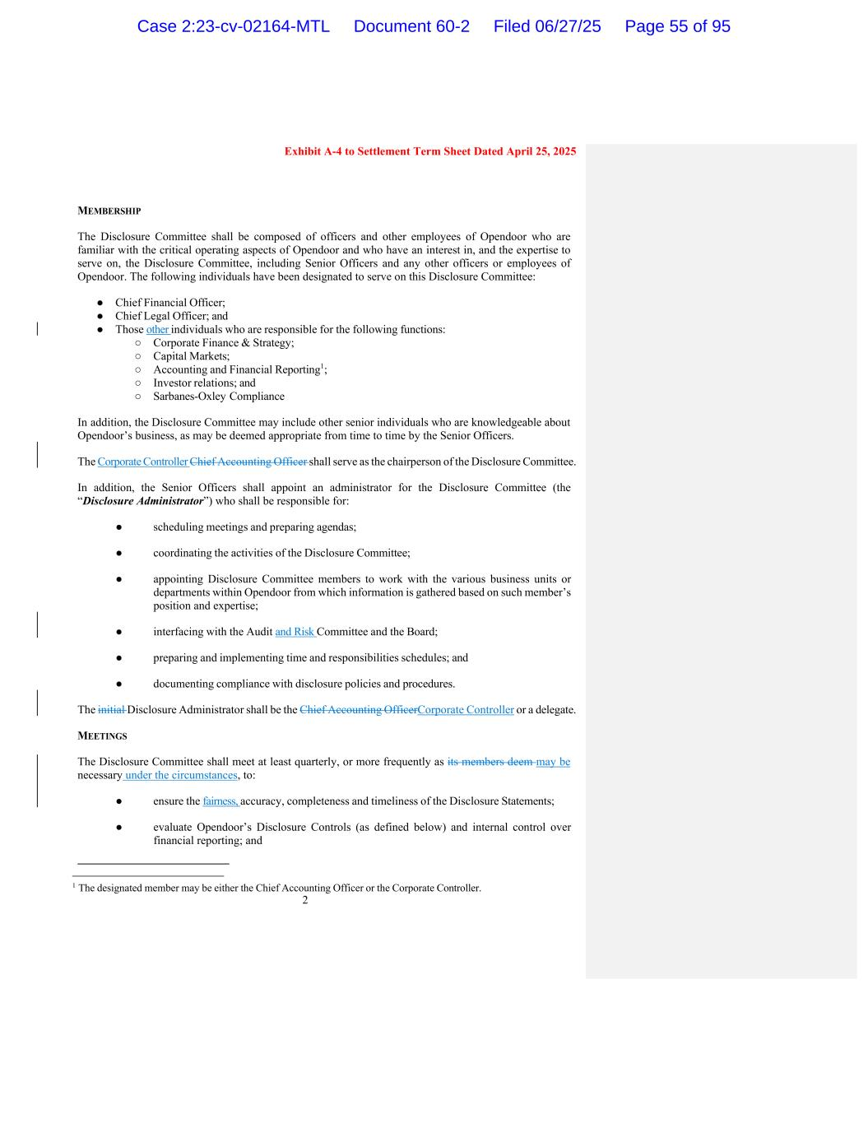
2 Exhibit A-4 to Settlement Term Sheet Dated April 25, 2025 MEMBERSHIP The Disclosure Committee shall be composed of officers and other employees of Opendoor who are familiar with the critical operating aspects of Opendoor and who have an interest in, and the expertise to serve on, the Disclosure Committee, including Senior Officers and any other officers or employees of Opendoor. The following individuals have been designated to serve on this Disclosure Committee: ● Chief Financial Officer; ● Chief Legal Officer; and ● Those other individuals who are responsible for the following functions: ○ Corporate Finance & Strategy; ○ Capital Markets; ○ Accounting and Financial Reporting1; ○ Investor relations; and ○ Sarbanes-Oxley Compliance In addition, the Disclosure Committee may include other senior individuals who are knowledgeable about Opendoor’s business, as may be deemed appropriate from time to time by the Senior Officers. The Corporate Controller Chief Accounting Officer shall serve as the chairperson of the Disclosure Committee. In addition, the Senior Officers shall appoint an administrator for the Disclosure Committee (the “Disclosure Administrator”) who shall be responsible for: ● scheduling meetings and preparing agendas; ● coordinating the activities of the Disclosure Committee; ● appointing Disclosure Committee members to work with the various business units or departments within Opendoor from which information is gathered based on such member’s position and expertise; ● interfacing with the Audit and Risk Committee and the Board; ● preparing and implementing time and responsibilities schedules; and ● documenting compliance with disclosure policies and procedures. The initial Disclosure Administrator shall be the Chief Accounting OfficerCorporate Controller or a delegate. MEETINGS The Disclosure Committee shall meet at least quarterly, or more frequently as its members deem may be necessary under the circumstances, to: ● ensure the fairness, accuracy, completeness and timeliness of the Disclosure Statements; ● evaluate Opendoor’s Disclosure Controls (as defined below) and internal control over financial reporting; and 1 The designated member may be either the Chief Accounting Officer or the Corporate Controller. Case 2:23-cv-02164-MTL Document 60-2 Filed 06/27/25 Page 55 of 95

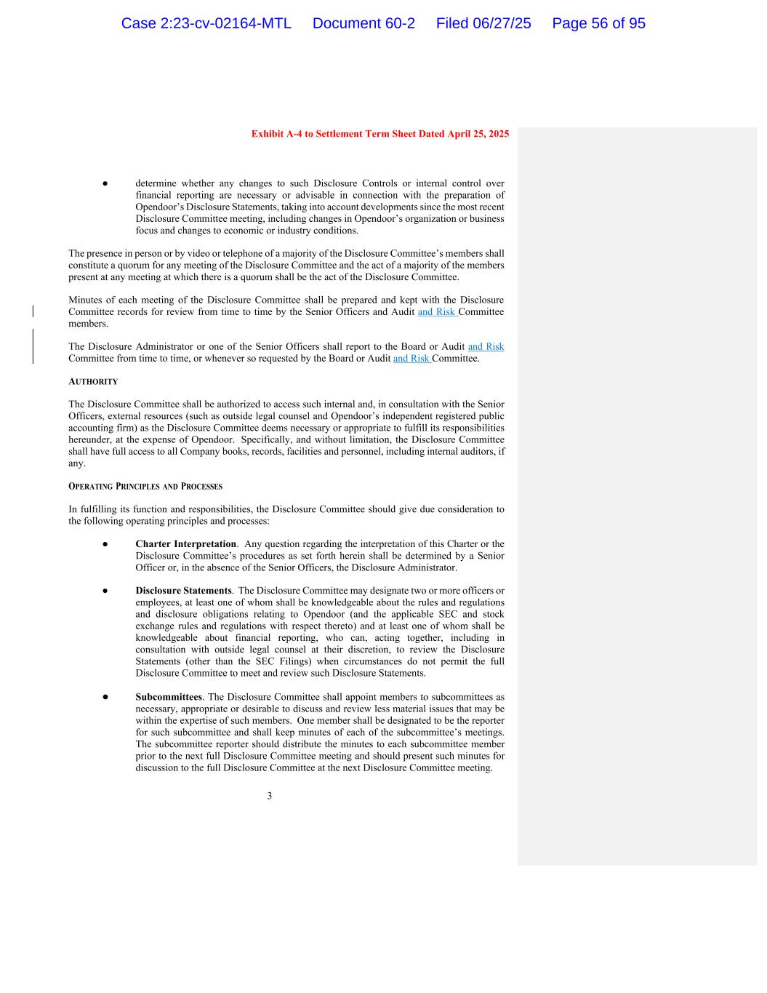
3 Exhibit A-4 to Settlement Term Sheet Dated April 25, 2025 ● determine whether any changes to such Disclosure Controls or internal control over financial reporting are necessary or advisable in connection with the preparation of Opendoor’s Disclosure Statements, taking into account developments since the most recent Disclosure Committee meeting, including changes in Opendoor’s organization or business focus and changes to economic or industry conditions. The presence in person or by video or telephone of a majority of the Disclosure Committee’s members shall constitute a quorum for any meeting of the Disclosure Committee and the act of a majority of the members present at any meeting at which there is a quorum shall be the act of the Disclosure Committee. Minutes of each meeting of the Disclosure Committee shall be prepared and kept with the Disclosure Committee records for review from time to time by the Senior Officers and Audit and Risk Committee members. The Disclosure Administrator or one of the Senior Officers shall report to the Board or Audit and Risk Committee from time to time, or whenever so requested by the Board or Audit and Risk Committee. AUTHORITY The Disclosure Committee shall be authorized to access such internal and, in consultation with the Senior Officers, external resources (such as outside legal counsel and Opendoor’s independent registered public accounting firm) as the Disclosure Committee deems necessary or appropriate to fulfill its responsibilities hereunder, at the expense of Opendoor. Specifically, and without limitation, the Disclosure Committee shall have full access to all Company books, records, facilities and personnel, including internal auditors, if any. OPERATING PRINCIPLES AND PROCESSES In fulfilling its function and responsibilities, the Disclosure Committee should give due consideration to the following operating principles and processes: ● Charter Interpretation. Any question regarding the interpretation of this Charter or the Disclosure Committee’s procedures as set forth herein shall be determined by a Senior Officer or, in the absence of the Senior Officers, the Disclosure Administrator. ● Disclosure Statements. The Disclosure Committee may designate two or more officers or employees, at least one of whom shall be knowledgeable about the rules and regulations and disclosure obligations relating to Opendoor (and the applicable SEC and stock exchange rules and regulations with respect thereto) and at least one of whom shall be knowledgeable about financial reporting, who can, acting together, including in consultation with outside legal counsel at their discretion, to review the Disclosure Statements (other than the SEC Filings) when circumstances do not permit the full Disclosure Committee to meet and review such Disclosure Statements. ● Subcommittees. The Disclosure Committee shall appoint members to subcommittees as necessary, appropriate or desirable to discuss and review less material issues that may be within the expertise of such members. One member shall be designated to be the reporter for such subcommittee and shall keep minutes of each of the subcommittee’s meetings. The subcommittee reporter should distribute the minutes to each subcommittee member prior to the next full Disclosure Committee meeting and should present such minutes for discussion to the full Disclosure Committee at the next Disclosure Committee meeting. Case 2:23-cv-02164-MTL Document 60-2 Filed 06/27/25 Page 56 of 95

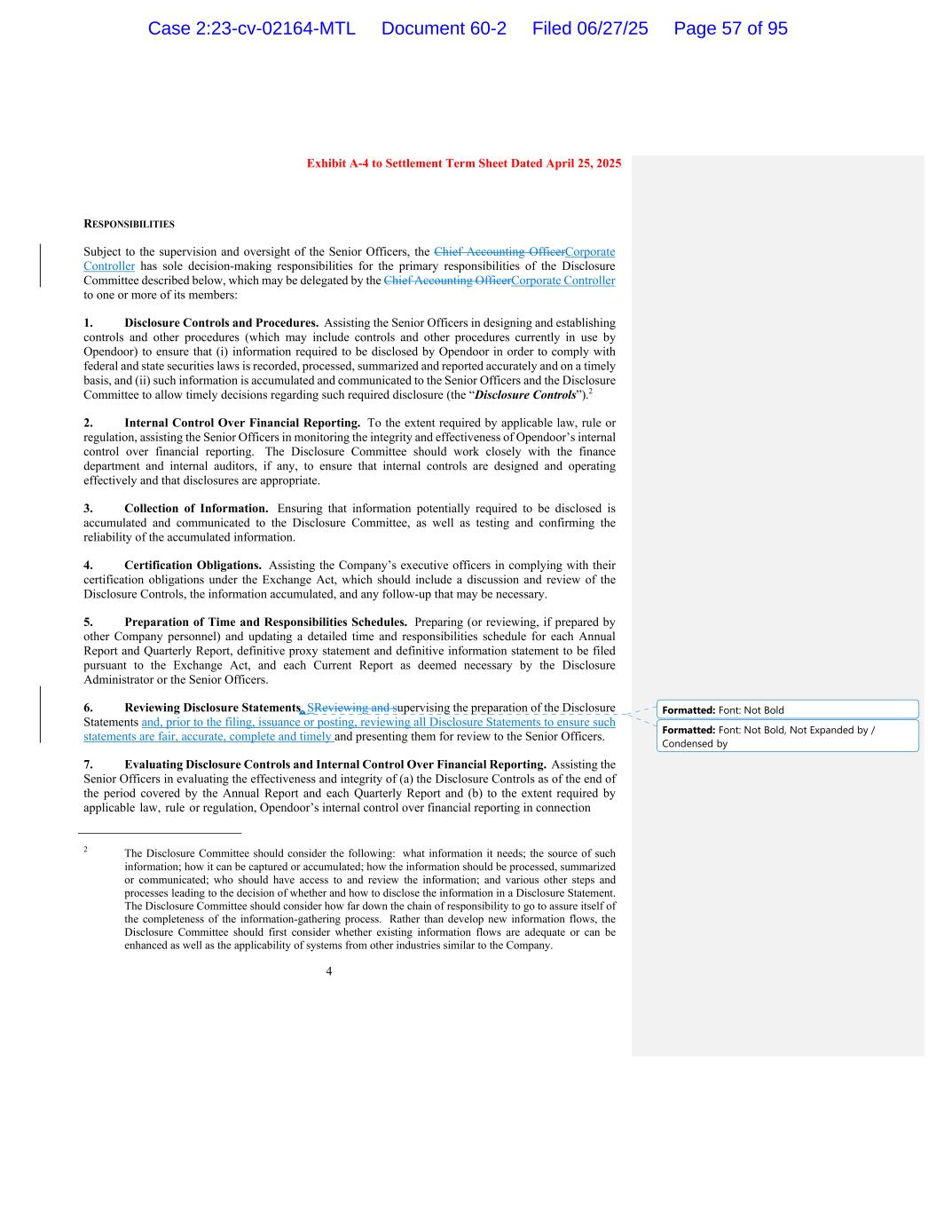
4 Exhibit A-4 to Settlement Term Sheet Dated April 25, 2025 RESPONSIBILITIES Subject to the supervision and oversight of the Senior Officers, the Chief Accounting OfficerCorporate Controller has sole decision-making responsibilities for the primary responsibilities of the Disclosure Committee described below, which may be delegated by the Chief Accounting OfficerCorporate Controller to one or more of its members: 1. Disclosure Controls and Procedures. Assisting the Senior Officers in designing and establishing controls and other procedures (which may include controls and other procedures currently in use by Opendoor) to ensure that (i) information required to be disclosed by Opendoor in order to comply with federal and state securities laws is recorded, processed, summarized and reported accurately and on a timely basis, and (ii) such information is accumulated and communicated to the Senior Officers and the Disclosure Committee to allow timely decisions regarding such required disclosure (the “Disclosure Controls”).2 2. Internal Control Over Financial Reporting. To the extent required by applicable law, rule or regulation, assisting the Senior Officers in monitoring the integrity and effectiveness of Opendoor’s internal control over financial reporting. The Disclosure Committee should work closely with the finance department and internal auditors, if any, to ensure that internal controls are designed and operating effectively and that disclosures are appropriate. 3. Collection of Information. Ensuring that information potentially required to be disclosed is accumulated and communicated to the Disclosure Committee, as well as testing and confirming the reliability of the accumulated information. 4. Certification Obligations. Assisting the Company’s executive officers in complying with their certification obligations under the Exchange Act, which should include a discussion and review of the Disclosure Controls, the information accumulated, and any follow-up that may be necessary. 5. Preparation of Time and Responsibilities Schedules. Preparing (or reviewing, if prepared by other Company personnel) and updating a detailed time and responsibilities schedule for each Annual Report and Quarterly Report, definitive proxy statement and definitive information statement to be filed pursuant to the Exchange Act, and each Current Report as deemed necessary by the Disclosure Administrator or the Senior Officers. 6. Reviewing Disclosure Statements. SReviewing and supervising the preparation of the Disclosure Statements and, prior to the filing, issuance or posting, reviewing all Disclosure Statements to ensure such statements are fair, accurate, complete and timely and presenting them for review to the Senior Officers. 7. Evaluating Disclosure Controls and Internal Control Over Financial Reporting. Assisting the Senior Officers in evaluating the effectiveness and integrity of (a) the Disclosure Controls as of the end of the period covered by the Annual Report and each Quarterly Report and (b) to the extent required by applicable law, rule or regulation, Opendoor’s internal control over financial reporting in connection 2 The Disclosure Committee should consider the following: what information it needs; the source of such information; how it can be captured or accumulated; how the information should be processed, summarized or communicated; who should have access to and review the information; and various other steps and processes leading to the decision of whether and how to disclose the information in a Disclosure Statement. The Disclosure Committee should consider how far down the chain of responsibility to go to assure itself of the completeness of the information-gathering process. Rather than develop new information flows, the Disclosure Committee should first consider whether existing information flows are adequate or can be enhanced as well as the applicability of systems from other industries similar to the Company. Formatted: Font: Not Bold Formatted: Font: Not Bold, Not Expanded by / Condensed by Case 2:23-cv-02164-MTL Document 60-2 Filed 06/27/25 Page 57 of 95

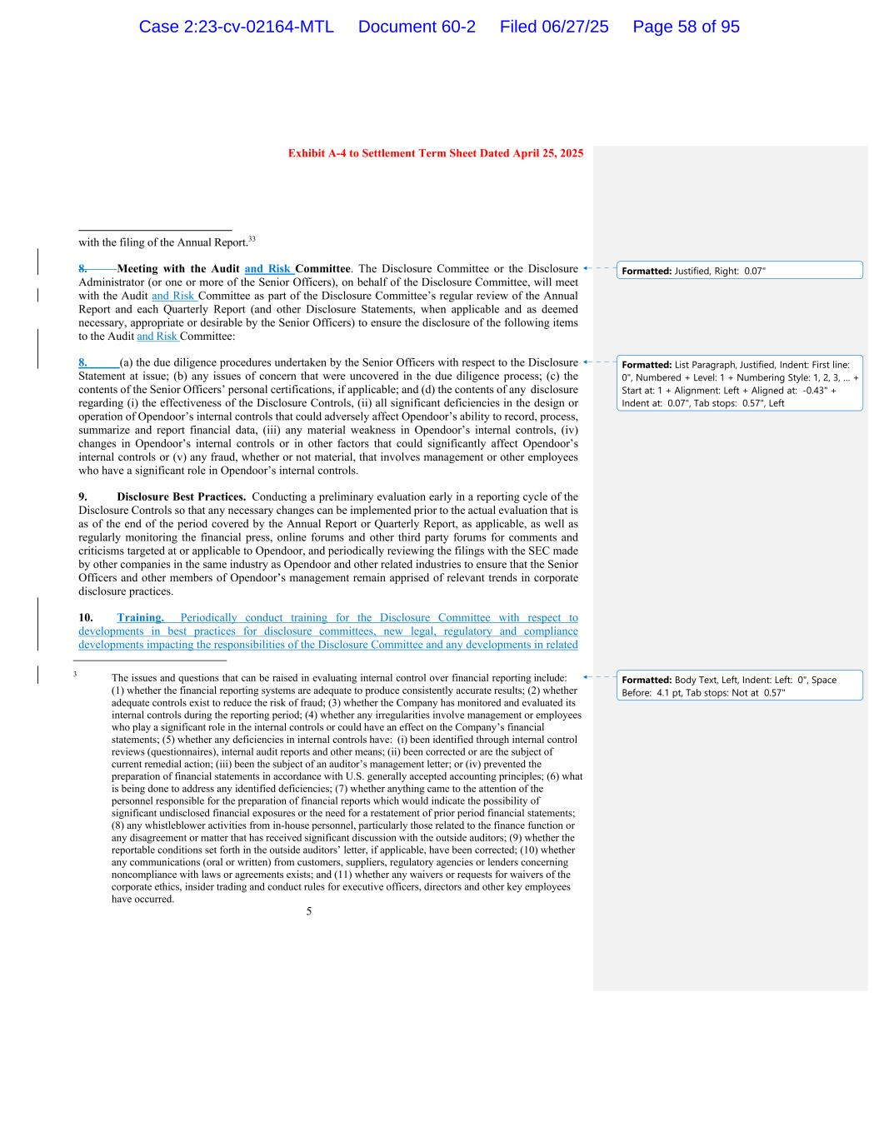
5 Exhibit A-4 to Settlement Term Sheet Dated April 25, 2025 with the filing of the Annual Report.33 8. Meeting with the Audit and Risk Committee. The Disclosure Committee or the Disclosure Administrator (or one or more of the Senior Officers), on behalf of the Disclosure Committee, will meet with the Audit and Risk Committee as part of the Disclosure Committee’s regular review of the Annual Report and each Quarterly Report (and other Disclosure Statements, when applicable and as deemed necessary, appropriate or desirable by the Senior Officers) to ensure the disclosure of the following items to the Audit and Risk Committee: 8. (a) the due diligence procedures undertaken by the Senior Officers with respect to the Disclosure Statement at issue; (b) any issues of concern that were uncovered in the due diligence process; (c) the contents of the Senior Officers’ personal certifications, if applicable; and (d) the contents of any disclosure regarding (i) the effectiveness of the Disclosure Controls, (ii) all significant deficiencies in the design or operation of Opendoor’s internal controls that could adversely affect Opendoor’s ability to record, process, summarize and report financial data, (iii) any material weakness in Opendoor’s internal controls, (iv) changes in Opendoor’s internal controls or in other factors that could significantly affect Opendoor’s internal controls or (v) any fraud, whether or not material, that involves management or other employees who have a significant role in Opendoor’s internal controls. 9. Disclosure Best Practices. Conducting a preliminary evaluation early in a reporting cycle of the Disclosure Controls so that any necessary changes can be implemented prior to the actual evaluation that is as of the end of the period covered by the Annual Report or Quarterly Report, as applicable, as well as regularly monitoring the financial press, online forums and other third party forums for comments and criticisms targeted at or applicable to Opendoor, and periodically reviewing the filings with the SEC made by other companies in the same industry as Opendoor and other related industries to ensure that the Senior Officers and other members of Opendoor’s management remain apprised of relevant trends in corporate disclosure practices. 10. Training. Periodically conduct training for the Disclosure Committee with respect to developments in best practices for disclosure committees, new legal, regulatory and compliance developments impacting the responsibilities of the Disclosure Committee and any developments in related 3 The issues and questions that can be raised in evaluating internal control over financial reporting include: (1) whether the financial reporting systems are adequate to produce consistently accurate results; (2) whether adequate controls exist to reduce the risk of fraud; (3) whether the Company has monitored and evaluated its internal controls during the reporting period; (4) whether any irregularities involve management or employees who play a significant role in the internal controls or could have an effect on the Company’s financial statements; (5) whether any deficiencies in internal controls have: (i) been identified through internal control reviews (questionnaires), internal audit reports and other means; (ii) been corrected or are the subject of current remedial action; (iii) been the subject of an auditor’s management letter; or (iv) prevented the preparation of financial statements in accordance with U.S. generally accepted accounting principles; (6) what is being done to address any identified deficiencies; (7) whether anything came to the attention of the personnel responsible for the preparation of financial reports which would indicate the possibility of significant undisclosed financial exposures or the need for a restatement of prior period financial statements; (8) any whistleblower activities from in-house personnel, particularly those related to the finance function or any disagreement or matter that has received significant discussion with the outside auditors; (9) whether the reportable conditions set forth in the outside auditors’ letter, if applicable, have been corrected; (10) whether any communications (oral or written) from customers, suppliers, regulatory agencies or lenders concerning noncompliance with laws or agreements exists; and (11) whether any waivers or requests for waivers of the corporate ethics, insider trading and conduct rules for executive officers, directors and other key employees have occurred. Formatted: Justified, Right: 0.07" Formatted: List Paragraph, Justified, Indent: First line: 0", Numbered + Level: 1 + Numbering Style: 1, 2, 3, … + Start at: 1 + Alignment: Left + Aligned at: -0.43" + Indent at: 0.07", Tab stops: 0.57", Left Formatted: Body Text, Left, Indent: Left: 0", Space Before: 4.1 pt, Tab stops: Not at 0.57" Case 2:23-cv-02164-MTL Document 60-2 Filed 06/27/25 Page 58 of 95

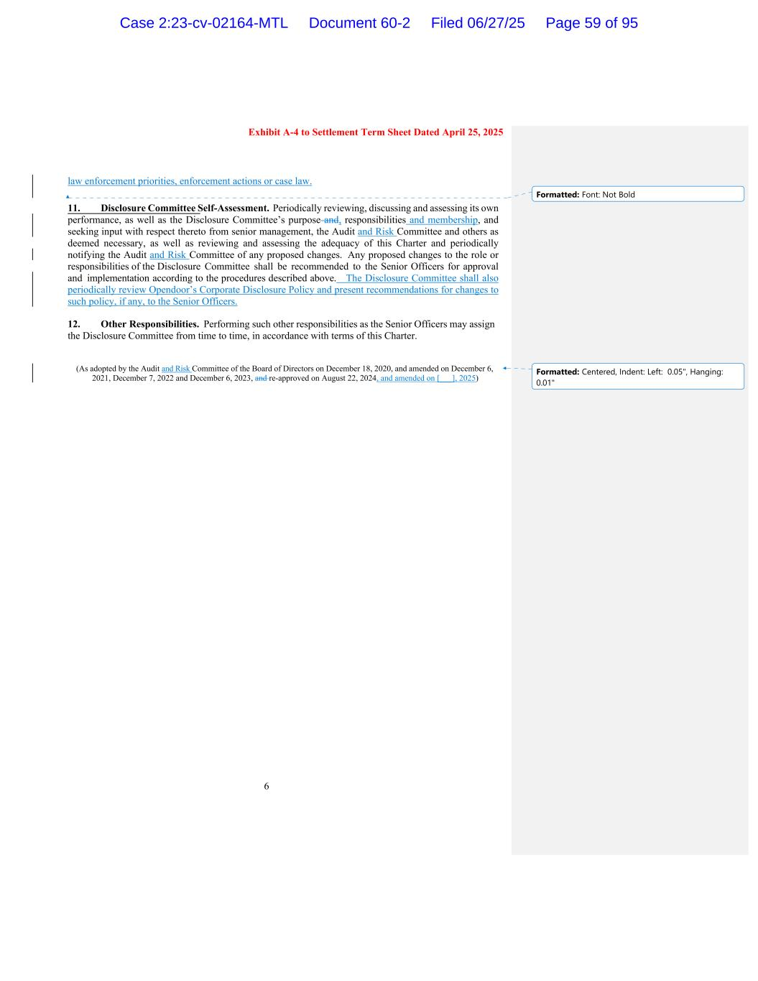
6 Exhibit A-4 to Settlement Term Sheet Dated April 25, 2025 law enforcement priorities, enforcement actions or case law. 11. Disclosure Committee Self-Assessment. Periodically reviewing, discussing and assessing its own performance, as well as the Disclosure Committee’s purpose and, responsibilities and membership, and seeking input with respect thereto from senior management, the Audit and Risk Committee and others as deemed necessary, as well as reviewing and assessing the adequacy of this Charter and periodically notifying the Audit and Risk Committee of any proposed changes. Any proposed changes to the role or responsibilities of the Disclosure Committee shall be recommended to the Senior Officers for approval and implementation according to the procedures described above. The Disclosure Committee shall also periodically review Opendoor’s Corporate Disclosure Policy and present recommendations for changes to such policy, if any, to the Senior Officers. 12. Other Responsibilities. Performing such other responsibilities as the Senior Officers may assign the Disclosure Committee from time to time, in accordance with terms of this Charter. (As adopted by the Audit and Risk Committee of the Board of Directors on December 18, 2020, and amended on December 6, 2021, December 7, 2022 and December 6, 2023, and re-approved on August 22, 2024, and amended on [___], 2025) Formatted: Font: Not Bold Formatted: Centered, Indent: Left: 0.05", Hanging: 0.01" Case 2:23-cv-02164-MTL Document 60-2 Filed 06/27/25 Page 59 of 95


Exhibit 4 Case 2:23-cv-02164-MTL Document 60-2 Filed 06/27/25 Page 60 of 95

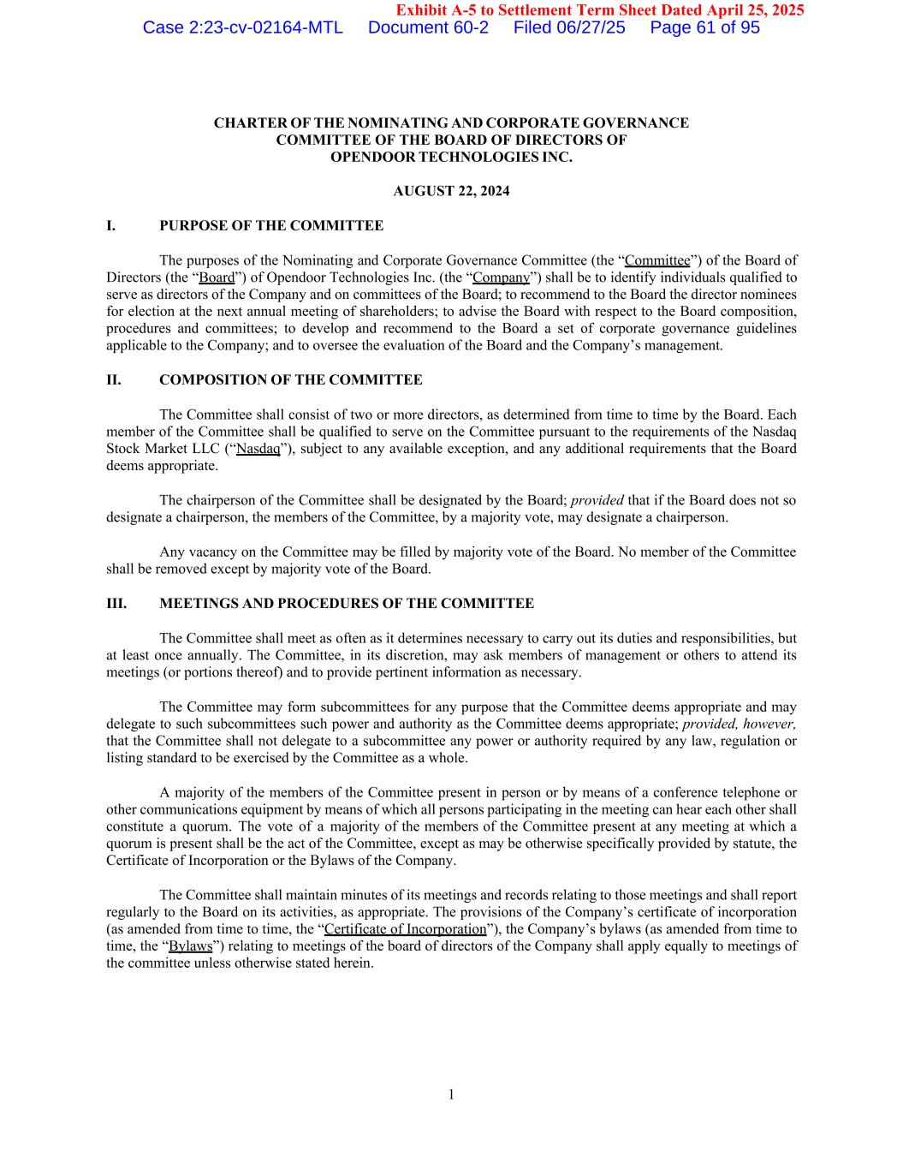
1 Exhibit A-5 to Settlement Term Sheet Dated April 25, 2025 CHARTER OF THE NOMINATING AND CORPORATE GOVERNANCE COMMITTEE OF THE BOARD OF DIRECTORS OF OPENDOOR TECHNOLOGIES INC. AUGUST 22, 2024 I. PURPOSE OF THE COMMITTEE The purposes of the Nominating and Corporate Governance Committee (the “Committee”) of the Board of Directors (the “Board”) of Opendoor Technologies Inc. (the “Company”) shall be to identify individuals qualified to serve as directors of the Company and on committees of the Board; to recommend to the Board the director nominees for election at the next annual meeting of shareholders; to advise the Board with respect to the Board composition, procedures and committees; to develop and recommend to the Board a set of corporate governance guidelines applicable to the Company; and to oversee the evaluation of the Board and the Company’s management. II. COMPOSITION OF THE COMMITTEE The Committee shall consist of two or more directors, as determined from time to time by the Board. Each member of the Committee shall be qualified to serve on the Committee pursuant to the requirements of the Nasdaq Stock Market LLC (“Nasdaq”), subject to any available exception, and any additional requirements that the Board deems appropriate. The chairperson of the Committee shall be designated by the Board; provided that if the Board does not so designate a chairperson, the members of the Committee, by a majority vote, may designate a chairperson. Any vacancy on the Committee may be filled by majority vote of the Board. No member of the Committee shall be removed except by majority vote of the Board. III. MEETINGS AND PROCEDURES OF THE COMMITTEE The Committee shall meet as often as it determines necessary to carry out its duties and responsibilities, but at least once annually. The Committee, in its discretion, may ask members of management or others to attend its meetings (or portions thereof) and to provide pertinent information as necessary. The Committee may form subcommittees for any purpose that the Committee deems appropriate and may delegate to such subcommittees such power and authority as the Committee deems appropriate; provided, however, that the Committee shall not delegate to a subcommittee any power or authority required by any law, regulation or listing standard to be exercised by the Committee as a whole. A majority of the members of the Committee present in person or by means of a conference telephone or other communications equipment by means of which all persons participating in the meeting can hear each other shall constitute a quorum. The vote of a majority of the members of the Committee present at any meeting at which a quorum is present shall be the act of the Committee, except as may be otherwise specifically provided by statute, the Certificate of Incorporation or the Bylaws of the Company. The Committee shall maintain minutes of its meetings and records relating to those meetings and shall report regularly to the Board on its activities, as appropriate. The provisions of the Company’s certificate of incorporation (as amended from time to time, the “Certificate of Incorporation”), the Company’s bylaws (as amended from time to time, the “Bylaws”) relating to meetings of the board of directors of the Company shall apply equally to meetings of the committee unless otherwise stated herein. Case 2:23-cv-02164-MTL Document 60-2 Filed 06/27/25 Page 61 of 95

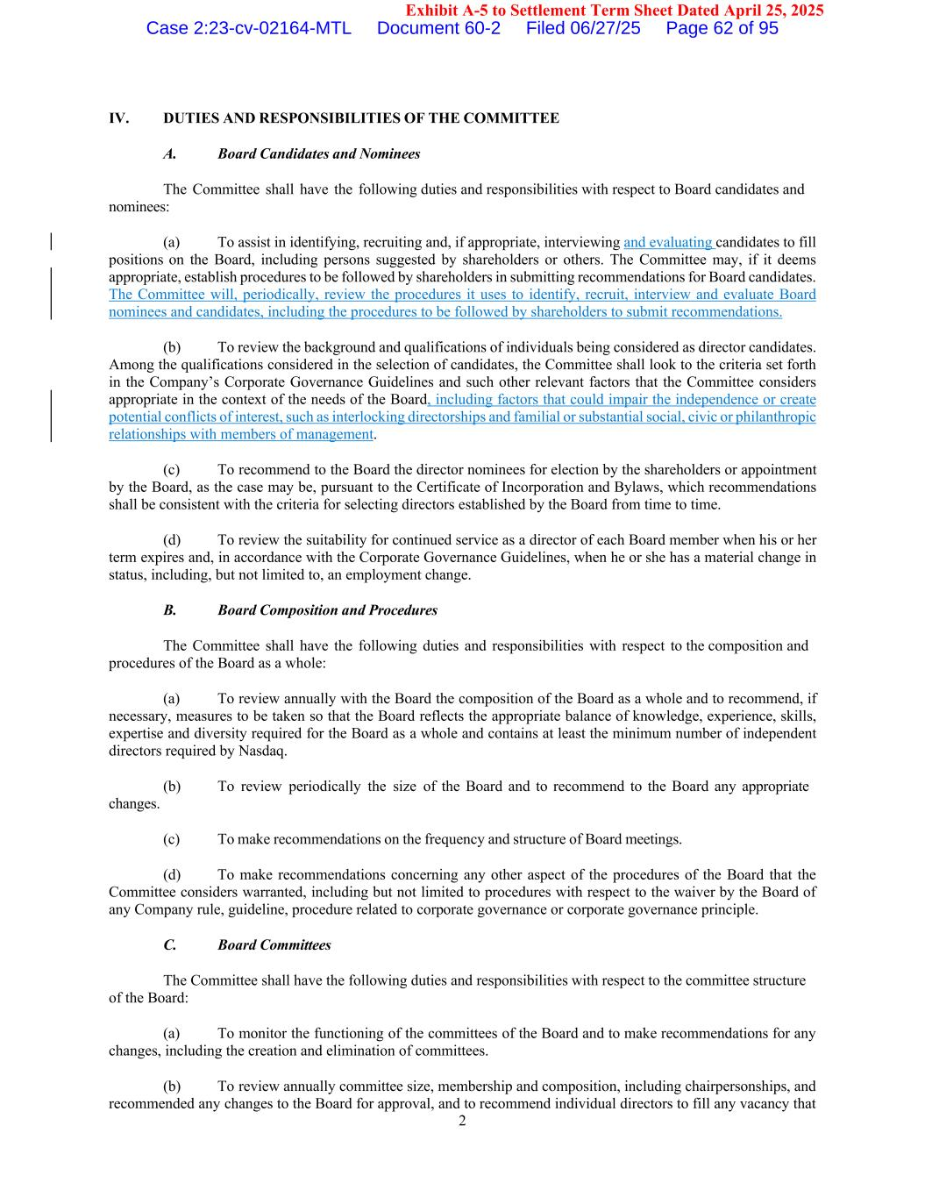
2 Exhibit A-5 to Settlement Term Sheet Dated April 25, 2025 IV. DUTIES AND RESPONSIBILITIES OF THE COMMITTEE A. Board Candidates and Nominees The Committee shall have the following duties and responsibilities with respect to Board candidates and nominees: (a) To assist in identifying, recruiting and, if appropriate, interviewing and evaluating candidates to fill positions on the Board, including persons suggested by shareholders or others. The Committee may, if it deems appropriate, establish procedures to be followed by shareholders in submitting recommendations for Board candidates. The Committee will, periodically, review the procedures it uses to identify, recruit, interview and evaluate Board nominees and candidates, including the procedures to be followed by shareholders to submit recommendations. (b) To review the background and qualifications of individuals being considered as director candidates. Among the qualifications considered in the selection of candidates, the Committee shall look to the criteria set forth in the Company’s Corporate Governance Guidelines and such other relevant factors that the Committee considers appropriate in the context of the needs of the Board, including factors that could impair the independence or create potential conflicts of interest, such as interlocking directorships and familial or substantial social, civic or philanthropic relationships with members of management. (c) To recommend to the Board the director nominees for election by the shareholders or appointment by the Board, as the case may be, pursuant to the Certificate of Incorporation and Bylaws, which recommendations shall be consistent with the criteria for selecting directors established by the Board from time to time. (d) To review the suitability for continued service as a director of each Board member when his or her term expires and, in accordance with the Corporate Governance Guidelines, when he or she has a material change in status, including, but not limited to, an employment change. B. Board Composition and Procedures The Committee shall have the following duties and responsibilities with respect to the composition and procedures of the Board as a whole: (a) To review annually with the Board the composition of the Board as a whole and to recommend, if necessary, measures to be taken so that the Board reflects the appropriate balance of knowledge, experience, skills, expertise and diversity required for the Board as a whole and contains at least the minimum number of independent directors required by Nasdaq. (b) To review periodically the size of the Board and to recommend to the Board any appropriate changes. (c) To make recommendations on the frequency and structure of Board meetings. (d) To make recommendations concerning any other aspect of the procedures of the Board that the Committee considers warranted, including but not limited to procedures with respect to the waiver by the Board of any Company rule, guideline, procedure related to corporate governance or corporate governance principle. C. Board Committees The Committee shall have the following duties and responsibilities with respect to the committee structure of the Board: (a) To monitor the functioning of the committees of the Board and to make recommendations for any changes, including the creation and elimination of committees. (b) To review annually committee size, membership and composition, including chairpersonships, and recommended any changes to the Board for approval, and to recommend individual directors to fill any vacancy that Case 2:23-cv-02164-MTL Document 60-2 Filed 06/27/25 Page 62 of 95


3 Exhibit A-5 to Settlement Term Sheet Dated April 25, 2025 might occur on any committee of the Board. Case 2:23-cv-02164-MTL Document 60-2 Filed 06/27/25 Page 63 of 95

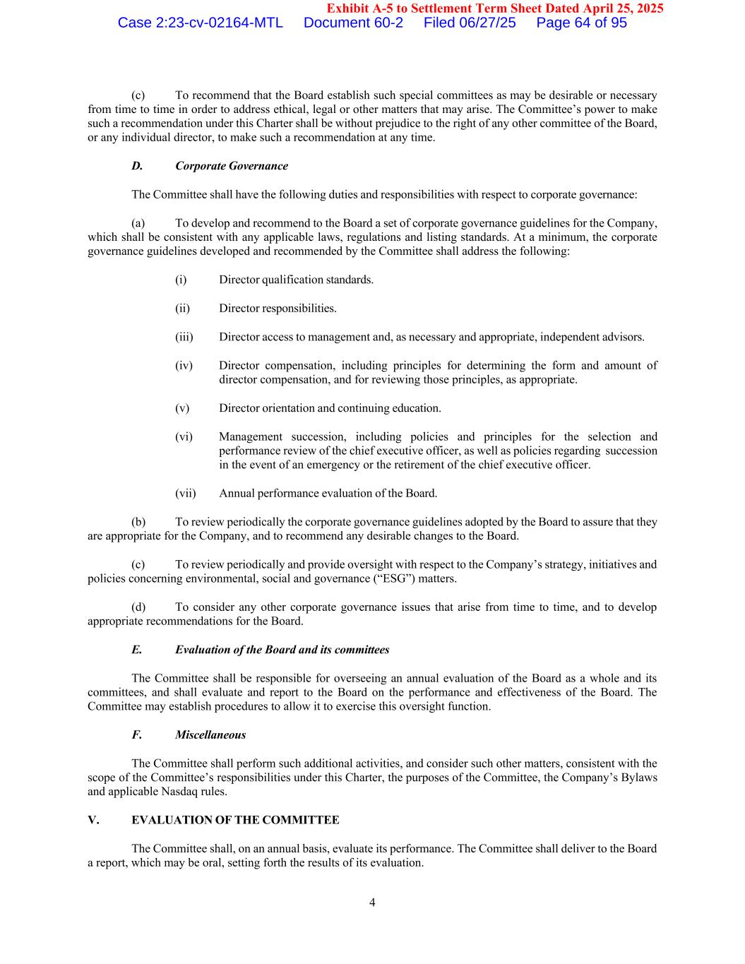
4 Exhibit A-5 to Settlement Term Sheet Dated April 25, 2025 (c) To recommend that the Board establish such special committees as may be desirable or necessary from time to time in order to address ethical, legal or other matters that may arise. The Committee’s power to make such a recommendation under this Charter shall be without prejudice to the right of any other committee of the Board, or any individual director, to make such a recommendation at any time. D. Corporate Governance The Committee shall have the following duties and responsibilities with respect to corporate governance: (a) To develop and recommend to the Board a set of corporate governance guidelines for the Company, which shall be consistent with any applicable laws, regulations and listing standards. At a minimum, the corporate governance guidelines developed and recommended by the Committee shall address the following: (i) Director qualification standards. (ii) Director responsibilities. (iii) Director access to management and, as necessary and appropriate, independent advisors. (iv) Director compensation, including principles for determining the form and amount of director compensation, and for reviewing those principles, as appropriate. (v) Director orientation and continuing education. (vi) Management succession, including policies and principles for the selection and performance review of the chief executive officer, as well as policies regarding succession in the event of an emergency or the retirement of the chief executive officer. (vii) Annual performance evaluation of the Board. (b) To review periodically the corporate governance guidelines adopted by the Board to assure that they are appropriate for the Company, and to recommend any desirable changes to the Board. (c) To review periodically and provide oversight with respect to the Company’s strategy, initiatives and policies concerning environmental, social and governance (“ESG”) matters. (d) To consider any other corporate governance issues that arise from time to time, and to develop appropriate recommendations for the Board. E. Evaluation of the Board and its committees The Committee shall be responsible for overseeing an annual evaluation of the Board as a whole and its committees, and shall evaluate and report to the Board on the performance and effectiveness of the Board. The Committee may establish procedures to allow it to exercise this oversight function. F. Miscellaneous The Committee shall perform such additional activities, and consider such other matters, consistent with the scope of the Committee’s responsibilities under this Charter, the purposes of the Committee, the Company’s Bylaws and applicable Nasdaq rules. V. EVALUATION OF THE COMMITTEE The Committee shall, on an annual basis, evaluate its performance. The Committee shall deliver to the Board a report, which may be oral, setting forth the results of its evaluation. Case 2:23-cv-02164-MTL Document 60-2 Filed 06/27/25 Page 64 of 95

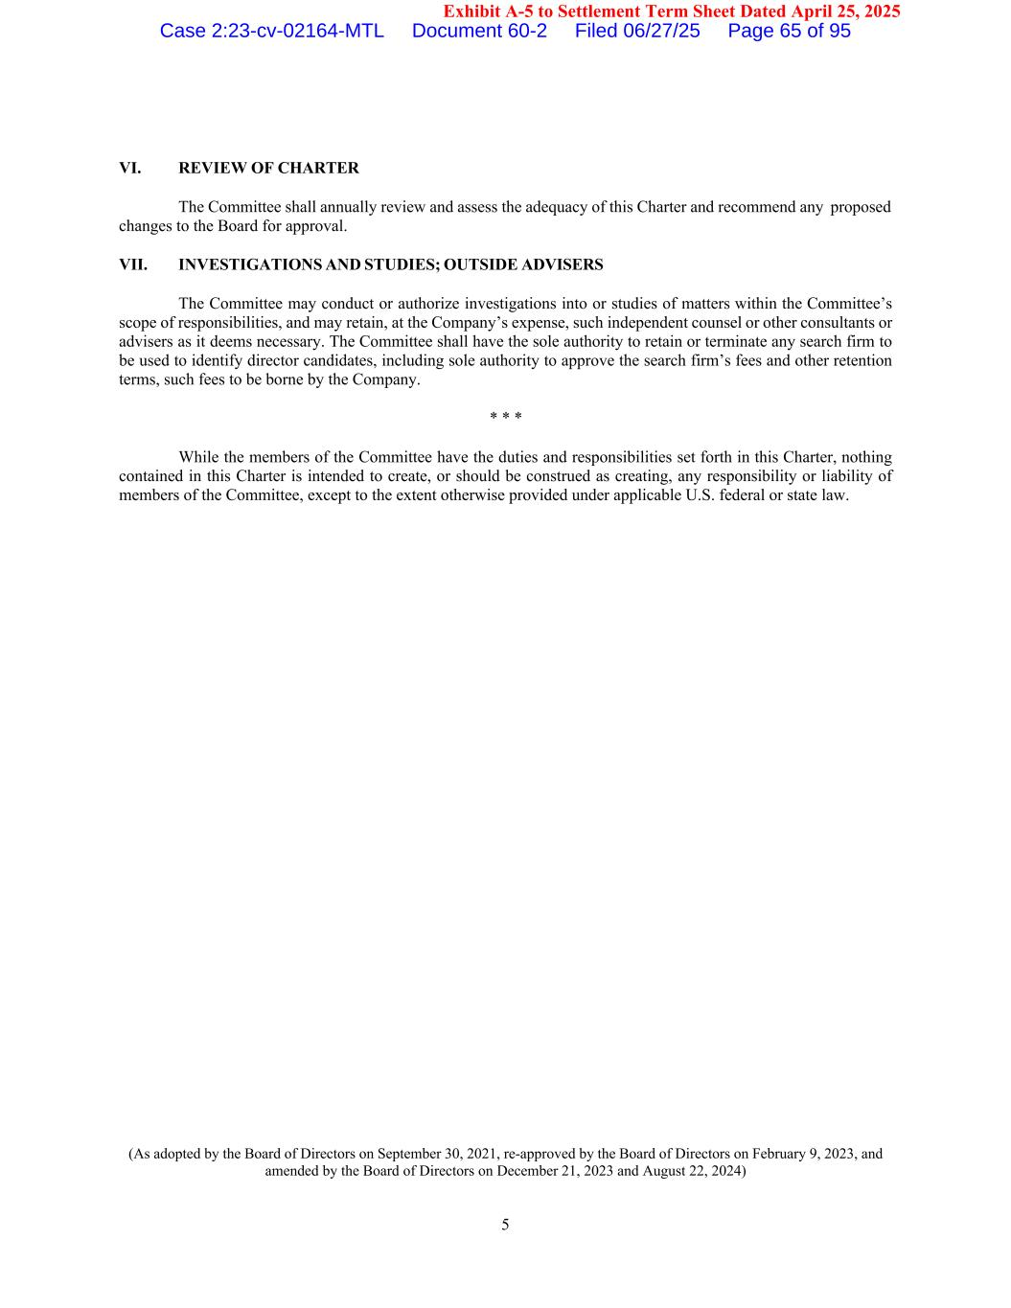
5 Exhibit A-5 to Settlement Term Sheet Dated April 25, 2025 VI. REVIEW OF CHARTER The Committee shall annually review and assess the adequacy of this Charter and recommend any proposed changes to the Board for approval. VII. INVESTIGATIONS AND STUDIES; OUTSIDE ADVISERS The Committee may conduct or authorize investigations into or studies of matters within the Committee’s scope of responsibilities, and may retain, at the Company’s expense, such independent counsel or other consultants or advisers as it deems necessary. The Committee shall have the sole authority to retain or terminate any search firm to be used to identify director candidates, including sole authority to approve the search firm’s fees and other retention terms, such fees to be borne by the Company. * * * While the members of the Committee have the duties and responsibilities set forth in this Charter, nothing contained in this Charter is intended to create, or should be construed as creating, any responsibility or liability of members of the Committee, except to the extent otherwise provided under applicable U.S. federal or state law. (As adopted by the Board of Directors on September 30, 2021, re-approved by the Board of Directors on February 9, 2023, and amended by the Board of Directors on December 21, 2023 and August 22, 2024) Case 2:23-cv-02164-MTL Document 60-2 Filed 06/27/25 Page 65 of 95


Exhibit 5 Case 2:23-cv-02164-MTL Document 60-2 Filed 06/27/25 Page 66 of 95

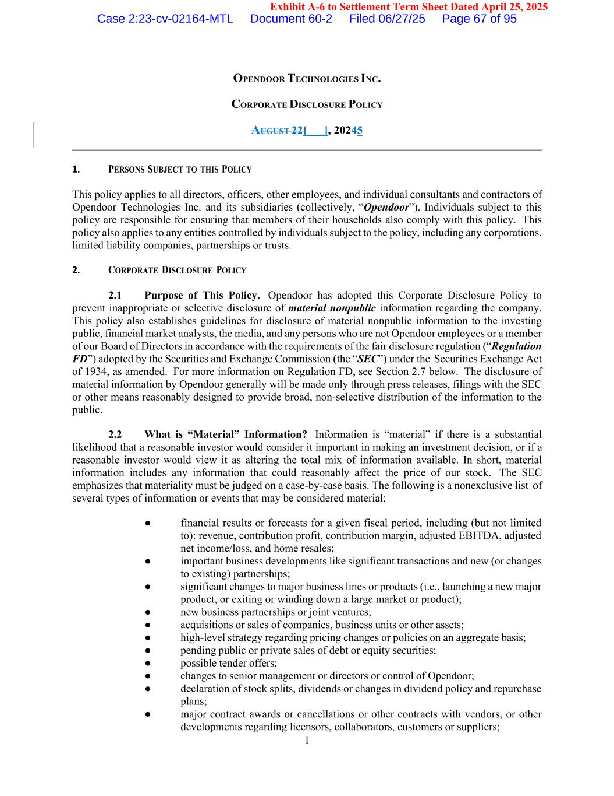
1 Exhibit A-6 to Settlement Term Sheet Dated April 25, 2025 OPENDOOR TECHNOLOGIES INC. CORPORATE DISCLOSURE POLICY AUGUST 22[___], 20245 1. PERSONS SUBJECT TO THIS POLICY This policy applies to all directors, officers, other employees, and individual consultants and contractors of Opendoor Technologies Inc. and its subsidiaries (collectively, “Opendoor”). Individuals subject to this policy are responsible for ensuring that members of their households also comply with this policy. This policy also applies to any entities controlled by individuals subject to the policy, including any corporations, limited liability companies, partnerships or trusts. 2. CORPORATE DISCLOSURE POLICY 2.1 Purpose of This Policy. Opendoor has adopted this Corporate Disclosure Policy to prevent inappropriate or selective disclosure of material nonpublic information regarding the company. This policy also establishes guidelines for disclosure of material nonpublic information to the investing public, financial market analysts, the media, and any persons who are not Opendoor employees or a member of our Board of Directors in accordance with the requirements of the fair disclosure regulation (“Regulation FD”) adopted by the Securities and Exchange Commission (the “SEC”) under the Securities Exchange Act of 1934, as amended. For more information on Regulation FD, see Section 2.7 below. The disclosure of material information by Opendoor generally will be made only through press releases, filings with the SEC or other means reasonably designed to provide broad, non-selective distribution of the information to the public. 2.2 What is “Material” Information? Information is “material” if there is a substantial likelihood that a reasonable investor would consider it important in making an investment decision, or if a reasonable investor would view it as altering the total mix of information available. In short, material information includes any information that could reasonably affect the price of our stock. The SEC emphasizes that materiality must be judged on a case-by-case basis. The following is a nonexclusive list of several types of information or events that may be considered material: ● financial results or forecasts for a given fiscal period, including (but not limited to): revenue, contribution profit, contribution margin, adjusted EBITDA, adjusted net income/loss, and home resales; ● important business developments like significant transactions and new (or changes to existing) partnerships; ● significant changes to major business lines or products (i.e., launching a new major product, or exiting or winding down a large market or product); ● new business partnerships or joint ventures; ● acquisitions or sales of companies, business units or other assets; ● high-level strategy regarding pricing changes or policies on an aggregate basis; ● pending public or private sales of debt or equity securities; ● possible tender offers; ● changes to senior management or directors or control of Opendoor; ● declaration of stock splits, dividends or changes in dividend policy and repurchase plans; ● major contract awards or cancellations or other contracts with vendors, or other developments regarding licensors, collaborators, customers or suppliers; Case 2:23-cv-02164-MTL Document 60-2 Filed 06/27/25 Page 67 of 95

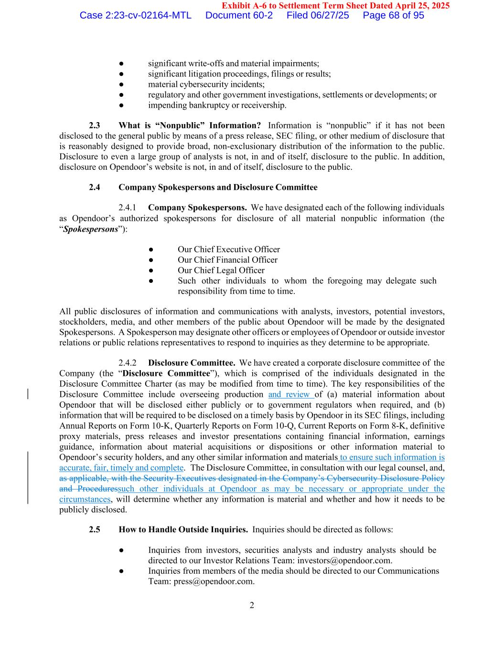
2 Exhibit A-6 to Settlement Term Sheet Dated April 25, 2025 ● significant write-offs and material impairments; ● significant litigation proceedings, filings or results; ● material cybersecurity incidents; ● regulatory and other government investigations, settlements or developments; or ● impending bankruptcy or receivership. 2.3 What is “Nonpublic” Information? Information is “nonpublic” if it has not been disclosed to the general public by means of a press release, SEC filing, or other medium of disclosure that is reasonably designed to provide broad, non-exclusionary distribution of the information to the public. Disclosure to even a large group of analysts is not, in and of itself, disclosure to the public. In addition, disclosure on Opendoor’s website is not, in and of itself, disclosure to the public. 2.4 Company Spokespersons and Disclosure Committee 2.4.1 Company Spokespersons. We have designated each of the following individuals as Opendoor’s authorized spokespersons for disclosure of all material nonpublic information (the “Spokespersons”): ● Our Chief Executive Officer ● Our Chief Financial Officer ● Our Chief Legal Officer ● Such other individuals to whom the foregoing may delegate such responsibility from time to time. All public disclosures of information and communications with analysts, investors, potential investors, stockholders, media, and other members of the public about Opendoor will be made by the designated Spokespersons. A Spokesperson may designate other officers or employees of Opendoor or outside investor relations or public relations representatives to respond to inquiries as they determine to be appropriate. 2.4.2 Disclosure Committee. We have created a corporate disclosure committee of the Company (the “Disclosure Committee”), which is comprised of the individuals designated in the Disclosure Committee Charter (as may be modified from time to time). The key responsibilities of the Disclosure Committee include overseeing production and review of (a) material information about Opendoor that will be disclosed either publicly or to government regulators when required, and (b) information that will be required to be disclosed on a timely basis by Opendoor in its SEC filings, including Annual Reports on Form 10-K, Quarterly Reports on Form 10-Q, Current Reports on Form 8-K, definitive proxy materials, press releases and investor presentations containing financial information, earnings guidance, information about material acquisitions or dispositions or other information material to Opendoor’s security holders, and any other similar information and materials to ensure such information is accurate, fair, timely and complete. The Disclosure Committee, in consultation with our legal counsel, and, as applicable, with the Security Executives designated in the Company’s Cybersecurity Disclosure Policy and Proceduressuch other individuals at Opendoor as may be necessary or appropriate under the circumstances, will determine whether any information is material and whether and how it needs to be publicly disclosed. 2.5 How to Handle Outside Inquiries. Inquiries should be directed as follows: ● Inquiries from investors, securities analysts and industry analysts should be directed to our Investor Relations Team: investors@opendoor.com. ● Inquiries from members of the media should be directed to our Communications Team: press@opendoor.com. Case 2:23-cv-02164-MTL Document 60-2 Filed 06/27/25 Page 68 of 95

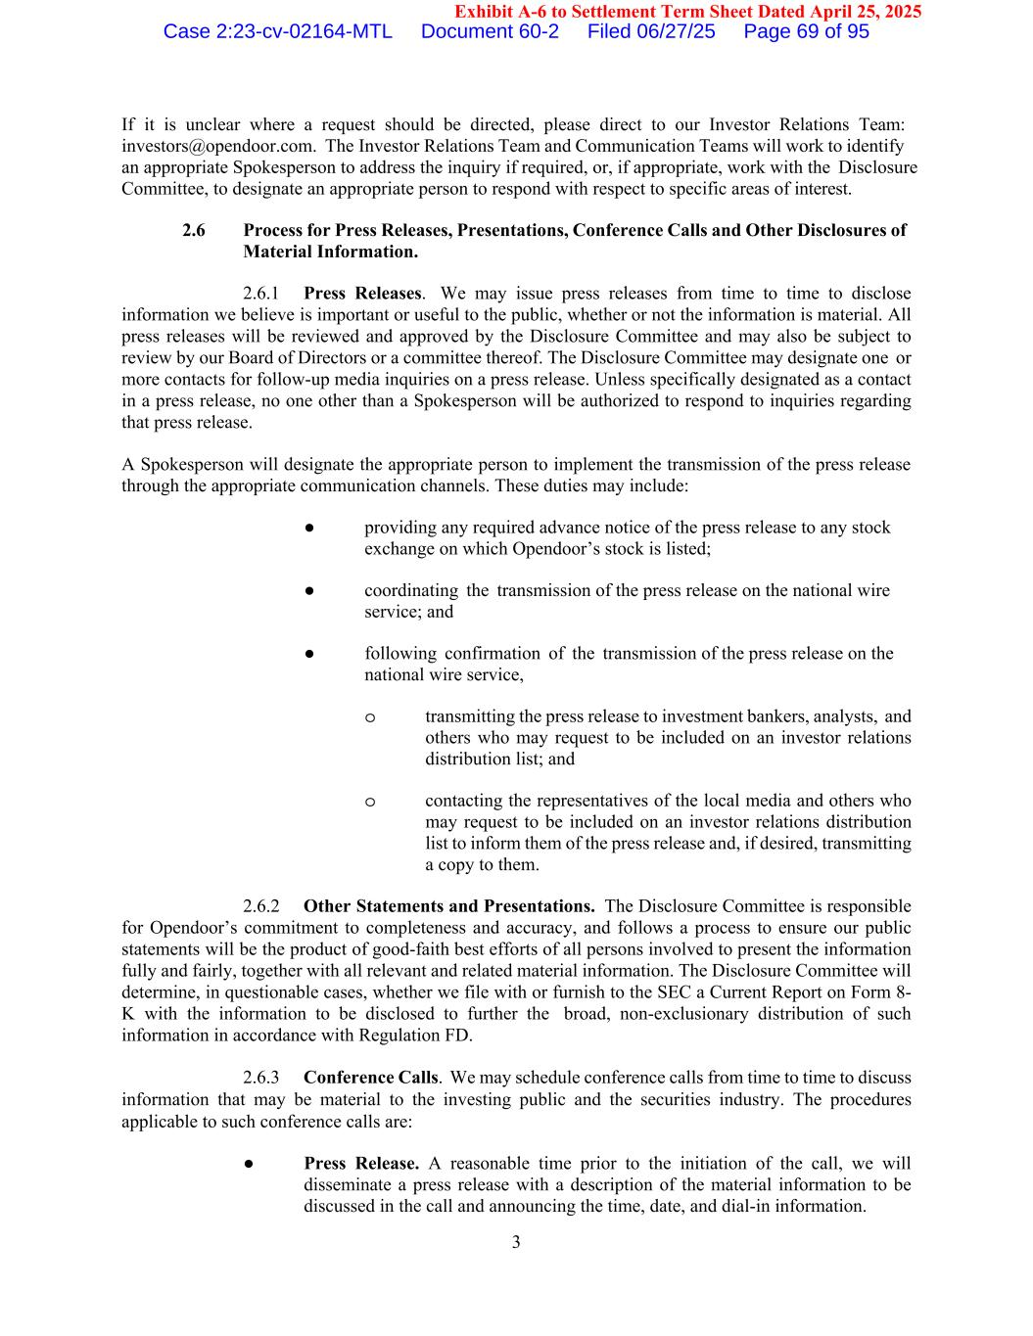
3 Exhibit A-6 to Settlement Term Sheet Dated April 25, 2025 If it is unclear where a request should be directed, please direct to our Investor Relations Team: investors@opendoor.com. The Investor Relations Team and Communication Teams will work to identify an appropriate Spokesperson to address the inquiry if required, or, if appropriate, work with the Disclosure Committee, to designate an appropriate person to respond with respect to specific areas of interest. 2.6 Process for Press Releases, Presentations, Conference Calls and Other Disclosures of Material Information. 2.6.1 Press Releases. We may issue press releases from time to time to disclose information we believe is important or useful to the public, whether or not the information is material. All press releases will be reviewed and approved by the Disclosure Committee and may also be subject to review by our Board of Directors or a committee thereof. The Disclosure Committee may designate one or more contacts for follow-up media inquiries on a press release. Unless specifically designated as a contact in a press release, no one other than a Spokesperson will be authorized to respond to inquiries regarding that press release. A Spokesperson will designate the appropriate person to implement the transmission of the press release through the appropriate communication channels. These duties may include: ● providing any required advance notice of the press release to any stock exchange on which Opendoor’s stock is listed; ● coordinating the transmission of the press release on the national wire service; and ● following confirmation of the transmission of the press release on the national wire service, o transmitting the press release to investment bankers, analysts, and others who may request to be included on an investor relations distribution list; and o contacting the representatives of the local media and others who may request to be included on an investor relations distribution list to inform them of the press release and, if desired, transmitting a copy to them. 2.6.2 Other Statements and Presentations. The Disclosure Committee is responsible for Opendoor’s commitment to completeness and accuracy, and follows a process to ensure our public statements will be the product of good-faith best efforts of all persons involved to present the information fully and fairly, together with all relevant and related material information. The Disclosure Committee will determine, in questionable cases, whether we file with or furnish to the SEC a Current Report on Form 8- K with the information to be disclosed to further the broad, non-exclusionary distribution of such information in accordance with Regulation FD. 2.6.3 Conference Calls. We may schedule conference calls from time to time to discuss information that may be material to the investing public and the securities industry. The procedures applicable to such conference calls are: ● Press Release. A reasonable time prior to the initiation of the call, we will disseminate a press release with a description of the material information to be discussed in the call and announcing the time, date, and dial-in information. Case 2:23-cv-02164-MTL Document 60-2 Filed 06/27/25 Page 69 of 95

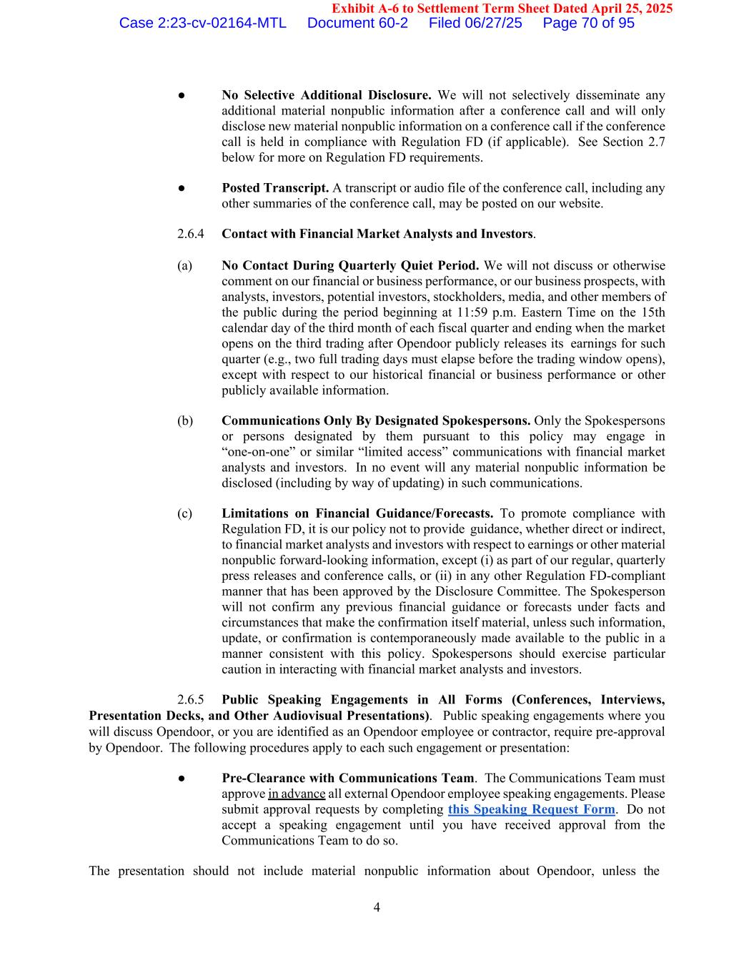
4 Exhibit A-6 to Settlement Term Sheet Dated April 25, 2025 ● No Selective Additional Disclosure. We will not selectively disseminate any additional material nonpublic information after a conference call and will only disclose new material nonpublic information on a conference call if the conference call is held in compliance with Regulation FD (if applicable). See Section 2.7 below for more on Regulation FD requirements. ● Posted Transcript. A transcript or audio file of the conference call, including any other summaries of the conference call, may be posted on our website. 2.6.4 Contact with Financial Market Analysts and Investors. (a) No Contact During Quarterly Quiet Period. We will not discuss or otherwise comment on our financial or business performance, or our business prospects, with analysts, investors, potential investors, stockholders, media, and other members of the public during the period beginning at 11:59 p.m. Eastern Time on the 15th calendar day of the third month of each fiscal quarter and ending when the market opens on the third trading after Opendoor publicly releases its earnings for such quarter (e.g., two full trading days must elapse before the trading window opens), except with respect to our historical financial or business performance or other publicly available information. (b) Communications Only By Designated Spokespersons. Only the Spokespersons or persons designated by them pursuant to this policy may engage in “one-on-one” or similar “limited access” communications with financial market analysts and investors. In no event will any material nonpublic information be disclosed (including by way of updating) in such communications. (c) Limitations on Financial Guidance/Forecasts. To promote compliance with Regulation FD, it is our policy not to provide guidance, whether direct or indirect, to financial market analysts and investors with respect to earnings or other material nonpublic forward-looking information, except (i) as part of our regular, quarterly press releases and conference calls, or (ii) in any other Regulation FD-compliant manner that has been approved by the Disclosure Committee. The Spokesperson will not confirm any previous financial guidance or forecasts under facts and circumstances that make the confirmation itself material, unless such information, update, or confirmation is contemporaneously made available to the public in a manner consistent with this policy. Spokespersons should exercise particular caution in interacting with financial market analysts and investors. 2.6.5 Public Speaking Engagements in All Forms (Conferences, Interviews, Presentation Decks, and Other Audiovisual Presentations). Public speaking engagements where you will discuss Opendoor, or you are identified as an Opendoor employee or contractor, require pre-approval by Opendoor. The following procedures apply to each such engagement or presentation: ● Pre-Clearance with Communications Team. The Communications Team must approve in advance all external Opendoor employee speaking engagements. Please submit approval requests by completing this Speaking Request Form. Do not accept a speaking engagement until you have received approval from the Communications Team to do so. The presentation should not include material nonpublic information about Opendoor, unless the Case 2:23-cv-02164-MTL Document 60-2 Filed 06/27/25 Page 70 of 95

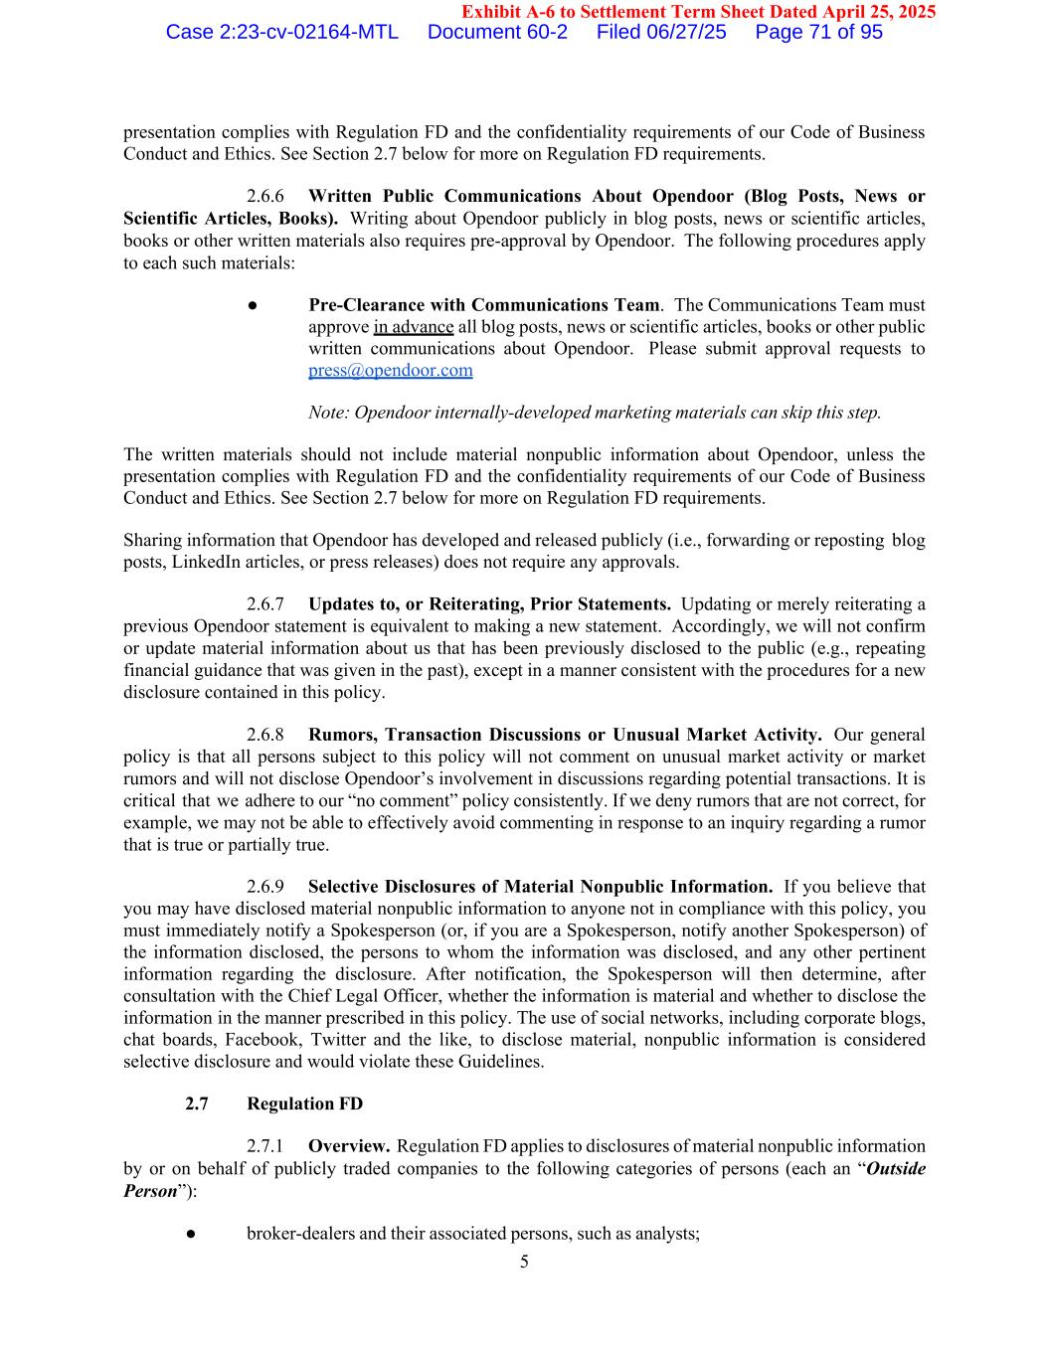
5 Exhibit A-6 to Settlement Term Sheet Dated April 25, 2025 presentation complies with Regulation FD and the confidentiality requirements of our Code of Business Conduct and Ethics. See Section 2.7 below for more on Regulation FD requirements. 2.6.6 Written Public Communications About Opendoor (Blog Posts, News or Scientific Articles, Books). Writing about Opendoor publicly in blog posts, news or scientific articles, books or other written materials also requires pre-approval by Opendoor. The following procedures apply to each such materials: ● Pre-Clearance with Communications Team. The Communications Team must approve in advance all blog posts, news or scientific articles, books or other public written communications about Opendoor. Please submit approval requests to press@opendoor.com Note: Opendoor internally-developed marketing materials can skip this step. The written materials should not include material nonpublic information about Opendoor, unless the presentation complies with Regulation FD and the confidentiality requirements of our Code of Business Conduct and Ethics. See Section 2.7 below for more on Regulation FD requirements. Sharing information that Opendoor has developed and released publicly (i.e., forwarding or reposting blog posts, LinkedIn articles, or press releases) does not require any approvals. 2.6.7 Updates to, or Reiterating, Prior Statements. Updating or merely reiterating a previous Opendoor statement is equivalent to making a new statement. Accordingly, we will not confirm or update material information about us that has been previously disclosed to the public (e.g., repeating financial guidance that was given in the past), except in a manner consistent with the procedures for a new disclosure contained in this policy. 2.6.8 Rumors, Transaction Discussions or Unusual Market Activity. Our general policy is that all persons subject to this policy will not comment on unusual market activity or market rumors and will not disclose Opendoor’s involvement in discussions regarding potential transactions. It is critical that we adhere to our “no comment” policy consistently. If we deny rumors that are not correct, for example, we may not be able to effectively avoid commenting in response to an inquiry regarding a rumor that is true or partially true. 2.6.9 Selective Disclosures of Material Nonpublic Information. If you believe that you may have disclosed material nonpublic information to anyone not in compliance with this policy, you must immediately notify a Spokesperson (or, if you are a Spokesperson, notify another Spokesperson) of the information disclosed, the persons to whom the information was disclosed, and any other pertinent information regarding the disclosure. After notification, the Spokesperson will then determine, after consultation with the Chief Legal Officer, whether the information is material and whether to disclose the information in the manner prescribed in this policy. The use of social networks, including corporate blogs, chat boards, Facebook, Twitter and the like, to disclose material, nonpublic information is considered selective disclosure and would violate these Guidelines. 2.7 Regulation FD 2.7.1 Overview. Regulation FD applies to disclosures of material nonpublic information by or on behalf of publicly traded companies to the following categories of persons (each an “Outside Person”): ● broker-dealers and their associated persons, such as analysts; Case 2:23-cv-02164-MTL Document 60-2 Filed 06/27/25 Page 71 of 95

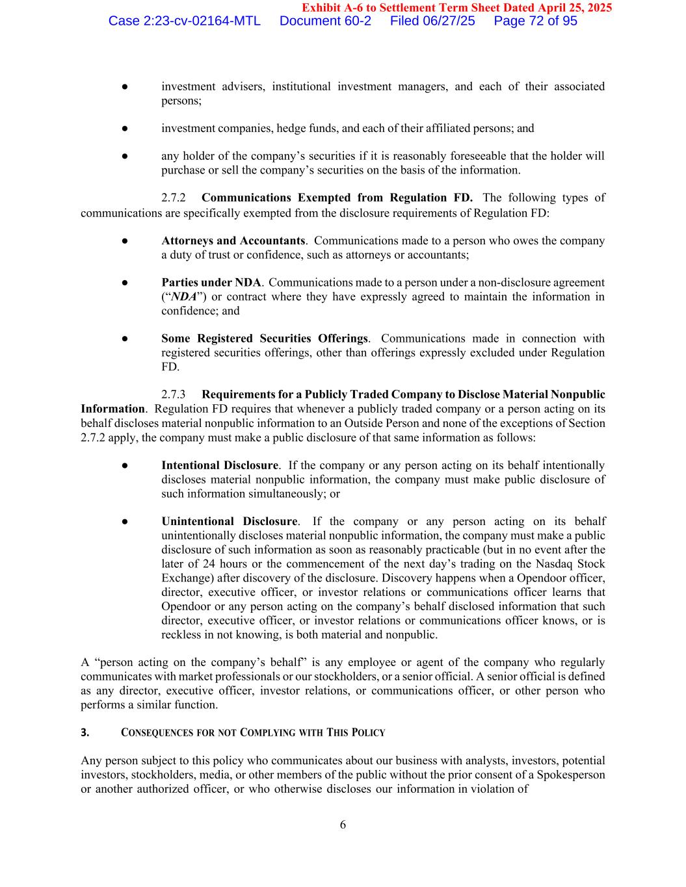
6 Exhibit A-6 to Settlement Term Sheet Dated April 25, 2025 ● investment advisers, institutional investment managers, and each of their associated persons; ● investment companies, hedge funds, and each of their affiliated persons; and ● any holder of the company’s securities if it is reasonably foreseeable that the holder will purchase or sell the company’s securities on the basis of the information. 2.7.2 Communications Exempted from Regulation FD. The following types of communications are specifically exempted from the disclosure requirements of Regulation FD: ● Attorneys and Accountants. Communications made to a person who owes the company a duty of trust or confidence, such as attorneys or accountants; ● Parties under NDA. Communications made to a person under a non-disclosure agreement (“NDA”) or contract where they have expressly agreed to maintain the information in confidence; and ● Some Registered Securities Offerings. Communications made in connection with registered securities offerings, other than offerings expressly excluded under Regulation FD. 2.7.3 Requirements for a Publicly Traded Company to Disclose Material Nonpublic Information. Regulation FD requires that whenever a publicly traded company or a person acting on its behalf discloses material nonpublic information to an Outside Person and none of the exceptions of Section 2.7.2 apply, the company must make a public disclosure of that same information as follows: ● Intentional Disclosure. If the company or any person acting on its behalf intentionally discloses material nonpublic information, the company must make public disclosure of such information simultaneously; or ● Unintentional Disclosure. If the company or any person acting on its behalf unintentionally discloses material nonpublic information, the company must make a public disclosure of such information as soon as reasonably practicable (but in no event after the later of 24 hours or the commencement of the next day’s trading on the Nasdaq Stock Exchange) after discovery of the disclosure. Discovery happens when a Opendoor officer, director, executive officer, or investor relations or communications officer learns that Opendoor or any person acting on the company’s behalf disclosed information that such director, executive officer, or investor relations or communications officer knows, or is reckless in not knowing, is both material and nonpublic. A “person acting on the company’s behalf” is any employee or agent of the company who regularly communicates with market professionals or our stockholders, or a senior official. A senior official is defined as any director, executive officer, investor relations, or communications officer, or other person who performs a similar function. 3. CONSEQUENCES FOR NOT COMPLYING WITH THIS POLICY Any person subject to this policy who communicates about our business with analysts, investors, potential investors, stockholders, media, or other members of the public without the prior consent of a Spokesperson or another authorized officer, or who otherwise discloses our information in violation of Case 2:23-cv-02164-MTL Document 60-2 Filed 06/27/25 Page 72 of 95

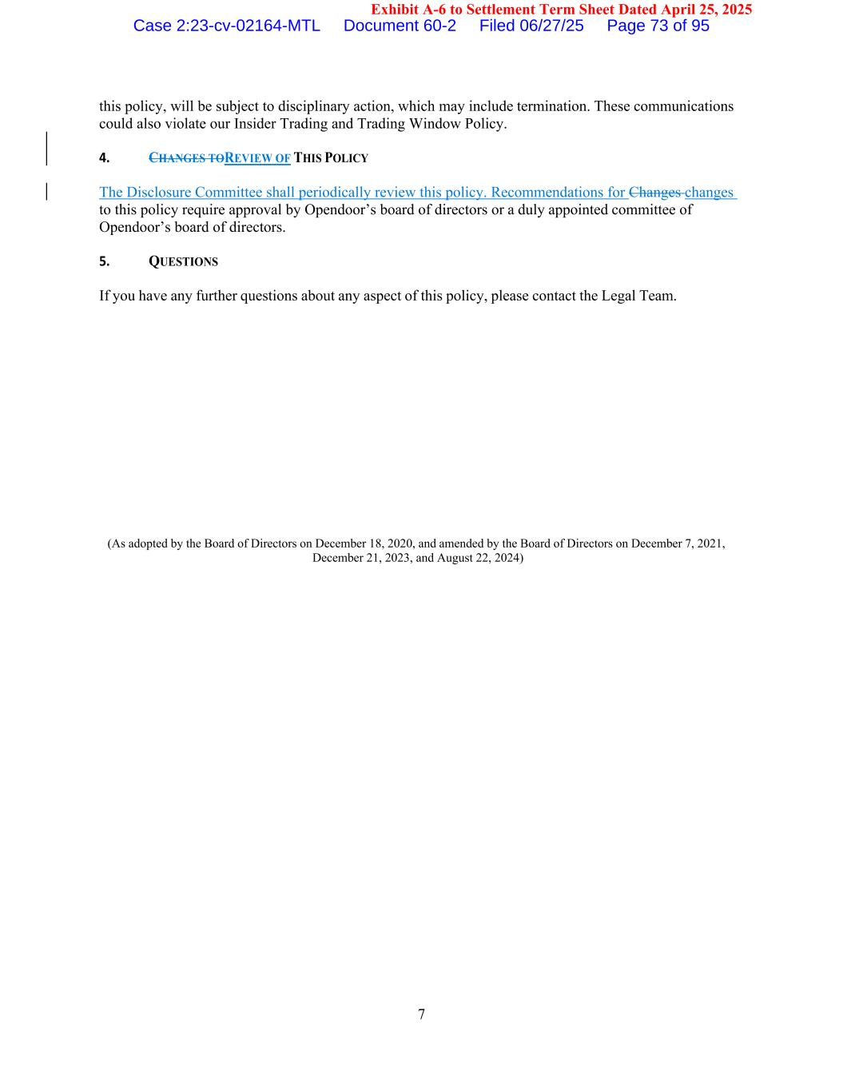
7 Exhibit A-6 to Settlement Term Sheet Dated April 25, 2025 this policy, will be subject to disciplinary action, which may include termination. These communications could also violate our Insider Trading and Trading Window Policy. 4. CHANGES TOREVIEW OF THIS POLICY The Disclosure Committee shall periodically review this policy. Recommendations for Changes changes to this policy require approval by Opendoor’s board of directors or a duly appointed committee of Opendoor’s board of directors. 5. QUESTIONS If you have any further questions about any aspect of this policy, please contact the Legal Team. (As adopted by the Board of Directors on December 18, 2020, and amended by the Board of Directors on December 7, 2021, December 21, 2023, and August 22, 2024) Case 2:23-cv-02164-MTL Document 60-2 Filed 06/27/25 Page 73 of 95

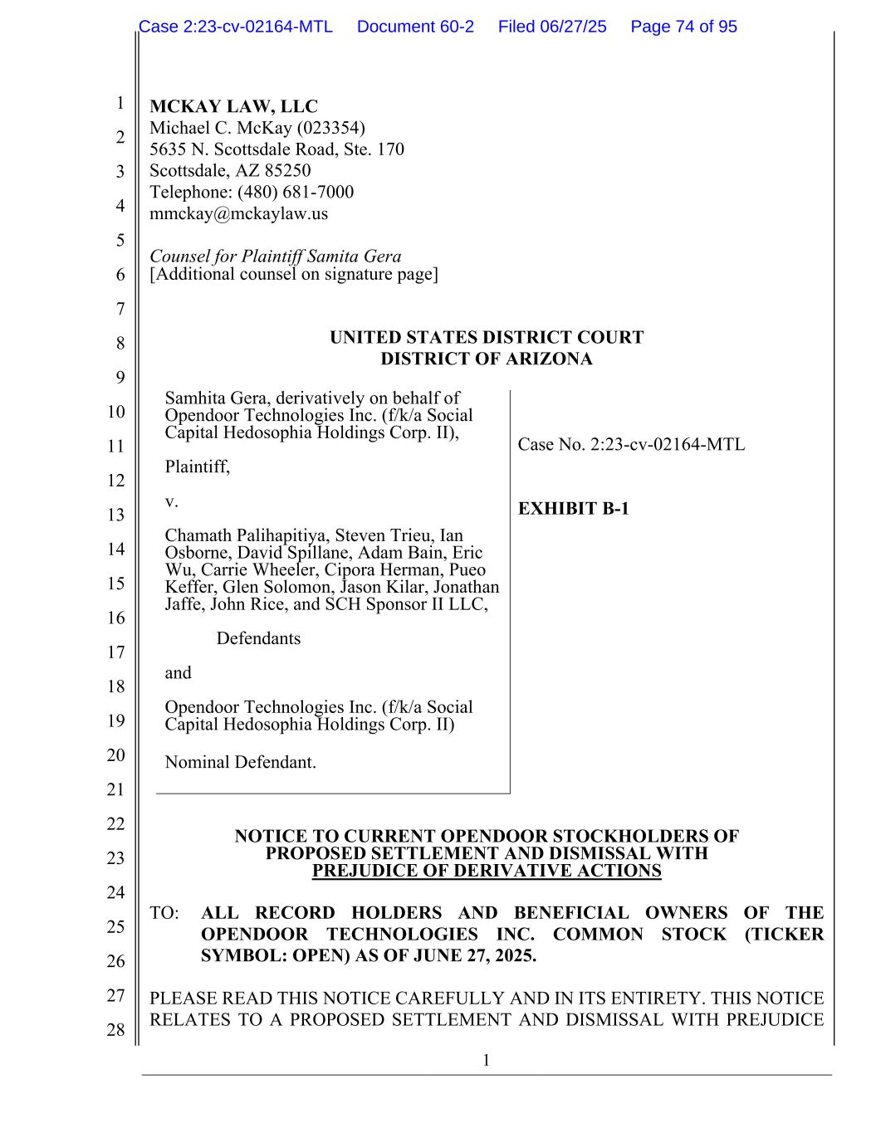
1 1 2 3 4 5 6 7 8 9 10 11 12 13 14 15 16 17 18 19 20 21 22 23 24 25 26 27 28 MCKAY LAW, LLC Michael C. McKay (023354) 5635 N. Scottsdale Road, Ste. 170 Scottsdale, AZ 85250 Telephone: (480) 681-7000 mmckay@mckaylaw.us Counsel for Plaintiff Samita Gera [Additional counsel on signature page] UNITED STATES DISTRICT COURT DISTRICT OF ARIZONA Samhita Gera, derivatively on behalf of Opendoor Technologies Inc. (f/k/a Social Capital Hedosophia Holdings Corp. II), Plaintiff, v. Chamath Palihapitiya, Steven Trieu, Ian Osborne, David Spillane, Adam Bain, Eric Wu, Carrie Wheeler, Cipora Herman, Pueo Keffer, Glen Solomon, Jason Kilar, Jonathan Jaffe, John Rice, and SCH Sponsor II LLC, Defendants and Opendoor Technologies Inc. (f/k/a Social Capital Hedosophia Holdings Corp. II) Nominal Defendant. Case No. 2:23-cv-02164-MTL EXHIBIT B-1 NOTICE TO CURRENT OPENDOOR STOCKHOLDERS OF PROPOSED SETTLEMENT AND DISMISSAL WITH PREJUDICE OF DERIVATIVE ACTIONS TO: ALL RECORD HOLDERS AND BENEFICIAL OWNERS OF THE OPENDOOR TECHNOLOGIES INC. COMMON STOCK (TICKER SYMBOL: OPEN) AS OF JUNE 27, 2025. PLEASE READ THIS NOTICE CAREFULLY AND IN ITS ENTIRETY. THIS NOTICE RELATES TO A PROPOSED SETTLEMENT AND DISMISSAL WITH PREJUDICE Case 2:23-cv-02164-MTL Document 60-2 Filed 06/27/25 Page 74 of 95

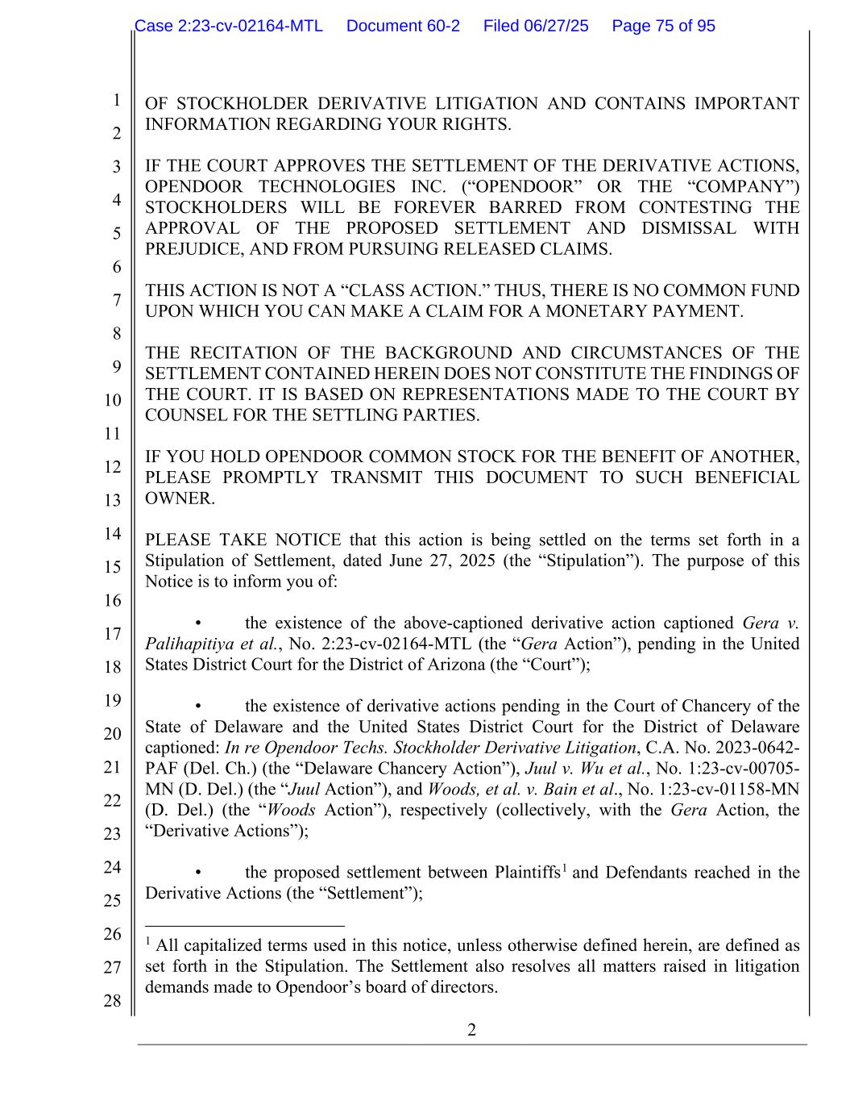
2 1 2 3 4 5 6 7 8 9 10 11 12 13 14 15 16 17 18 19 20 21 22 23 24 25 26 27 28 OF STOCKHOLDER DERIVATIVE LITIGATION AND CONTAINS IMPORTANT INFORMATION REGARDING YOUR RIGHTS. IF THE COURT APPROVES THE SETTLEMENT OF THE DERIVATIVE ACTIONS, OPENDOOR TECHNOLOGIES INC. (“OPENDOOR” OR THE “COMPANY”) STOCKHOLDERS WILL BE FOREVER BARRED FROM CONTESTING THE APPROVAL OF THE PROPOSED SETTLEMENT AND DISMISSAL WITH PREJUDICE, AND FROM PURSUING RELEASED CLAIMS. THIS ACTION IS NOT A “CLASS ACTION.” THUS, THERE IS NO COMMON FUND UPON WHICH YOU CAN MAKE A CLAIM FOR A MONETARY PAYMENT. THE RECITATION OF THE BACKGROUND AND CIRCUMSTANCES OF THE SETTLEMENT CONTAINED HEREIN DOES NOT CONSTITUTE THE FINDINGS OF THE COURT. IT IS BASED ON REPRESENTATIONS MADE TO THE COURT BY COUNSEL FOR THE SETTLING PARTIES. IF YOU HOLD OPENDOOR COMMON STOCK FOR THE BENEFIT OF ANOTHER, PLEASE PROMPTLY TRANSMIT THIS DOCUMENT TO SUCH BENEFICIAL OWNER. PLEASE TAKE NOTICE that this action is being settled on the terms set forth in a Stipulation of Settlement, dated June 27, 2025 (the “Stipulation”). The purpose of this Notice is to inform you of: • the existence of the above-captioned derivative action captioned Gera v. Palihapitiya et al., No. 2:23-cv-02164-MTL (the “Gera Action”), pending in the United States District Court for the District of Arizona (the “Court”); • the existence of derivative actions pending in the Court of Chancery of the State of Delaware and the United States District Court for the District of Delaware captioned: In re Opendoor Techs. Stockholder Derivative Litigation, C.A. No. 2023-0642- PAF (Del. Ch.) (the “Delaware Chancery Action”), Juul v. Wu et al., No. 1:23-cv-00705- MN (D. Del.) (the “Juul Action”), and Woods, et al. v. Bain et al., No. 1:23-cv-01158-MN (D. Del.) (the “Woods Action”), respectively (collectively, with the Gera Action, the “Derivative Actions”); • the proposed settlement between Plaintiffs1 and Defendants reached in the Derivative Actions (the “Settlement”); 1 All capitalized terms used in this notice, unless otherwise defined herein, are defined as set forth in the Stipulation. The Settlement also resolves all matters raised in litigation demands made to Opendoor’s board of directors. Case 2:23-cv-02164-MTL Document 60-2 Filed 06/27/25 Page 75 of 95

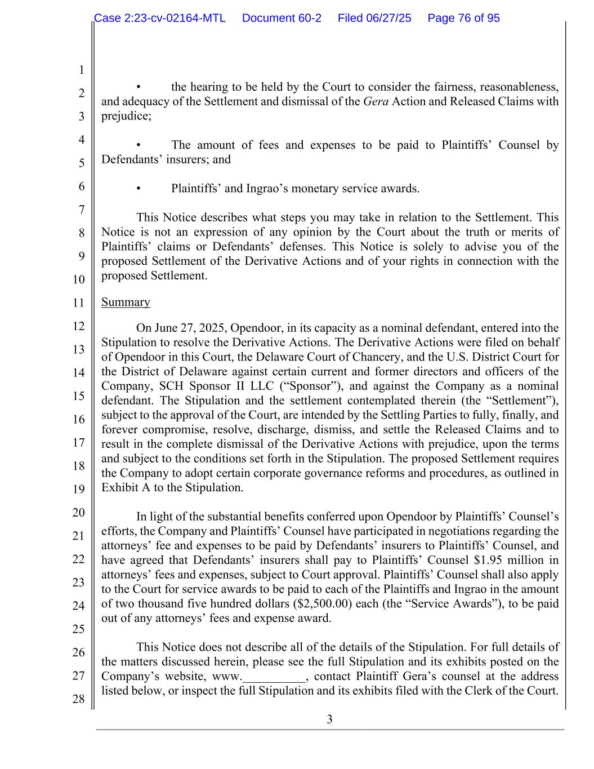
3 1 2 3 4 5 6 7 8 9 10 11 12 13 14 15 16 17 18 19 20 21 22 23 24 25 26 27 28 • the hearing to be held by the Court to consider the fairness, reasonableness, and adequacy of the Settlement and dismissal of the Gera Action and Released Claims with prejudice; • The amount of fees and expenses to be paid to Plaintiffs’ Counsel by Defendants’ insurers; and • Plaintiffs’ and Ingrao’s monetary service awards. This Notice describes what steps you may take in relation to the Settlement. This Notice is not an expression of any opinion by the Court about the truth or merits of Plaintiffs’ claims or Defendants’ defenses. This Notice is solely to advise you of the proposed Settlement of the Derivative Actions and of your rights in connection with the proposed Settlement. Summary On June 27, 2025, Opendoor, in its capacity as a nominal defendant, entered into the Stipulation to resolve the Derivative Actions. The Derivative Actions were filed on behalf of Opendoor in this Court, the Delaware Court of Chancery, and the U.S. District Court for the District of Delaware against certain current and former directors and officers of the Company, SCH Sponsor II LLC (“Sponsor”), and against the Company as a nominal defendant. The Stipulation and the settlement contemplated therein (the “Settlement”), subject to the approval of the Court, are intended by the Settling Parties to fully, finally, and forever compromise, resolve, discharge, dismiss, and settle the Released Claims and to result in the complete dismissal of the Derivative Actions with prejudice, upon the terms and subject to the conditions set forth in the Stipulation. The proposed Settlement requires the Company to adopt certain corporate governance reforms and procedures, as outlined in Exhibit A to the Stipulation. In light of the substantial benefits conferred upon Opendoor by Plaintiffs’ Counsel’s efforts, the Company and Plaintiffs’ Counsel have participated in negotiations regarding the attorneys’ fee and expenses to be paid by Defendants’ insurers to Plaintiffs’ Counsel, and have agreed that Defendants’ insurers shall pay to Plaintiffs’ Counsel $1.95 million in attorneys’ fees and expenses, subject to Court approval. Plaintiffs’ Counsel shall also apply to the Court for service awards to be paid to each of the Plaintiffs and Ingrao in the amount of two thousand five hundred dollars ($2,500.00) each (the “Service Awards”), to be paid out of any attorneys’ fees and expense award. This Notice does not describe all of the details of the Stipulation. For full details of the matters discussed herein, please see the full Stipulation and its exhibits posted on the Company’s website, www.__________, contact Plaintiff Gera’s counsel at the address listed below, or inspect the full Stipulation and its exhibits filed with the Clerk of the Court. Case 2:23-cv-02164-MTL Document 60-2 Filed 06/27/25 Page 76 of 95

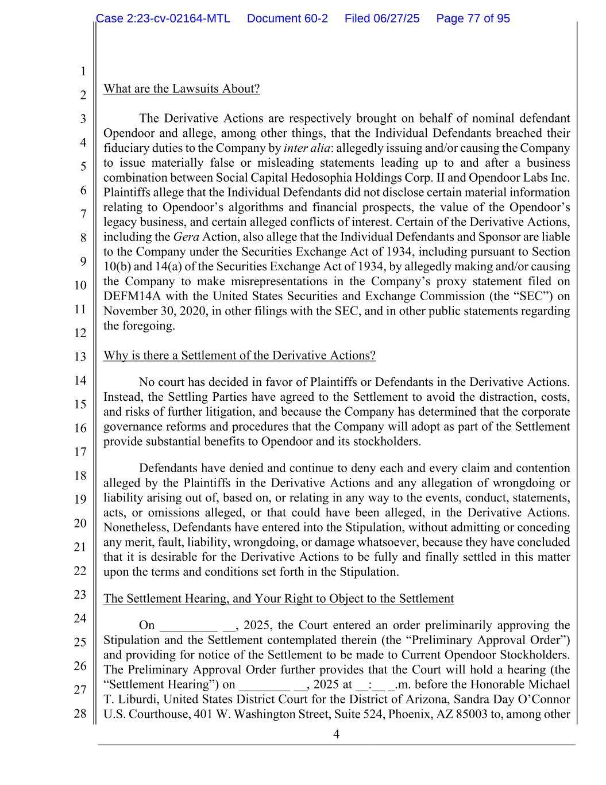
4 1 2 3 4 5 6 7 8 9 10 11 12 13 14 15 16 17 18 19 20 21 22 23 24 25 26 27 28 What are the Lawsuits About? The Derivative Actions are respectively brought on behalf of nominal defendant Opendoor and allege, among other things, that the Individual Defendants breached their fiduciary duties to the Company by inter alia: allegedly issuing and/or causing the Company to issue materially false or misleading statements leading up to and after a business combination between Social Capital Hedosophia Holdings Corp. II and Opendoor Labs Inc. Plaintiffs allege that the Individual Defendants did not disclose certain material information relating to Opendoor’s algorithms and financial prospects, the value of the Opendoor’s legacy business, and certain alleged conflicts of interest. Certain of the Derivative Actions, including the Gera Action, also allege that the Individual Defendants and Sponsor are liable to the Company under the Securities Exchange Act of 1934, including pursuant to Section 10(b) and 14(a) of the Securities Exchange Act of 1934, by allegedly making and/or causing the Company to make misrepresentations in the Company’s proxy statement filed on DEFM14A with the United States Securities and Exchange Commission (the “SEC”) on November 30, 2020, in other filings with the SEC, and in other public statements regarding the foregoing. Why is there a Settlement of the Derivative Actions? No court has decided in favor of Plaintiffs or Defendants in the Derivative Actions. Instead, the Settling Parties have agreed to the Settlement to avoid the distraction, costs, and risks of further litigation, and because the Company has determined that the corporate governance reforms and procedures that the Company will adopt as part of the Settlement provide substantial benefits to Opendoor and its stockholders. Defendants have denied and continue to deny each and every claim and contention alleged by the Plaintiffs in the Derivative Actions and any allegation of wrongdoing or liability arising out of, based on, or relating in any way to the events, conduct, statements, acts, or omissions alleged, or that could have been alleged, in the Derivative Actions. Nonetheless, Defendants have entered into the Stipulation, without admitting or conceding any merit, fault, liability, wrongdoing, or damage whatsoever, because they have concluded that it is desirable for the Derivative Actions to be fully and finally settled in this matter upon the terms and conditions set forth in the Stipulation. The Settlement Hearing, and Your Right to Object to the Settlement On _________ __, 2025, the Court entered an order preliminarily approving the Stipulation and the Settlement contemplated therein (the “Preliminary Approval Order”) and providing for notice of the Settlement to be made to Current Opendoor Stockholders. The Preliminary Approval Order further provides that the Court will hold a hearing (the “Settlement Hearing”) on ________ __, 2025 at __:__ _.m. before the Honorable Michael T. Liburdi, United States District Court for the District of Arizona, Sandra Day O’Connor U.S. Courthouse, 401 W. Washington Street, Suite 524, Phoenix, AZ 85003 to, among other Case 2:23-cv-02164-MTL Document 60-2 Filed 06/27/25 Page 77 of 95

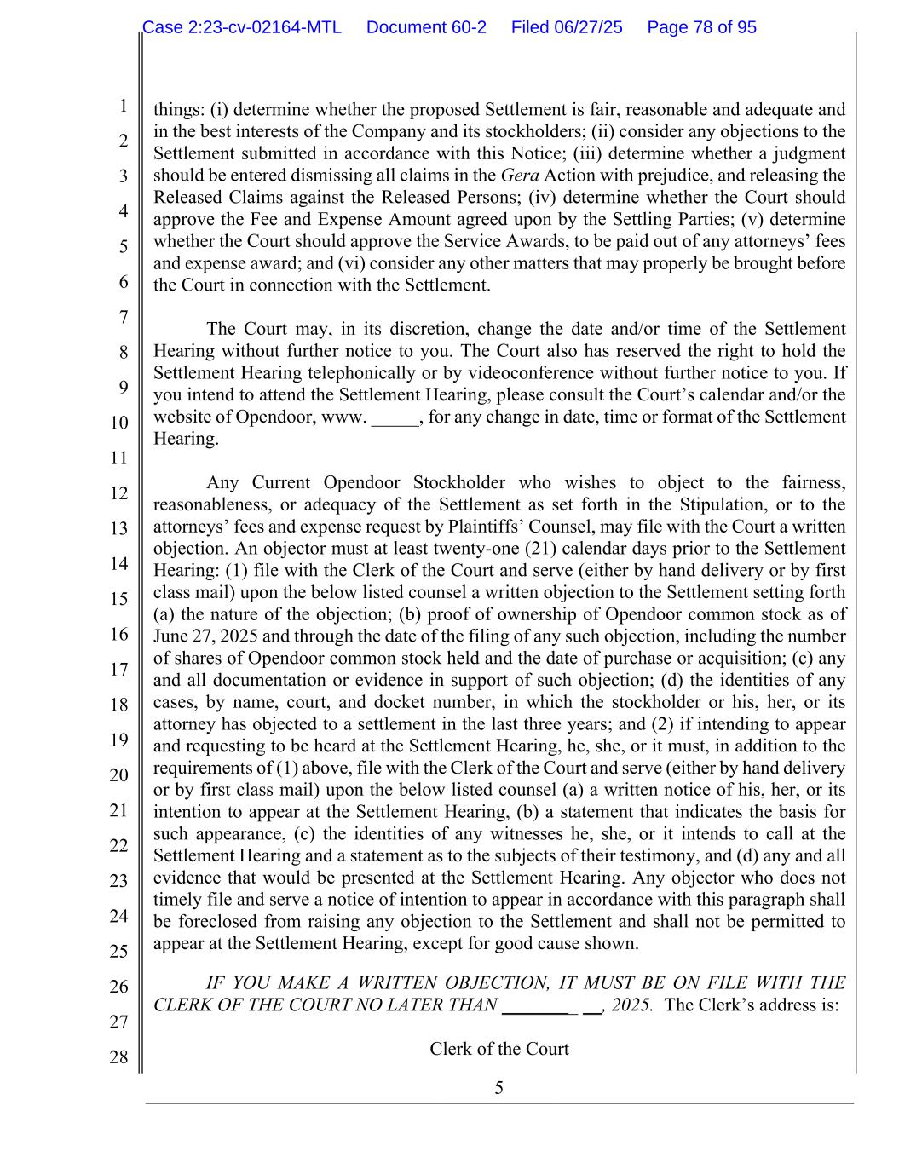
5 1 2 3 4 5 6 7 8 9 10 11 12 13 14 15 16 17 18 19 20 21 22 23 24 25 26 27 28 things: (i) determine whether the proposed Settlement is fair, reasonable and adequate and in the best interests of the Company and its stockholders; (ii) consider any objections to the Settlement submitted in accordance with this Notice; (iii) determine whether a judgment should be entered dismissing all claims in the Gera Action with prejudice, and releasing the Released Claims against the Released Persons; (iv) determine whether the Court should approve the Fee and Expense Amount agreed upon by the Settling Parties; (v) determine whether the Court should approve the Service Awards, to be paid out of any attorneys’ fees and expense award; and (vi) consider any other matters that may properly be brought before the Court in connection with the Settlement. The Court may, in its discretion, change the date and/or time of the Settlement Hearing without further notice to you. The Court also has reserved the right to hold the Settlement Hearing telephonically or by videoconference without further notice to you. If you intend to attend the Settlement Hearing, please consult the Court’s calendar and/or the website of Opendoor, www. _____, for any change in date, time or format of the Settlement Hearing. Any Current Opendoor Stockholder who wishes to object to the fairness, reasonableness, or adequacy of the Settlement as set forth in the Stipulation, or to the attorneys’ fees and expense request by Plaintiffs’ Counsel, may file with the Court a written objection. An objector must at least twenty-one (21) calendar days prior to the Settlement Hearing: (1) file with the Clerk of the Court and serve (either by hand delivery or by first class mail) upon the below listed counsel a written objection to the Settlement setting forth (a) the nature of the objection; (b) proof of ownership of Opendoor common stock as of June 27, 2025 and through the date of the filing of any such objection, including the number of shares of Opendoor common stock held and the date of purchase or acquisition; (c) any and all documentation or evidence in support of such objection; (d) the identities of any cases, by name, court, and docket number, in which the stockholder or his, her, or its attorney has objected to a settlement in the last three years; and (2) if intending to appear and requesting to be heard at the Settlement Hearing, he, she, or it must, in addition to the requirements of (1) above, file with the Clerk of the Court and serve (either by hand delivery or by first class mail) upon the below listed counsel (a) a written notice of his, her, or its intention to appear at the Settlement Hearing, (b) a statement that indicates the basis for such appearance, (c) the identities of any witnesses he, she, or it intends to call at the Settlement Hearing and a statement as to the subjects of their testimony, and (d) any and all evidence that would be presented at the Settlement Hearing. Any objector who does not timely file and serve a notice of intention to appear in accordance with this paragraph shall be foreclosed from raising any objection to the Settlement and shall not be permitted to appear at the Settlement Hearing, except for good cause shown. IF YOU MAKE A WRITTEN OBJECTION, IT MUST BE ON FILE WITH THE CLERK OF THE COURT NO LATER THAN ________ __, 2025. The Clerk’s address is: Clerk of the Court Case 2:23-cv-02164-MTL Document 60-2 Filed 06/27/25 Page 78 of 95

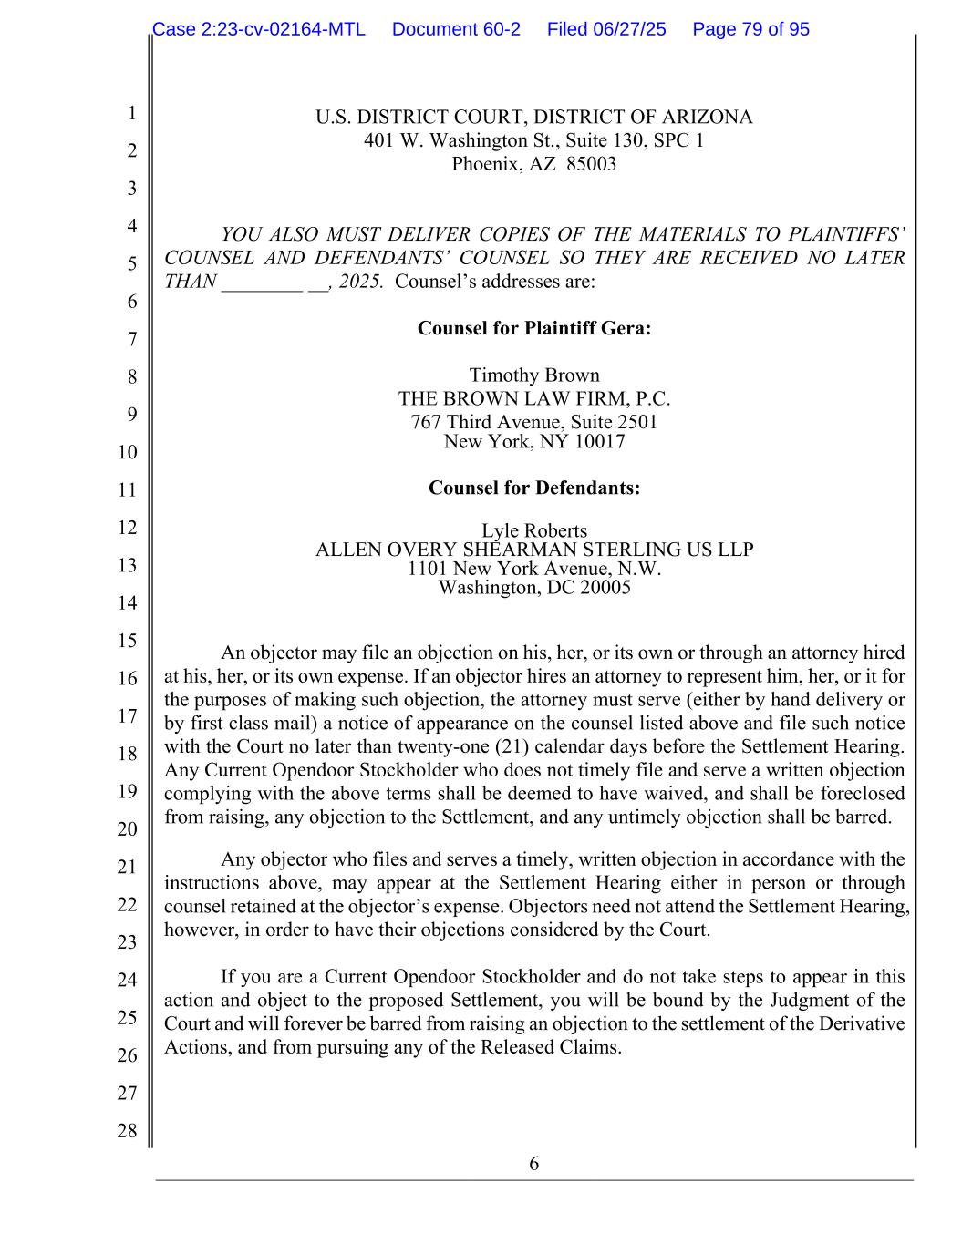
6 1 2 3 4 5 6 7 8 9 10 11 12 13 14 15 16 17 18 19 20 21 22 23 24 25 26 27 28 U.S. DISTRICT COURT, DISTRICT OF ARIZONA 401 W. Washington St., Suite 130, SPC 1 Phoenix, AZ 85003 YOU ALSO MUST DELIVER COPIES OF THE MATERIALS TO PLAINTIFFS’ COUNSEL AND DEFENDANTS’ COUNSEL SO THEY ARE RECEIVED NO LATER THAN ________ __, 2025. Counsel’s addresses are: Counsel for Plaintiff Gera: Timothy Brown THE BROWN LAW FIRM, P.C. 767 Third Avenue, Suite 2501 New York, NY 10017 Counsel for Defendants: Lyle Roberts ALLEN OVERY SHEARMAN STERLING US LLP 1101 New York Avenue, N.W. Washington, DC 20005 An objector may file an objection on his, her, or its own or through an attorney hired at his, her, or its own expense. If an objector hires an attorney to represent him, her, or it for the purposes of making such objection, the attorney must serve (either by hand delivery or by first class mail) a notice of appearance on the counsel listed above and file such notice with the Court no later than twenty-one (21) calendar days before the Settlement Hearing. Any Current Opendoor Stockholder who does not timely file and serve a written objection complying with the above terms shall be deemed to have waived, and shall be foreclosed from raising, any objection to the Settlement, and any untimely objection shall be barred. Any objector who files and serves a timely, written objection in accordance with the instructions above, may appear at the Settlement Hearing either in person or through counsel retained at the objector’s expense. Objectors need not attend the Settlement Hearing, however, in order to have their objections considered by the Court. If you are a Current Opendoor Stockholder and do not take steps to appear in this action and object to the proposed Settlement, you will be bound by the Judgment of the Court and will forever be barred from raising an objection to the settlement of the Derivative Actions, and from pursuing any of the Released Claims. Case 2:23-cv-02164-MTL Document 60-2 Filed 06/27/25 Page 79 of 95

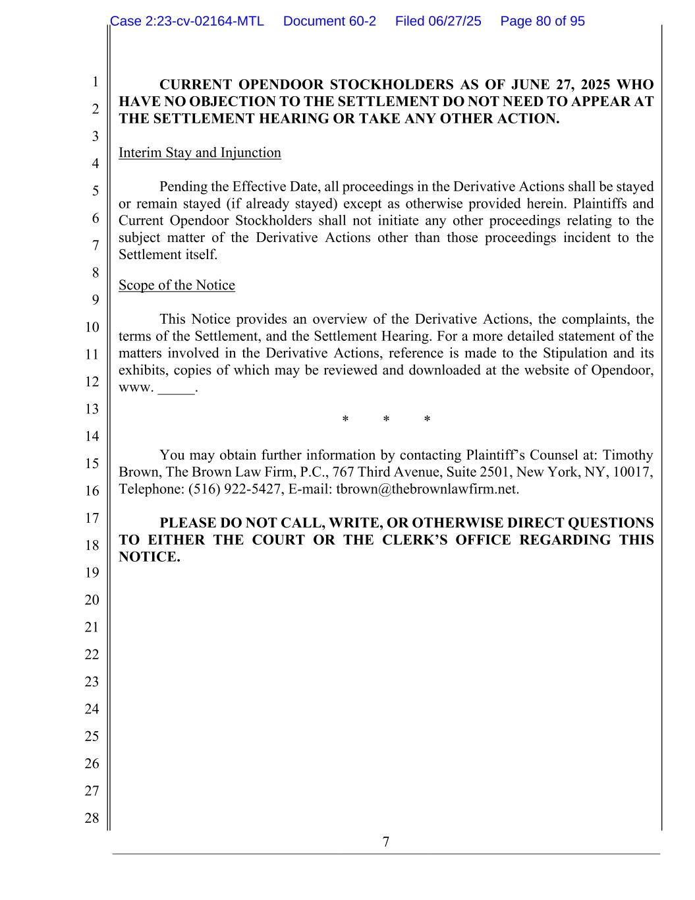
7 1 2 3 4 5 6 7 8 9 10 11 12 13 14 15 16 17 18 19 20 21 22 23 24 25 26 27 28 CURRENT OPENDOOR STOCKHOLDERS AS OF JUNE 27, 2025 WHO HAVE NO OBJECTION TO THE SETTLEMENT DO NOT NEED TO APPEAR AT THE SETTLEMENT HEARING OR TAKE ANY OTHER ACTION. Interim Stay and Injunction Pending the Effective Date, all proceedings in the Derivative Actions shall be stayed or remain stayed (if already stayed) except as otherwise provided herein. Plaintiffs and Current Opendoor Stockholders shall not initiate any other proceedings relating to the subject matter of the Derivative Actions other than those proceedings incident to the Settlement itself. Scope of the Notice This Notice provides an overview of the Derivative Actions, the complaints, the terms of the Settlement, and the Settlement Hearing. For a more detailed statement of the matters involved in the Derivative Actions, reference is made to the Stipulation and its exhibits, copies of which may be reviewed and downloaded at the website of Opendoor, www. _____. * * * You may obtain further information by contacting Plaintiff’s Counsel at: Timothy Brown, The Brown Law Firm, P.C., 767 Third Avenue, Suite 2501, New York, NY, 10017, Telephone: (516) 922-5427, E-mail: tbrown@thebrownlawfirm.net. PLEASE DO NOT CALL, WRITE, OR OTHERWISE DIRECT QUESTIONS TO EITHER THE COURT OR THE CLERK’S OFFICE REGARDING THIS NOTICE. Case 2:23-cv-02164-MTL Document 60-2 Filed 06/27/25 Page 80 of 95

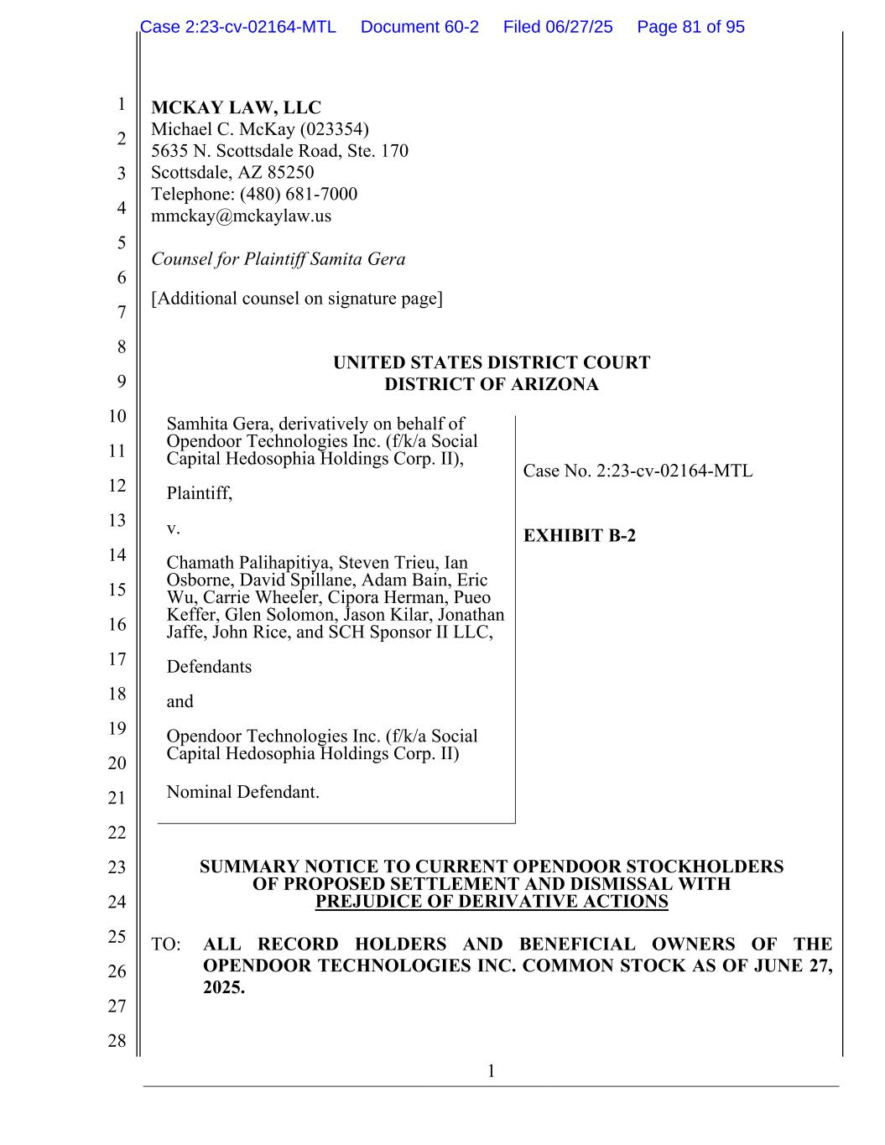
1 1 2 3 4 5 6 7 8 9 10 11 12 13 14 15 16 17 18 19 20 21 22 23 24 25 26 27 28 MCKAY LAW, LLC Michael C. McKay (023354) 5635 N. Scottsdale Road, Ste. 170 Scottsdale, AZ 85250 Telephone: (480) 681-7000 mmckay@mckaylaw.us Counsel for Plaintiff Samita Gera [Additional counsel on signature page] UNITED STATES DISTRICT COURT DISTRICT OF ARIZONA Samhita Gera, derivatively on behalf of Opendoor Technologies Inc. (f/k/a Social Capital Hedosophia Holdings Corp. II), Plaintiff, v. Chamath Palihapitiya, Steven Trieu, Ian Osborne, David Spillane, Adam Bain, Eric Wu, Carrie Wheeler, Cipora Herman, Pueo Keffer, Glen Solomon, Jason Kilar, Jonathan Jaffe, John Rice, and SCH Sponsor II LLC, Defendants and Opendoor Technologies Inc. (f/k/a Social Capital Hedosophia Holdings Corp. II) Nominal Defendant. Case No. 2:23-cv-02164-MTL EXHIBIT B-2 SUMMARY NOTICE TO CURRENT OPENDOOR STOCKHOLDERS OF PROPOSED SETTLEMENT AND DISMISSAL WITH PREJUDICE OF DERIVATIVE ACTIONS TO: ALL RECORD HOLDERS AND BENEFICIAL OWNERS OF THE OPENDOOR TECHNOLOGIES INC. COMMON STOCK AS OF JUNE 27, 2025. Case 2:23-cv-02164-MTL Document 60-2 Filed 06/27/25 Page 81 of 95

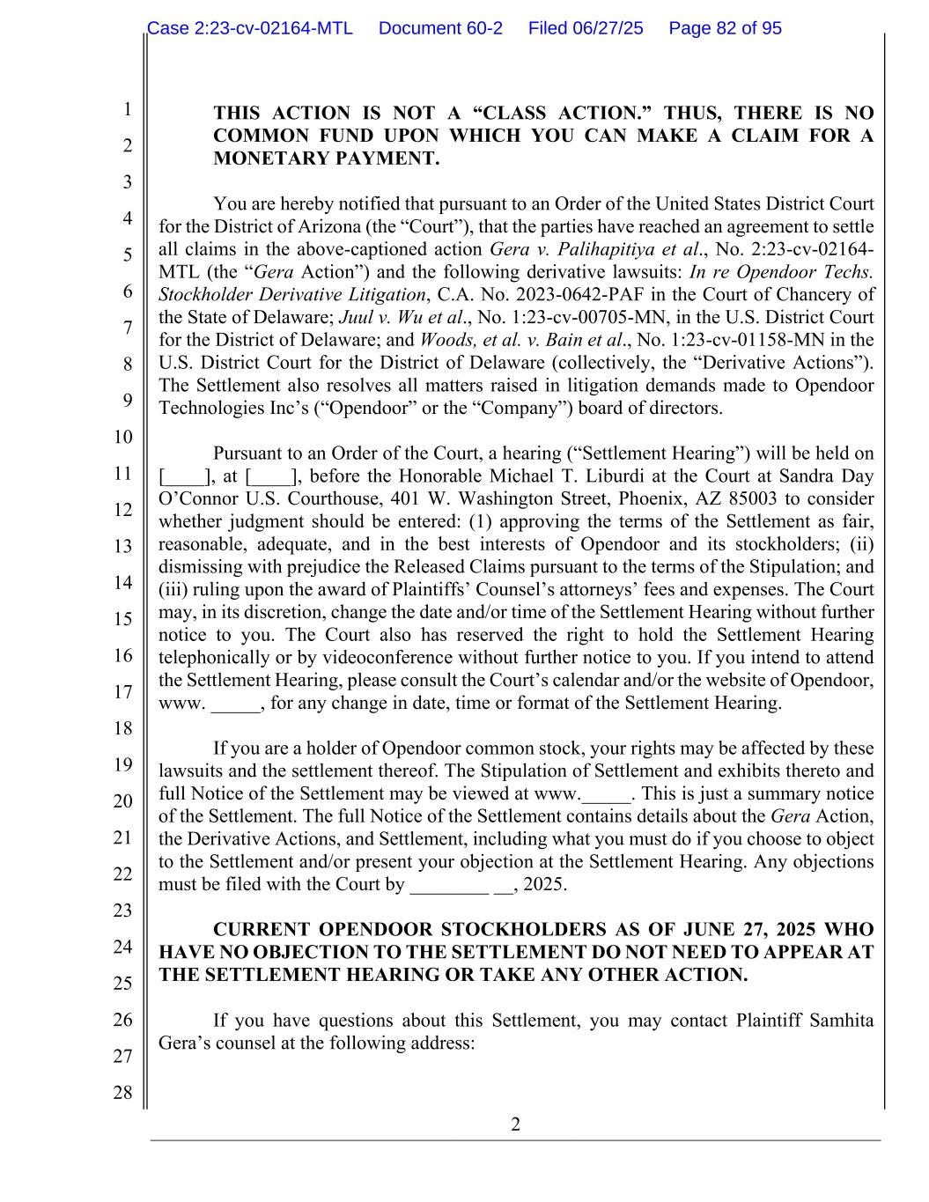
2 1 2 3 4 5 6 7 8 9 10 11 12 13 14 15 16 17 18 19 20 21 22 23 24 25 26 27 28 THIS ACTION IS NOT A “CLASS ACTION.” THUS, THERE IS NO COMMON FUND UPON WHICH YOU CAN MAKE A CLAIM FOR A MONETARY PAYMENT. You are hereby notified that pursuant to an Order of the United States District Court for the District of Arizona (the “Court”), that the parties have reached an agreement to settle all claims in the above-captioned action Gera v. Palihapitiya et al., No. 2:23-cv-02164- MTL (the “Gera Action”) and the following derivative lawsuits: In re Opendoor Techs. Stockholder Derivative Litigation, C.A. No. 2023-0642-PAF in the Court of Chancery of the State of Delaware; Juul v. Wu et al., No. 1:23-cv-00705-MN, in the U.S. District Court for the District of Delaware; and Woods, et al. v. Bain et al., No. 1:23-cv-01158-MN in the U.S. District Court for the District of Delaware (collectively, the “Derivative Actions”). The Settlement also resolves all matters raised in litigation demands made to Opendoor Technologies Inc’s (“Opendoor” or the “Company”) board of directors. Pursuant to an Order of the Court, a hearing (“Settlement Hearing”) will be held on [____], at [____], before the Honorable Michael T. Liburdi at the Court at Sandra Day O’Connor U.S. Courthouse, 401 W. Washington Street, Phoenix, AZ 85003 to consider whether judgment should be entered: (1) approving the terms of the Settlement as fair, reasonable, adequate, and in the best interests of Opendoor and its stockholders; (ii) dismissing with prejudice the Released Claims pursuant to the terms of the Stipulation; and (iii) ruling upon the award of Plaintiffs’ Counsel’s attorneys’ fees and expenses. The Court may, in its discretion, change the date and/or time of the Settlement Hearing without further notice to you. The Court also has reserved the right to hold the Settlement Hearing telephonically or by videoconference without further notice to you. If you intend to attend the Settlement Hearing, please consult the Court’s calendar and/or the website of Opendoor, www. _____, for any change in date, time or format of the Settlement Hearing. If you are a holder of Opendoor common stock, your rights may be affected by these lawsuits and the settlement thereof. The Stipulation of Settlement and exhibits thereto and full Notice of the Settlement may be viewed at www._____. This is just a summary notice of the Settlement. The full Notice of the Settlement contains details about the Gera Action, the Derivative Actions, and Settlement, including what you must do if you choose to object to the Settlement and/or present your objection at the Settlement Hearing. Any objections must be filed with the Court by ________ __, 2025. CURRENT OPENDOOR STOCKHOLDERS AS OF JUNE 27, 2025 WHO HAVE NO OBJECTION TO THE SETTLEMENT DO NOT NEED TO APPEAR AT THE SETTLEMENT HEARING OR TAKE ANY OTHER ACTION. If you have questions about this Settlement, you may contact Plaintiff Samhita Gera’s counsel at the following address: Case 2:23-cv-02164-MTL Document 60-2 Filed 06/27/25 Page 82 of 95

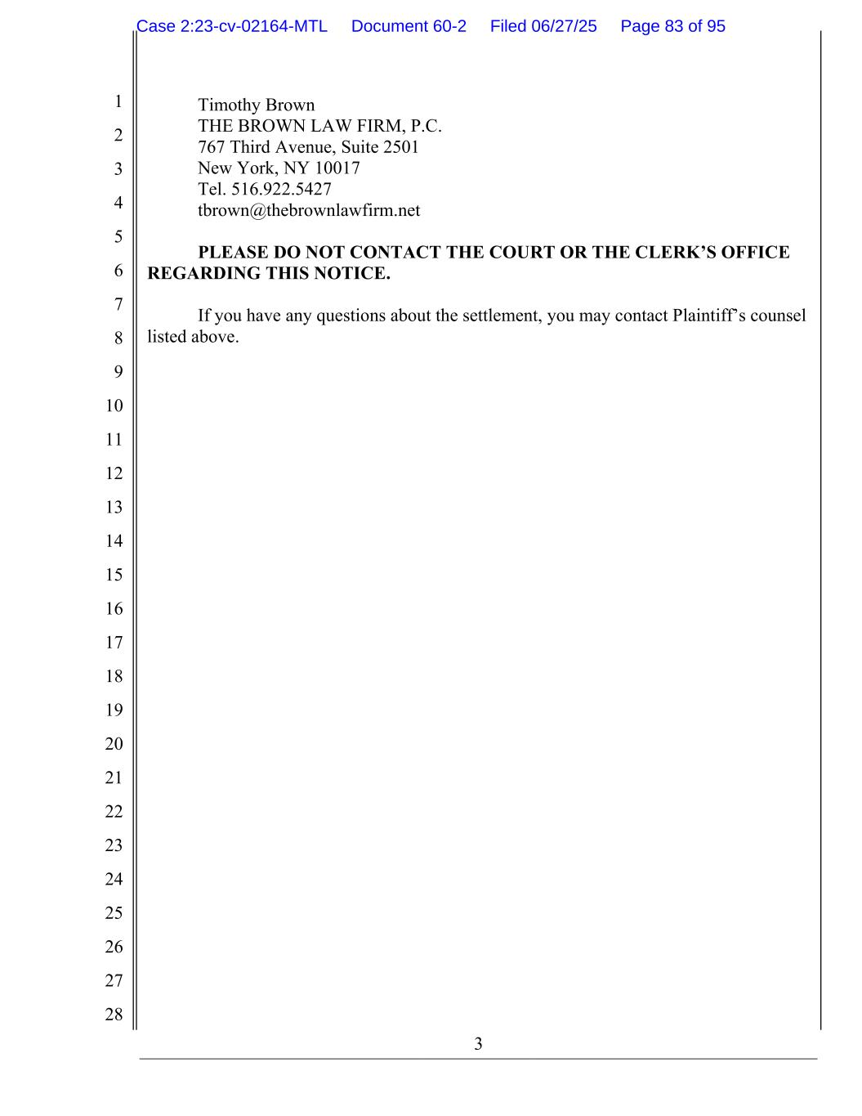
3 1 2 3 4 5 6 7 8 9 10 11 12 13 14 15 16 17 18 19 20 21 22 23 24 25 26 27 28 Timothy Brown THE BROWN LAW FIRM, P.C. 767 Third Avenue, Suite 2501 New York, NY 10017 Tel. 516.922.5427 tbrown@thebrownlawfirm.net PLEASE DO NOT CONTACT THE COURT OR THE CLERK’S OFFICE REGARDING THIS NOTICE. If you have any questions about the settlement, you may contact Plaintiff’s counsel listed above. Case 2:23-cv-02164-MTL Document 60-2 Filed 06/27/25 Page 83 of 95

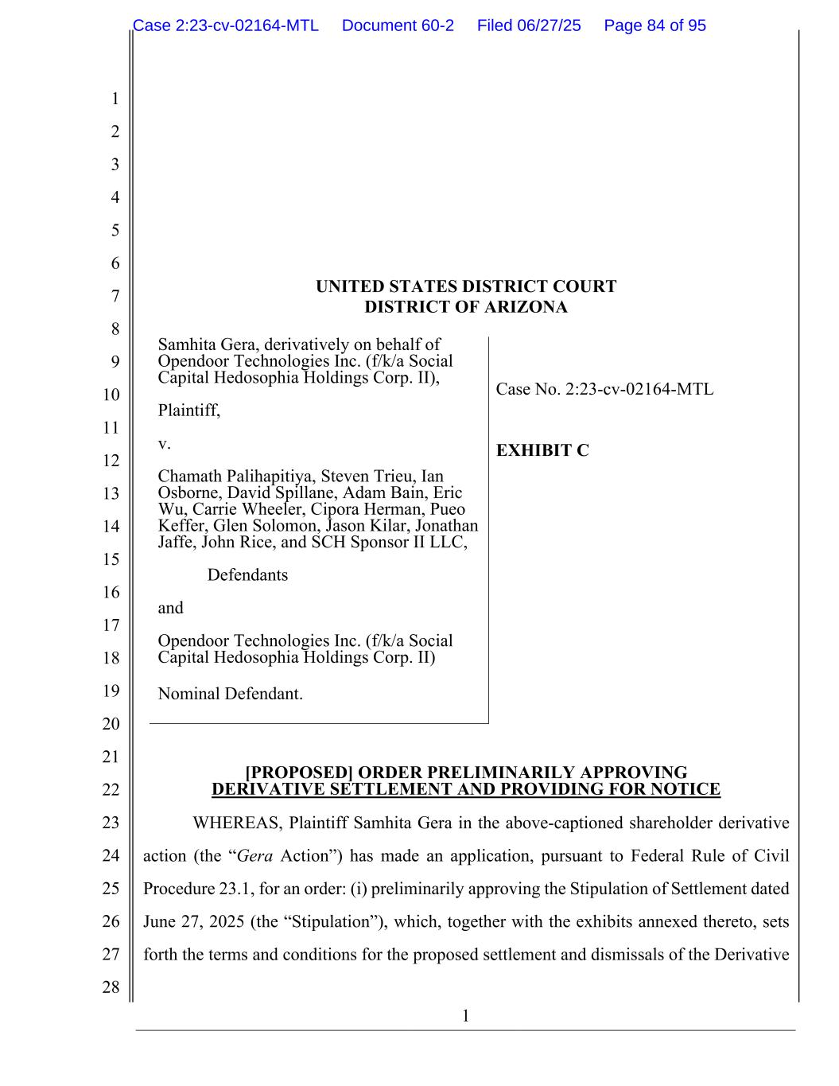
1 1 2 3 4 5 6 7 8 9 10 11 12 13 14 15 16 17 18 19 20 21 22 23 24 25 26 27 28 UNITED STATES DISTRICT COURT DISTRICT OF ARIZONA Samhita Gera, derivatively on behalf of Opendoor Technologies Inc. (f/k/a Social Capital Hedosophia Holdings Corp. II), Plaintiff, v. Chamath Palihapitiya, Steven Trieu, Ian Osborne, David Spillane, Adam Bain, Eric Wu, Carrie Wheeler, Cipora Herman, Pueo Keffer, Glen Solomon, Jason Kilar, Jonathan Jaffe, John Rice, and SCH Sponsor II LLC, Defendants and Opendoor Technologies Inc. (f/k/a Social Capital Hedosophia Holdings Corp. II) Nominal Defendant. Case No. 2:23-cv-02164-MTL EXHIBIT C [PROPOSED] ORDER PRELIMINARILY APPROVING DERIVATIVE SETTLEMENT AND PROVIDING FOR NOTICE WHEREAS, Plaintiff Samhita Gera in the above-captioned shareholder derivative action (the “Gera Action”) has made an application, pursuant to Federal Rule of Civil Procedure 23.1, for an order: (i) preliminarily approving the Stipulation of Settlement dated June 27, 2025 (the “Stipulation”), which, together with the exhibits annexed thereto, sets forth the terms and conditions for the proposed settlement and dismissals of the Derivative Case 2:23-cv-02164-MTL Document 60-2 Filed 06/27/25 Page 84 of 95

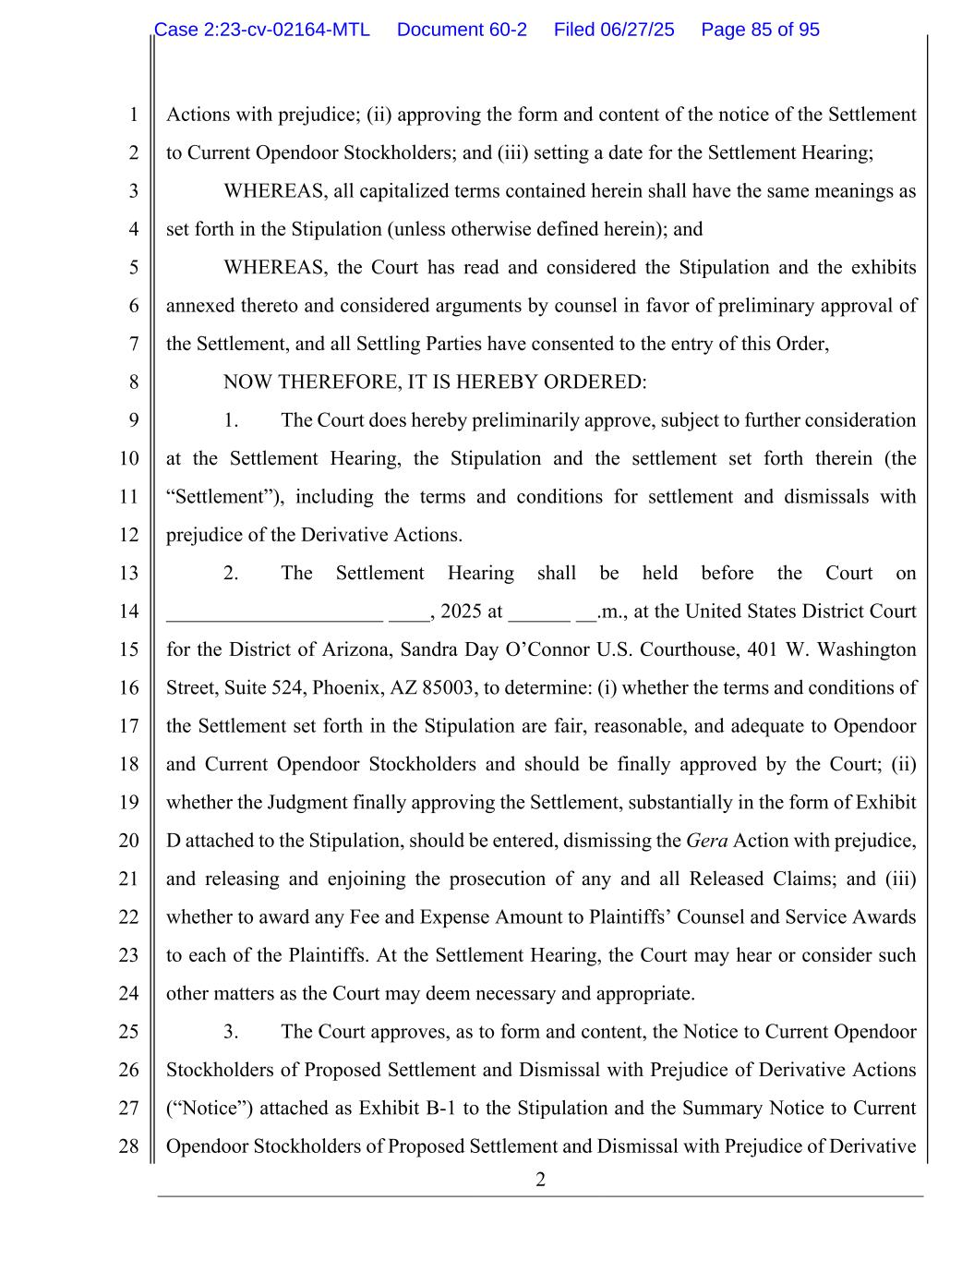
2 1 2 3 4 5 6 7 8 9 10 11 12 13 14 15 16 17 18 19 20 21 22 23 24 25 26 27 28 Actions with prejudice; (ii) approving the form and content of the notice of the Settlement to Current Opendoor Stockholders; and (iii) setting a date for the Settlement Hearing; WHEREAS, all capitalized terms contained herein shall have the same meanings as set forth in the Stipulation (unless otherwise defined herein); and WHEREAS, the Court has read and considered the Stipulation and the exhibits annexed thereto and considered arguments by counsel in favor of preliminary approval of the Settlement, and all Settling Parties have consented to the entry of this Order, NOW THEREFORE, IT IS HEREBY ORDERED: 1. The Court does hereby preliminarily approve, subject to further consideration at the Settlement Hearing, the Stipulation and the settlement set forth therein (the “Settlement”), including the terms and conditions for settlement and dismissals with prejudice of the Derivative Actions. 2. The Settlement Hearing shall be held before the Court on _____________________ ____, 2025 at ______ __.m., at the United States District Court for the District of Arizona, Sandra Day O’Connor U.S. Courthouse, 401 W. Washington Street, Suite 524, Phoenix, AZ 85003, to determine: (i) whether the terms and conditions of the Settlement set forth in the Stipulation are fair, reasonable, and adequate to Opendoor and Current Opendoor Stockholders and should be finally approved by the Court; (ii) whether the Judgment finally approving the Settlement, substantially in the form of Exhibit D attached to the Stipulation, should be entered, dismissing the Gera Action with prejudice, and releasing and enjoining the prosecution of any and all Released Claims; and (iii) whether to award any Fee and Expense Amount to Plaintiffs’ Counsel and Service Awards to each of the Plaintiffs. At the Settlement Hearing, the Court may hear or consider such other matters as the Court may deem necessary and appropriate. 3. The Court approves, as to form and content, the Notice to Current Opendoor Stockholders of Proposed Settlement and Dismissal with Prejudice of Derivative Actions (“Notice”) attached as Exhibit B-1 to the Stipulation and the Summary Notice to Current Opendoor Stockholders of Proposed Settlement and Dismissal with Prejudice of Derivative Case 2:23-cv-02164-MTL Document 60-2 Filed 06/27/25 Page 85 of 95

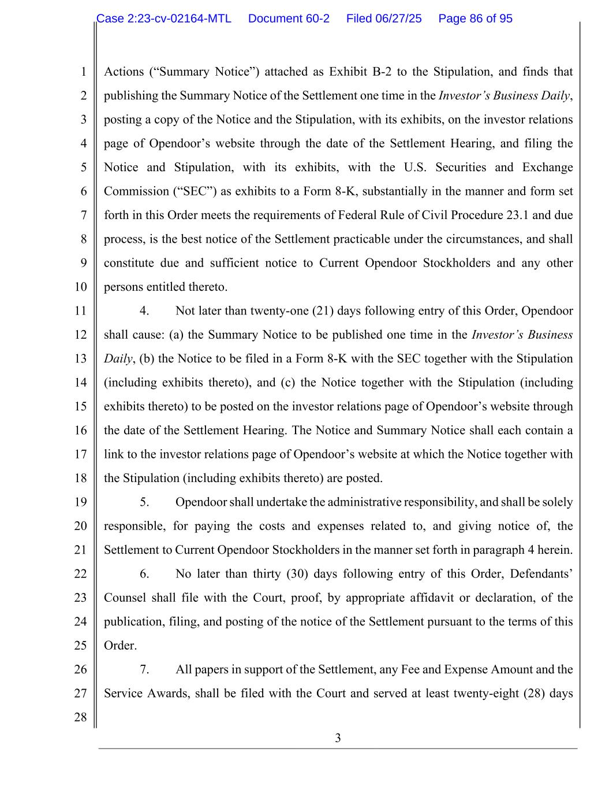
3 1 2 3 4 5 6 7 8 9 10 11 12 13 14 15 16 17 18 19 20 21 22 23 24 25 26 27 28 Actions (“Summary Notice”) attached as Exhibit B-2 to the Stipulation, and finds that publishing the Summary Notice of the Settlement one time in the Investor’s Business Daily, posting a copy of the Notice and the Stipulation, with its exhibits, on the investor relations page of Opendoor’s website through the date of the Settlement Hearing, and filing the Notice and Stipulation, with its exhibits, with the U.S. Securities and Exchange Commission (“SEC”) as exhibits to a Form 8-K, substantially in the manner and form set forth in this Order meets the requirements of Federal Rule of Civil Procedure 23.1 and due process, is the best notice of the Settlement practicable under the circumstances, and shall constitute due and sufficient notice to Current Opendoor Stockholders and any other persons entitled thereto. 4. Not later than twenty-one (21) days following entry of this Order, Opendoor shall cause: (a) the Summary Notice to be published one time in the Investor’s Business Daily, (b) the Notice to be filed in a Form 8-K with the SEC together with the Stipulation (including exhibits thereto), and (c) the Notice together with the Stipulation (including exhibits thereto) to be posted on the investor relations page of Opendoor’s website through the date of the Settlement Hearing. The Notice and Summary Notice shall each contain a link to the investor relations page of Opendoor’s website at which the Notice together with the Stipulation (including exhibits thereto) are posted. 5. Opendoor shall undertake the administrative responsibility, and shall be solely responsible, for paying the costs and expenses related to, and giving notice of, the Settlement to Current Opendoor Stockholders in the manner set forth in paragraph 4 herein. 6. No later than thirty (30) days following entry of this Order, Defendants’ Counsel shall file with the Court, proof, by appropriate affidavit or declaration, of the publication, filing, and posting of the notice of the Settlement pursuant to the terms of this Order. 7. All papers in support of the Settlement, any Fee and Expense Amount and the Service Awards, shall be filed with the Court and served at least twenty-eight (28) days Case 2:23-cv-02164-MTL Document 60-2 Filed 06/27/25 Page 86 of 95

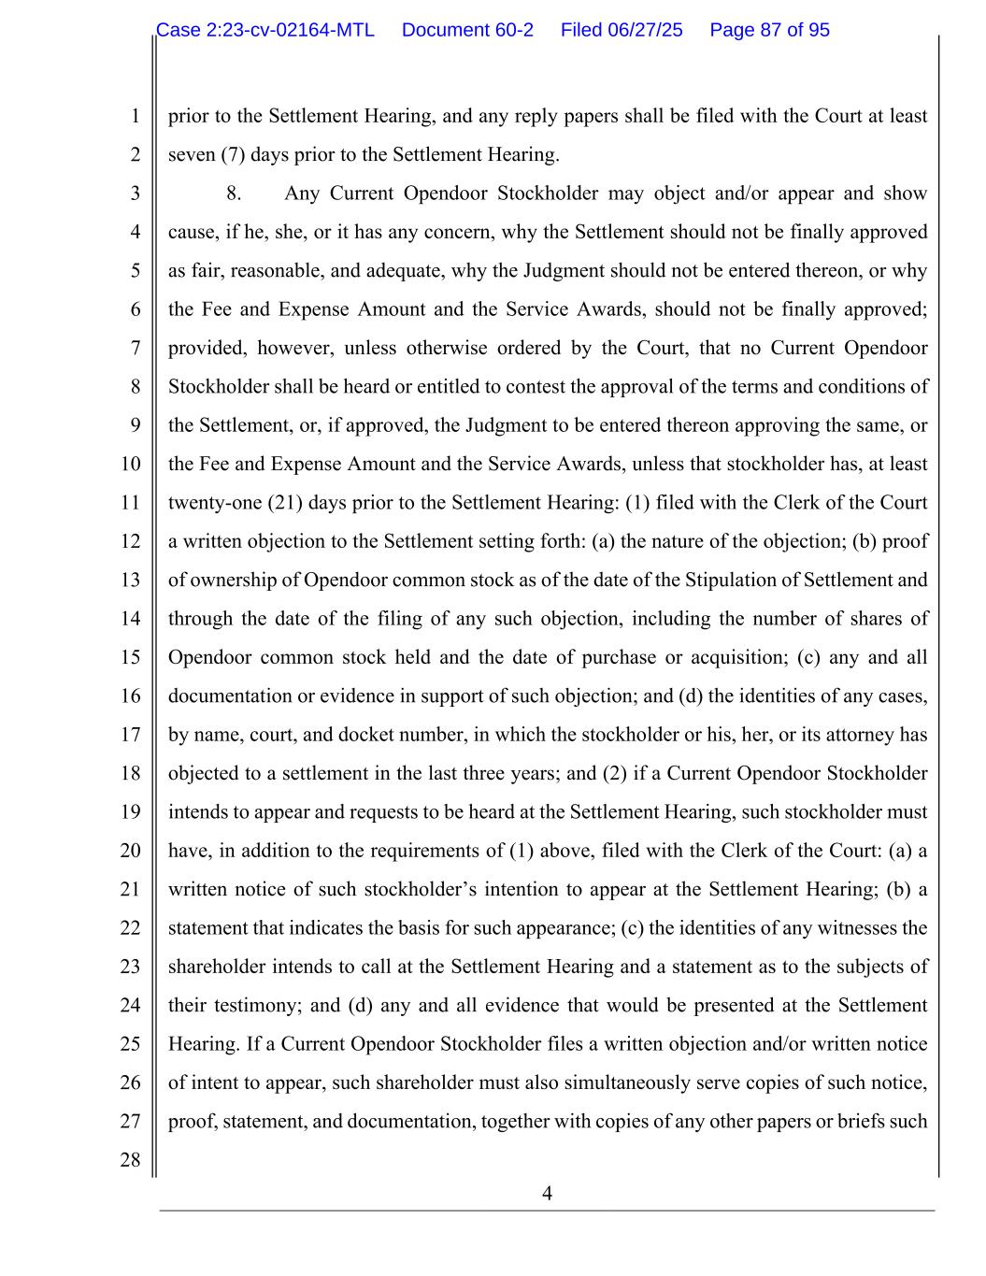
4 1 2 3 4 5 6 7 8 9 10 11 12 13 14 15 16 17 18 19 20 21 22 23 24 25 26 27 28 prior to the Settlement Hearing, and any reply papers shall be filed with the Court at least seven (7) days prior to the Settlement Hearing. 8. Any Current Opendoor Stockholder may object and/or appear and show cause, if he, she, or it has any concern, why the Settlement should not be finally approved as fair, reasonable, and adequate, why the Judgment should not be entered thereon, or why the Fee and Expense Amount and the Service Awards, should not be finally approved; provided, however, unless otherwise ordered by the Court, that no Current Opendoor Stockholder shall be heard or entitled to contest the approval of the terms and conditions of the Settlement, or, if approved, the Judgment to be entered thereon approving the same, or the Fee and Expense Amount and the Service Awards, unless that stockholder has, at least twenty-one (21) days prior to the Settlement Hearing: (1) filed with the Clerk of the Court a written objection to the Settlement setting forth: (a) the nature of the objection; (b) proof of ownership of Opendoor common stock as of the date of the Stipulation of Settlement and through the date of the filing of any such objection, including the number of shares of Opendoor common stock held and the date of purchase or acquisition; (c) any and all documentation or evidence in support of such objection; and (d) the identities of any cases, by name, court, and docket number, in which the stockholder or his, her, or its attorney has objected to a settlement in the last three years; and (2) if a Current Opendoor Stockholder intends to appear and requests to be heard at the Settlement Hearing, such stockholder must have, in addition to the requirements of (1) above, filed with the Clerk of the Court: (a) a written notice of such stockholder’s intention to appear at the Settlement Hearing; (b) a statement that indicates the basis for such appearance; (c) the identities of any witnesses the shareholder intends to call at the Settlement Hearing and a statement as to the subjects of their testimony; and (d) any and all evidence that would be presented at the Settlement Hearing. If a Current Opendoor Stockholder files a written objection and/or written notice of intent to appear, such shareholder must also simultaneously serve copies of such notice, proof, statement, and documentation, together with copies of any other papers or briefs such Case 2:23-cv-02164-MTL Document 60-2 Filed 06/27/25 Page 87 of 95

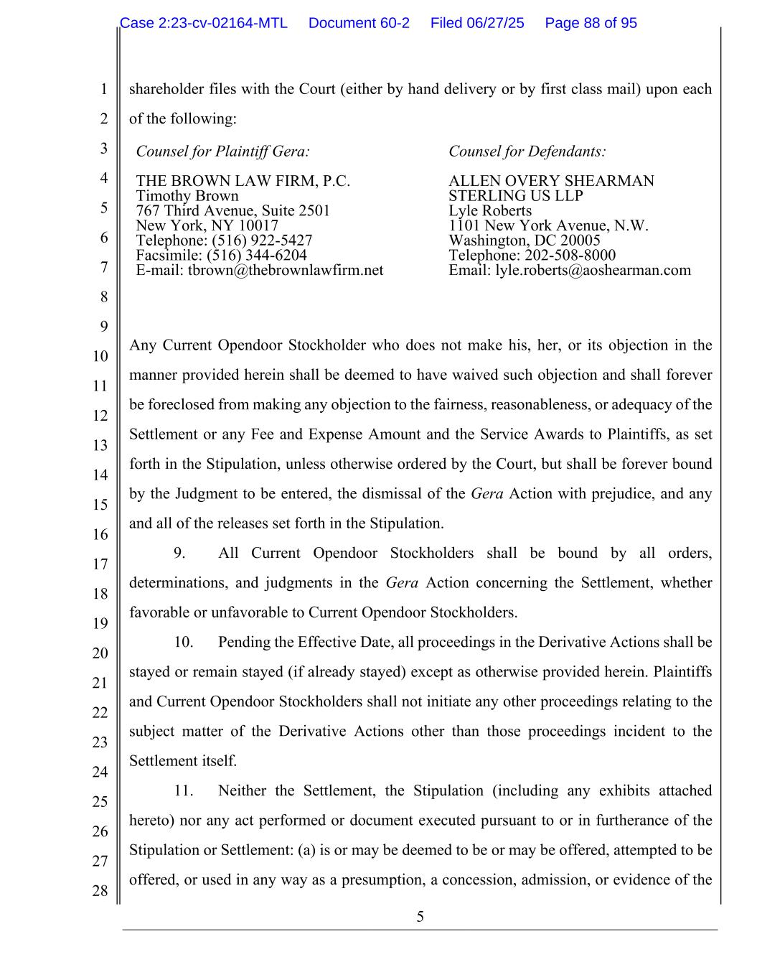
5 1 2 3 4 5 6 7 8 9 10 11 12 13 14 15 16 17 18 19 20 21 22 23 24 25 26 27 28 shareholder files with the Court (either by hand delivery or by first class mail) upon each of the following: Counsel for Plaintiff Gera: THE BROWN LAW FIRM, P.C. Timothy Brown 767 Third Avenue, Suite 2501 New York, NY 10017 Telephone: (516) 922-5427 Facsimile: (516) 344-6204 E-mail: tbrown@thebrownlawfirm.net Counsel for Defendants: ALLEN OVERY SHEARMAN STERLING US LLP Lyle Roberts 1101 New York Avenue, N.W. Washington, DC 20005 Telephone: 202-508-8000 Email: lyle.roberts@aoshearman.com Any Current Opendoor Stockholder who does not make his, her, or its objection in the manner provided herein shall be deemed to have waived such objection and shall forever be foreclosed from making any objection to the fairness, reasonableness, or adequacy of the Settlement or any Fee and Expense Amount and the Service Awards to Plaintiffs, as set forth in the Stipulation, unless otherwise ordered by the Court, but shall be forever bound by the Judgment to be entered, the dismissal of the Gera Action with prejudice, and any and all of the releases set forth in the Stipulation. 9. All Current Opendoor Stockholders shall be bound by all orders, determinations, and judgments in the Gera Action concerning the Settlement, whether favorable or unfavorable to Current Opendoor Stockholders. 10. Pending the Effective Date, all proceedings in the Derivative Actions shall be stayed or remain stayed (if already stayed) except as otherwise provided herein. Plaintiffs and Current Opendoor Stockholders shall not initiate any other proceedings relating to the subject matter of the Derivative Actions other than those proceedings incident to the Settlement itself. 11. Neither the Settlement, the Stipulation (including any exhibits attached hereto) nor any act performed or document executed pursuant to or in furtherance of the Stipulation or Settlement: (a) is or may be deemed to be or may be offered, attempted to be offered, or used in any way as a presumption, a concession, admission, or evidence of the Case 2:23-cv-02164-MTL Document 60-2 Filed 06/27/25 Page 88 of 95

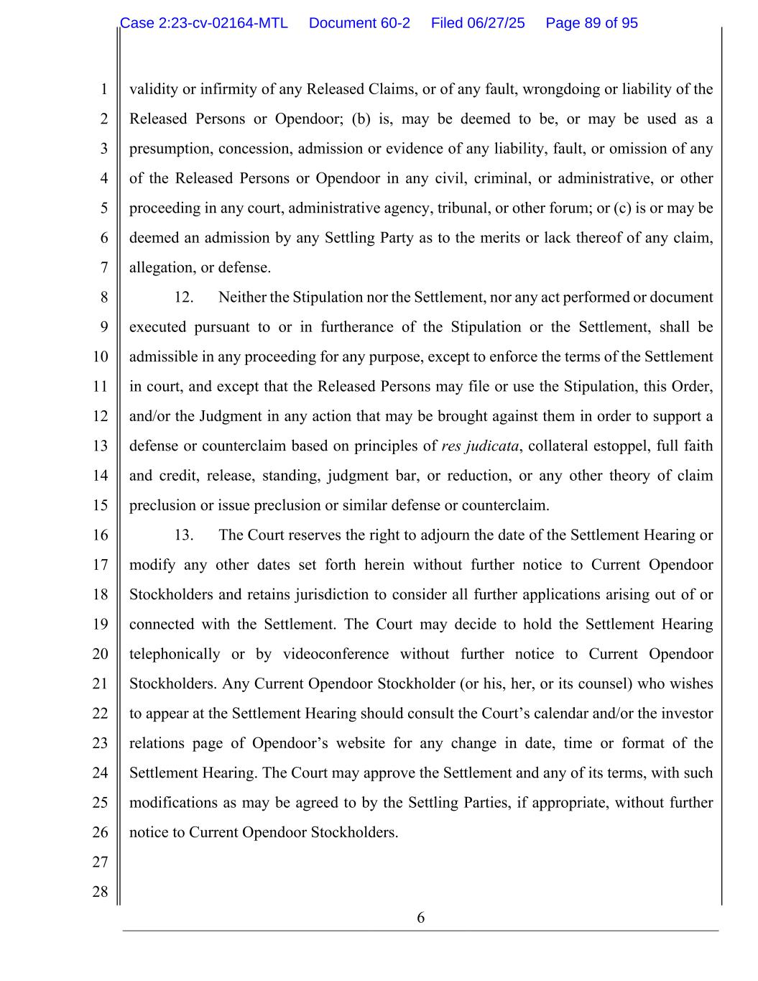
6 1 2 3 4 5 6 7 8 9 10 11 12 13 14 15 16 17 18 19 20 21 22 23 24 25 26 27 28 validity or infirmity of any Released Claims, or of any fault, wrongdoing or liability of the Released Persons or Opendoor; (b) is, may be deemed to be, or may be used as a presumption, concession, admission or evidence of any liability, fault, or omission of any of the Released Persons or Opendoor in any civil, criminal, or administrative, or other proceeding in any court, administrative agency, tribunal, or other forum; or (c) is or may be deemed an admission by any Settling Party as to the merits or lack thereof of any claim, allegation, or defense. 12. Neither the Stipulation nor the Settlement, nor any act performed or document executed pursuant to or in furtherance of the Stipulation or the Settlement, shall be admissible in any proceeding for any purpose, except to enforce the terms of the Settlement in court, and except that the Released Persons may file or use the Stipulation, this Order, and/or the Judgment in any action that may be brought against them in order to support a defense or counterclaim based on principles of res judicata, collateral estoppel, full faith and credit, release, standing, judgment bar, or reduction, or any other theory of claim preclusion or issue preclusion or similar defense or counterclaim. 13. The Court reserves the right to adjourn the date of the Settlement Hearing or modify any other dates set forth herein without further notice to Current Opendoor Stockholders and retains jurisdiction to consider all further applications arising out of or connected with the Settlement. The Court may decide to hold the Settlement Hearing telephonically or by videoconference without further notice to Current Opendoor Stockholders. Any Current Opendoor Stockholder (or his, her, or its counsel) who wishes to appear at the Settlement Hearing should consult the Court’s calendar and/or the investor relations page of Opendoor’s website for any change in date, time or format of the Settlement Hearing. The Court may approve the Settlement and any of its terms, with such modifications as may be agreed to by the Settling Parties, if appropriate, without further notice to Current Opendoor Stockholders. Case 2:23-cv-02164-MTL Document 60-2 Filed 06/27/25 Page 89 of 95


7 1 2 3 4 5 6 7 8 9 10 11 12 13 14 15 16 17 18 19 20 21 22 23 24 25 26 27 28 IT IS SO ORDERED. DATED: HONORABLE MICHAEL T. LIBURDI UNITED STATES DISTRICT JUDGE Case 2:23-cv-02164-MTL Document 60-2 Filed 06/27/25 Page 90 of 95

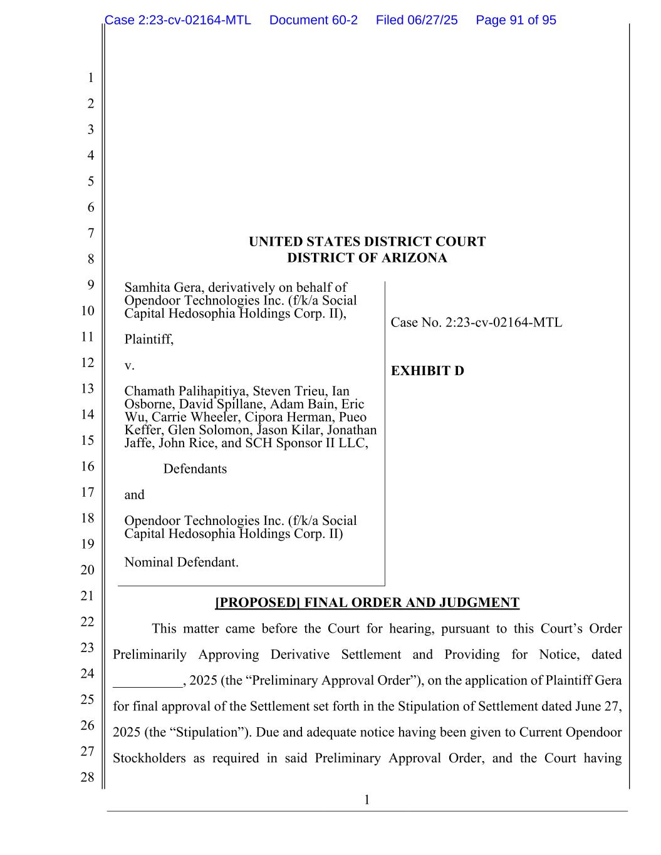
1 1 2 3 4 5 6 7 8 9 10 11 12 13 14 15 16 17 18 19 20 21 22 23 24 25 26 27 28 UNITED STATES DISTRICT COURT DISTRICT OF ARIZONA Samhita Gera, derivatively on behalf of Opendoor Technologies Inc. (f/k/a Social Capital Hedosophia Holdings Corp. II), Plaintiff, v. Chamath Palihapitiya, Steven Trieu, Ian Osborne, David Spillane, Adam Bain, Eric Wu, Carrie Wheeler, Cipora Herman, Pueo Keffer, Glen Solomon, Jason Kilar, Jonathan Jaffe, John Rice, and SCH Sponsor II LLC, Defendants and Opendoor Technologies Inc. (f/k/a Social Capital Hedosophia Holdings Corp. II) Nominal Defendant. Case No. 2:23-cv-02164-MTL EXHIBIT D [PROPOSED] FINAL ORDER AND JUDGMENT This matter came before the Court for hearing, pursuant to this Court’s Order Preliminarily Approving Derivative Settlement and Providing for Notice, dated __________, 2025 (the “Preliminary Approval Order”), on the application of Plaintiff Gera for final approval of the Settlement set forth in the Stipulation of Settlement dated June 27, 2025 (the “Stipulation”). Due and adequate notice having been given to Current Opendoor Stockholders as required in said Preliminary Approval Order, and the Court having Case 2:23-cv-02164-MTL Document 60-2 Filed 06/27/25 Page 91 of 95

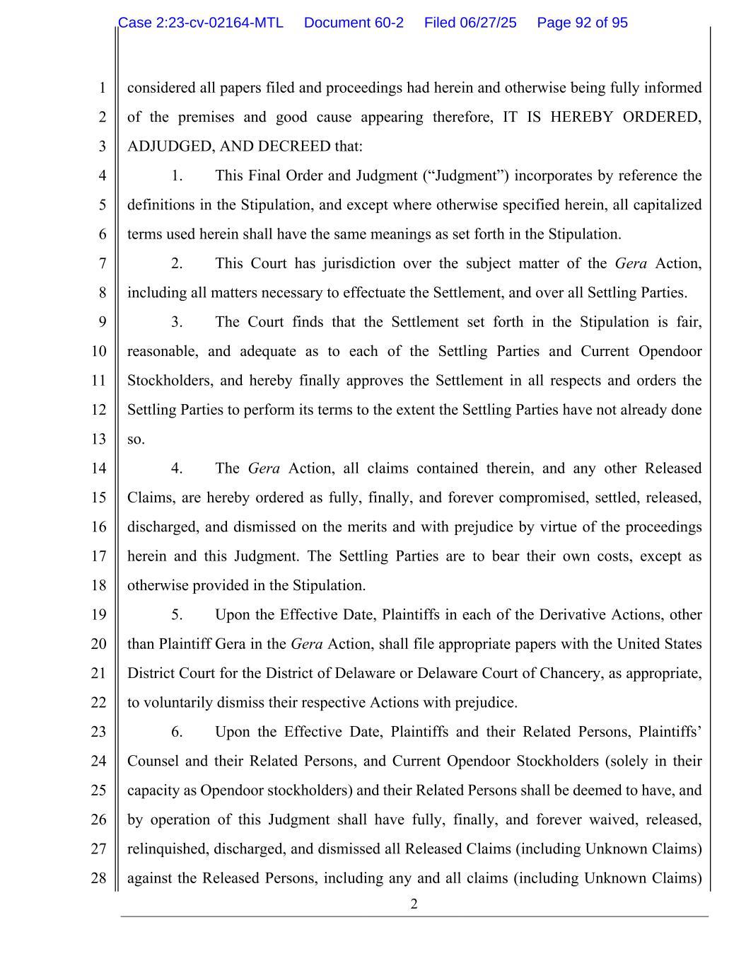
2 1 2 3 4 5 6 7 8 9 10 11 12 13 14 15 16 17 18 19 20 21 22 23 24 25 26 27 28 considered all papers filed and proceedings had herein and otherwise being fully informed of the premises and good cause appearing therefore, IT IS HEREBY ORDERED, ADJUDGED, AND DECREED that: 1. This Final Order and Judgment (“Judgment”) incorporates by reference the definitions in the Stipulation, and except where otherwise specified herein, all capitalized terms used herein shall have the same meanings as set forth in the Stipulation. 2. This Court has jurisdiction over the subject matter of the Gera Action, including all matters necessary to effectuate the Settlement, and over all Settling Parties. 3. The Court finds that the Settlement set forth in the Stipulation is fair, reasonable, and adequate as to each of the Settling Parties and Current Opendoor Stockholders, and hereby finally approves the Settlement in all respects and orders the Settling Parties to perform its terms to the extent the Settling Parties have not already done so. 4. The Gera Action, all claims contained therein, and any other Released Claims, are hereby ordered as fully, finally, and forever compromised, settled, released, discharged, and dismissed on the merits and with prejudice by virtue of the proceedings herein and this Judgment. The Settling Parties are to bear their own costs, except as otherwise provided in the Stipulation. 5. Upon the Effective Date, Plaintiffs in each of the Derivative Actions, other than Plaintiff Gera in the Gera Action, shall file appropriate papers with the United States District Court for the District of Delaware or Delaware Court of Chancery, as appropriate, to voluntarily dismiss their respective Actions with prejudice. 6. Upon the Effective Date, Plaintiffs and their Related Persons, Plaintiffs’ Counsel and their Related Persons, and Current Opendoor Stockholders (solely in their capacity as Opendoor stockholders) and their Related Persons shall be deemed to have, and by operation of this Judgment shall have fully, finally, and forever waived, released, relinquished, discharged, and dismissed all Released Claims (including Unknown Claims) against the Released Persons, including any and all claims (including Unknown Claims) Case 2:23-cv-02164-MTL Document 60-2 Filed 06/27/25 Page 92 of 95

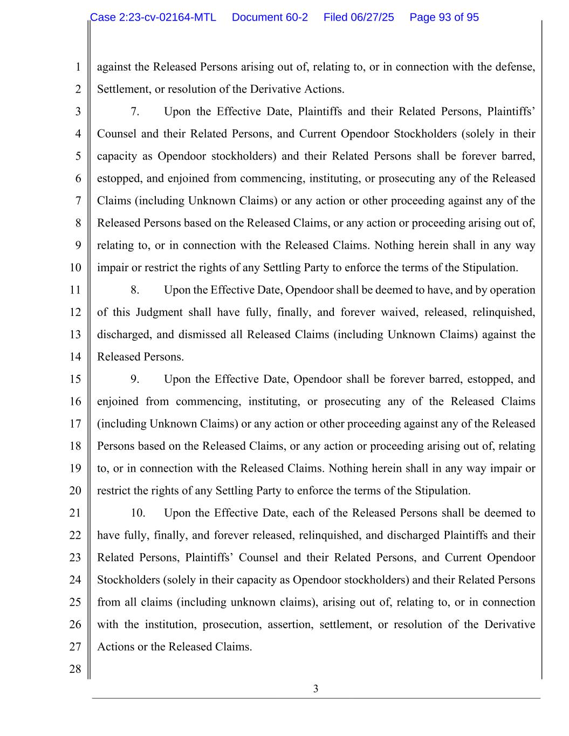
3 1 2 3 4 5 6 7 8 9 10 11 12 13 14 15 16 17 18 19 20 21 22 23 24 25 26 27 28 against the Released Persons arising out of, relating to, or in connection with the defense, Settlement, or resolution of the Derivative Actions. 7. Upon the Effective Date, Plaintiffs and their Related Persons, Plaintiffs’ Counsel and their Related Persons, and Current Opendoor Stockholders (solely in their capacity as Opendoor stockholders) and their Related Persons shall be forever barred, estopped, and enjoined from commencing, instituting, or prosecuting any of the Released Claims (including Unknown Claims) or any action or other proceeding against any of the Released Persons based on the Released Claims, or any action or proceeding arising out of, relating to, or in connection with the Released Claims. Nothing herein shall in any way impair or restrict the rights of any Settling Party to enforce the terms of the Stipulation. 8. Upon the Effective Date, Opendoor shall be deemed to have, and by operation of this Judgment shall have fully, finally, and forever waived, released, relinquished, discharged, and dismissed all Released Claims (including Unknown Claims) against the Released Persons. 9. Upon the Effective Date, Opendoor shall be forever barred, estopped, and enjoined from commencing, instituting, or prosecuting any of the Released Claims (including Unknown Claims) or any action or other proceeding against any of the Released Persons based on the Released Claims, or any action or proceeding arising out of, relating to, or in connection with the Released Claims. Nothing herein shall in any way impair or restrict the rights of any Settling Party to enforce the terms of the Stipulation. 10. Upon the Effective Date, each of the Released Persons shall be deemed to have fully, finally, and forever released, relinquished, and discharged Plaintiffs and their Related Persons, Plaintiffs’ Counsel and their Related Persons, and Current Opendoor Stockholders (solely in their capacity as Opendoor stockholders) and their Related Persons from all claims (including unknown claims), arising out of, relating to, or in connection with the institution, prosecution, assertion, settlement, or resolution of the Derivative Actions or the Released Claims. Case 2:23-cv-02164-MTL Document 60-2 Filed 06/27/25 Page 93 of 95

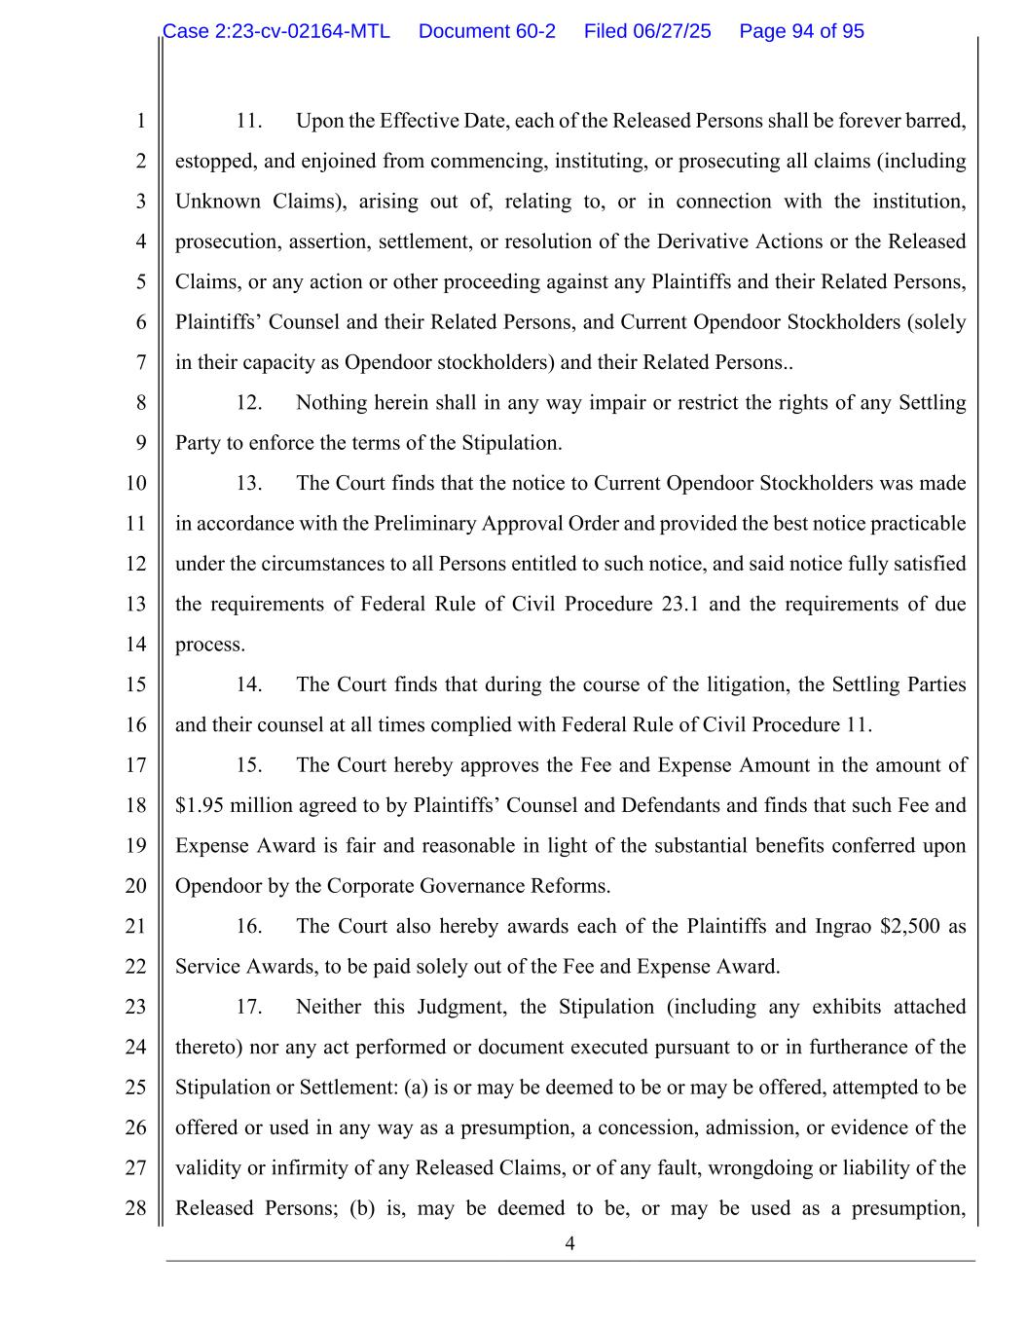
4 1 2 3 4 5 6 7 8 9 10 11 12 13 14 15 16 17 18 19 20 21 22 23 24 25 26 27 28 11. Upon the Effective Date, each of the Released Persons shall be forever barred, estopped, and enjoined from commencing, instituting, or prosecuting all claims (including Unknown Claims), arising out of, relating to, or in connection with the institution, prosecution, assertion, settlement, or resolution of the Derivative Actions or the Released Claims, or any action or other proceeding against any Plaintiffs and their Related Persons, Plaintiffs’ Counsel and their Related Persons, and Current Opendoor Stockholders (solely in their capacity as Opendoor stockholders) and their Related Persons.. 12. Nothing herein shall in any way impair or restrict the rights of any Settling Party to enforce the terms of the Stipulation. 13. The Court finds that the notice to Current Opendoor Stockholders was made in accordance with the Preliminary Approval Order and provided the best notice practicable under the circumstances to all Persons entitled to such notice, and said notice fully satisfied the requirements of Federal Rule of Civil Procedure 23.1 and the requirements of due process. 14. The Court finds that during the course of the litigation, the Settling Parties and their counsel at all times complied with Federal Rule of Civil Procedure 11. 15. The Court hereby approves the Fee and Expense Amount in the amount of $1.95 million agreed to by Plaintiffs’ Counsel and Defendants and finds that such Fee and Expense Award is fair and reasonable in light of the substantial benefits conferred upon Opendoor by the Corporate Governance Reforms. 16. The Court also hereby awards each of the Plaintiffs and Ingrao $2,500 as Service Awards, to be paid solely out of the Fee and Expense Award. 17. Neither this Judgment, the Stipulation (including any exhibits attached thereto) nor any act performed or document executed pursuant to or in furtherance of the Stipulation or Settlement: (a) is or may be deemed to be or may be offered, attempted to be offered or used in any way as a presumption, a concession, admission, or evidence of the validity or infirmity of any Released Claims, or of any fault, wrongdoing or liability of the Released Persons; (b) is, may be deemed to be, or may be used as a presumption, Case 2:23-cv-02164-MTL Document 60-2 Filed 06/27/25 Page 94 of 95

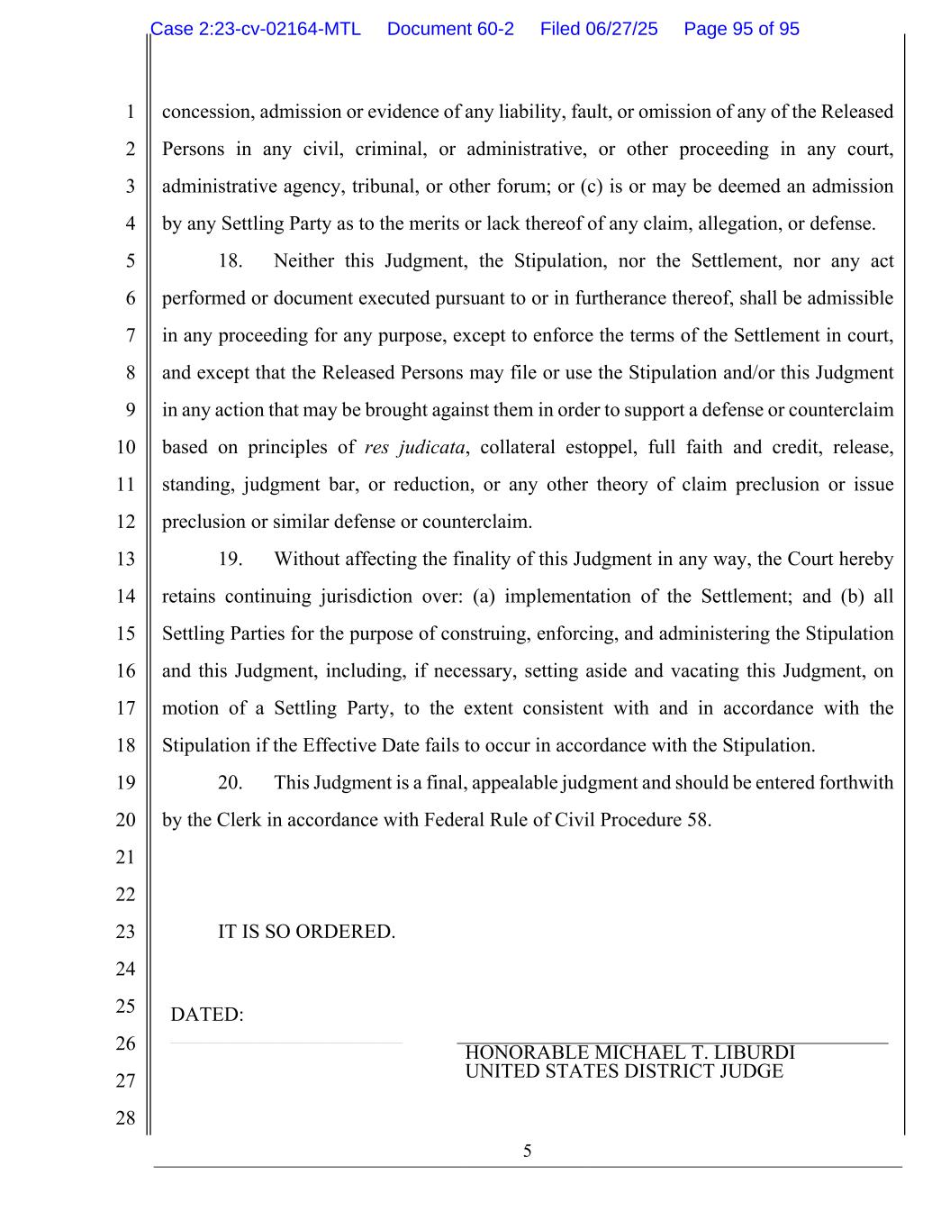
5 1 2 3 4 5 6 7 8 9 10 11 12 13 14 15 16 17 18 19 20 21 22 23 24 25 26 27 28 concession, admission or evidence of any liability, fault, or omission of any of the Released Persons in any civil, criminal, or administrative, or other proceeding in any court, administrative agency, tribunal, or other forum; or (c) is or may be deemed an admission by any Settling Party as to the merits or lack thereof of any claim, allegation, or defense. 18. Neither this Judgment, the Stipulation, nor the Settlement, nor any act performed or document executed pursuant to or in furtherance thereof, shall be admissible in any proceeding for any purpose, except to enforce the terms of the Settlement in court, and except that the Released Persons may file or use the Stipulation and/or this Judgment in any action that may be brought against them in order to support a defense or counterclaim based on principles of res judicata, collateral estoppel, full faith and credit, release, standing, judgment bar, or reduction, or any other theory of claim preclusion or issue preclusion or similar defense or counterclaim. 19. Without affecting the finality of this Judgment in any way, the Court hereby retains continuing jurisdiction over: (a) implementation of the Settlement; and (b) all Settling Parties for the purpose of construing, enforcing, and administering the Stipulation and this Judgment, including, if necessary, setting aside and vacating this Judgment, on motion of a Settling Party, to the extent consistent with and in accordance with the Stipulation if the Effective Date fails to occur in accordance with the Stipulation. 20. This Judgment is a final, appealable judgment and should be entered forthwith by the Clerk in accordance with Federal Rule of Civil Procedure 58. IT IS SO ORDERED. DATED: _______________________ HONORABLE MICHAEL T. LIBURDI UNITED STATES DISTRICT JUDGE Case 2:23-cv-02164-MTL Document 60-2 Filed 06/27/25 Page 95 of 95

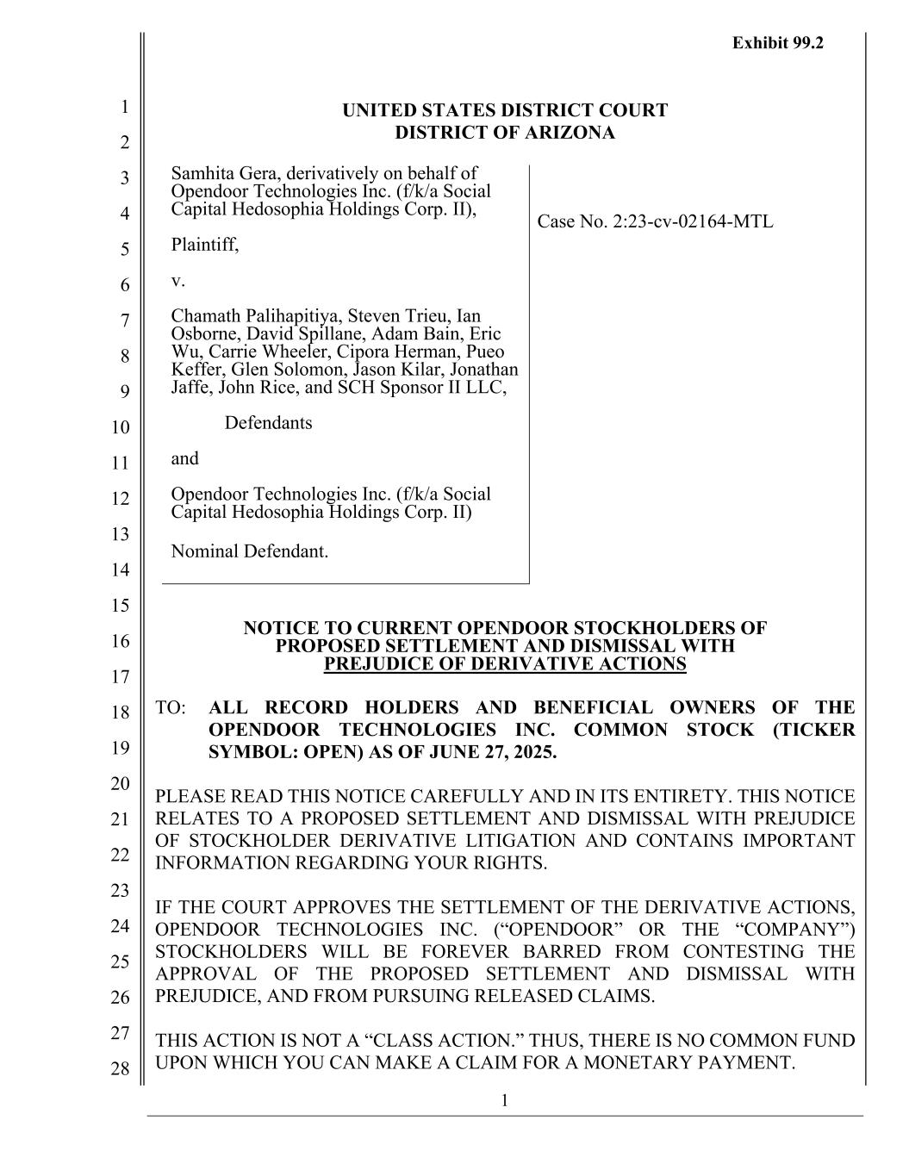
1 1 2 3 4 5 6 7 8 9 10 11 12 13 14 15 16 17 18 19 20 21 22 23 24 25 26 27 28 UNITED STATES DISTRICT COURT DISTRICT OF ARIZONA Samhita Gera, derivatively on behalf of Opendoor Technologies Inc. (f/k/a Social Capital Hedosophia Holdings Corp. II), Plaintiff, v. Chamath Palihapitiya, Steven Trieu, Ian Osborne, David Spillane, Adam Bain, Eric Wu, Carrie Wheeler, Cipora Herman, Pueo Keffer, Glen Solomon, Jason Kilar, Jonathan Jaffe, John Rice, and SCH Sponsor II LLC, Defendants and Opendoor Technologies Inc. (f/k/a Social Capital Hedosophia Holdings Corp. II) Nominal Defendant. Case No. 2:23-cv-02164-MTL NOTICE TO CURRENT OPENDOOR STOCKHOLDERS OF PROPOSED SETTLEMENT AND DISMISSAL WITH PREJUDICE OF DERIVATIVE ACTIONS TO: ALL RECORD HOLDERS AND BENEFICIAL OWNERS OF THE OPENDOOR TECHNOLOGIES INC. COMMON STOCK (TICKER SYMBOL: OPEN) AS OF JUNE 27, 2025. PLEASE READ THIS NOTICE CAREFULLY AND IN ITS ENTIRETY. THIS NOTICE RELATES TO A PROPOSED SETTLEMENT AND DISMISSAL WITH PREJUDICE OF STOCKHOLDER DERIVATIVE LITIGATION AND CONTAINS IMPORTANT INFORMATION REGARDING YOUR RIGHTS. IF THE COURT APPROVES THE SETTLEMENT OF THE DERIVATIVE ACTIONS, OPENDOOR TECHNOLOGIES INC. (“OPENDOOR” OR THE “COMPANY”) STOCKHOLDERS WILL BE FOREVER BARRED FROM CONTESTING THE APPROVAL OF THE PROPOSED SETTLEMENT AND DISMISSAL WITH PREJUDICE, AND FROM PURSUING RELEASED CLAIMS. THIS ACTION IS NOT A “CLASS ACTION.” THUS, THERE IS NO COMMON FUND UPON WHICH YOU CAN MAKE A CLAIM FOR A MONETARY PAYMENT. Exhibit 99.2

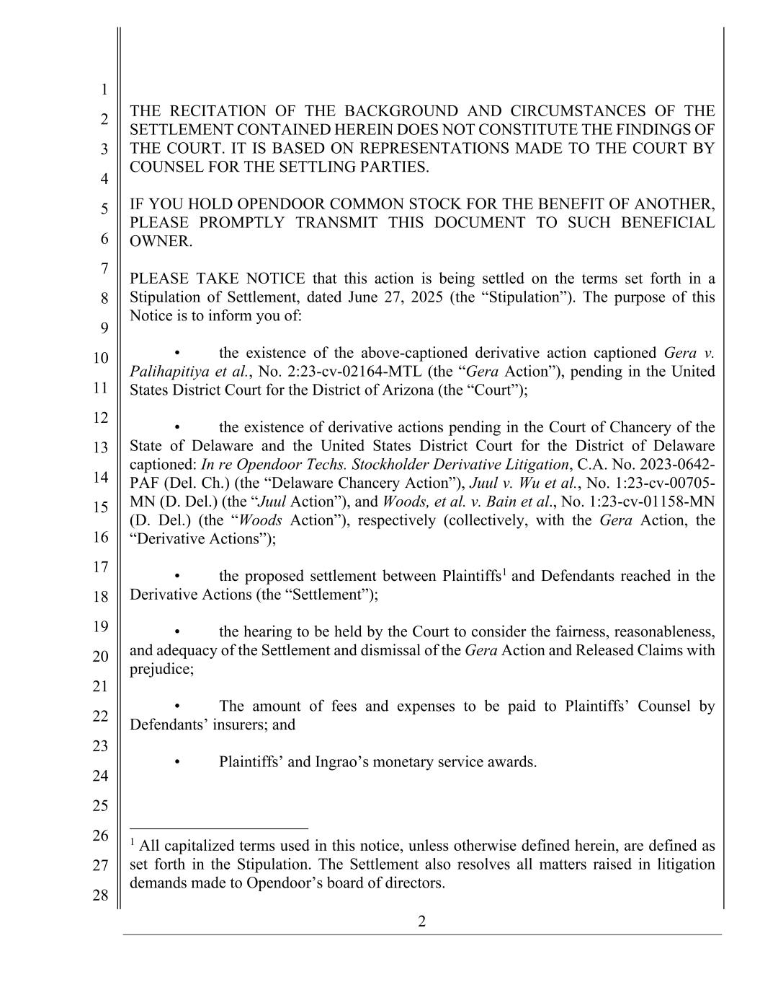
2 1 2 3 4 5 6 7 8 9 10 11 12 13 14 15 16 17 18 19 20 21 22 23 24 25 26 27 28 THE RECITATION OF THE BACKGROUND AND CIRCUMSTANCES OF THE SETTLEMENT CONTAINED HEREIN DOES NOT CONSTITUTE THE FINDINGS OF THE COURT. IT IS BASED ON REPRESENTATIONS MADE TO THE COURT BY COUNSEL FOR THE SETTLING PARTIES. IF YOU HOLD OPENDOOR COMMON STOCK FOR THE BENEFIT OF ANOTHER, PLEASE PROMPTLY TRANSMIT THIS DOCUMENT TO SUCH BENEFICIAL OWNER. PLEASE TAKE NOTICE that this action is being settled on the terms set forth in a Stipulation of Settlement, dated June 27, 2025 (the “Stipulation”). The purpose of this Notice is to inform you of: • the existence of the above-captioned derivative action captioned Gera v. Palihapitiya et al., No. 2:23-cv-02164-MTL (the “Gera Action”), pending in the United States District Court for the District of Arizona (the “Court”); • the existence of derivative actions pending in the Court of Chancery of the State of Delaware and the United States District Court for the District of Delaware captioned: In re Opendoor Techs. Stockholder Derivative Litigation, C.A. No. 2023-0642- PAF (Del. Ch.) (the “Delaware Chancery Action”), Juul v. Wu et al., No. 1:23-cv-00705- MN (D. Del.) (the “Juul Action”), and Woods, et al. v. Bain et al., No. 1:23-cv-01158-MN (D. Del.) (the “Woods Action”), respectively (collectively, with the Gera Action, the “Derivative Actions”); • the proposed settlement between Plaintiffs1 and Defendants reached in the Derivative Actions (the “Settlement”); • the hearing to be held by the Court to consider the fairness, reasonableness, and adequacy of the Settlement and dismissal of the Gera Action and Released Claims with prejudice; • The amount of fees and expenses to be paid to Plaintiffs’ Counsel by Defendants’ insurers; and • Plaintiffs’ and Ingrao’s monetary service awards. 1 All capitalized terms used in this notice, unless otherwise defined herein, are defined as set forth in the Stipulation. The Settlement also resolves all matters raised in litigation demands made to Opendoor’s board of directors.

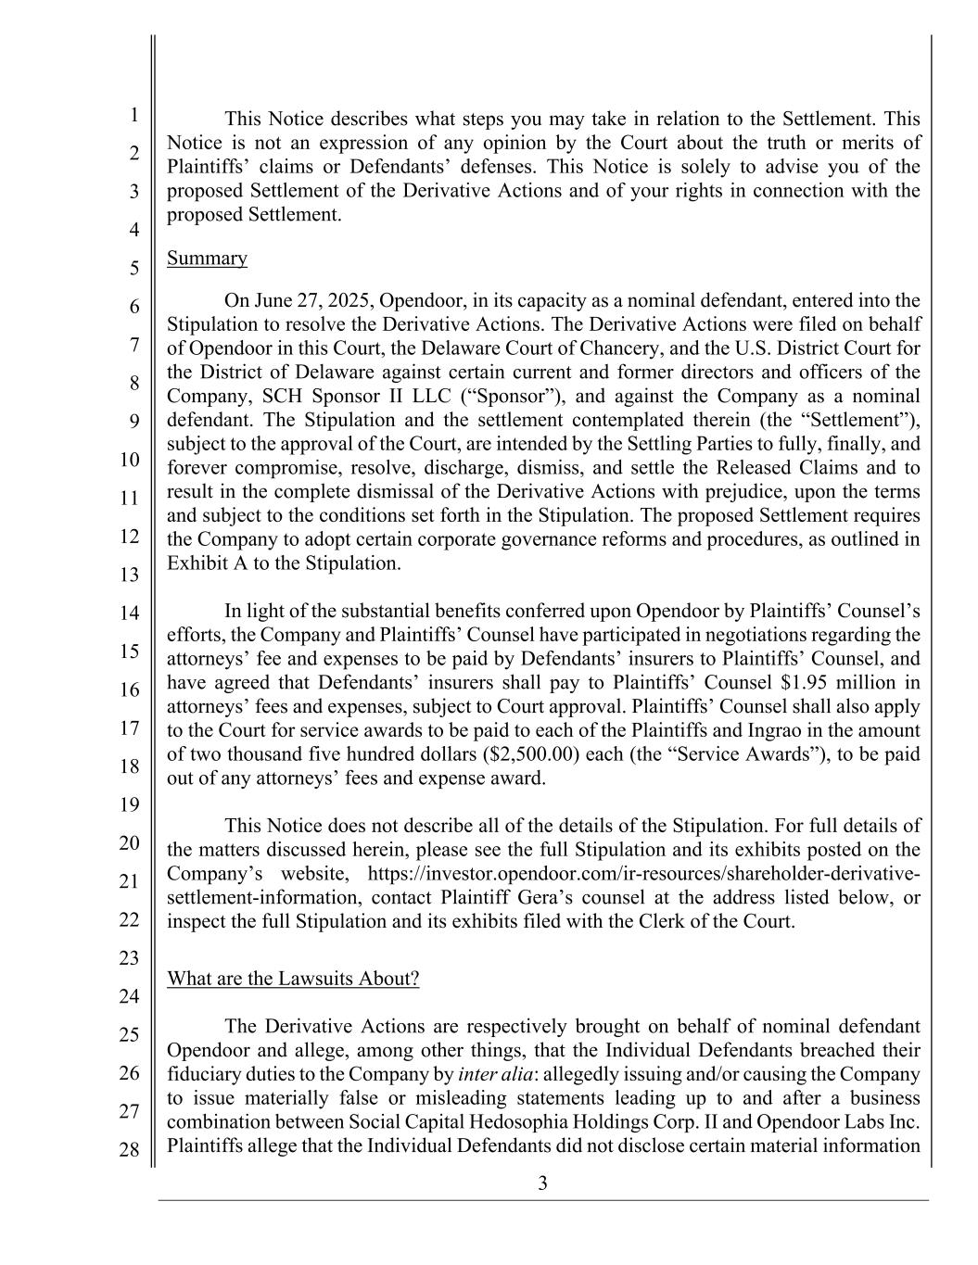
3 1 2 3 4 5 6 7 8 9 10 11 12 13 14 15 16 17 18 19 20 21 22 23 24 25 26 27 28 This Notice describes what steps you may take in relation to the Settlement. This Notice is not an expression of any opinion by the Court about the truth or merits of Plaintiffs’ claims or Defendants’ defenses. This Notice is solely to advise you of the proposed Settlement of the Derivative Actions and of your rights in connection with the proposed Settlement. Summary On June 27, 2025, Opendoor, in its capacity as a nominal defendant, entered into the Stipulation to resolve the Derivative Actions. The Derivative Actions were filed on behalf of Opendoor in this Court, the Delaware Court of Chancery, and the U.S. District Court for the District of Delaware against certain current and former directors and officers of the Company, SCH Sponsor II LLC (“Sponsor”), and against the Company as a nominal defendant. The Stipulation and the settlement contemplated therein (the “Settlement”), subject to the approval of the Court, are intended by the Settling Parties to fully, finally, and forever compromise, resolve, discharge, dismiss, and settle the Released Claims and to result in the complete dismissal of the Derivative Actions with prejudice, upon the terms and subject to the conditions set forth in the Stipulation. The proposed Settlement requires the Company to adopt certain corporate governance reforms and procedures, as outlined in Exhibit A to the Stipulation. In light of the substantial benefits conferred upon Opendoor by Plaintiffs’ Counsel’s efforts, the Company and Plaintiffs’ Counsel have participated in negotiations regarding the attorneys’ fee and expenses to be paid by Defendants’ insurers to Plaintiffs’ Counsel, and have agreed that Defendants’ insurers shall pay to Plaintiffs’ Counsel $1.95 million in attorneys’ fees and expenses, subject to Court approval. Plaintiffs’ Counsel shall also apply to the Court for service awards to be paid to each of the Plaintiffs and Ingrao in the amount of two thousand five hundred dollars ($2,500.00) each (the “Service Awards”), to be paid out of any attorneys’ fees and expense award. This Notice does not describe all of the details of the Stipulation. For full details of the matters discussed herein, please see the full Stipulation and its exhibits posted on the Company’s website, https://investor.opendoor.com/ir-resources/shareholder-derivative- settlement-information, contact Plaintiff Gera’s counsel at the address listed below, or inspect the full Stipulation and its exhibits filed with the Clerk of the Court. What are the Lawsuits About? The Derivative Actions are respectively brought on behalf of nominal defendant Opendoor and allege, among other things, that the Individual Defendants breached their fiduciary duties to the Company by inter alia: allegedly issuing and/or causing the Company to issue materially false or misleading statements leading up to and after a business combination between Social Capital Hedosophia Holdings Corp. II and Opendoor Labs Inc. Plaintiffs allege that the Individual Defendants did not disclose certain material information

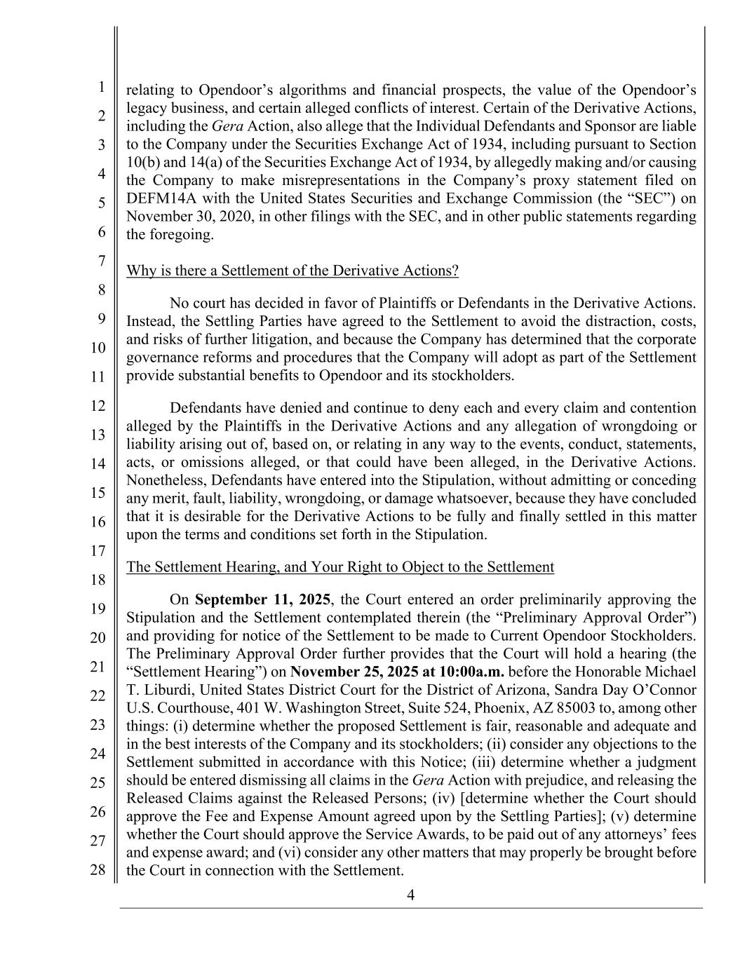
4 1 2 3 4 5 6 7 8 9 10 11 12 13 14 15 16 17 18 19 20 21 22 23 24 25 26 27 28 relating to Opendoor’s algorithms and financial prospects, the value of the Opendoor’s legacy business, and certain alleged conflicts of interest. Certain of the Derivative Actions, including the Gera Action, also allege that the Individual Defendants and Sponsor are liable to the Company under the Securities Exchange Act of 1934, including pursuant to Section 10(b) and 14(a) of the Securities Exchange Act of 1934, by allegedly making and/or causing the Company to make misrepresentations in the Company’s proxy statement filed on DEFM14A with the United States Securities and Exchange Commission (the “SEC”) on November 30, 2020, in other filings with the SEC, and in other public statements regarding the foregoing. Why is there a Settlement of the Derivative Actions? No court has decided in favor of Plaintiffs or Defendants in the Derivative Actions. Instead, the Settling Parties have agreed to the Settlement to avoid the distraction, costs, and risks of further litigation, and because the Company has determined that the corporate governance reforms and procedures that the Company will adopt as part of the Settlement provide substantial benefits to Opendoor and its stockholders. Defendants have denied and continue to deny each and every claim and contention alleged by the Plaintiffs in the Derivative Actions and any allegation of wrongdoing or liability arising out of, based on, or relating in any way to the events, conduct, statements, acts, or omissions alleged, or that could have been alleged, in the Derivative Actions. Nonetheless, Defendants have entered into the Stipulation, without admitting or conceding any merit, fault, liability, wrongdoing, or damage whatsoever, because they have concluded that it is desirable for the Derivative Actions to be fully and finally settled in this matter upon the terms and conditions set forth in the Stipulation. The Settlement Hearing, and Your Right to Object to the Settlement On September 11, 2025, the Court entered an order preliminarily approving the Stipulation and the Settlement contemplated therein (the “Preliminary Approval Order”) and providing for notice of the Settlement to be made to Current Opendoor Stockholders. The Preliminary Approval Order further provides that the Court will hold a hearing (the “Settlement Hearing”) on November 25, 2025 at 10:00a.m. before the Honorable Michael T. Liburdi, United States District Court for the District of Arizona, Sandra Day O’Connor U.S. Courthouse, 401 W. Washington Street, Suite 524, Phoenix, AZ 85003 to, among other things: (i) determine whether the proposed Settlement is fair, reasonable and adequate and in the best interests of the Company and its stockholders; (ii) consider any objections to the Settlement submitted in accordance with this Notice; (iii) determine whether a judgment should be entered dismissing all claims in the Gera Action with prejudice, and releasing the Released Claims against the Released Persons; (iv) [determine whether the Court should approve the Fee and Expense Amount agreed upon by the Settling Parties]; (v) determine whether the Court should approve the Service Awards, to be paid out of any attorneys’ fees and expense award; and (vi) consider any other matters that may properly be brought before the Court in connection with the Settlement.

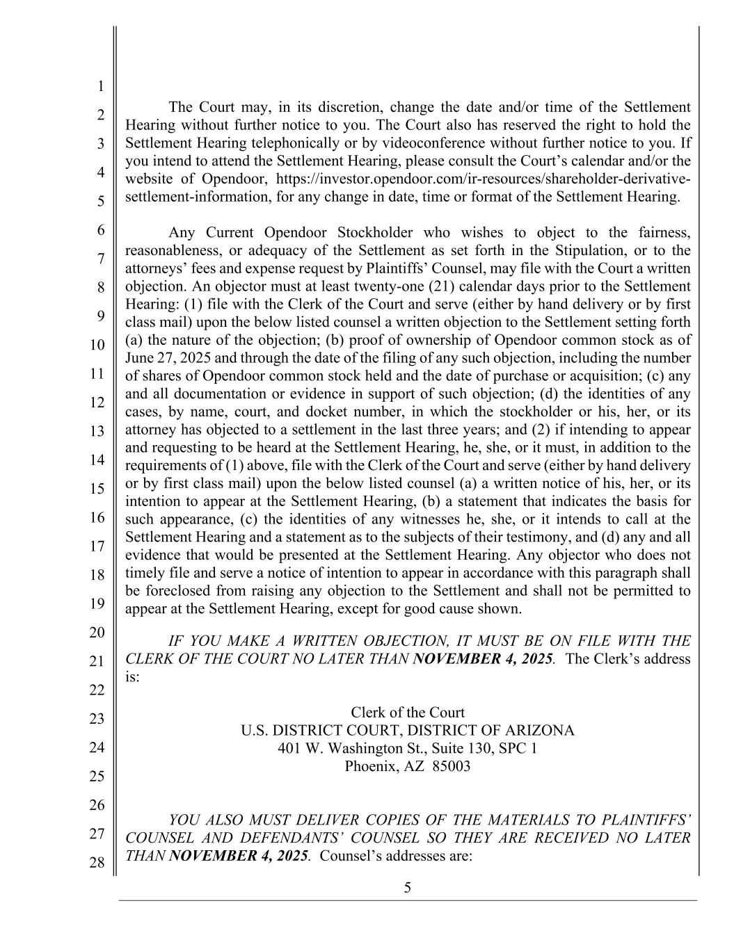
5 1 2 3 4 5 6 7 8 9 10 11 12 13 14 15 16 17 18 19 20 21 22 23 24 25 26 27 28 The Court may, in its discretion, change the date and/or time of the Settlement Hearing without further notice to you. The Court also has reserved the right to hold the Settlement Hearing telephonically or by videoconference without further notice to you. If you intend to attend the Settlement Hearing, please consult the Court’s calendar and/or the website of Opendoor, https://investor.opendoor.com/ir-resources/shareholder-derivative- settlement-information, for any change in date, time or format of the Settlement Hearing. Any Current Opendoor Stockholder who wishes to object to the fairness, reasonableness, or adequacy of the Settlement as set forth in the Stipulation, or to the attorneys’ fees and expense request by Plaintiffs’ Counsel, may file with the Court a written objection. An objector must at least twenty-one (21) calendar days prior to the Settlement Hearing: (1) file with the Clerk of the Court and serve (either by hand delivery or by first class mail) upon the below listed counsel a written objection to the Settlement setting forth (a) the nature of the objection; (b) proof of ownership of Opendoor common stock as of June 27, 2025 and through the date of the filing of any such objection, including the number of shares of Opendoor common stock held and the date of purchase or acquisition; (c) any and all documentation or evidence in support of such objection; (d) the identities of any cases, by name, court, and docket number, in which the stockholder or his, her, or its attorney has objected to a settlement in the last three years; and (2) if intending to appear and requesting to be heard at the Settlement Hearing, he, she, or it must, in addition to the requirements of (1) above, file with the Clerk of the Court and serve (either by hand delivery or by first class mail) upon the below listed counsel (a) a written notice of his, her, or its intention to appear at the Settlement Hearing, (b) a statement that indicates the basis for such appearance, (c) the identities of any witnesses he, she, or it intends to call at the Settlement Hearing and a statement as to the subjects of their testimony, and (d) any and all evidence that would be presented at the Settlement Hearing. Any objector who does not timely file and serve a notice of intention to appear in accordance with this paragraph shall be foreclosed from raising any objection to the Settlement and shall not be permitted to appear at the Settlement Hearing, except for good cause shown. IF YOU MAKE A WRITTEN OBJECTION, IT MUST BE ON FILE WITH THE CLERK OF THE COURT NO LATER THAN NOVEMBER 4, 2025. The Clerk’s address is: Clerk of the Court U.S. DISTRICT COURT, DISTRICT OF ARIZONA 401 W. Washington St., Suite 130, SPC 1 Phoenix, AZ 85003 YOU ALSO MUST DELIVER COPIES OF THE MATERIALS TO PLAINTIFFS’ COUNSEL AND DEFENDANTS’ COUNSEL SO THEY ARE RECEIVED NO LATER THAN NOVEMBER 4, 2025. Counsel’s addresses are:

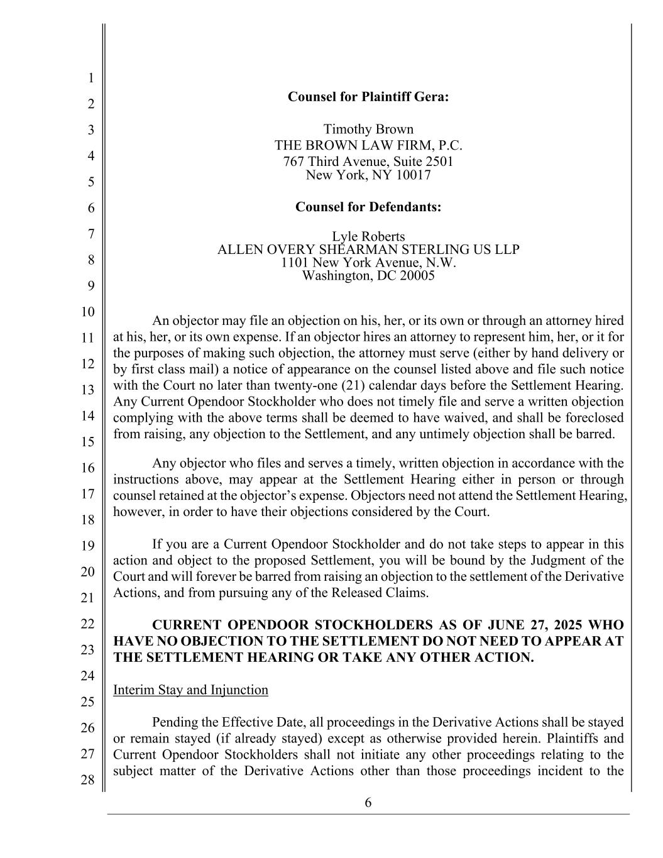
6 1 2 3 4 5 6 7 8 9 10 11 12 13 14 15 16 17 18 19 20 21 22 23 24 25 26 27 28 Counsel for Plaintiff Gera: Timothy Brown THE BROWN LAW FIRM, P.C. 767 Third Avenue, Suite 2501 New York, NY 10017 Counsel for Defendants: Lyle Roberts ALLEN OVERY SHEARMAN STERLING US LLP 1101 New York Avenue, N.W. Washington, DC 20005 An objector may file an objection on his, her, or its own or through an attorney hired at his, her, or its own expense. If an objector hires an attorney to represent him, her, or it for the purposes of making such objection, the attorney must serve (either by hand delivery or by first class mail) a notice of appearance on the counsel listed above and file such notice with the Court no later than twenty-one (21) calendar days before the Settlement Hearing. Any Current Opendoor Stockholder who does not timely file and serve a written objection complying with the above terms shall be deemed to have waived, and shall be foreclosed from raising, any objection to the Settlement, and any untimely objection shall be barred. Any objector who files and serves a timely, written objection in accordance with the instructions above, may appear at the Settlement Hearing either in person or through counsel retained at the objector’s expense. Objectors need not attend the Settlement Hearing, however, in order to have their objections considered by the Court. If you are a Current Opendoor Stockholder and do not take steps to appear in this action and object to the proposed Settlement, you will be bound by the Judgment of the Court and will forever be barred from raising an objection to the settlement of the Derivative Actions, and from pursuing any of the Released Claims. CURRENT OPENDOOR STOCKHOLDERS AS OF JUNE 27, 2025 WHO HAVE NO OBJECTION TO THE SETTLEMENT DO NOT NEED TO APPEAR AT THE SETTLEMENT HEARING OR TAKE ANY OTHER ACTION. Interim Stay and Injunction Pending the Effective Date, all proceedings in the Derivative Actions shall be stayed or remain stayed (if already stayed) except as otherwise provided herein. Plaintiffs and Current Opendoor Stockholders shall not initiate any other proceedings relating to the subject matter of the Derivative Actions other than those proceedings incident to the

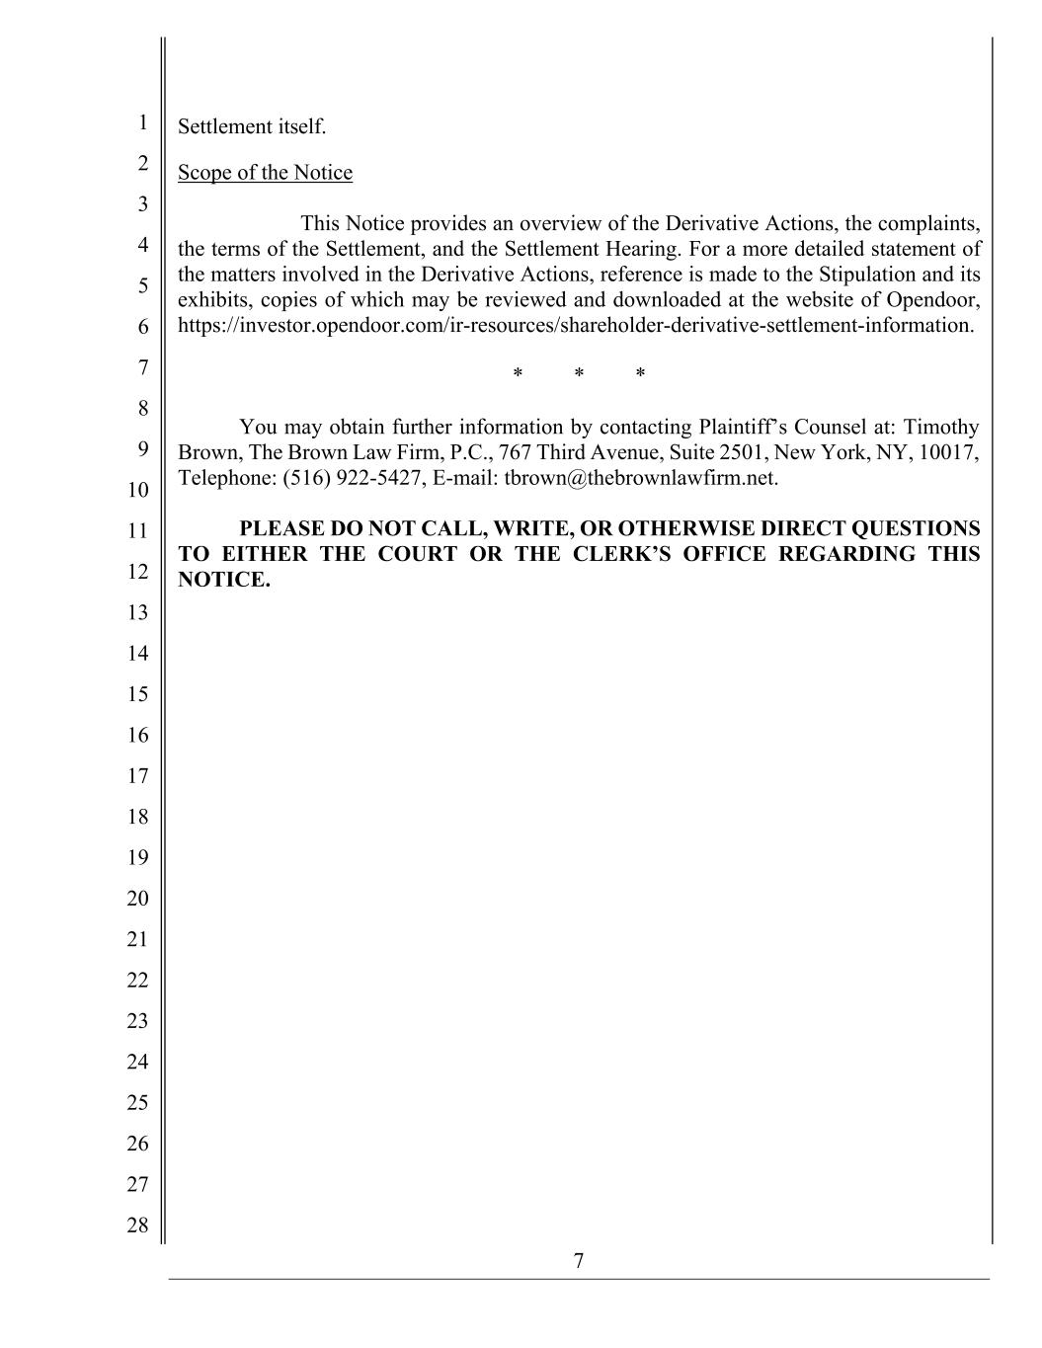
7 1 2 3 4 5 6 7 8 9 10 11 12 13 14 15 16 17 18 19 20 21 22 23 24 25 26 27 28 Settlement itself. Scope of the Notice This Notice provides an overview of the Derivative Actions, the complaints, the terms of the Settlement, and the Settlement Hearing. For a more detailed statement of the matters involved in the Derivative Actions, reference is made to the Stipulation and its exhibits, copies of which may be reviewed and downloaded at the website of Opendoor, https://investor.opendoor.com/ir-resources/shareholder-derivative-settlement-information. * * * You may obtain further information by contacting Plaintiff’s Counsel at: Timothy Brown, The Brown Law Firm, P.C., 767 Third Avenue, Suite 2501, New York, NY, 10017, Telephone: (516) 922-5427, E-mail: tbrown@thebrownlawfirm.net. PLEASE DO NOT CALL, WRITE, OR OTHERWISE DIRECT QUESTIONS TO EITHER THE COURT OR THE CLERK’S OFFICE REGARDING THIS NOTICE.

